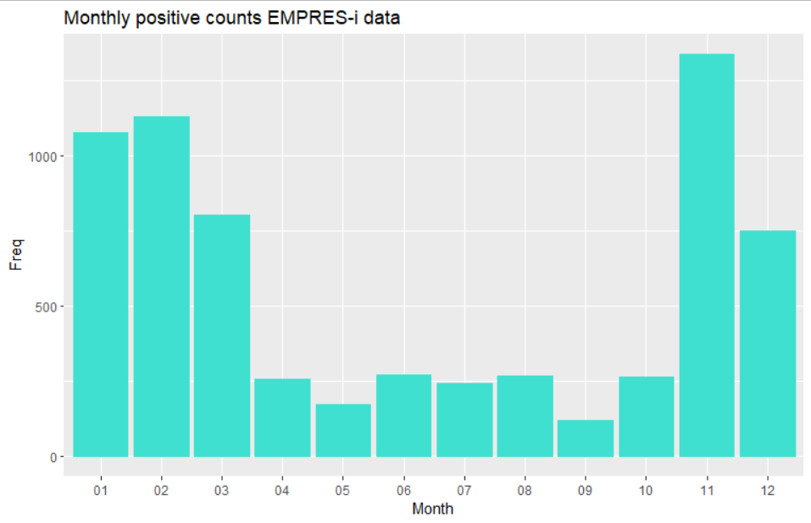

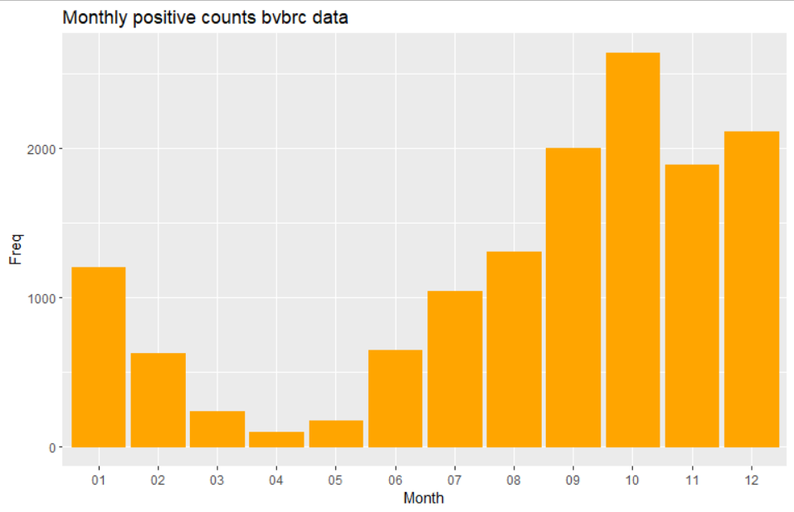

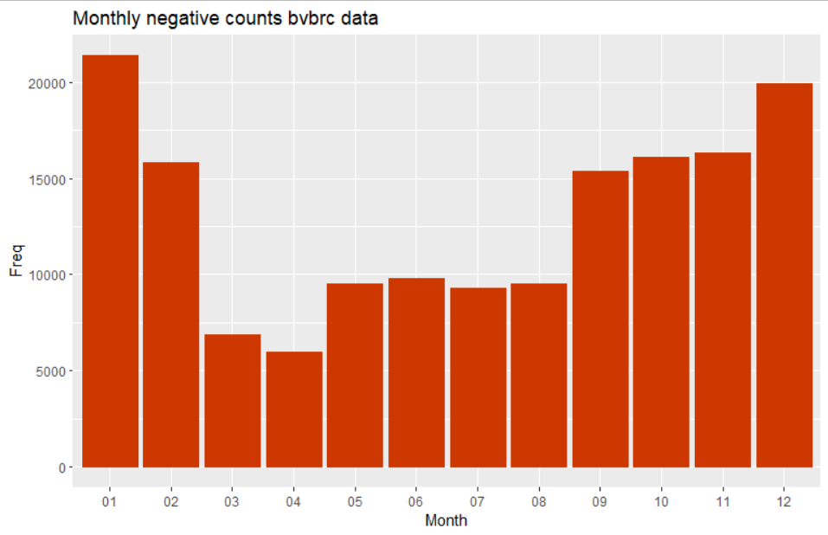

**Table of subtype info from EMPRES-i**

|  |  |  |
| --- | --- | --- |
| Subtype | Pathogenicity | Freq |
| H10N7 | LPAI | 1 |
| H5 | HPAI | 92 |
| H5 | LPAI | 3 |
| H5N1 | HPAI | 4021 |
| H5N1 | LPAI | 1 |
| H5N2 | HPAI | 2 |
| H5N2 | LPAI | 2 |
| H5N3 | HPAI | 15 |
| H5N4 | HPAI | 14 |
| H5N5 | HPAI | 87 |
| H5N6 | HPAI | 104 |
| H5N8 | HPAI | 2373 |
| H5N8 | LPAI | 7 |
| H5N9 | HPAI | 3 |
| H7 | HPAI | 1 |
| H7 | LPAI | 1 |
| H7N7 | HPAI | 2 |
| HPAI | HPAI | 2 |
| LPAI | LPAI | 5 |

**Table of subtype info from BV-BRC**

|  |  |  |  |  |  |
| --- | --- | --- | --- | --- | --- |
| Subtype | Freq | Subtype | Freq | Subtype | Freq |
| Not recorded | 13134 | **H7N1** | 1 | **HxN1** | 2 |
| H1N1 | 8 | **H7N2** | 1 | **HxN2** | 5 |
| H1N2 | 2 | **H7N3** | 4 | **HxN3** | 3 |
| H1N3 | 1 | **H7N5** | 1 | **HxN6** | 4 |
| H1N6 | 1 | **H7N7** | 5 | **HxN8** | 12 |
| H1NY | 2 | **H7Nx** | 6 | **HxNx** | 452 |
| H2N3 | 2 | **H8N4** | 2 | **HXNX** | 2 |
| H2N5 | 10 | **H8Nx** | 1 | **HxNy** | 26 |
| H2N7 | 11 | **H10N4** | 3 | **Mixed** | 2 |
| H2N9 | 3 | **H10N5** | 1 |  |  |
| H3N1 | 1 | **H10N7** | 10 |  |  |
| H3N2 | 5 | **H10NY** | 1 |  |  |
| H3N6 | 3 | **H11N1** | 3 |  |  |
| H3N8 | 23 | **H11N2** | 1 |  |  |
| H3Ny | 1 | **H11N9** | 7 |  |  |
| H4N6 | 22 | **H12N5** | 2 |  |  |
| H4N8 | 1 | **H13N2** | 3 |  |  |
| H4Nx | 2 | **H13N3** | 1 |  |  |
| H5N1 | 1 | **H13N6** | 4 |  |  |
| H5N2 | 5 | **H13N8** | 16 |  |  |
| H5N3 | 2 | **H13Nx** | 14 |  |  |
| H5N6 | 7 | **H16N2** | 1 |  |  |
| H5N8 | 53 | **H16N3** | 28 |  |  |
| H5Nx | 6 | **H16N6** | 5 |  |  |
| H6N1 | 3 | **H16Nx** | 8 |  |  |
| H6N2 | 8 |  |  |  |  |
| H6N3 | 1 |  |  |  |  |
| H6N5 | 3 |  |  |  |  |
| H6N7 | 1 |  |  |  |  |
| H6N8 | 15 |  |  |  |  |
| H6Nx | 8 |  |  |  |  |
|  |  |  |  |  |  |