

**BOOKNEST: Final Project Report**

By

Jamile Obeid, **ID:** 762004935

Malak Alqaryouti, **ID:** 759007889

Lana Kendakji, **ID:** 757001591

Sara Hijazi, **ID:** 387006935

**Supervised by**

Dr. Ali Assi

Department of Electrical Engineering and Computing

Rochester Institute of Technology, Dubai

United Arab Emirates

Spring 2025

| **CRITERIA** | | **MAX. GRADE** | **GROUP GRADE** | **FEEDBACK** |
| --- | --- | --- | --- | --- |
| **CLO** | **Implementation** |  |  |  |
| 2 | Using Responsive Design (e.g. Bootstrap, Semantic-UI) -- a few pages including a mix of static and dynamic views | 10 |  |  |
| 3,5 | Javascript and jQuery HTML for The App and Frontend-Side Processing (e.g. ajax) | 10 |  |  |
| 4,5 | Server-Side Processing (e.g. Spring Boot and REST APIs) | 15 |  |  |
| 4 | Database Integration using JPA | 15 |  |  |
|  | Git and Github (commits, history, …) | 5 |  |  |
|  | Completeness of The Project (i.e. working code) | 15 |  |  |
|  | **Documentation** |  |  |  |
| 1-5 | Short (summary) Report | 10 |  |  |
| 1-5 | Final Report | 15 |  |  |
| 1-5 | Presentation | 5 |  |  |
|  | TOTAL-GRADE | 100 |  |  |

**Manifesto**

The below table demonstrates each student’s contribution in implementing different parts of the project:

| **Implementation** | **Student Name** |
| --- | --- |
| Home Page | Malak AlQaryouti |
| Discover Page | Lana Kendakji |
| Nobel Page | Jamile Obeid |
| Profile Page | Sara Hijazi |
| FAQs Page | Malak AlQaryouti  Jamile Obeid |
| Scenario 1 | Step 1 & 3: Sara Hijazi  Step 2: Lana Kendakji |
| Scenario 2 | Step 1: Lana Kendakji  Step 2: Sara Hijazi |
| Scenario 3 | Jamile Obeid |
| NewsLetter | Malak AlQaryouti |

**Abstract**

We created a full-stack application called ‘BOOKNEST’, designed to help users discover books by genre, review, and manage books. Key features include user authentication, customizable reading lists, book reviews, and a dedicated page for Nobel Prize-winning authors. The front-end was developed using HTML, CSS, and Semantic UI, while the back-end utilizes Java with Spring Boot framework and JavaScript.

**Problem Definition / Context**

Readers often look for a single platform where they can find new books, add reviews, and track their reading progress in today's age. Some current popular platforms, like Goodreads, can be overwhelming for some users, as they may lack some features that book readers need.

Our platform, BookNest, solves this problem by providing a visually appealing and a user-friendly platform that has all important features a reader needs. Users can explore books by genre, explore Nobel Prize information, and view curated lists such as “New Releases” or “Thrillers You Must Read”. Moreover, our platform also has features like reading lists, newsletter subscriptions, reviews, and user profiles.

Our goal is to provide a simple yet powerful platform for book lovers, students, and casual readers who want a more personalized and fun reading experience.

**Technologies Used**

Our project was developed using ‘*IntelliJ IDEA’*. We used Spring Boot, Spring Data JPA, and MySQL for the backend, and HTML, CSS, Semantic UI, and Mustache for the frontend. Each team member worked on a separate branch in our GitHub repository, and we merged our work after completing our parts to ensure smooth collaboration.

**Brief Description of Current Similar Solutions**

There are already several existing platforms that help readers find and manage their books, some of the most notable platforms are Goodreads, StoryGraph, and LibraryThing and they all have different features that cater to different audiences. GoodReads for example is owned by Amazon and is considered the most popular reading platform however it may come off as cluttered and outdated in terms of user experience. StoryGraph has unique features like mood-based reading, but it lacks community usage and has limited books. Lastly, we have LibraryThing which caters to mostly collectors and serious readers so it is more difficult to learn the platform for beginners. Each of these platforms offers valuable features that we as BookNest are trying to adapt from and learn.

**Main Features**

BookNest offers users a wide range of well thought out features that were tailored to improve the reading experience of our users. Our users can browse and discover our wide range of books by genre and access curated book collections such as “New Releases" and “Thrillers you must Read”. Users can also access a special section dedicated to Nobel Prize-winning authors. Our platform supports user authentication, which allows users to create accounts where they can customize reading lists and add reviews, our platform also provides each user a profile that tracks their reading journey. Additionally, BookNest has a newsletter feature that sends users weekly updates.

**Design Approach**

Our design approach focused on creating a clean, user-friendly, and visually appealing website. We used Semantic UI to maintain a consistent and modern style across all pages, ensuring a professional user experience. Pages were organized with sections including Home, Discover, Nobel Prize, and Profile. We chose a warm color palette and readable fonts to match the theme of books and literature.

**Interaction Scenarios**

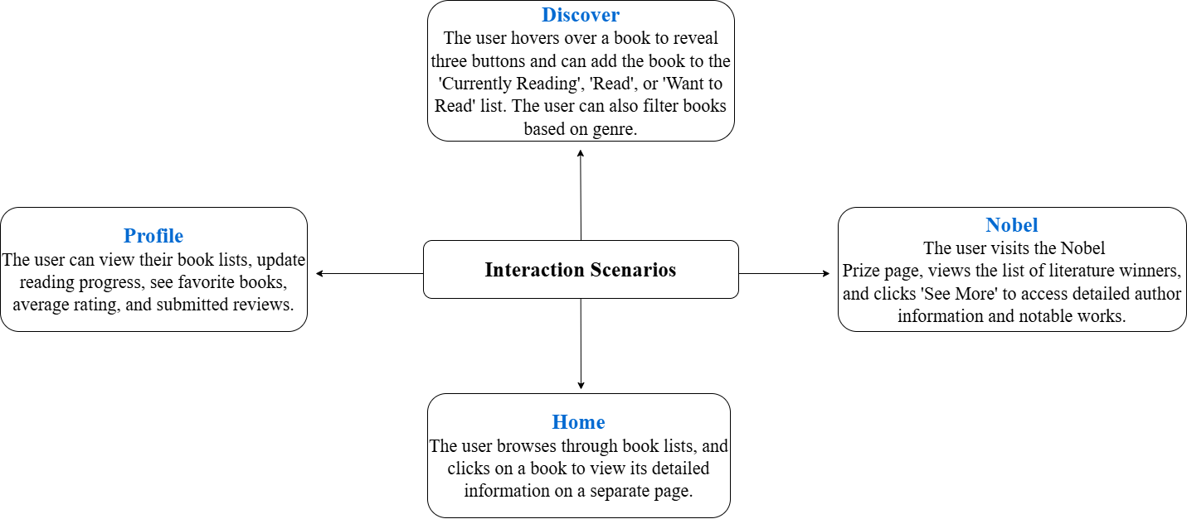

### **Database Design and Implementation**

We designed the database for BookNest with clarity in mind. We used **MariaDB** as our relational database management system because it's compatible with Spring Boot.

Key entities in our database include:

* **Users**: Stores user credentials, profile data, and preferences.
* **Books**: Contains book metadata such as title, author, genre, publication date, ISBN, and thumbnail URL.
* **Reading Lists**: Allows users to create and manage their own personalized reading lists.
* **Authors**: Includes Nobel Prize information, biography, and a relationship to their published works.
* **Newsletter Subscriptions**: Tracks which users are subscribed to weekly updates.
* **Nobel Prizes**: Records details about Nobel Prize awards
* **Nobel Books**: Stores specific books written by Nobel Prize-winning authors.
* **Quote:**: Collects famous quotes from books or authors
* **Notable Speeches**: Stores important speeches delivered by Nobel prize winners
* **Fun Facts**: Stores interesting trivia and facts related to literature, authors, or books
* **Fun Fac**t: Stores interesting trivia and facts related to literature for the home page

### **Technical Architecture**

