

**Written Consent Form**

**Survey Respondent**

**Survey Link:**

<https://survey.ucalgary.ca/jfe/form/SV_0xsMqeVEO69dKQu>

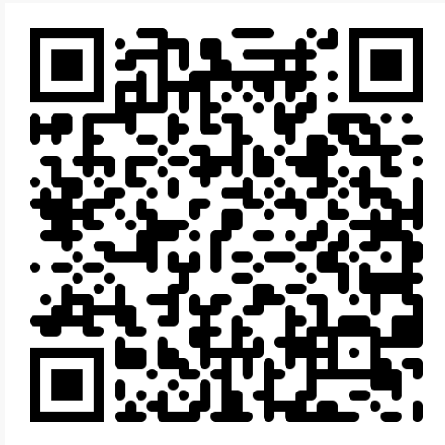

**Title of Project:** Navigating the Climate Information Landscape: Investigating the Susceptibility of Post-Secondary Students in Calgary to Climate Information Disorder

**Title of Survey Promotion:** Investigating the Credibility of Climate Change Information as Perceived by Post-Secondary Students

**Survey Platform: Qualtrics**

*The following are the questions included in the survey*

**Introduction:**

Hello! We are UofC undergraduate students looking to assess the perceived trustworthiness of climate change information on various media platforms.

The survey will take 5 to 10 minutes of your time and participation is completely voluntary. Please be aware that you can skip any question you are not comfortable answering or withdraw from the survey by exiting out. If you exit the survey without clicking the final “submit” button, your answers will not be recorded. Please note that due to the anonymous nature of all survey responses, once you hit “submit” on the survey your data cannot be withdrawn from the study.

For a more thorough explanation of what participation entails in this survey, please read through the linked consent form: <https://docs.google.com/document/d/1Ko_PhCfBC8pa55HmSRrETobrPendL4PO/edit?usp=sharing&ouid=115292717636331430227&rtpof=true&sd=true>

By continuing on to the questions you are acknowledging that you are:

a) a post-secondary student residing in Calgary between the age of 18 and 30

b) consenting to the use of your answers in this research project

Reminder: participation in this survey is completely voluntary, you can choose to exit the survey at any point, in which case your answers will not be collected.

All survey answers will remain anonymous. Do you consent to your answers being used in this research project?

* Yes I consent to participation in this research project

**Participant Demographics**

For the following questions, please select the answers that best describe you

Q1: How old are you?

* 18 to 20
* 21 to 23
* 24 to 27
* 28 to 30

Q2: What is the current stage of your education program?

* Bachelor’s: 1st or 2nd year
* Bachelor’s: 3rd or 4th+ year
* Technical Diploma/Applied degree: 1st or 2nd + year
* Master’s
* PhD

Q3: Select the field of study that best fits your education program

* Architecture, Planning, Landscape, Construction
* Arts
* Biological Sciences
* Business
* Communication
* Earth Sciences (Geology, Geophysics, Geography, Environmental, Archeology)
* Economics, Justice, & Policy
* Education & Teaching
* Engineering, Energy & Technology
* Health, Medicine, & Public Safety
* Humanities
* Hospitality & Tourism
* Kinesiology
* Legal professions & Studies
* Manufacturing, Automation, Transportation
* Mathematics and Computer science
* Physical and chemical sciences
* Social & Behavioural Science
* Other ______

Q4: Select the highest level of education held by either of your parents

* Grade School
* High School Diploma
* Technician Diploma/Applied degree program (2 years program)
* Bachelor’s Degree
* Master’s Degree
* PhD
* Professional Degree (e.g. MD, JD, etc)

Q5: Move the slider along the spectrum to best align with your political beliefs

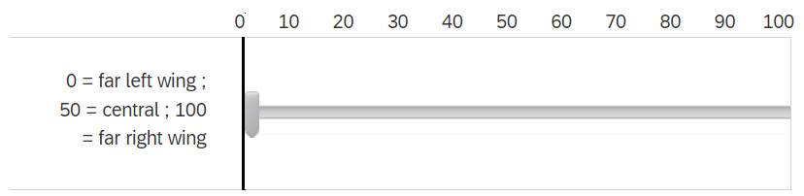

Q6: What post-secondary institution do you attend?

* University of Calgary
* Southern Alberta Institution of Technology
* Mount Royal University
* Alberta University of the Arts
* Other _____

**Trustworthiness of Information Platforms**

Q1: Please rank the following media platforms in terms of which you use to access information about climate change.

(1) = most often accessed, (8) = least often or never accessed

* Radio
* Newspaper (printed or online)
* Social Media (e.g. Facebook, Instagram, TikTok, Youtube, Reddit, etc)
* Internet (e.g. search engines, websites & blogs)
* Peers (other students)
* Family & Friends
* Teachers/Instructors/Professors

Q2: Please rank the following media platforms, from most to least trustworthy in terms of their communication of climate change information.

(1) = most trustworthy, (8) = least or not trustworthy

* Radio
* Newspaper (printed or online)
* Social Media (e.g. Facebook, Instagram, TikTok, Youtube, Reddit, etc)
* Internet (e.g. search engines, websites & blogs)
* Peers (other students)
* Family & Friends
* Teachers/Instructors/Professors

**Accuracy & Verification of Sources**

Please note that climate change will be shortened to "CC" in the following questions and answers

Q1: How accurate do you think the climate change information presented by each source type is?

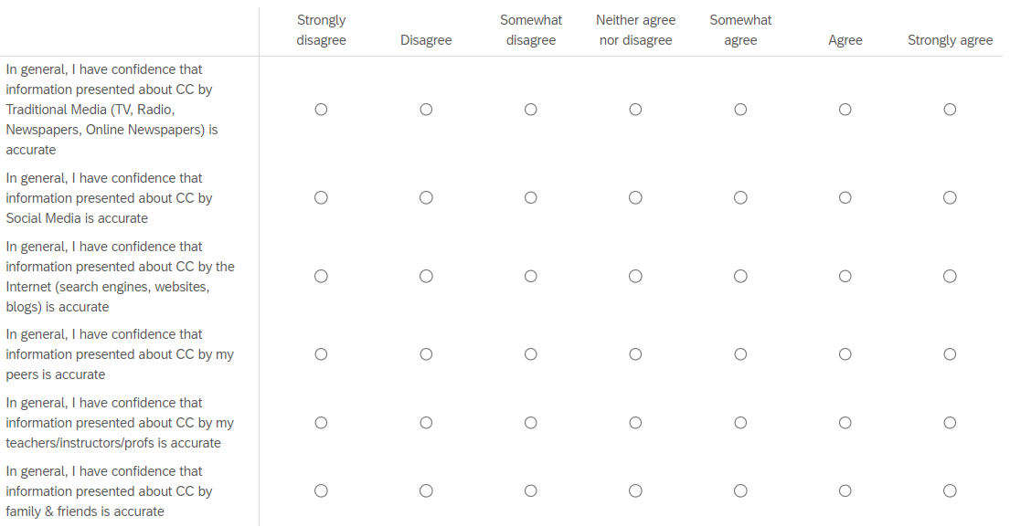

Q2: How often do you verify the information presented to you by each source type?

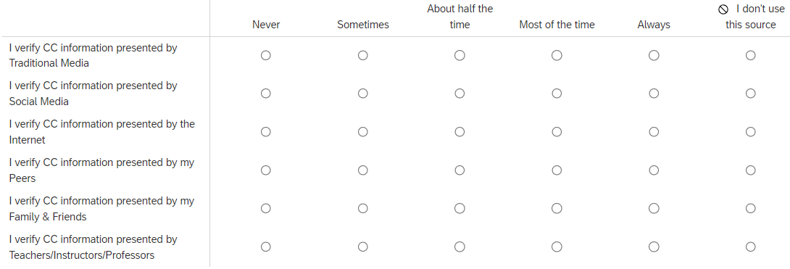

Q3: Please fill in the list below with up to five specific creators you access most often to learn about climate change. These creators can be news organizations, content creators in social media, podcasters, TV show hosts, etc.

Add one creator per box; you don’t have to use all, or even any, of the boxes.

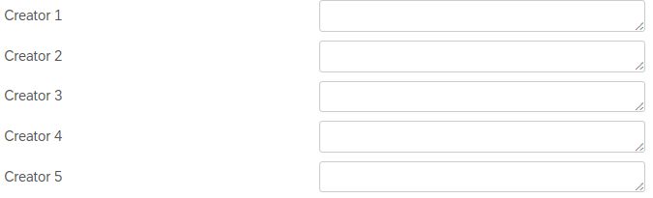

Q4: How much time do you spend on social media per day?

* Less than 1 hour per day
* 1 to 2 hours per day
* 2 to 3 hours per day
* More than 3 hours per day
* Unsure

**Perspective on climate change**

Q1: Please indicate your personal perception of climate change

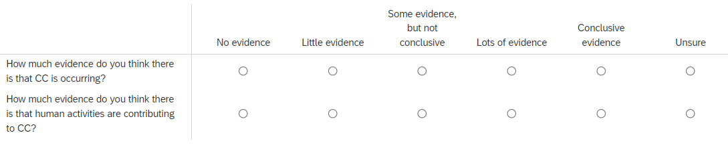

**Conclusion & Thank you**

That's it! Thank you for answering our questions :) By hitting "submit" you are consenting to the use of your answers in our research.

If you have any questions about this survey or would like to see the results of our research, you can contact us at althea.brolsma@ucalgary (researcher) and/or eve.robinson@ucalgary.ca (Supervisor)

If you’re interested in being interviewed for this project, please fill out the linked form with your email! The provided email will not be connected to your survey answers and does not change the anonymous nature of the survey.

*Add interview signup link here once published*

We thank you for your time spent taking this survey.

Your response has been recorded.

**Interview Signup Link:**

<https://survey.ucalgary.ca/jfe/form/SV_8nRjFAL7r7GpEai>

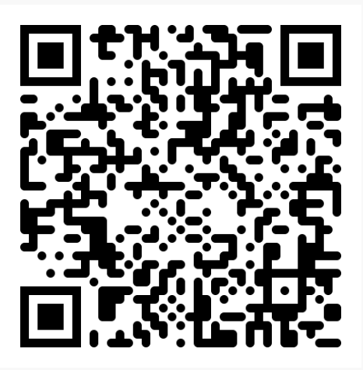

**Survey Title:** Email Collection for Climate Change Information Credibility Project Interviews

**Introduction:**

Hello and thank you for showing interest in participating in an interview for our capstone project! As a reminder, this project is researching the perceived trustworthiness of climate change information on various media platforms.

The interview portion of our study will take place as a 1-on-1 interview that will last approximately 30-45 minutes.

Please note that by submitting your email you do not have to participate in the interview process but you are consenting to us contacting you with further information. You can withdraw from the research project at any time.

The submitted contact information will be kept secure file only accessible to the researchers of this project through 2 factor authentication. Once interviews have been conducted, all personal identifiers in the data will be destroyed.

**Sign-up:**

Q1: Please select the program pool your degree most corresponds with:

* Arts & Humanities
* Business & Communications
* Health, Administrative, Education
* Law & Social Science
* Science
* Technology, Engineering, Math
* Trades & Services

Q2: Please write your information in the corresponding boxes:

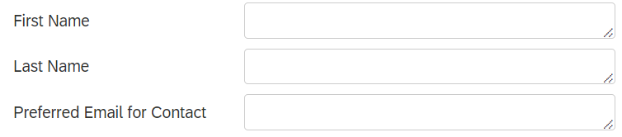

**Thank you & Conclusion:**

Thank you for your interest and support! We'll be in contact shortly.

If you have any questions about this survey or would like to see the results of our research, you can contact us at althea.brolsma@ucalgary (student researcher) and/or eve.robinson@ucalgary.ca (Supervisor)

Reminder: By hitting "submit" you are consenting to us contacting you about participation in an interview. Please be aware that you can withdraw from the interview process at any point of the study.