**Supplementary Table Legends**

**Supplementary Table S1.** List of tumors, clinical features, treatment, response, and sequencing characteristics.

**Supplementary Table S2.** Raw sequencing data.

**Supplementary Table S3.** Transcript data of differential gene expression.

**Supplementary Table S4.** Genes associated with progression-free survival.

**Supplementary Table S5.** Genes associated with overall survival.

**Supplementary Table S6.** Immune-related expression profile gene signatures

**Supplementary Table S7.** In-silico cell type enrichment analysis using xCell.

**Supplementary Figure S1.** Relative expression levels of *MITF* and *AXL* in baseline melanoma biopsies show no significant difference between patients with complete response (*n* = 32) or rapid progression (*n* = 40). CR, biopsies from patients with complete response; PD, biopsies from patients with rapid progression.

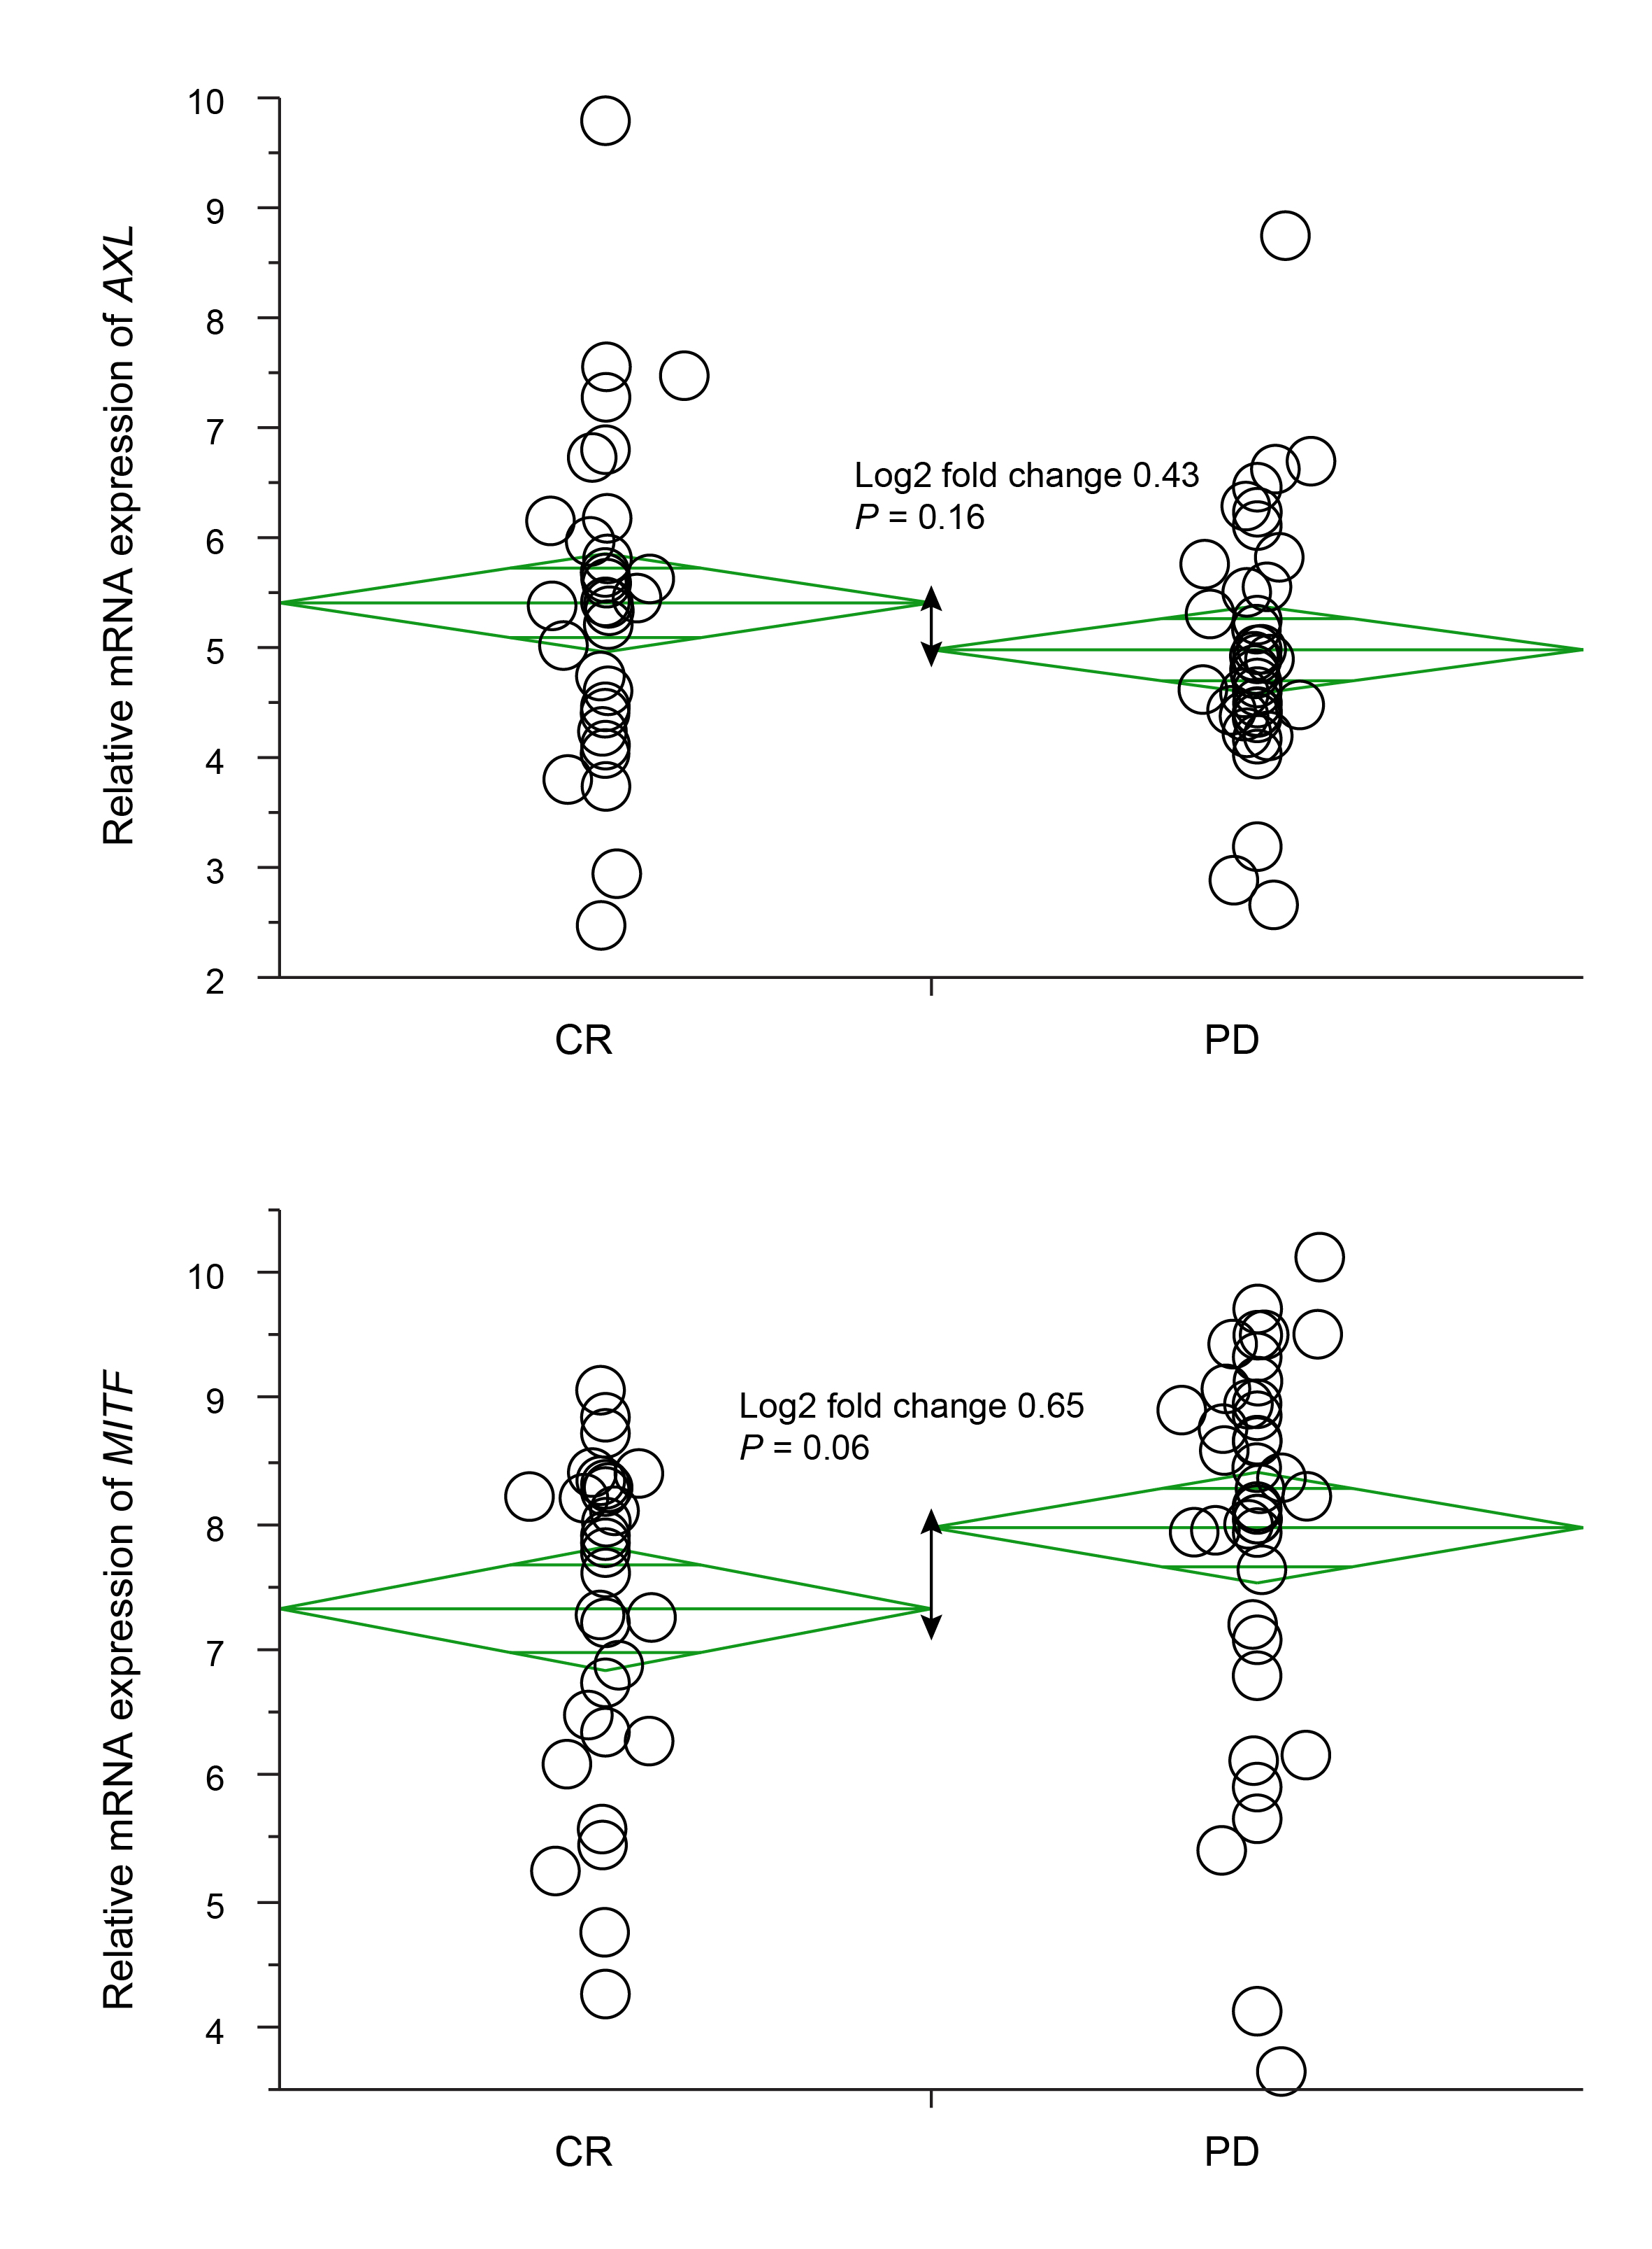

**Supplementary Figure S2.** Correlation of differential gene expression between patients with CR or PD according to treatment with vemurafenib alone or cobimetinib combined with vemurafenib. CR, biopsies from patients with complete response; PD, biopsies from patients with rapid progression.

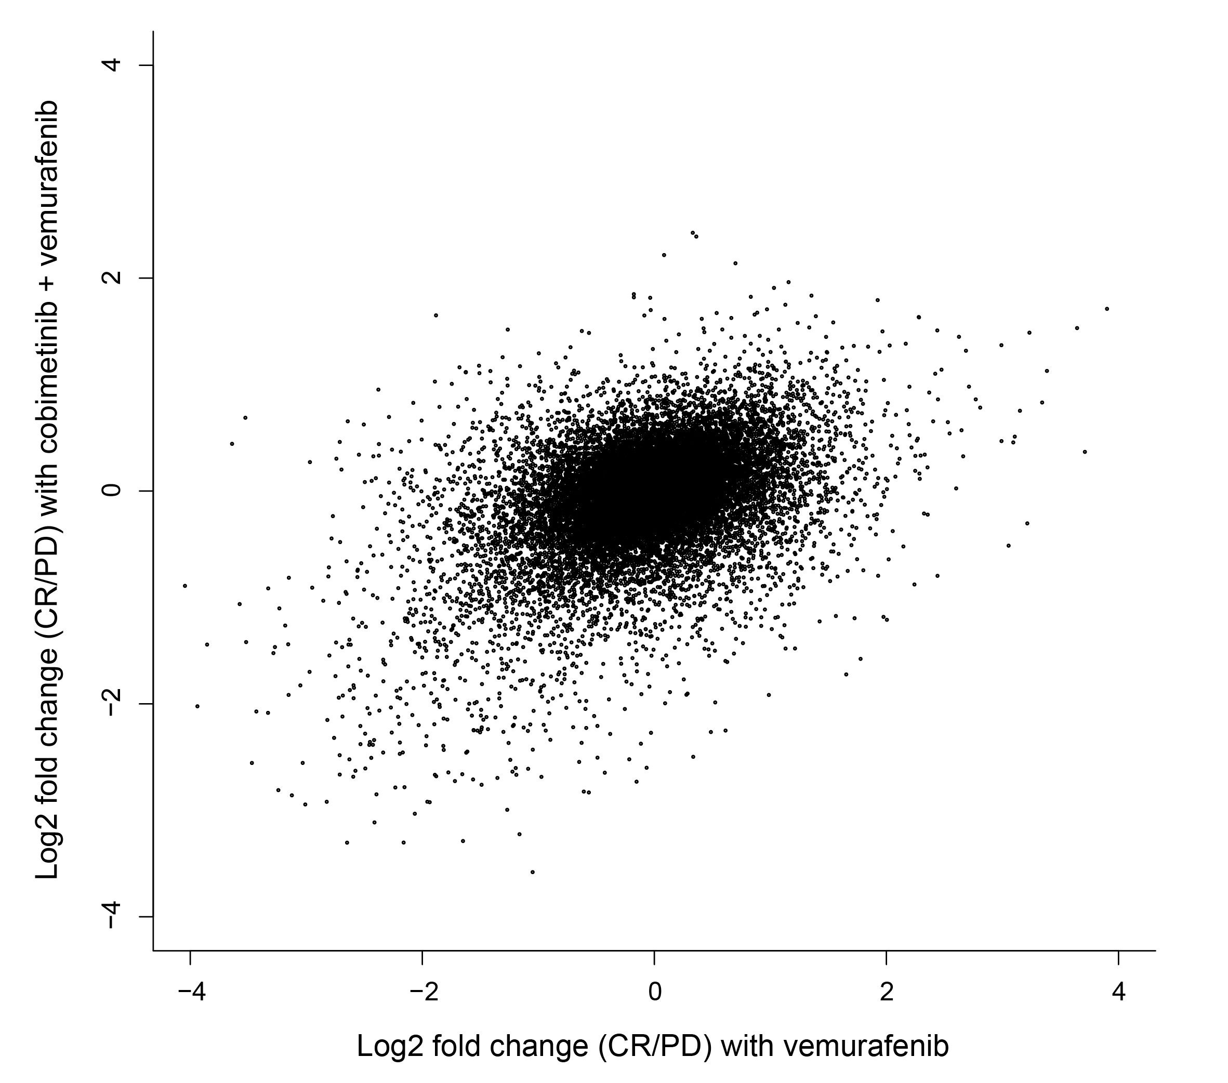

**Supplementary Figure S3.** Boxplot of CD8+ T cells in the tumor center by immunohistochemistry in patients with complete response or rapid progression (*n* = 37). CR, biopsies from patients with complete response; PD, biopsies from patients with rapid progression.

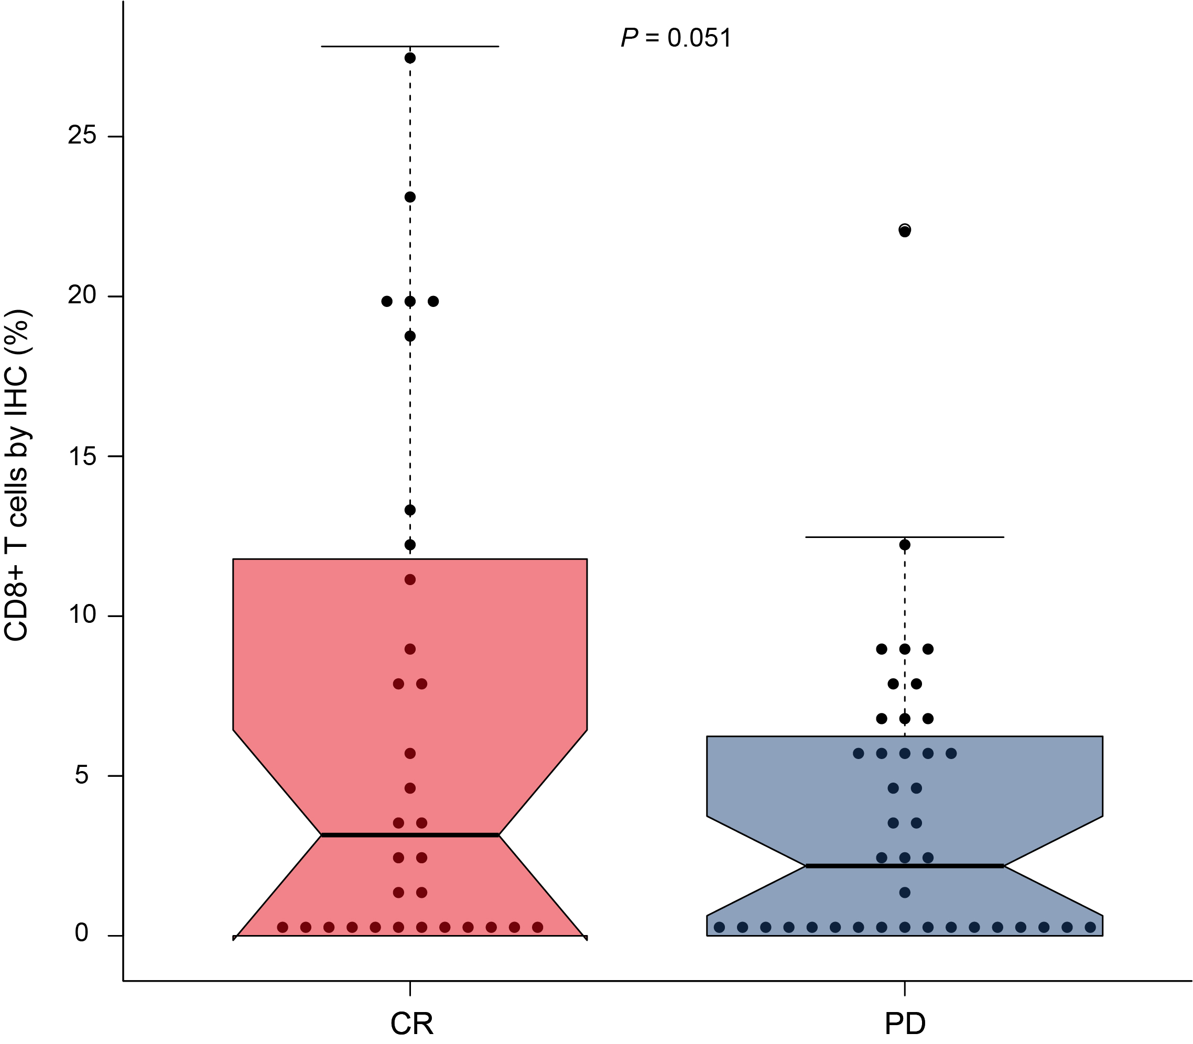

**Supplementary Figure S4.** Correlation between CD8+ T cells in the tumor center by immunohistochemistry and CD8+ T cell levels inferred from RNA-Seq using xCell (*n* = 16). IHC, immunohistochemistry.

