**Task 6 Part1: context model Team Green**

„System“

Appointment Management

„System“

Accounting/Billing

„System“

Patient Management

„System“

Drug Database

„System“

Patients Transfer

**„System“**

**Team Green Application**

**Task 6 Part 2: Activity diagrams for the communication with the Appointment Management System**

**Activity 1**: Request for the coming appointment dates of a patient

Request: Patient

appointment

dates

Ask for appointment dates of this patient

Appointment

System

Searches dates for this patient in appointment system

Patient appointment dates

Patientappointment

Request **Result**

Return appointment dates of the patient

Return that there are no appointment dates for this patient

available

not available

Extern System: Appointment Management System

Intern System: Team Green Application

Intern System: Team Green Application

Extern System: Appointment Management System

**Activity 2**: Request to fix an appointment date for a patient

Request to fix an appointment date for a patient

Ask to fix an appointment date in a particular time space

Appointment

System

Searches available dates for patient in appointment system

Available appointment dates

Patient appointment date fixing

Request ->**Result**

Returns fixed date for the patient

Return that there are no dates in this time space available. And Suggests free appointment dates

available

not available

**Task 6 Part 2: Activity diagrams for the communication with the Accounting/Billing System**

**Activity**: Request to create bill of performed services

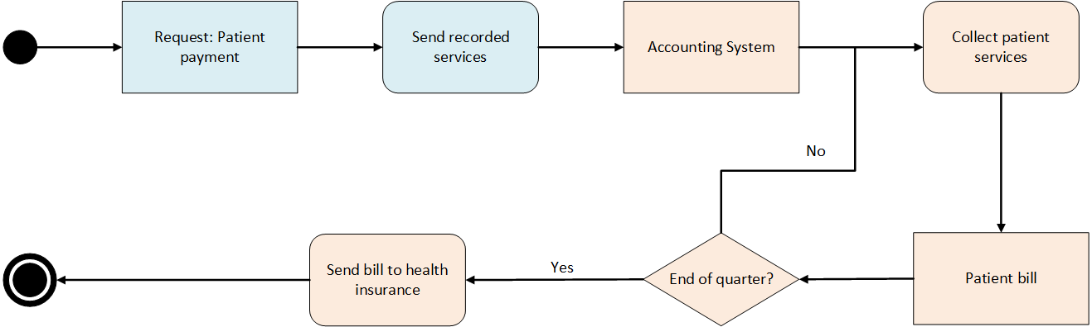

Extern System: Accounting / Billing System

Intern System: Team Green Application

**Task 6 Part 2: Activity diagrams for the communication with the Patient Transfer System**

**Activity**: Request for Transferring a Patient

allow

Sending Request to Transfer Patient

Request: Transferring a Patient

Answer to Request

Sending OK for Data Flow

Storing Patient Data

Sending Cancel for Data Flow

Checking Request Result

Checking Request Result

Sending Patient Data

deny

Extern System: Patient Transfer System

Intern System: Team Green Application