**High Level Architecture**

**Webbrowser**

**Database**

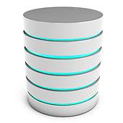

**UI Manager**

**Application: DoctorGreen**

**Java Webserver: jetty**

**Client**

**Server**

**Application Doctor Green – Views, Models, Controllers**

|  |  |  |
| --- | --- | --- |
| **Views** | **Models** | **Controllers** |
| PatientInfo - View | PatientInfo - Model | PatientInfo - Controller |
| Message - View | Message - Model | Message - Controller |
| Case - View (Case/Diagnose) | Case - Model | Case - Controller |
| Treatment - View (Treatment/Medication) | Treatment - Model | Treatment - Controller |

**Software Architecture**

**WEBBROWSER**

**Vaadin Client Side Engine**

**Client Side UI**

**HTTPS**

**Request**

**HTTPS**

**Response**

**CONTROLLER**

**PatientInfo**

**Treatment**

**Message**

**Case**

**VIEW**

**PatientInfo**

**Treatment**

**Message**

**Case**

**UserInterface**

**Vaadin**

**Output**

**MODEL**

**PatientInfo**

**Treatment**

**Message**

**Case**

**CLASS**

**DATABASE**



**DataBinding**

**Vaadin**

**Modified UML CLASS DIAGRAM**

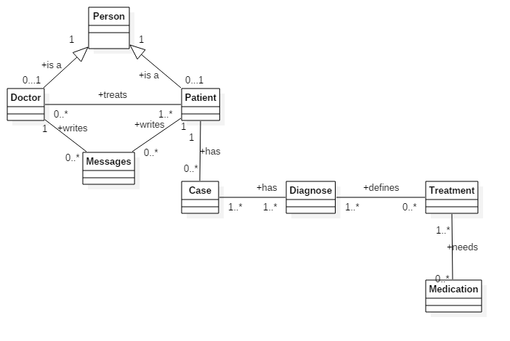

**Modified UML CLASS DIAGRAM**

