**Topic and Objectives**

The web application we have developed for this project is called Snippets Hub. Several lecturers on this course have instructed us to start creating a repository of small code snippets for common methods, functions and styling etc. The purpose of which being that when one is writing a program that may need to contain one of these small snippets of code you can simply copy it from your repository and place in it your program code rather than having to write it from scratch.

The objective of our app, Snippets Hub, is to allow users to create personal profiles where they can store these handy snippets of code. The app also allows users to create groups where they can store and share code snippets amongst a group of friends or classmates. Groups also contain a facility for members to leave comments and chat to each other about the code. This application is aimed at coders of all levels and all languages.

**Target Audiences**

The main target audience for our web application is a class of students studying coding and software development. Our web application will provide a space where students can share helpful snippets of code on their profiles as a repository for themselves, other users on the application who have registered can also view their code snippets. Registered users on the app can also form groups which they can share code on particular topics together, e.g. a class sharing snippets of code on the various topics covered in class. Based on this typical scenario usage of our web app we will develop an app which caters for a peer based learning initiative amongst coders. The “Create Group” feature of our app is specifically being developed to facilitate students by providing a collective repository for sharing ideas and snippets on topics covered in class.

**Structural Diagram**

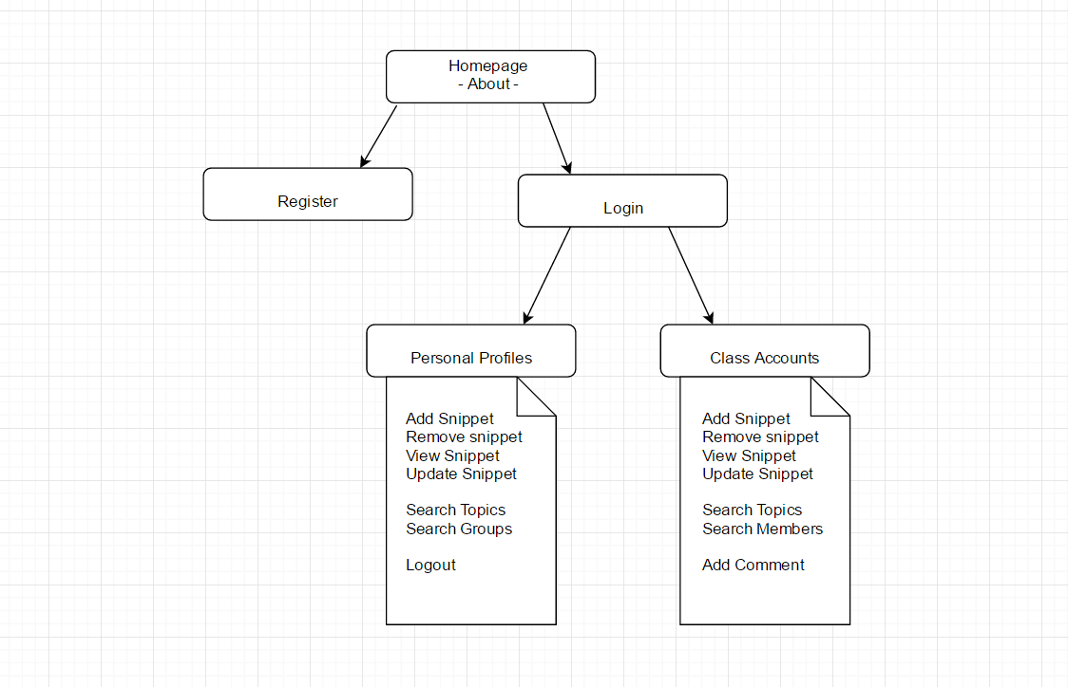

**Visual Design**

**Layout:**

**Font:**

We chose a sans serif font for the main content of our website. Sans serif is a style of font without serifs. This style of font is appropriate for ensuring readability for the user because the style is plain text without decoration.

**Colour Scheme:**

We have chosen a simple colour scheme to ensure ease of navigation for the user to explore the features of the website. We have made sure to allocate appropriate colours so that the user can easily differentiate between the navigation bar, active links, and the main readable content on the page.

**Screen Resolution:**

**Database Design and Use**

**Members:**

Member ID (Username??)

Email

First Name

Surname

Date of Birth

**Groups:**

Group ID

Group Name

Date Formed

**Snippets:**

Snippet Number

Member ID (Username)

Title

Content

Date Added

**Comments:**

Comment Number

Title

Content

Member ID (Username)

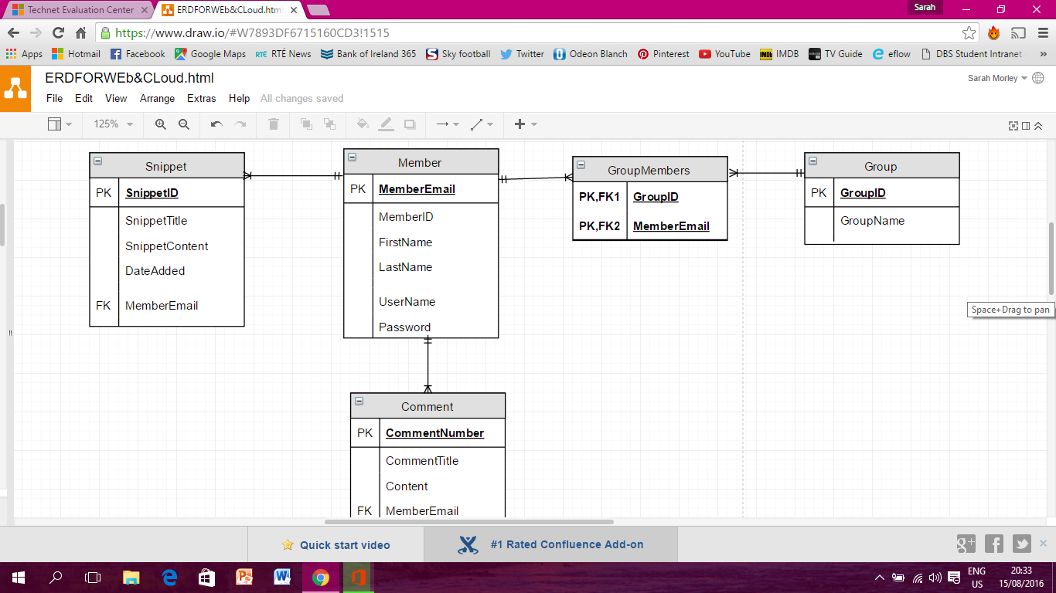

**XML as a database**

We are planning on creating a hybrid XML database. We plan to store the content of comments and code snippets as XML files.

**Technologies and Techniques**

**Maintenance**

**Search Engine Optimisation**

Semantic tags

Keywords

Description

Different meaningful titles for each page, etc.

**Strengths and Weakness**

**Conclusion**

**Bibliography**