**COSC 3206 Midterm Report**

Matt Depatie and Sarah Crowe

**Introduction**

In this report, we will discuss the progress of our game, which is still untitled. Work done with the game engine, the game’s art and the game’s design will be presented and discussed. Ideas presented in our proposal will be updated or changed depending on how they evolved during the game development process.

**Game Engine**

Through the course of trying to make the actual game, we’ve had a lot of trouble trying to learn Game Maker. We did some of the more important tutorials included with the program, but a lot of it has been googling and trial and error. Despite this, we still feel that Game Maker will allow us to create the game we envisioned. There have been frustrations with the restrictions and reduced resources that come with the free version. Some of the more helpful functions that are implemented into the engine are removed in the free license of Game Maker, which makes getting help from others with a paid version futile in some cases. There was a brief period where we thought it might be easier to make with a different engine/language but we ultimately decided to stick with our original idea.

One thing we did change in terms of the engine is that we’re trying to find extensions in the game maker community that might help us along with scripting. We initially thought we would learn Game Maker Language and script everything we wanted to do ourselves, but there’s not even close to enough time. Neither of us have used Game Maker before and there’s a lot more to it than we initially thought (not that we thought it was overly simple or anything).

**Demo and Deviations**

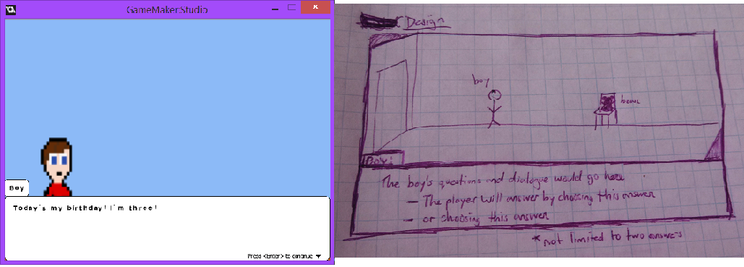 Thus far in the development of our game, we’ve been working towards the demo as our end goal. Quite honestly, the main goal so far has been “make it work”. We’ve really struggled with simply getting the first scene functional. Each area has been iteratively designed separately instead of the game being iteratively designed as a whole, but it’s working well. We’ve written the story, arted the art, designed the game and gone back and revised each one. We’re still not completely satisfied as if it were our finished product, but when we look at the work in progress demo, we’re happy with where it’s at. It’s on track and shaping up to our vision.

At this point, our game is pretty much what we proposed. The image above shows where we are now and where we started. To the left is our current iteration of the game and our original design of what we wanted it to look like is on the right. Our characters are still the boy and the bear, the setting is still the boy’s bedroom, and the gameplay is still based on dialogue choices. The story is probably the biggest change; it was conceptualized as divergent and branching, but ideas for a more linear story with the illusion of choice has come up a couple times. Another small change is the viewpoint of the game (see: art assets). We think that our biggest changes will be in the more superficial details, such as subtle changes of colours and decorations in the room. We may not have the time or knowledge to implement those things, but our base game is essentially what we wanted it to be at the beginning of the semester.

**Art Assets – Pixel Art**

The art of the game has been a challenge. First, we looked at royalty free art assets to see if we could use stock images until the game engine was functional. After this search, it became clear that using our own art assets would be easier in general. Even if we first created the simplest sprites as placeholders in the prototype, it would still retain the look and basic style we are trying to achieve.

The first object drawn was the young boy. Since the demo goal is simply the one scene with no aging involved, creating this first sprite would be the most practical. After an hour or so, the first piece of pixel art was created for the game. This image was created in a 32 by 32 pixel square with 16 bit colours.

HAL 9000:Users:MMDepatie:team6:Game Sprites:32Boy1.png

The image in word looks a little fuzzy but the idea is there. The boy will be positioned on the left of the screen, looking at his toy. We wanted the large eyes to instil a cute but also creepy gaze. As a first draft, this was a success. However, there is room for improvement. Next was the room. At first we wanted an isometric look to the room, this way giving our space some depth to the otherwise 2D image. This is the first attempt created in a 256 by 128 pixel space.

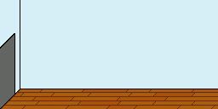

The look of the game we want is not the MS paint look. This room did not accomplish this goal. However, this room prototype did inspire us. Differentiation looks pretty cool. The different colour used in the floorboards looked pretty good, and inspired a new prototype. For now, the main error was in the room size vs. the size of the boy. Without any modification, adding the boy to the room looked like this.

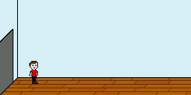

The first attempted solution was to try and scale the boy to a larger size. So, scaling the sprite to 48 by 48 skewed the boy. This is attributed to base-2 art design. This size looked right, but the boy simply did not. Scaling to 64 by 64 kept the look of the boy, but he did not fit in the room. At that size, the boy was as tall (if not taller) than the doorway. Two things had to be done now, the boy had to be scaled to 64 by 64 (this helped Game Maker) and the room had to be redrawn to fit the boy.

At this point, the perspective of the room changed. Instead of the isometric look, we switched to a flat 2D point of view. This made it easier to fit the boy in the space. This also allowed for easier floor/wall differentiation. Now, the floor could simply be one colour and the wall another and the distinction would be simply made. The first redraw of the room, once again 256 by 128, looked like this.



This space was a lot simpler to place the boy in, but having only 2 colours looked a little too simple. While trying to avoid this MS paint look, we applied tiles to the wall. We wanted this effect to be subtle, which pixels changing colour, either one step lighter or one step darker. We called this “Pixel Differentiation”, because it sounds cool. When applied to this space, the room looks like this.



Did you notice the difference? This room is now using a total of 6 colours for the floor and walls instead of 2. It is the simplest way to avoid the MS paint look and adds “imperfection” to the space. Now that the room, in its simplest form, looks acceptable, we could move onto the boy. Scaling the boy to 64 by 64 added a lot of advantages. Now, for every pixel we had in 32 by 32, we now have a 4 by 4 pixel square in its place. With that, we thinned the black border of the boy and also applied pixel differentiation. The boy sprite now looks like this.

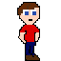

Of course more work can be done, but with every change and new prototype we are getting closer to the final look of the game. The simple space also gives us a special trick. We now only need objects to give height to the boy. We first had the doorway to give height, but now we don’t have that limitation. Placing a bed, for instance, in the room with a height relative to his mouth would give the boy the size of a small child. Doing the same thing, but with smaller dimensions to the bed, would make the boy “grow” without ever changing his sprite. This trick may or may not be exploited in the final version of the game.

The next step in terms of pixel art would be to create animation frames for the boy and to play with lighting. Shadows are pretty simple to do, it just depends on how many light sources we want in the room. A quick rough shadow prototype was done. The following image encompasses everything we have worked on so far, the best version of the room and boy, with a quick shadow added. Compare this to spites without pixel differentiation.

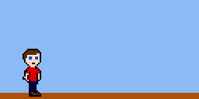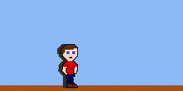

**Art Assets – Music**

*Matt did the music we hope to use. He will now write this section in first person.*

I’m a bass player. I took piano lessons when I was a kid but now I just play bass. I have composed before; mainly quick upbeat jams to pass the time. Recording music for a game is a first. So, I figured I would start with some bass line and turn it into a song. My goal was to record something about a minute long. After recording, the song was a little less than 3 minutes long.

At first I wanted to use the Twin Peaks theme, since it’s quite happy and sad at the same time. Sarah laughed and thought I should try to make something of my own. I reluctantly agreed. Even though I’m not using the theme, I’m still taking inspiration from it. This is probably the reason I used synth in the track.

I recorded the bass line in Garage Band using a microphone and my practice amp. I then used Apple Loops to add the drums into the song. I was able to add keys using the Rock Band 3 Keyboard and a USB to MIDI adapter. The final result has a sort of theme I can use throughout the game and rerecord it to either make it happier or darker. The version of the song featured in the demo needs to be rerecorded so that the bass and keys sync with the drum loop.

**Design Choices**

The main gameplay element we want in our game is the player influence. How we want to approach this has changed a bit. We do not have our full story written out yet and we want the divergence to be as simple as possible. For now, we want only certain dialogue choices to change the course of the game. Having every choice lead to a different outcome would be too hard to do. It is possible to give the player the illusion of choice; tricking the player into thinking an ultimately unimportant choice was meaningful. As long as the sum of the player actions still has impact, the goal of our game will be accomplished. We have evaluated this design choice with Lens #32: The Lens of Meaningful Choices.

The limitation that we want to impose on the player is a design choice made to fit the story we wanted to tell. Since the bear/toy is the vessel for the player, the player’s action is limited to this form. The young boy is talking to the bear for advice, so it made sense that the only interaction the player can have is by communication via the bear. Looking at this decision with Lens #53: The Lens of Control, we limited the player’s actions within our world but still gave them opportunities to change and impact it by the one mechanic given to them: communication.

We are using pixel art so we can have the simplest defined boy in our game. There was no need to specify a name or history or even detailed features. In this sense, we are taking advantage of Natural Simplification. We want our players to see part of themselves in the young boy, and being photorealistic would make that harder. *Matt is writing the next few lines*. The boy, in his current design state, looks a little like me. He’s white, blue eyes, brown hair. This is a personal story, to an extent, and I am using some of my past experiences to help me write it. In that sense, I do have a personal attachment to the young boy, which is probably why he looks like me in the broadest sense of the term.

As discussed in the Art Assets section, we changed the room perspective from isometric a flat 2D space. With the help of Lens #21: The Lens of Functional Space, we were able to determine which space would be ideal. The isometric room made it difficult to give proper height to the boy. The flat view removed that problem and will allow us to give the boy height using other objects in the room. The space we give the player is finite; the bear will never leave the room. However, the conflicts in the game usually take place outside the room. We didn’t want the player to be involved directly with these conflicts. We only want the player to influence how someone will act either before or after these conflicts. Therefore, the player’s direct actions never leave the room, but the lasting impact they will have on the boy will extend to the world beyond what is presented to them.

We have been and will continue to development our game with an iterative design mentality. Every change we make brings us one step closer to our final product. We set simple goals for each small prototype, taking the development one tiny step at a time. So far, it’s worked out for the best. In the art assets, we were able to see fairly early on what looked like our intended vision and what looked like MS Paint. Through our trial and error with Game Maker, we were able to set realistic goals for our demo. These are goals we have essentially achieved.