

|  |
| --- |
| Web-based Vital Signs Database |
|  |
| *BY SARAH OAKMAN (z5206178)* |

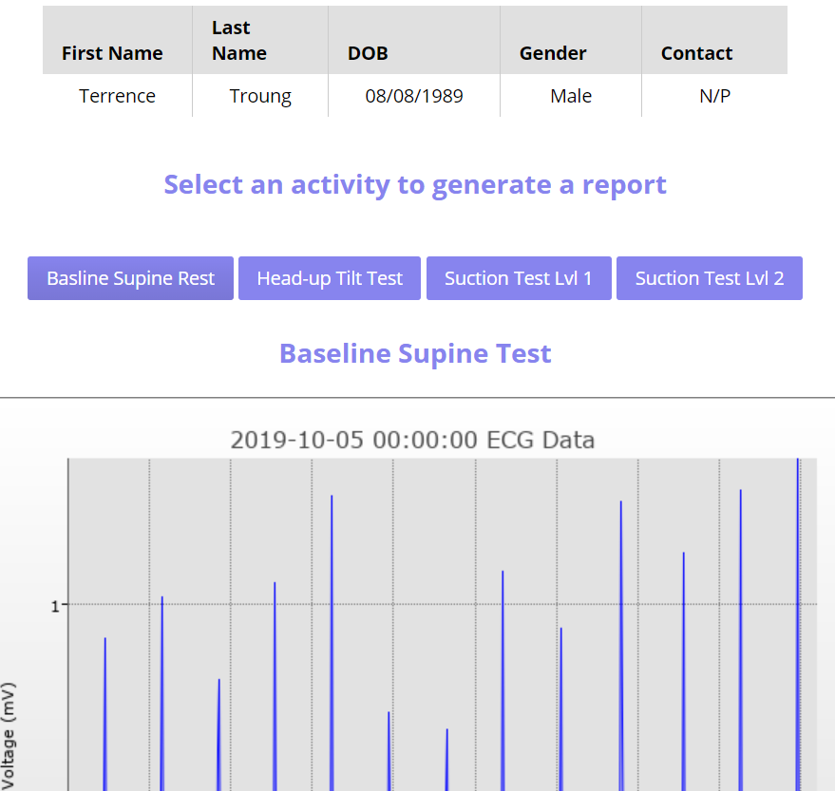

# Database Design

## Overview

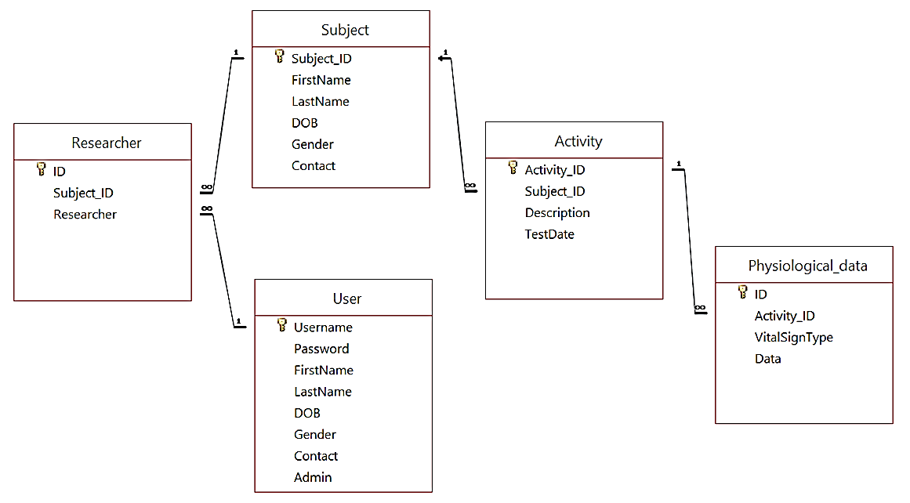The Database Design for the Web-based Vital Signs application builds from the database given with minor changes and additional tables. An overview of the Database Design can be seen in Figure 1.

*Figure 1: Overview of Database*

|  |  |  |  |  |  |  |  |  |  |
| --- | --- | --- | --- | --- | --- | --- | --- | --- | --- |
| Explanation of Database Design  The Database Design for this system is quite simple but effective for the work required.  A Researcher and User table were added to allow for the collection of researchers and administrators.  The Researcher table holds the assignments of subjects to researchers, where a subject can have multiple associations with different researchers. Also, a researcher can have numerous subjects. This Researcher table is linked to the Subject table by the subject id which can be used to find and retrieve desired data. It is also linked to the User table by a researcher’s username.  The User table is used to store registered researchers and administrators on the system. It contains their login details such as a username and password and also their personal details. The admin field is used to indicate whether the user is a researcher or administrator, which helps to distinguish between their roles on the website.  The minor change to the database design provided, was the contact field’s input mask found within the Subject table. The mask was altered to include only two digits in the area code section to match Australian standards. However, contact numbers that are not 10 digits long, such as those where the user does not enter an area code, have been considered and handled in order to be added to the table as data.  The remaining database design is identical to that provided.  Justification of database design  The Researcher table is used to hold the associations between subjects and researchers. This makes it easy to find subjects that are associated with researchers through simple queries which filter according to subject id or a researcher’s username to obtain data.  Only one User table was constructed as a researcher and administrator share the same fields. So instead of creating two tables, an Admin field was added to identify between them. This reduces the number of queries that need to be done, for instance when logging in. Also, the Admin status can be stored in order to show the right information and access rights for each user.  It is noted that the Activity and Physiological_data table could have been further normalized, perhaps improving the design. However, due to late notice of this and a lack of remaining time, normalization of this data did not occur. In theory, the table may have been broking down into the separate activities and the Physiological_data table could have been normalized by the different physiological tests. However, despite not accomplishing this, this simplistic database design allows for effective functioning of the website.  Appropriate keys and indexes for each table were also chosen and used. The Researcher table uses an Autonumber id, since other fields such as the subject id may not be unique. For the user table, the username was used as a primary key since this should always be unique for secure logging in purposes. This is always unique and users are notified if they try to add or edit a researcher with a username that already exists.  The relationships between tables are linked by common fields which are their foreign keys. This structure worked for the functioning of the website and allowed for correct data to be found and shown from multiple tables.  User manual  Several sample researchers were created so that the system’s functionality could be tested.  To visit the user login page (landing page for this website) use the link provided:  <http://engpwws003/z5206178$/BIOMPROJECT/lib/login.php>  Login details for viewing the system as a researcher or admin are supplied below.   |  |  |  | | --- | --- | --- | | **Type of user** | **Username** | **Password** | | **Researcher** | joe22 | Joe12345 | | **Admin** | kate10 | Kate1234 |   User Interface Description  The website was separated by researcher and administrator roles which could not be accessed unless the user is successfully logged in. Also, a researcher may not access an administrator page by entering a URL and vice versa. All of the data that is added or edited is updated immediately and does not require page reloading. Appropriate alerts and messages were added to let the user know what occurred when adding, editing and assigning.  Researcher Interface Description  Log on page   * Log on with correct username and password if you exist in the system * After successfully logging on, the subject page is loaded * Before successfully logging in, a researcher cannot access the website without being redirected back to the login page   *Figure 2: Login Form*  Subject page  *Figure 3: Subject page*   * Navigation bar which has the subject page and logout accessible from it. * Subject button when pressed reloads the current page. * Search bar to search through your assigned subjects which searches across all fields. For example, if you entered ‘female’ it would show all subjects that corresponding detail. Also, searching is case insensitive. * Add subject button creates a pop up modal page allowing a subject to be added if the JavaScript verification is successful. It automatically adds this user to your list of assigned subjects as the assumption has been made that they are the researcher’s patient. * A list of subjects who you are assigned to are shown in alphabetical order with their personal details and an option to browse data or edit subject. * The browse data button goes to the corresponding subject’s browse data page which shows their personal details along with the option to select each type of activity and view the results, if any. It shows their ECG and PPG graphed and the heart rate and blood pressure tabulated. If no results are found, a ‘No results found’ message is shown.   *Figure 4: Browse Data Page*   * The edit subject button is pressed it sends you to a page which allows you to enter details to update the subject on successful JavaScript verification. After editing the user is redirected to the subject page. To leave this page without editing simply press the back button on your web browser. * Logging out calls a php file which unsets any session variables which were used to verify whether the user was logged in and what type of user they were. The user can no longer access any page besides the log on page.   Administrator Interface Description   * Login the same way as a researcher * Subject page is loaded after logging in * Navigation bar has subjects, researchers, activity summary and logout options available * Also shows an alphabetically sorted list of all subjects which can be searched through in the same described in the Researcher Interface Description * The list of all subjects shows their personal details and the ability to browse their data. However, the administrator does not have editing capabilities but instead can assign researchers to this subject * Browsing data renders the same page as the one described in the researcher section but with the administrator’s navigation bar * Assign researchers page shows a list of all available researches which are selected or not according to whether they are already assigned to the subject. Selecting multiple checkboxes allows you to assign the subject to these researchers when the assign button is pressed. If the cancel button is pressed, no assigning occurs   *Figure 5: Assign Researches to subjects*   * Researcher page which you get to by selecting it from the navigation bar, shows a list of all researchers with their personal details and an option to edit them * Edit page is where you can input the fields you want to update and it shows corresponding error messages or form validation messages. The researcher is edited on successful verification by JavaScript functions. To leave this page without editing, simply press the back button on your web browser * The add researcher button when pressed opens up a modal where researcher details need to be added into. After successful adding a researcher, they will appear in the list of researchers.   *Figure 6: Researcher Page*   * Activity summary page shows the graphs of mean heart rate and standard deviation against age as well as a tabulated form of this data for each activity. * Logout by pressing the corresponding button in the navigation bar which redirects them to the login page and they cannot access the system again unless done so by logging in   *Figure 7: Activity Summary Page*  Benefits of this User Interface   * Easy to use * Coherent design and structure * Everything is clearly labelled such as buttons and page titles * Separates the website according to roles for easy navigation * Functioning as required * Secure system * Shows error and validation messages so the user knows what’s going on |