Remnant Chronicles Site Plan

Sarah Penfold

WDD 131

Overview

The purpose of this web page is to find fan favorite quotes from remnant chronicles. There will also be other information about the book series for those who are interested.

Audience
Fans who want more information on the series and a place for them to find well-liked quotes. If there is interest in reading Remnant chronicles, then they can get more information.

Branding

Website Logo
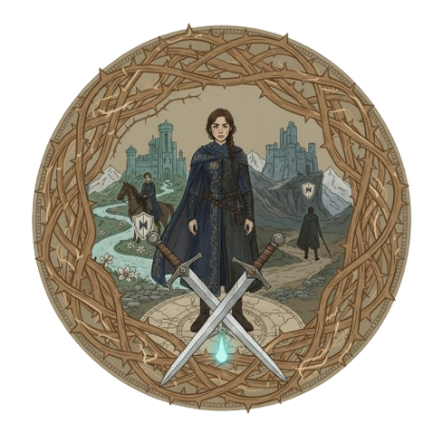

Style Guide

Color Palette
Primary | Secondary | Accent 1 | Accent 2
#A87C5C | #3C6E71 | #C7D1D4 | #808C99

Typography

Heading Font: Cinzel Decorative

https://fonts.google.com/selection?preview.text=Remnant%20chronicles&query=Cinzel+Decorative

Paragraph Font: Cardo

https://fonts.google.com/specimen/Cardo?preview.text=Remnant%20chronicles&query=Cardo

Navigation
Home Page2 Page3

Home

Summary (possible)

Character (possible)

Content

Home:
- Hero image
- Overview
- Book cover images
- Quote generator
  - Includes quotes, context, and meaning
- When the user clicks one of the book covers, it will generate a quote from that book
Characters:
- Information on characters
- full name
- family
- kingdom origin
- development throughout the book

Summary:
- Plot
- Love triangle development
- Themes
- Quotes
- Setting
- Underlying problem

Overview:
The Remnant Chronicles follows Princess Lia of Morrighan, who flees her unwanted political wedding only to find herself pursued by both the jilted Prince and a deadly Assassin, neither of whose identities she knows, as they all cross paths in a remote village. After a compelling deception and a tragic betrayal, Lia is captured and brought to the enemy kingdom of Venda, where she must navigate the dangerous court of the Komizar while wrestling with the truth of her own secret "Gift" of sight and the two men who love her. The series culminates in an epic confrontation where Lia must embrace her destiny and unite the fractured kingdoms against a rising tide of ancient prophecy and war to save her people and forge a new future for the Remnant world.

Quote table:
Book | Quote | Context | Meaning
The Kiss of Deception | “Today was the day a thousand dreams would die, and a single dream would be born.” | The day Lia flees her wedding—her duty dies behind her, but she follows her dreams. | Fate isn’t chosen for you. You decide who you are and what dreams to follow.
The Kiss of Deception | “Taking another life, even a guilty one, should never be easy.” | Lia’s mother tells her this while she is witnessing an execution. | Even criminals are human; taking a life should never feel easy.
The Kiss of Deception | “Who was this girl who thumbed her nose at two kingdoms?” | Rafe reflects after learning Lia fled the wedding. | Standing up for yourself shows courage and draws respect.
The Kiss of Deception | “There were two ways to approach the inevitable: being dragged to meet your fate or taking the offensive.” | Lia is captured by Kaden and decides to take control of her situation. | You can either let circumstances control you or rise to meet them.
The Heart of Betrayal | “If one can't be trusted in love, one can't be trusted in anything. Some things can't be forgiven.” | Lia reflects on her relationship with Kaden and trust. | Trust is foundational—without it, nothing else holds.
The Heart of Betrayal | “Maybe there was no one way to define it. Maybe there were as many shades of love as the blues of the sky.” | Lia weighs her love for Kaden and Rafe and realizes both are different. | Love isn’t one-size-fits-all; it can exist in many forms.
The Heart of Betrayal | “It can take years to mold a dream. It takes only a fraction of a second for it to be shattered.” | Lia realizes her plans are threatened by outside forces. | Dreams take time to build but can be destroyed instantly.
The Heart of Betrayal | “The prince has grand dreams. Is it worth it to have any other kind?” | Rafe discusses his ambitions while acting as an emissary. | Dreams should challenge and push you to grow.
The Beauty of Darkness | “It doesn't matter how many universes come and go. I will always remember who we were together.” | Rafe expresses his love as forces threaten to separate them. | Even if relationships end, the memories and growth remain.
The Beauty of Darkness | “You couldn't command love to stop any more than a marriage document could order it to appear…” | Lia realizes she may need to let Rafe go. | Love can’t be controlled; letting go takes time and pain.
The Beauty of Darkness | “When we lose a battle, we have to regroup and move forward again…” | Lia encourages resilience after repeated setbacks. | Don’t dwell on failure—adapt and keep moving forward.
The Beauty of Darkness | “It was only me, a thousand blinking stars, and the beauty of darkness…” | Lia reflects after the war about her future. | Your life is shaped by your own choices—not others.

Kiss of deception:
Summary:
Princess Arabella Celestine Idris Jezelia flees her wedding day to work at an inn. She goes by her alias Lia and falls in love with the prince that she was supposed to marry, Rafe, and the assassin trained to kill her, Kaden. Lia struggles to hide her identity as she keeps up her newfound duties in the inn.

Themes:
- Tradition
- Duty vs. desire
- Deception and secrets

Heart of Betrayal:
Summary:
After being captured by Kaden, Lia finds ways to adapt to Venda. While Rafe discovers much his kingdom is despised there. Rafe and Lia make plans to escape and head towards Dalbreck. But the Komizar has other plans for Lia that interfere with their escape plans.

Themes:
- Betrayal
- Self-discovery
- Political intrigue

Beauty of Darkness:
Summary:
After escaping Venda half alive, Rafe tenderly cares for Lia as they journey towards an outpost. Lia soon learns that Rafe has no intention on taking her back to her kingdom. She journey’s back on her own and learns the full truth of the war that is raging in Morrighan.

Themes:
- Leadership
- Love vs. duty
- Survival

Kaden:

Identity: The Assassin sent by the kingdom of Venda to kill Princess Lia.

Origin: He is from Venda, the savage kingdom that is considered an enemy to Morrighan.

Skills: Highly trained assassin, expert in tracking, fighting, and camouflage. He is exceptionally stealthy and observant.

Personality: Brooding, intense, cynical, and emotionally guarded, but fiercely loyal and protective of those he cares about. He possesses a dry wit that surfaces occasionally.

Rafe:
Identity: The Crown Prince (and later King) of Dalbreck.

Origin: The Royal House of Dalbreck, the wealthiest and most militarily advanced of the three main kingdoms.

Skills: Political savvy, excellent swordsman, adept strategist, and skilled at maintaining his cover (he posed as a common worker when seeking Lia).

Personality: Commanding and regal, but also kind and brave. He can be stubborn, blunt, and highly protective of Lia, sometimes to the point of being controlling.

Lia:

Identity: Princess (First Daughter) of Morrighan, the kingdom of tradition and desert terrain.

Origin: The Royal House of Morrighan

Skills: Initially thought to be just a princess, she proves to be highly resilient, a quick learner in survival, observant, and a formidable leader in battle and politics.

Personality: Headstrong, compassionate, stubborn, and deeply devoted to her few close friends. She is a natural leader who inspires loyalty.

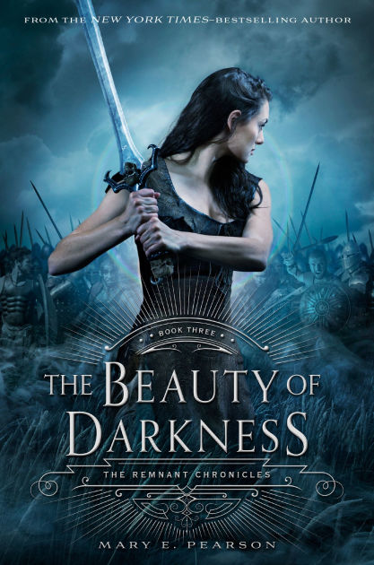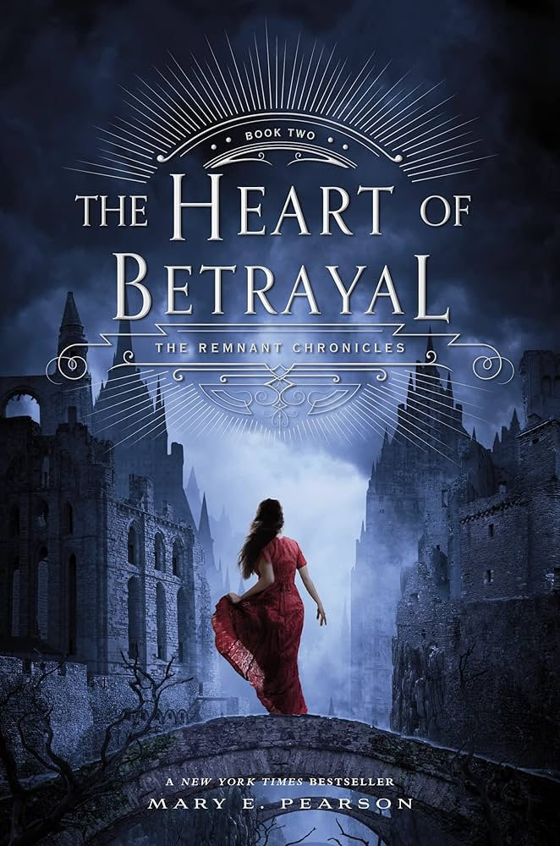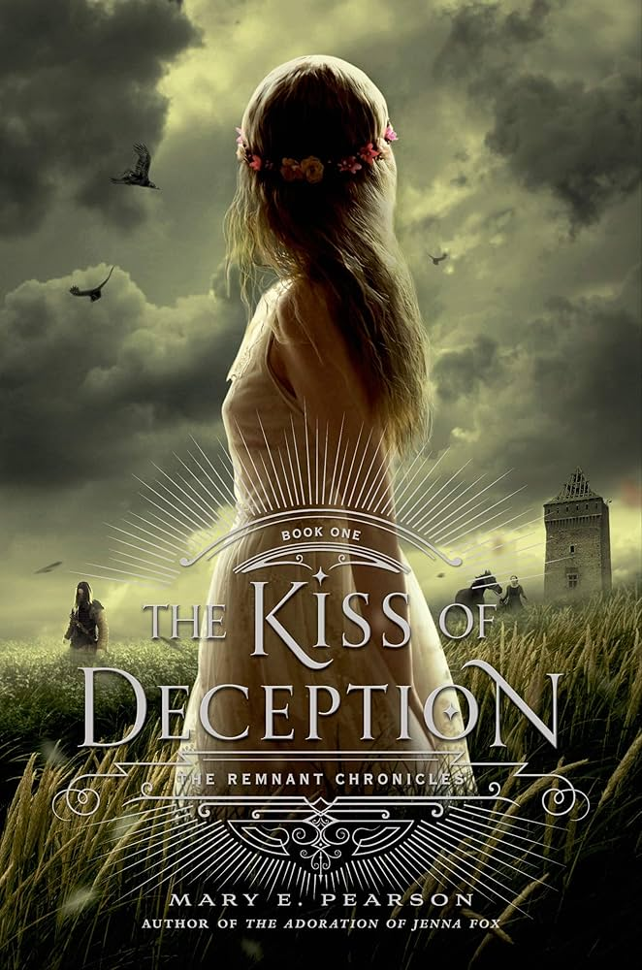
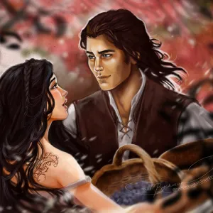
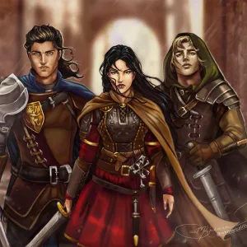

Wireframes

