**MVC (Model-view-controller)**

MVC is a popular way of organising code by determining each section has a purpose, and each purpose is different e.g. usability, functionality, accessibility etc.

**THE PARTS OF MVC**

**Model:** Model includes the raw information/ data needed for functionality. It defines the essential components of the [database, app, etc.]. For example, if building a calculator, the model code would define what a calculation and how to handle it. .

**View:** View code is made up of all the functions that directly interact with the user. This is the usability / accessibility of the code and is usually defined by how the user sees and interacts with it.

**Controller:** Controller code acts as a liaison between the Model and the View, receiving the user input and deciding what to do with it. It’s the brains of the application, and ties together the model and the view.

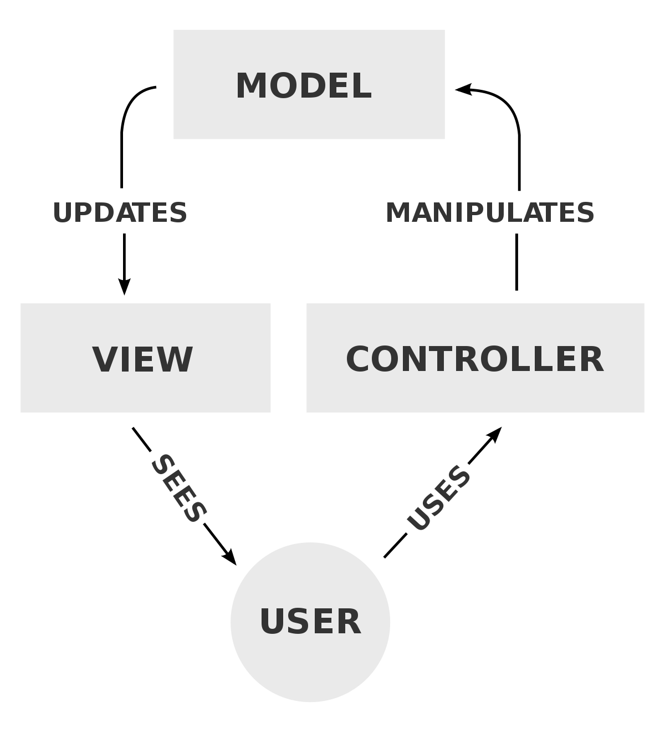

In the case of the library application:

Model: The code behind the programme i.e. get and set data

View: The function that enables the user to interact – i.e. able to view books in library

Control: The ability to manipulate the model i.e. add books, delete books