M6 - Lecture 13
Sarah Redmon
2026-04-21

R Markdown
This is an R Markdown document. Markdown is a simple formatting syntax for authoring HTML, PDF, and MS Word documents. For more details on using R Markdown see http://rmarkdown.rstudio.com.
When you click the Knit button a document will be generated that includes both content as well as the output of any embedded R code chunks within the document. You can embed an R code chunk like this:
summary(cars)
## speed dist
## Min. : 4.0 Min. : 2.00
## 1st Qu.:12.0 1st Qu.: 26.00
## Median :15.0 Median : 36.00
## Mean :15.4 Mean : 42.98
## 3rd Qu.:19.0 3rd Qu.: 56.00
## Max. :25.0 Max. :120.00

Including Plots
You can also embed plots, for example:
library(ggplot2)
qplot(data = mpg, x = drv, fill = drv)
## Warning: `qplot()` was deprecated in ggplot2 3.4.0.
## This warning is displayed once per session.
## Call `lifecycle::last_lifecycle_warnings()` to see where this warning was
## generated.
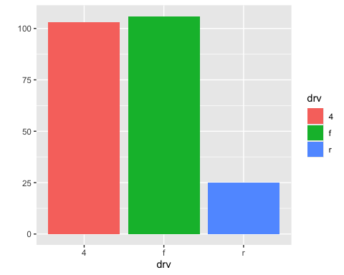
italic
bold
strikethrough
bold
EKU CS Department

First-level header

Second-level header

Third-level header
- one item
- one item
- one item
  - one more item
  - one more item
  - one more item
- the first item
- the second item
- the third item
  - one unordered item
  - one unordered item
“I thoroughly disapprove of duels. If a man should challenge me, I would take him kindly and forgivingly by the hand and lead him to a quiet place and kill him.”
— Mark Twain
This text is displayed verbatim / preformatted
This text is displayed verbatim / preformatted
par(mar = c(4, 4, 0.1, 0.1))
plot(pressure, pch = 19, type = "b")
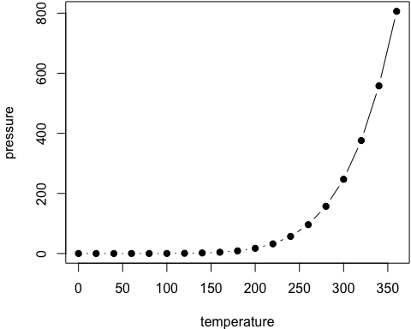
par(mfrow = c(1, 2))
plot(pressure, pch = 19, type = "b")
plot(mpg ~ hp, data = mtcars, pch = 19)
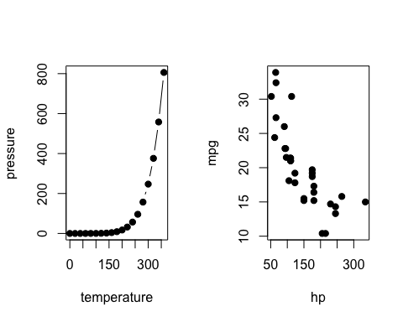
out.width = '50%'
knitr::include_graphics(rep("knit-logo.png", 2))

knitr::kable(
list(
head(iris[, 1:2], 3),
head(mtcars[, 1:3], 5)
),
caption = 'A Tale of Two Tables.', booktabs = TRUE
)
A Tale of Two Tables.
Sepal.Length | Sepal.Width
5.1 | 3.5
4.9 | 3.0
4.7 | 3.2

 | mpg | cyl | disp
Mazda RX4 | 21.0 | 6 | 160
Mazda RX4 Wag | 21.0 | 6 | 160
Datsun 710 | 22.8 | 4 | 108
Hornet 4 Drive | 21.4 | 6 | 258
Hornet Sportabout | 18.7 | 8 | 360
knitr::kable(
head(mtcars[, 1:8], 10), booktabs = TRUE,
caption = 'A table of the first 10 rows of the mtcars data.'
)
A table of the first 10 rows of the mtcars data.
 | mpg | cyl | disp | hp | drat | wt | qsec | vs
Mazda RX4 | 21.0 | 6 | 160.0 | 110 | 3.90 | 2.620 | 16.46 | 0
Mazda RX4 Wag | 21.0 | 6 | 160.0 | 110 | 3.90 | 2.875 | 17.02 | 0
Datsun 710 | 22.8 | 4 | 108.0 | 93 | 3.85 | 2.320 | 18.61 | 1
Hornet 4 Drive | 21.4 | 6 | 258.0 | 110 | 3.08 | 3.215 | 19.44 | 1
Hornet Sportabout | 18.7 | 8 | 360.0 | 175 | 3.15 | 3.440 | 17.02 | 0
Valiant | 18.1 | 6 | 225.0 | 105 | 2.76 | 3.460 | 20.22 | 1
Duster 360 | 14.3 | 8 | 360.0 | 245 | 3.21 | 3.570 | 15.84 | 0
Merc 240D | 24.4 | 4 | 146.7 | 62 | 3.69 | 3.190 | 20.00 | 1
Merc 230 | 22.8 | 4 | 140.8 | 95 | 3.92 | 3.150 | 22.90 | 1
Merc 280 | 19.2 | 6 | 167.6 | 123 | 3.92 | 3.440 | 18.30 | 1

