|  |
| --- |
| inPatient(patientNumber, lastName, firstName,address,phoneNumber, dateOfBirth, maritalStatus, DatePlacedOnWaitingList, wardRequired,durationStay, datePlacedOnWard,DateLeftWard, name,ClinicNumber,staffNumber,bedNumber)  Primary Key patientNumber  Foreign Key name, clinicNumber reference localDoctor  Foreign Key staffNumber reference consultant |
| outpatient(patientNumber, lastName, firstName,address,phoneNumber, dateOfBirth, maritalStatus,date, time, name,ClinicNumber,staff number)  Primary Key patientNumber  Foreign Key name, clinicNumber reference localDoctor  Foreign Key staffNumber reference consultant |
| EmergencyContact(patientNumber, name, relationship, address,phoneNumber)  Primary key PaitentNumber |
| MedicationList(patientNumber,staffNumber,drugNumber,drugName, unitPerDay,startDay, FinishDay)  Primary key PatientNumber, durgNumber  Foreign key staffNumber reference doctor |
| LocalDoctor(name, clinicNumber, address, phoneNumber)  Primary Key name,ClinicNumber |
| Appointment(consltantName, conslatantNumber,date,appointmentNumber,time, room,patientNumber)  Primary key appointmentNumber  Foreign key patientNumber reference inpatient, outpatient |
| GeneralSupplies( itemNumber, name, description, quantity, reorderLevel,costPerUnit, type,supplierNumber,ordereddate)  Primarykey itemNumber  Foreign key supplierNumber reference suppliers |
| PharmaceuticalSupplies(itemNumber, name, description, quantity, reorderLevel,costPerUnit,dosage, supplierNumber, ordereddate)  Primary key itemNumber  Foreign key supplierNumber reference suppliers |
| Suppliers(supplierName,supplierNumber,address, phoneNumber, faxNumber)  Primary key supplierNumber |
| Obtain(itemNumber,staffNumber,requestionNumber,wardNumber,quantityrequird, dateOrdered,dateReceived. )  PRIMARY KEY itemNumber, staffNumber  Foreign key itemNumber reference supplies  Foreign key staffNumber reference chargeNurse |
| SeniorNurse(StaffNumber,Name,address, phoneNumber,position, numberOfHour, Shift,wardNumber)  Primary key StaffNumber.  Foreign key wardNumber reference ward |
| Junior Nurse(StaffNumber,Name,address, phoneNumber,position, numberOfHour, Shift,wardNumber)  Primary key StaffNumber.  Foreign key wardNumber reference ward |
| auxiliaries(StaffNumber,Name,address, phoneNumber,position, numberOfHour, Shift,wardNumber)  Primary key StaffNumber.  Foreign key wardNumber reference ward |
| Doctor(StaffNumber,Name,address, phoneNumber,position, numberOfHour, Shift,wardNumber)  Primary key StaffNumber.  Foreign key wardNumber reference ward |
| Consultant(StaffNumber,Name,address, phoneNumber,position, numberOfHour, Shift,wardNumber)  Primary key StaffNumber.  Foreign key wardNumber reference ward |
| chargeNurse (StaffNumber,Name,address, phoneNumber,position, numberOfHour, Shift,wardNumber)  Primary key StaffNumber.  Foreign key wardNumber reference ward |
| Create(StaffNumber,Date,shift,staffOnDutyThatDay,wardNumber)  PRIMARY KEY staffNumber  Foreign Key staffNumber reference chargeNurse |
| Ward(WardNumber,WardName,PhoneNumber, location, NumberOFBeds,nameofchargeNurse,staffNumber)  Primary key WardNumber  Foreign key staffNumber reference chargeNurse |
| Specialties(chargeNurseStaffNumber, staffNumber, specialties)  Primary key chargeNurseStaffNumber |
| StaffSchedule (Date, shift, SatffOnDutythat day)  Primary key day, shift |

**Data Queries**

**Medical Director View**

1. List the details of a specific ward.

Select *

FROM ward

where wardNumber =9

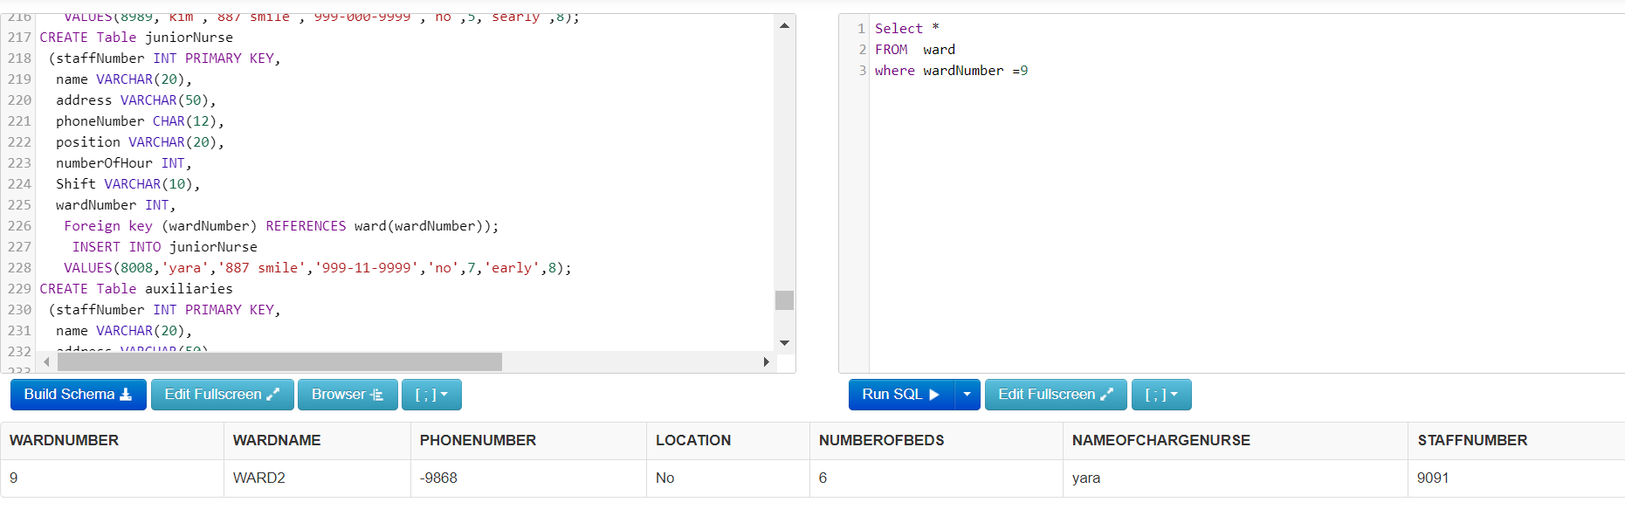

1. List each ward number and a count of the number of beds for each ward.

Select wardNumber, numberOFBeds

FROM Ward

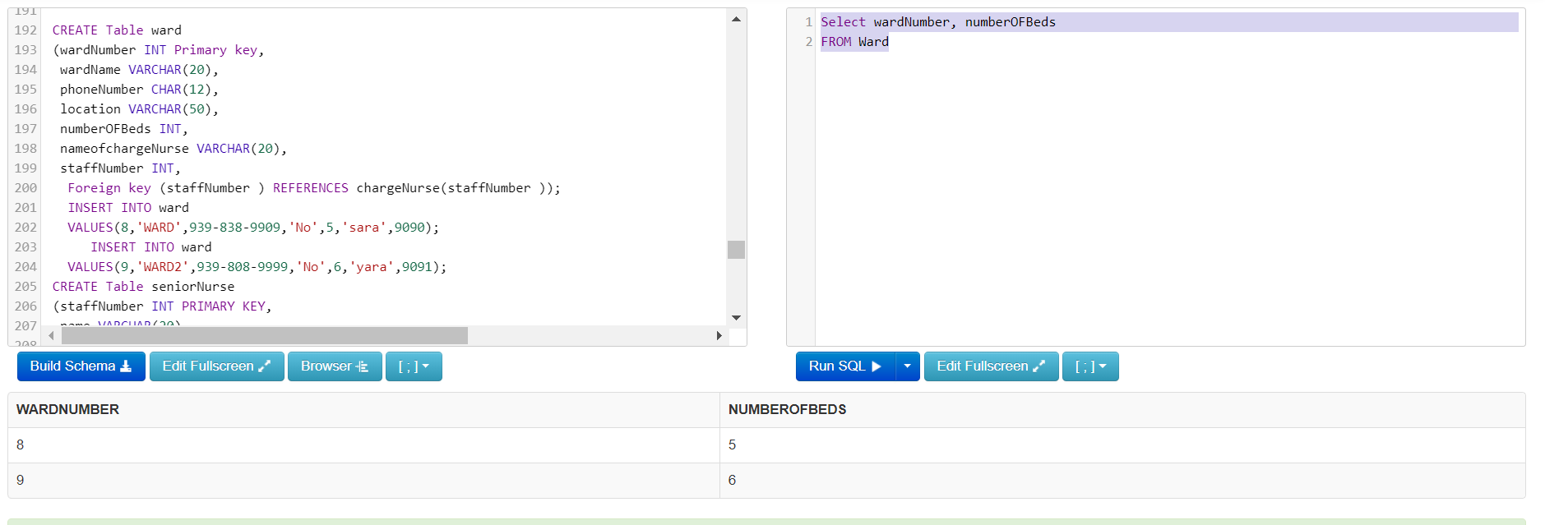

1. List each surgical supply and the total quantity in stock, ordered by total quantity in stock descending.

Select *

FROM generalSupplies

Where type='S'

ORDER BY quantity DESC

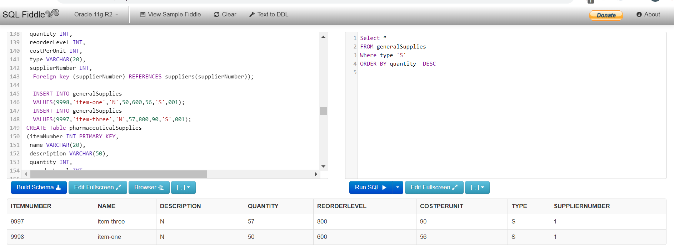

1. List each surgical supply and a sum of the quantity in stock for each item that has a re-order level greater than 10.

Select itemNumber, sum(quantity )

FROM generalSupplies

Where type='S' AND reorderLevel>10

Group by itemNumber

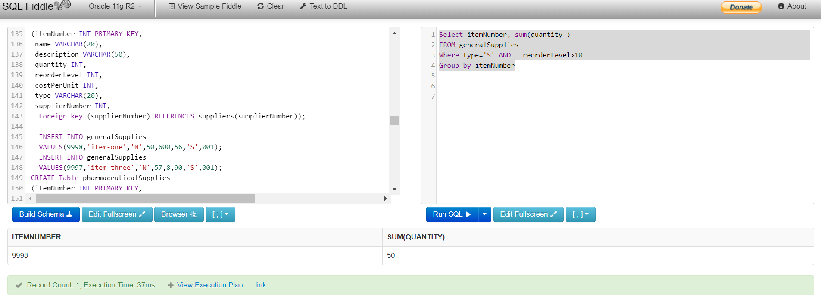

1. List the details for each surgical supply item that has a cost per unit greater than $9.00.

Select *

FROM generalSupplies

Where type='S' AND costPerUnit>9

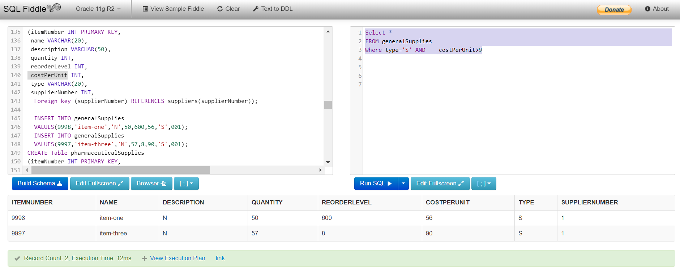

1. List all the suppliers that do not have a phone number on file.

SELECT *

FROM suppliers

Where phoneNumber is Null

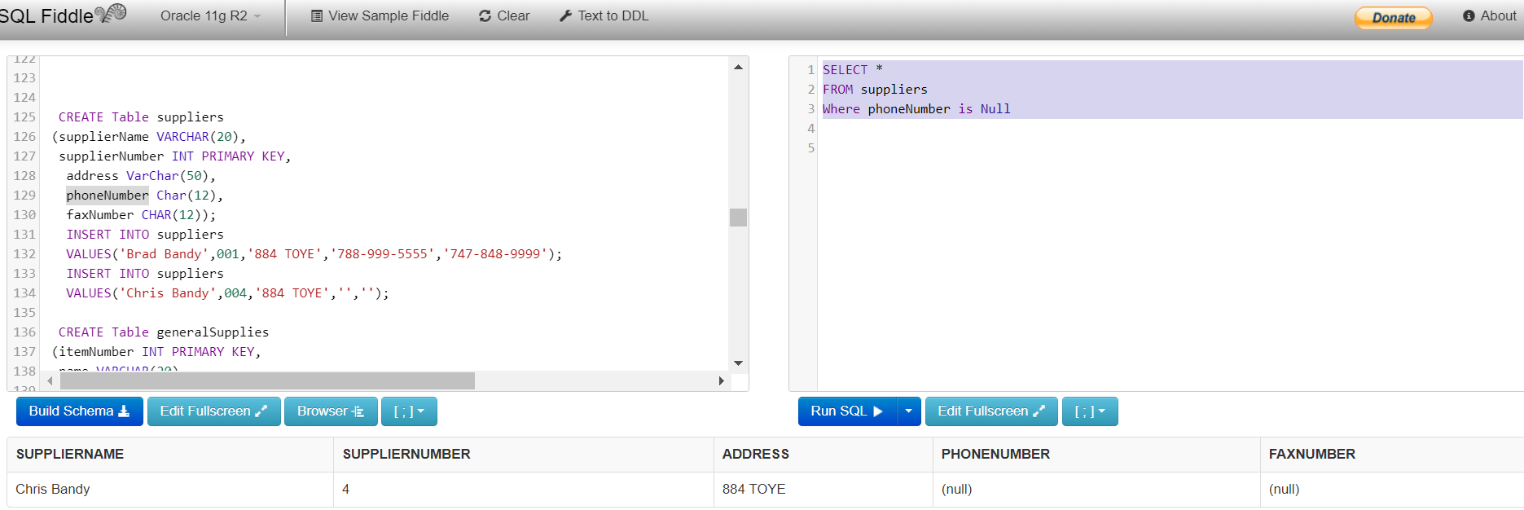

1. List each supplier and a count of the different products that they currently supply.

SELECT suppliers.supplierName,count (DISTINCT generalSupplies.itemNumber)

FROM suppliers, generalSupplies

where suppliers.supplierNumber = generalSupplies.supplierNumber

Group by suppliers.supplierName

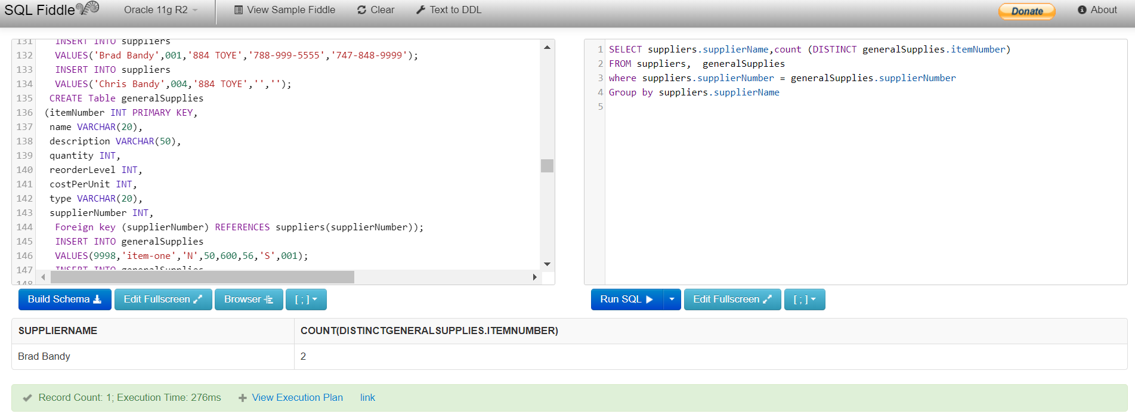

1. List the details for each local clinic and the number of patients that they have referred over the past year.

SELECT localDoctor.clinicNumber,count(inPatient.patientNumber)

FROM localDoctor,inPatient

where inPatient.name=localDoctor.name

GROUP BY localDoctor.clinicNumber

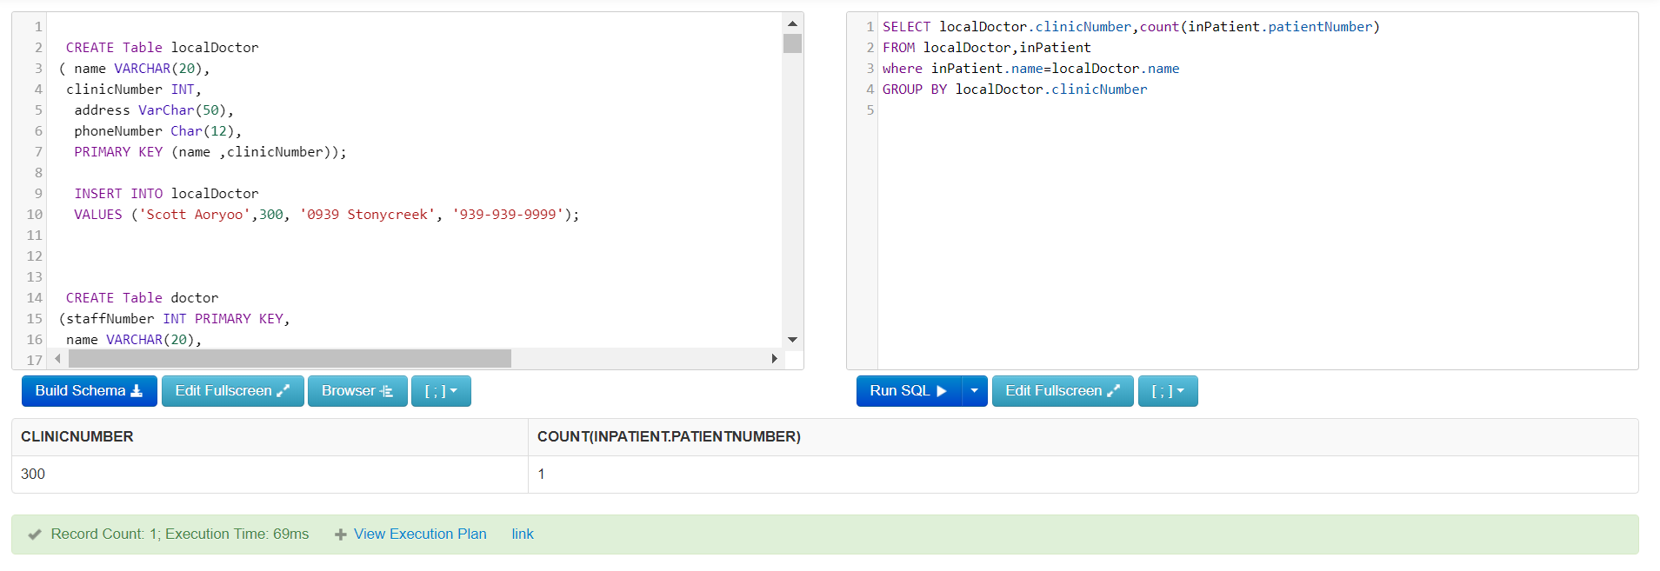

1. List the number of patients treated at the outpatient clinic each day ordered by date.

SELECT datee, Count(patientNumber)

FROM outPatient

Group by datee

Order by datee

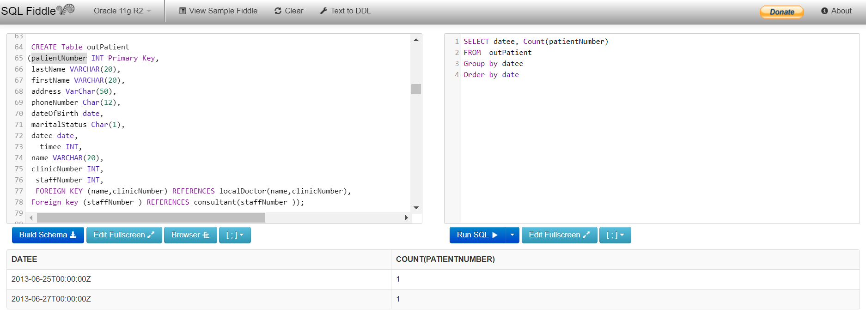

1. List all of the patients currently on the waiting list for In Patient services

SELECT *

FROM inPatient

where DatePlacedOnWaitingList Is Not NULL

AND datePlacedOnWard is NULL

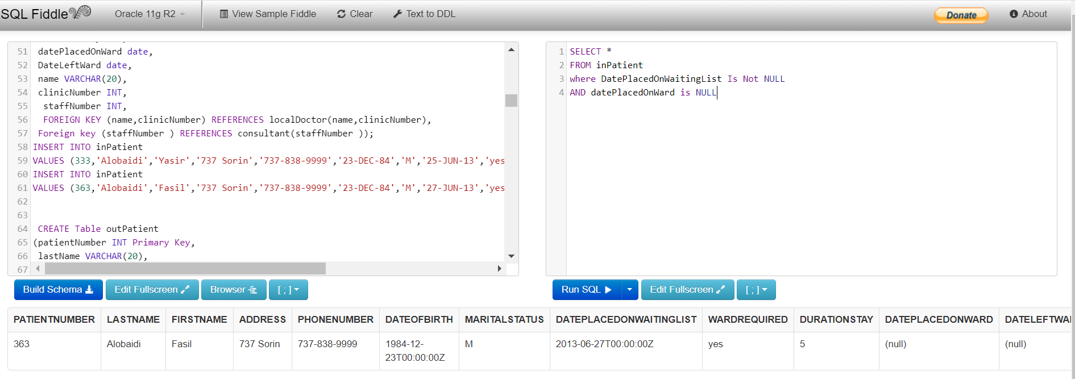

**Charge Nurse View**

1. List the staff number and name of staff in a given ward, ordered by staff name.

SELECT staffNumber,nameofchargeNurse as name

FROM ward

WHERE wardNumber=8

Union

select staffNumber, name

From juniorNurse

where wardNumber=8

Union

select staffNumber, name

From seniorNurse

where wardNumber=8

Union

select staffNumber, name

From auxiliaries

where wardNumber=8

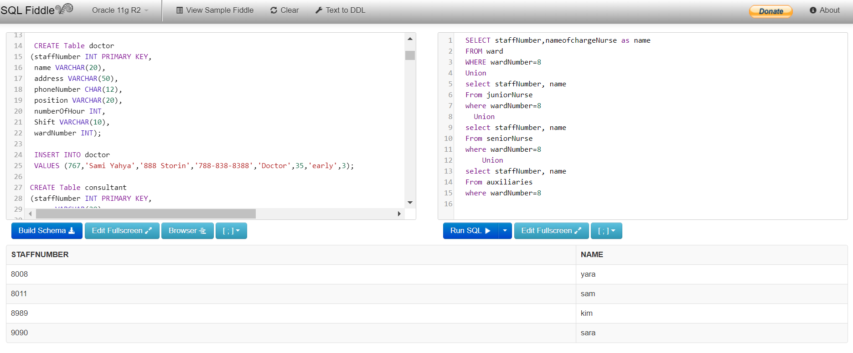

1. List the name of each Charge Nurse on each ward, ordered by ward number.

SELECT nameofchargeNurse,wardNumber,wardName

FROM ward

order by wardNumber

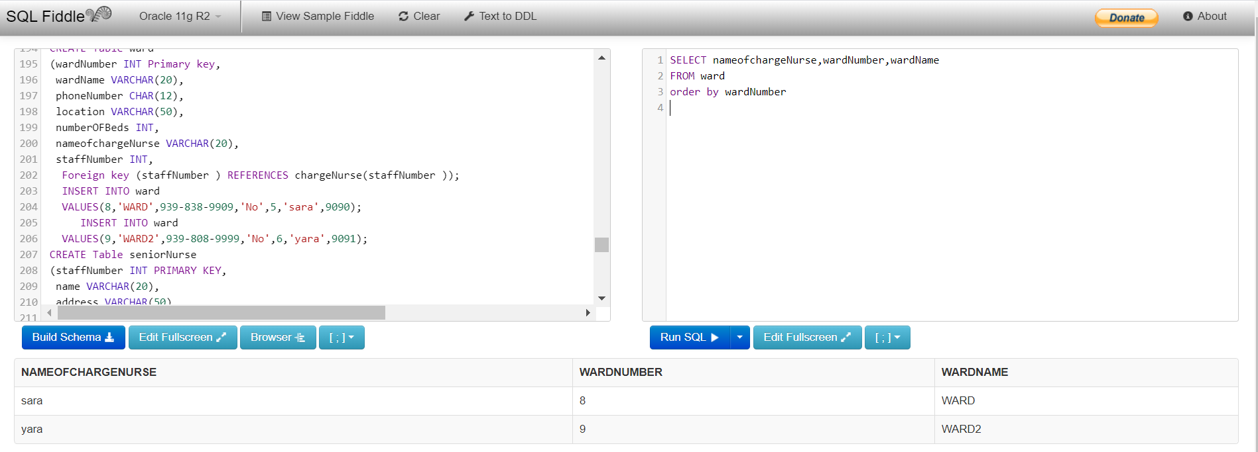

1. List the name of each patient that has stayed in a specific bed.

SELECT patientNumber,lastName, firstName

FROM inPatient

WHERE datePlacedOnWard IS Not NULL AND bedNumber=80

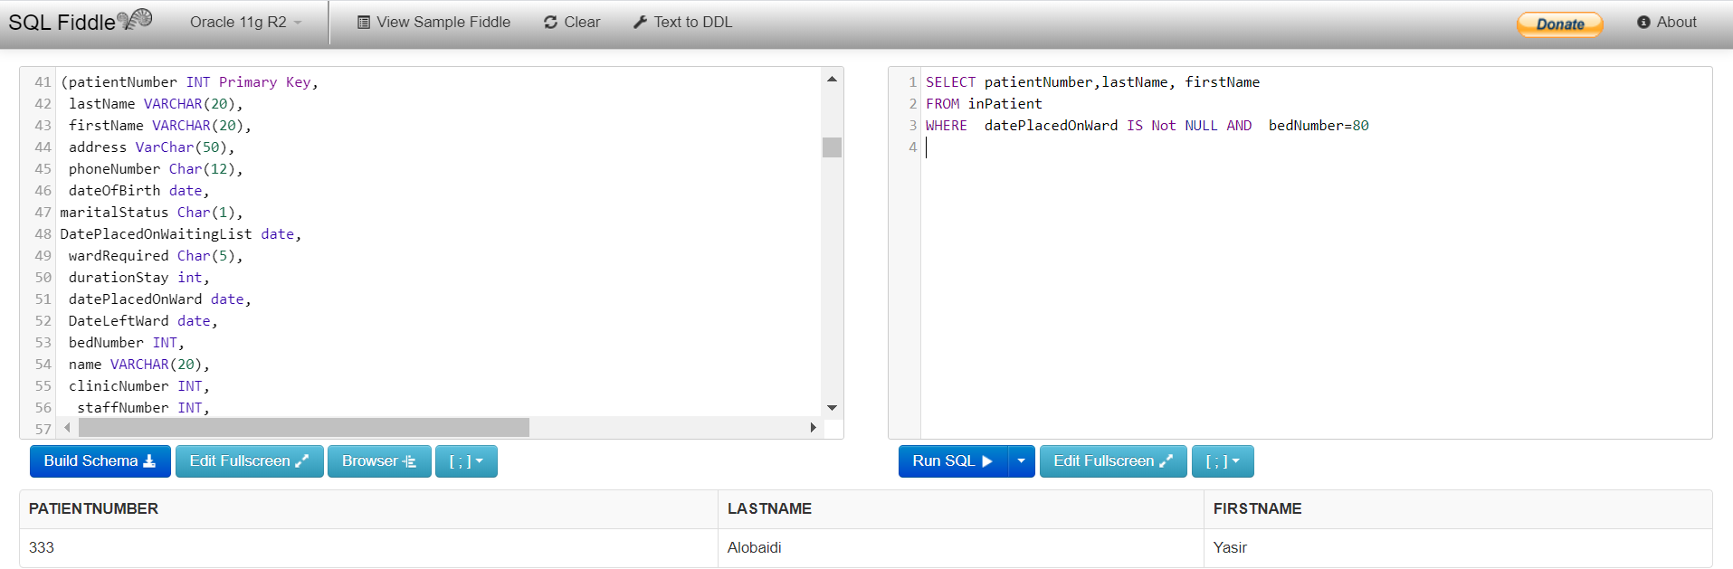

1. List all of the supplies ordered on a specific day.

SELECT itemNumber

FROM generalSupplies

WHERE orderedDate ='03-JUL-20'

UNION

SELECT itemNumber

FROM pharmaceuticalSupplies

WHERE orderedDate ='03-JUL-20'

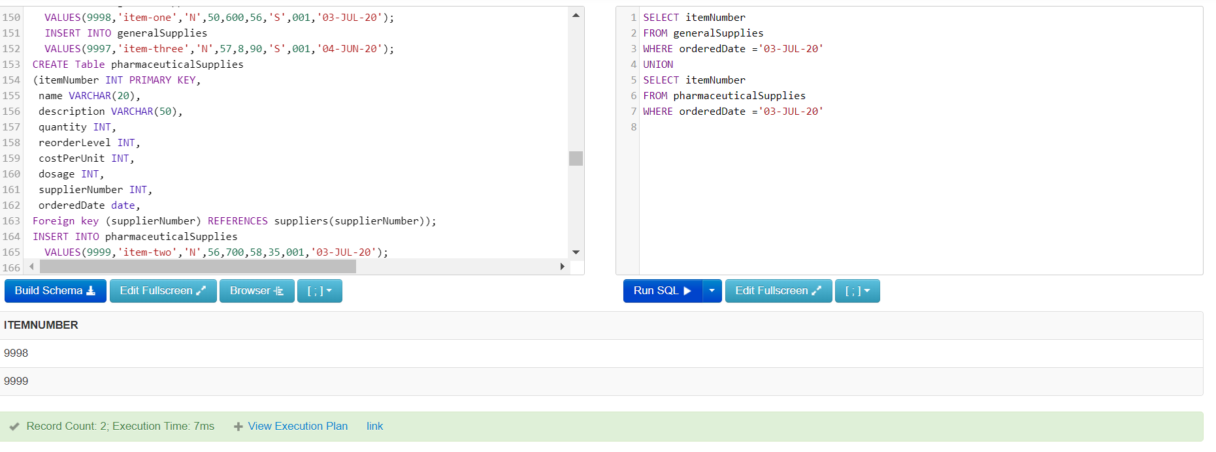

1. List each ward and shift (early, late, etc.) and a count of staff on duty.

SELECT ward.wardNumber,ward.shift,count(seniorNurse.staffNumber) AS numberOfSeniorNurse,count(juniorNurse.staffNumber)AS numberOfjuniorNurse

FROM ward,seniorNurse,juniorNurse

group by ward.wardNumber,ward.shift

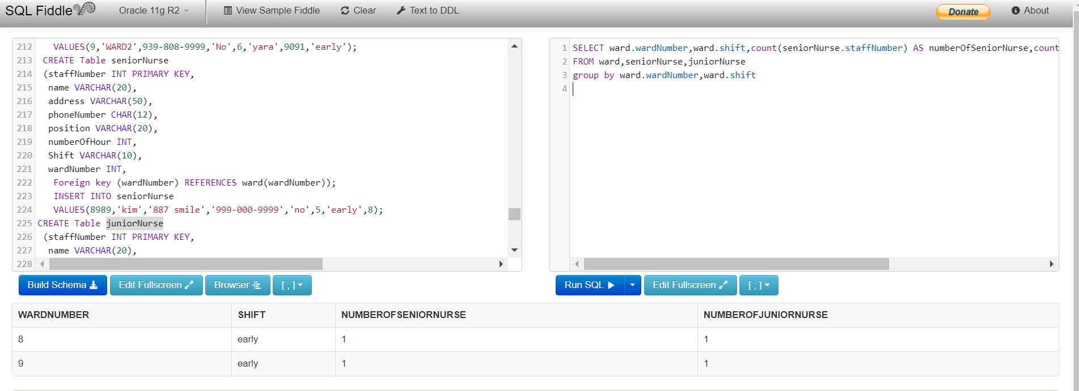

OR

SELECT staffNumber, Date1 as workdate, shift,staffONDUTY,wardNumber

FROM createrelation

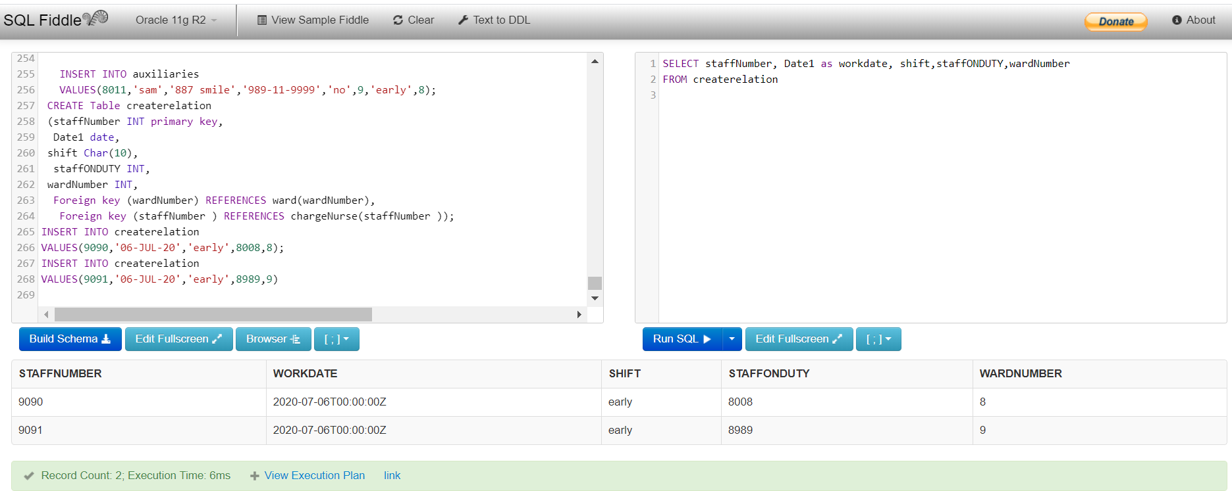

1. List the immediate family contact details for all patients.

SELECT *

FROM emergencyContact

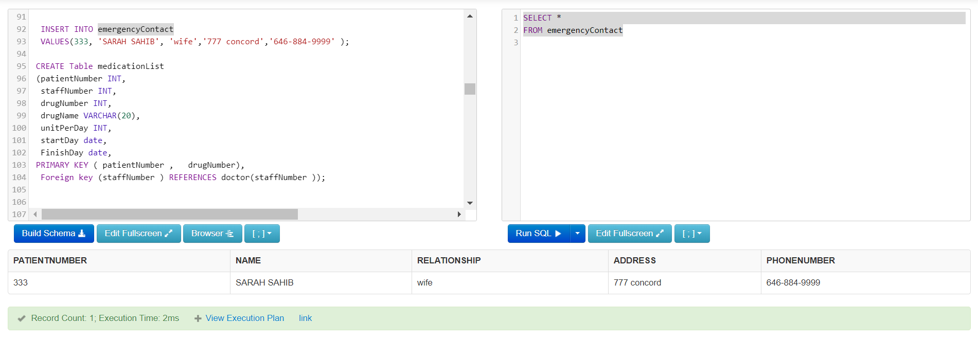

1. List every staff person who provides specialist care on each ward.

SELECT ward.wardNumber, specialties.staffNumber

FROM ward, specialties

where specialties.chargeNurseStaffNumber = ward.staffNumber

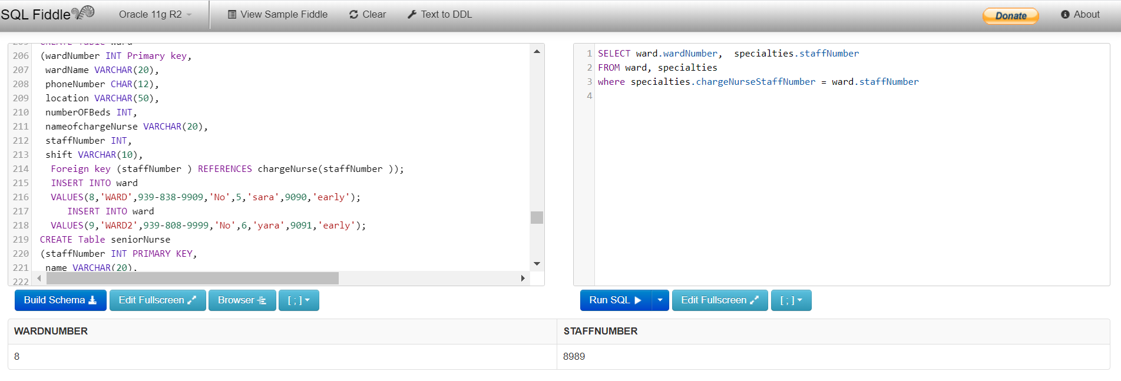

1. List the patient ID and the maximum dosage of the patient taking he highest dosage of a

Pharmaceutical supply.

SELECT medicationList.patientNumber, pharmaceuticalSupplies. dosage

FROM medicationList, pharmaceuticalSupplies

where medicationList.drugNumber=pharmaceuticalSupplies.itemNumber

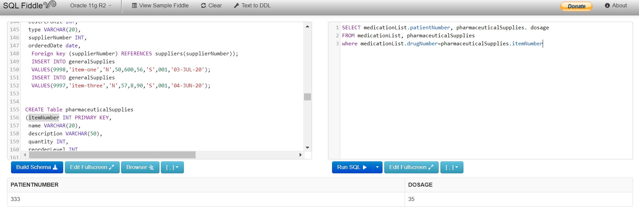

1. List the details for the pharmaceutical supply that is most frequently ordered.

select itemNumber, count(itemNumber) AS value_occurrence

from pharmaceuticalSupplies

group by itemNumber

order by value_occurrence DESC

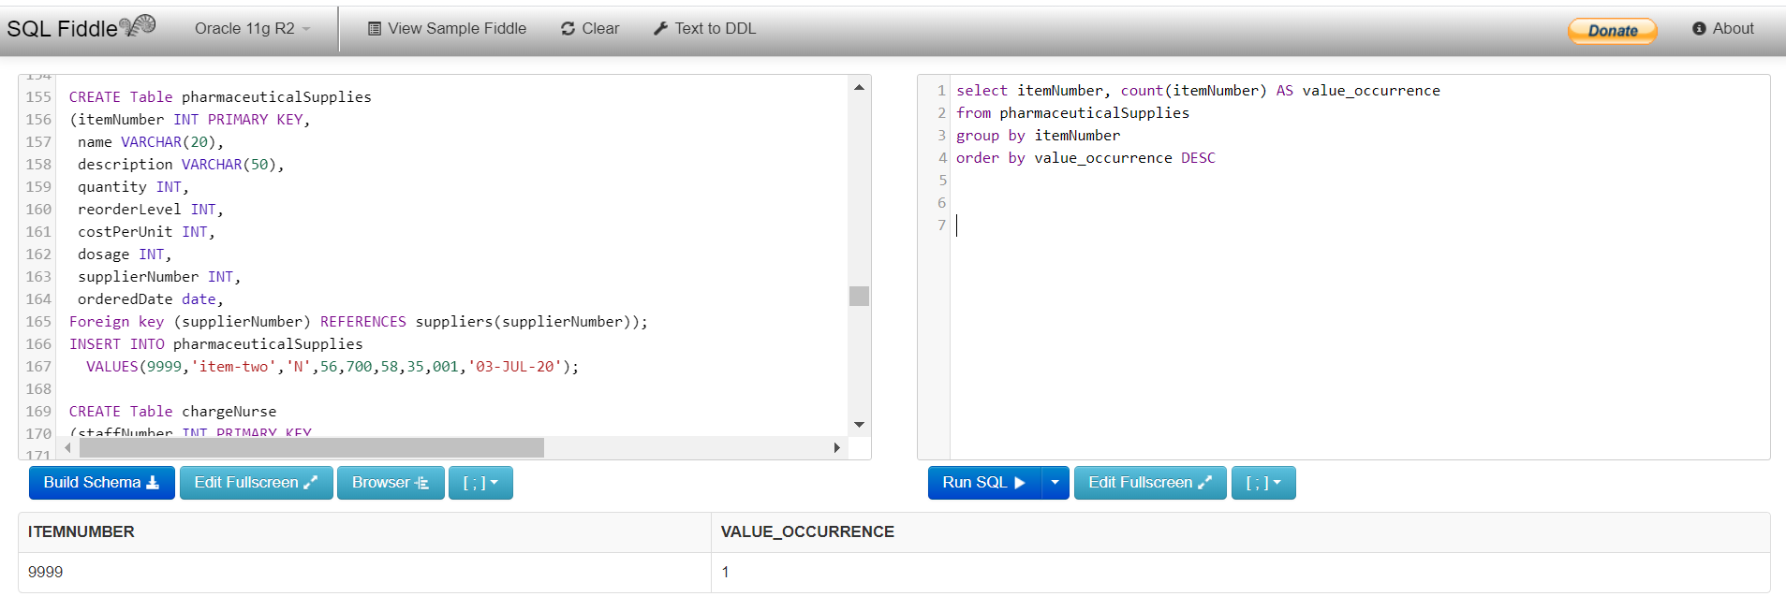

1. List a count of patient appointments per week.

SELECT to_char(to_date(date1,'DD-MM-YY'),'WW') as "Week",count(appointmentNumber)

FROM appointment

Group by to_char(to_date(date1,'DD-MM-YY'),'WW')

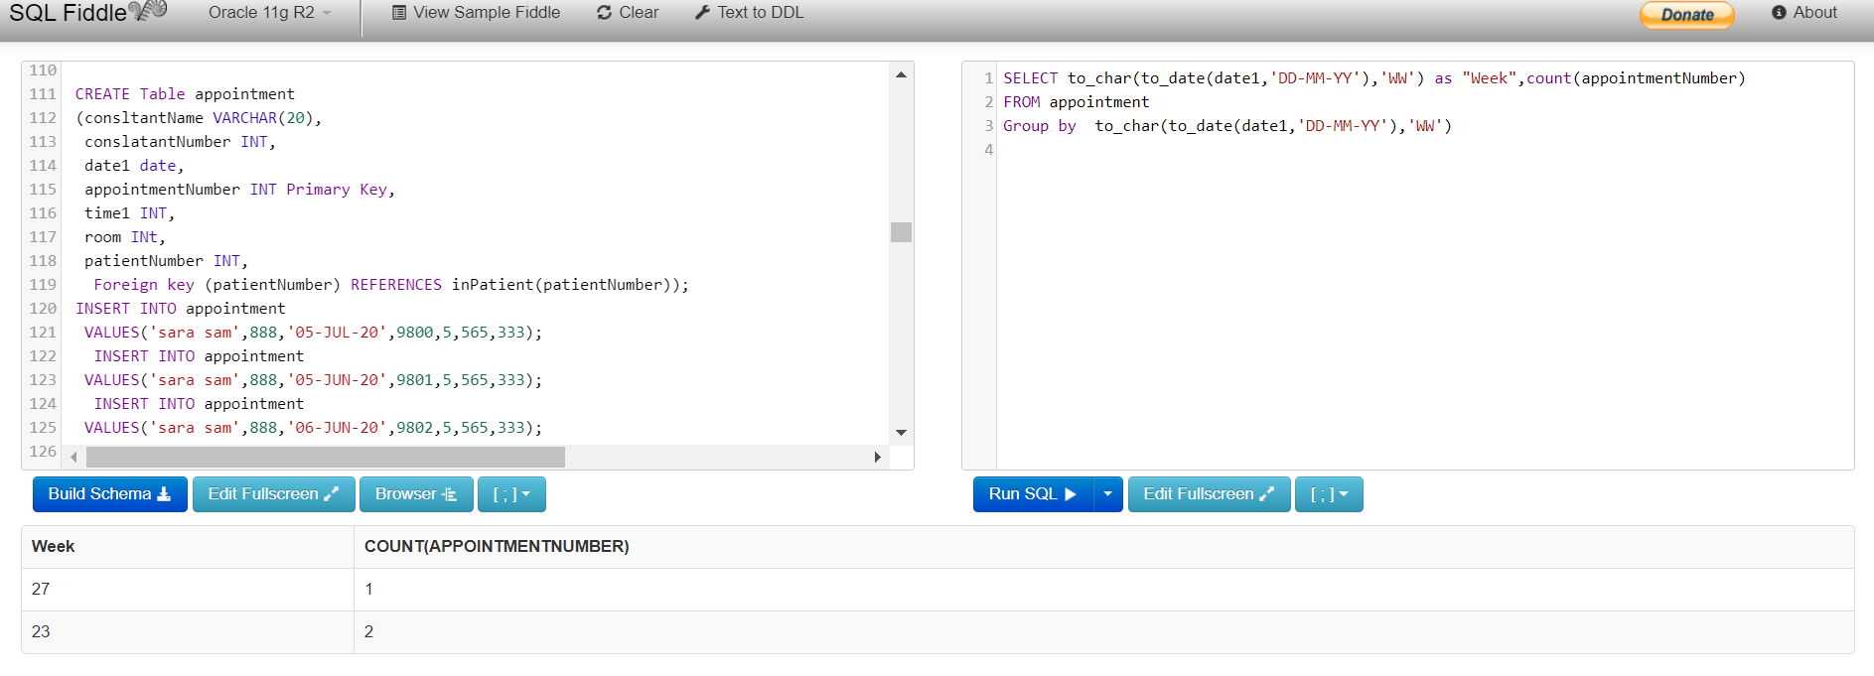

<http://sqlfiddle.com/#!4/359952>

