SIMATS ENGINEERING
ASSESSMENT TOOL 1
COURSE NAME: SARAH SHARMEEN R
COURSE CODE: Computer Networks-CSA0708
COURSE OUTCOME COVERED
CO1: Apply the functions of OSI layer in enabling reliable data transmission across networks. (BL2, BL3)
Assessment Tool Weightage: 40%
Description about the assessment tool:
Short-answer questions effectively measure conceptual understanding, logical reasoning, and the ability to apply theoretical knowledge without requiring lengthy descriptive responses. This assessment method is also efficient for evaluating multiple OSI-related concepts within a limited time while ensuring objective and consistent evaluation.
Short Answer Test
1. A company needs to transfer a 150 MB design file from a client computer to a remote server over a network with a bandwidth of 50 Mbps. The Transport Layer divides the file into 1500-byte segments, while the Data Link Layer encapsulates each segment into frames by adding 40 bytes of header and trailer. Calculate the total number of segments and frames transmitted, the total transmission overhead introduced by the Data Link Layer, and estimate the total transmission time (ignoring propagation delay). Explain how the Transport and Data Link layers ensure reliable communication.
SOLUTION:
File size in bytes
150 MB = 150,000,000 bytes
Number of segments (Transport Layer)
Segment size = 1500 bytes (payload)
Total segments = 150,000,000 / 1500 = 100,000 segments
Number of frames (Data Link Layer)
Each segment gets wrapped into exactly one frame (1:1 mapping), so: Total frames = 100,000 frames
Frame size = 1500 + 40 = 1540 bytes each
Data Link Layer overhead
Overhead per frame = 40 bytes
Total overhead = 100,000 × 40 = 4,000,000 bytes = 4 MB
Total data actually transmitted (with overhead)
Total bytes sent = 100,000 × 1540 = 154,000,000 bytes
Convert to bits: 154,000,000 × 8 = 1,232,000,000 bits
Transmission time
Bandwidth = 50 Mbps = 50,000,000 bits/sec
Transmission time = 1,232,000,000 / 50,000,000 = 24.64 seconds How Transport and Data Link layers ensure reliability:
1. Sequence numbers - each segment is numbered so the receiver can detect loss, duplication, or reordering, and reassemble data correctly. 2. Acknowledgments (ACKs) - receiver confirms successful receipt; missing ACKs trigger retransmission.
3. Retransmission (ARQ) - lost or corrupted segments are automatically resent after a timeout.
4. Flow control - sliding window mechanism prevents the sender from overwhelming the receiver's buffer.
5. Congestion control - adjusts sending rate based on network conditions to avoid packet loss from congestion.
6. Checksums - verify segment data integrity end-to-end.
Data Link Layer :
1. Framing - adds header/trailer (like your 40 bytes) to mark frame boundaries and carry control info.
2. Error detection - CRC (Cyclic Redundancy Check) or checksum in the trailer detects bit errors introduced during transmission over the physical medium.
3. ARQ at link level - some link-layer protocols (e.g., HDLC) also retransmit corrupted/lost frames between adjacent nodes (hop-by-hop), before Transport-layer end-to-end retransmission even kicks in.
4. Flow control - regulates frame flow between two directly connected devices.
5. MAC (Media Access Control) - manages access to shared medium to avoid collisions (e.g., CSMA/CD, CSMA/CA).
2. A Transport Layer protocol uses a sliding window size of 6 frames. Each frame carries 1024 bytes of user data. If the sender transmits 48 frames, calculate the number of transmission windows required. If one frame in every window is lost and must be retransmitted, determine the total number of retransmissions. Explain how flow control improves communication efficiency.
SOLUTION:
Number of transmission windows
Window size = 6 frames per window
Total frames = 48
Number of windows = 48 / 6 = 8 windows
Total retransmissions
1 frame lost per window → needs 1 retransmission per window Total retransmissions = 8 windows × 1 lost frame = 8 retransmissions
How Flow Control Improves Communication Efficiency
1. Prevents receiver buffer overflow
The sender is restricted to sending only as many frames (here, 6) as the receiver can handle before needing an acknowledgment. This stops a fast sender from overwhelming a slow receiver, which would otherwise cause dropped frames and wasted bandwidth.
2. Enables pipelining instead of stop-and-wait
Without flow control or with a window size of , the sender would have to wait for an ACK after every single frame - very inefficient. A sliding window lets multiple frames (up to the window size) be sent before an ACK is required, keeping the communication channel busier and improving throughput.
3. Reduces idle time on the link
While waiting for ACKs of earlier frames, the sender can continue transmitting later frames within the window. This overlapping of transmission and acknowledgment reduces the total time the link sits idle.
4. Balances sender and receiver speeds
Flow control dynamically (in protocols like TCP) or statically (fixed window) matches the sender's transmission rate to the receiver's processing/storage capacity, avoiding both congestion at the receiver and underutilization of the sender's capability.
5. Improves error recovery efficiency
With a bounded window, when a frame is lost, only the frames within that window need to be considered for retransmission (especially in Selective Repeat), rather than resending the entire data stream - as seen in your example, only 1 out of 6 frames per window needed retransmission, not all 48.
3. A 12,000-byte IP packet is transmitted through a router where the Maximum Transmission Unit (MTU) is 1500 bytes. Assuming each fragment requires a 20-byte IP header, calculate the total number of fragments created and the total header overhead introduced. Explain how the Network Layer ensures successful delivery of fragmented packets to the destination.
SOLUTION:
Data to be fragmented
Total IP packet size = 12,000 bytes
Original IP header = 20 bytes
Data (payload) = 12,000 − 20 = 11,980 bytes
Data carried per fragment
MTU = 1500 bytes
Header per fragment = 20 bytes
Data per fragment = 1500 − 20 = 1480 bytes
Number of fragments
Number of fragments = ⌈11,980 / 1480⌉ = ⌈8.09⌉ = 9 fragments
So,
Fragments 1–8: 1480 bytes of data each = 11,840 bytes
Fragment 9: 11,980 − 11,840 = 140 bytes of data (last fragment, smaller)
Total header overhead
Overhead = 9 fragments × 20 bytes = 180 bytes
Total transmitted (data + all headers) = 11,980 + 180 = 12,160 bytes
How the Network Layer Ensures Successful Delivery of Fragmented Packets
1. Identification field
Every fragment of the same original packet carries the same Identification (ID) number in its IP header. This lets the destination know which fragments belong together for reassembly, even if fragments from different packets arrive interleaved.
2. Fragment Offset field
Each fragment's header includes an offset value indicating where its data belongs within the original packet. This allows the receiver to reassemble fragments in the correct order, even if they arrive out of sequence.
3. More Fragments (MF) flag
A flag bit is set to 1 for all fragments except the last one, which has MF = 0. This tells the destination when it has received the final fragment and can determine the total original packet length.
4. Don't Fragment (DF) flag
If set, this tells routers not to fragment the packet; if the packet exceeds the MTU, it's dropped and an ICMP error is sent back — used for Path MTU Discovery.
5. Independent routing
Each fragment is treated as an independent IP packet and can take a different path to the destination. Reassembly happens only at the final destination host, not at intermediate routers (this avoids overburdening routers with reassembly work).
6. Time to Live (TTL) and fragment timeout
If not all fragments of a packet arrive within a certain time (fragment
reassembly timeout), the destination discards the partial data and typically triggers an ICMP "Time Exceeded" (fragment reassembly timeout) message back to the sender.
7. Checksum (per fragment header)
Each fragment's IP header has its own checksum to detect corruption in the header during transit, ensuring routers/destination can catch header-level errors early.
4. A Transport Layer protocol uses a sliding window size of 6 frames. Each frame carries 1024 bytes of user data. If the sender transmits 48 frames, calculate the number of transmission windows required. If one frame in every window is lost and must be retransmitted, determine the total number of retransmissions. Explain how flow control improves communication efficiency.
SOLUTION:
Number of transmission windows
Window size = 6 frames per window
Total frames = 48
Number of windows = 48 / 6 = 8 windows
Total retransmissions
1 frame lost per window → 1 retransmission needed per window Total retransmissions = 8 windows × 1 lost frame = 8 retransmissions
Total frames actually sent over the link = 48 original + 8 retransmitted = 56 frames, though only 48 unique data frames.
How Flow Control Improves Communication Efficiency
1. Prevents receiver buffer overflow
The sender is limited to sending only as many frames (here, 6) as the receiver can handle before an acknowledgment is needed. This stops a fast sender from overwhelming a slow receiver, which would otherwise cause dropped frames and wasted bandwidth.
2. Enables pipelining instead of stop-and-wait
Without flow control (window size = 1), the sender would have to wait for an ACK after every single frame, which is very inefficient. A sliding window lets
multiple frames (up to the window size) be sent before an ACK is required, keeping the channel busier and improving throughput.
3. Reduces idle time on the link
While waiting for ACKs of earlier frames, the sender can continue transmitting later frames within the window, overlapping transmission and acknowledgment and reducing idle link time.
4. Balances sender and receiver speeds
Flow control (fixed window, as here, or dynamic as in TCP) matches the sender's transmission rate to the receiver's processing/storage capacity, avoiding both receiver overload and underutilization of available bandwidth.
5. Improves error recovery efficiency
With a bounded window, when a frame is lost, only frames within that window need retransmission (especially with Selective Repeat) rather than resending the entire data stream - as seen above, only 1 of 6 frames per window needed retransmission, not all 48.
5. A multimedia application transfers a 600 MB video file. The Session Layer inserts a synchronization checkpoint after every 60 MB of transmitted data. During transmission, a failure occurs after 390 MB has been transferred. Determine the number of checkpoints created before failure and calculate the amount of data that must be retransmitted after recovery. Explain the importance of synchronization in the Session Layer.
SOLUTION:
Checkpoints created before failure
Checkpoint interval = every 60 MB
Failure occurs at 390 MB
Checkpoints are placed at: 60, 120, 180, 240, 300, 360 MB (the next one would be at 420 MB, which is past the failure point)
Number of checkpoints created before failure = 6 checkpoints
Data to be retransmitted after recovery
Last successful checkpoint = 360 MB
Failure point = 390 MB
Importance of Synchronization in the Session Layer
1. Enables efficient recovery from failure
By inserting checkpoints (synchronization points) periodically, the Session Layer allows communication to resume from the last checkpoint instead of restarting the entire transfer from scratch — as seen above, only 30 MB needed retransmission instead of all 390 MB.
2. Manages and maintains sessions (dialog control)
The Session Layer establishes, maintains, and terminates the logical connection ("session") between two communicating applications, keeping track of whose turn it is to transmit in half-duplex communication and coordinating data exchange in full-duplex communication.
3. Saves time and bandwidth
Without synchronization checkpoints, any failure mid-transfer would require re-sending the entire file, wasting significant time and network resources — especially costly for large files like this 600 MB video.
4. Supports session recovery and fault tolerance
If a session is interrupted (due to network failure, crash, or timeout), synchronization points allow the system to detect exactly where the failure occurred and resume gracefully, improving reliability of long-duration transfers like video/audio streaming or large file uploads.
5. Maintains data consistency
Checkpoints ensure both sender and receiver agree on how much data has been successfully processed/acknowledged, preventing data duplication or gaps when the session resumes.
6. Useful for multimedia and real-time applications
For video/audio transmission specifically, synchronization also helps coordinate related data streams (e.g., audio-video sync) and manage session state across potentially unreliable or long-lived connections.
6. Before transmission, the Presentation Layer compresses a 900 MB file by 40%. The compressed data is encrypted, adding 5% overhead to the compressed size. Calculate the compressed file size, the encrypted file size, and the total percentage reduction compared to the original file. Explain how the Presentation Layer improves transmission efficiency and security.
SOLUTION:
● Original file size = 900 MB
● Compression = 40%
● Encryption overhead = 5% of compressed size
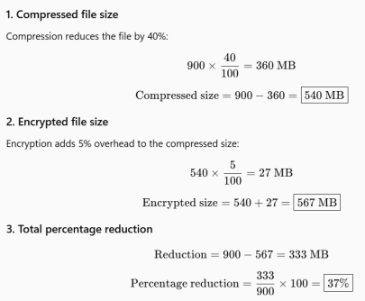
Final Answer:
● Compressed file size: 540 MB
● Encrypted file size: 567 MB
● Total percentage reduction: 37%
Role of the Presentation Layer:
The Presentation Layer improves transmission efficiency by compressing data, which reduces the amount of data that needs to be transmitted and therefore saves bandwidth and transmission time. It improves security by encrypting the data, making it difficult for unauthorized users to understand or access the information during transmission.
7.An FTP application transfers 3 GB of data over a network with an effective throughput of 120 Mbps. The Application Layer divides the data into requests of 3 MB each. Calculate the total number of requests generated and estimate the total transmission time in seconds. Discuss how the Application Layer provides reliable services to users.
SOLUTION:
Given:
● Total data = 3 GB
● Effective throughput = 120 Mbps
● Each request = 3 MB
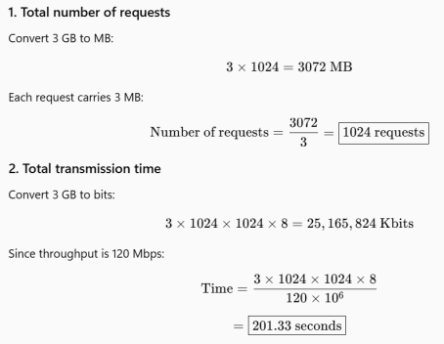
Final Answer:
● Total number of requests: 1024
● Total transmission time: Approximately 201.33 seconds (about 3.36 minutes)
How the Application Layer provides reliable services:
The Application Layer provides network services directly to users and applications. In FTP, it enables reliable file transfer by:
● Establishing communication between the client and server. ● Dividing large files into manageable requests.
● Handling file uploads and downloads.
● Providing authentication using usernames and passwords. ● Supporting error handling and retransmission when data is lost or corrupted.
8.A packet experiences the following processing delays at different OSI layers: Application Layer = 4 ms, Transport Layer = 3 ms, Network Layer = 5 ms, Data Link Layer = 2 ms, and Physical Layer = 1 ms. The propagation delay is 18 ms, and the transmission delay is 12 ms. Calculate the total end-to-end delay experienced by the packet and explain how each layer contributes to the communication process.
SOLUTION:
Given:
● Application Layer processing delay = 4 ms
● Transport Layer processing delay = 3 ms
● Network Layer processing delay = 5 ms
● Data Link Layer processing delay = 2 ms
● Physical Layer processing delay = 1 ms
● Propagation delay = 18 ms
● Transmission delay = 12 ms
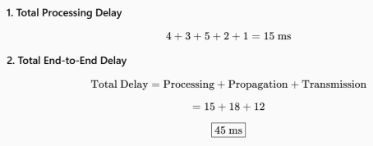Final Answer:
Total end-to-end delay = 45 ms
Contribution of Each OSI Layer:
1. Application Layer (4 ms): Provides network services to the user, such as email, web browsing, and file transfer.
2. Transport Layer (3 ms): Provides end-to-end communication, segmentation, flow control, and error recovery.
3. Network Layer (5 ms): Determines the best path and handles logical addressing and routing of packets.
4. Data Link Layer (2 ms): Frames the data and provides physical addressing and error detection.
5. Physical Layer (1 ms): Converts data into electrical, optical, or radio signals and transmits them through the physical medium.
Propagation delay (18 ms): Time taken for the signal to travel from the sender to the receiver.
Transmission delay (12 ms): Time required to place all the packet's bits onto the transmission link.
Therefore, the packet experiences a total end-to-end delay of 45 ms.
9.A network transfers 80 MB of useful data using frames of 1600 bytes, where each frame contains 80 bytes of protocol overhead added by different OSI layers. Calculate the total number of frames required, the total overhead transmitted, and the transmission efficiency as a percentage. Explain how protocol overhead affects network performance.
SOLUTION:
Given:
● Useful data = 80 MB
● Frame size = 1600 bytes
● Protocol overhead per frame = 80 bytes
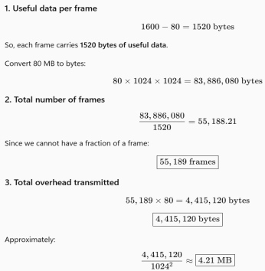
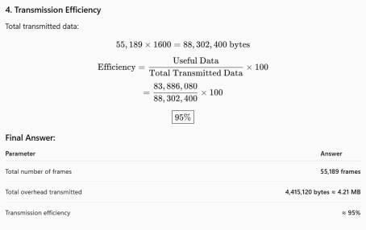Effect of Protocol Overhead on Network Performance:
Protocol overhead consists of additional information such as headers, addresses, error-checking information, and control information added by different OSI layers. It is necessary for reliable and organized communication, but it increases the total amount of data transmitted. Therefore, higher overhead reduces transmission efficiency, consumes more bandwidth, and can increase transmission time. In this case, the network achieves approximately 95% efficiency, meaning about 5% of the transmitted data is protocol overhead.
10.A hospital transfers a patient's medical record of 240 MB through an IoT-enabled healthcare network. The Presentation Layer compresses the data by 30%, the Transport Layer divides the compressed data into 1400-byte segments, and the Data Link Layer adds 60 bytes of overhead to each frame. Calculate the compressed file size, the total number of segments transmitted, the total protocol overhead introduced, and the final amount of data transmitted across the Physical Layer. Explain how multiple OSI layers work together to ensure secure and reliable communication.
SOLUTION:
Given:
● Original medical record = 240 MB
● Compression = 30%
● Segment size = 1400 bytes
● Data Link Layer overhead per frame = 60 bytes
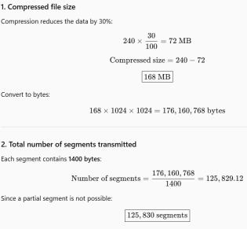
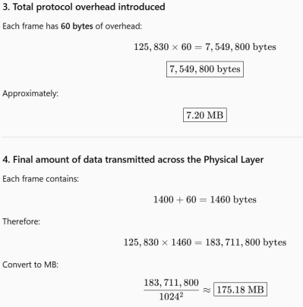How Multiple OSI Layers Work Together:
● Presentation Layer: Compresses the medical record, reducing the amount of data that needs to be transmitted.
● Transport Layer: Divides the compressed data into smaller segments and provides reliable end-to-end delivery.
● Network Layer: Uses logical addressing and routing to find the correct path to the destination.
● Data Link Layer: Adds frame headers and overhead and provides error detection for reliable delivery across each network link.
● Physical Layer: Converts the frames into electrical, optical, or wireless signals and transmits them through the network medium.
Together, these layers ensure that the patient's medical record is efficiently transmitted, correctly routed, reliably delivered, and protected during communication.

