**MINI PROJECT DBMS**

**AIM:**

To make an online website for buying and returning of books between customers and sellers.

**TECH USED:**

FRONT-END:

HTML, CSS, JavaScript, JQuery

BACK-END:

XAMPP, PHP

MySQL

**SCREENSHOTS & EXPLANATION:**

List of **Tables** in the **Database** involved in the project :

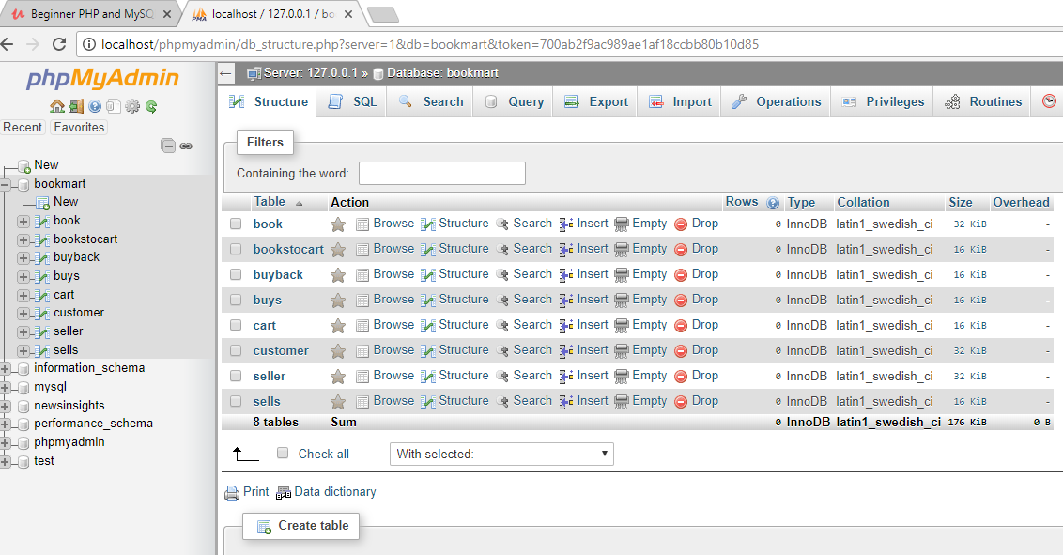

**Home** - User first sees this page on login. Basic data for each book is displayed here for a number of books from the book table.(book name, author, genres)

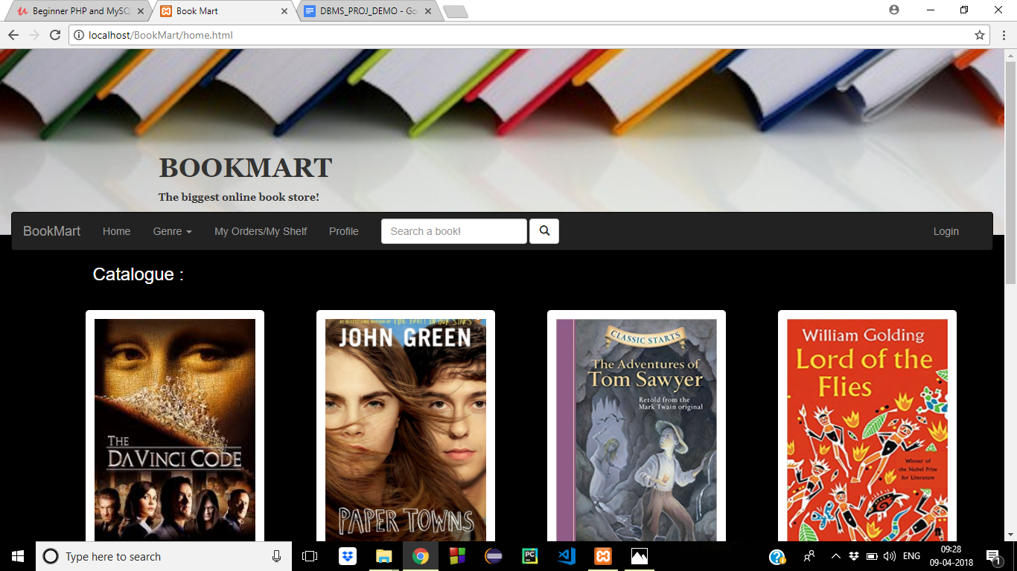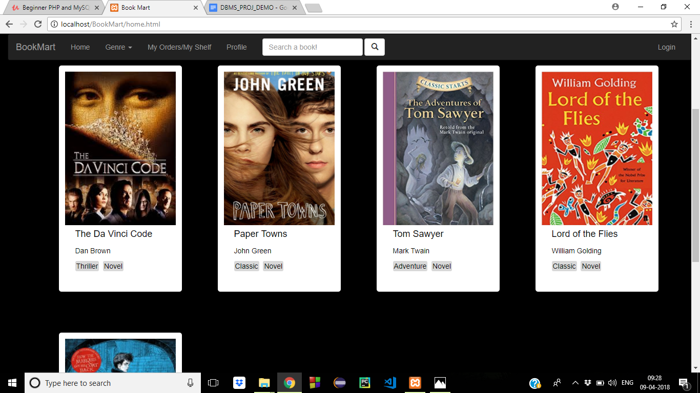

**Book page** - When a book is selected from the home page, this page is opened up. It gives a detailed report of the selected book with the following information - title, author, summary, sellers, price, genre.

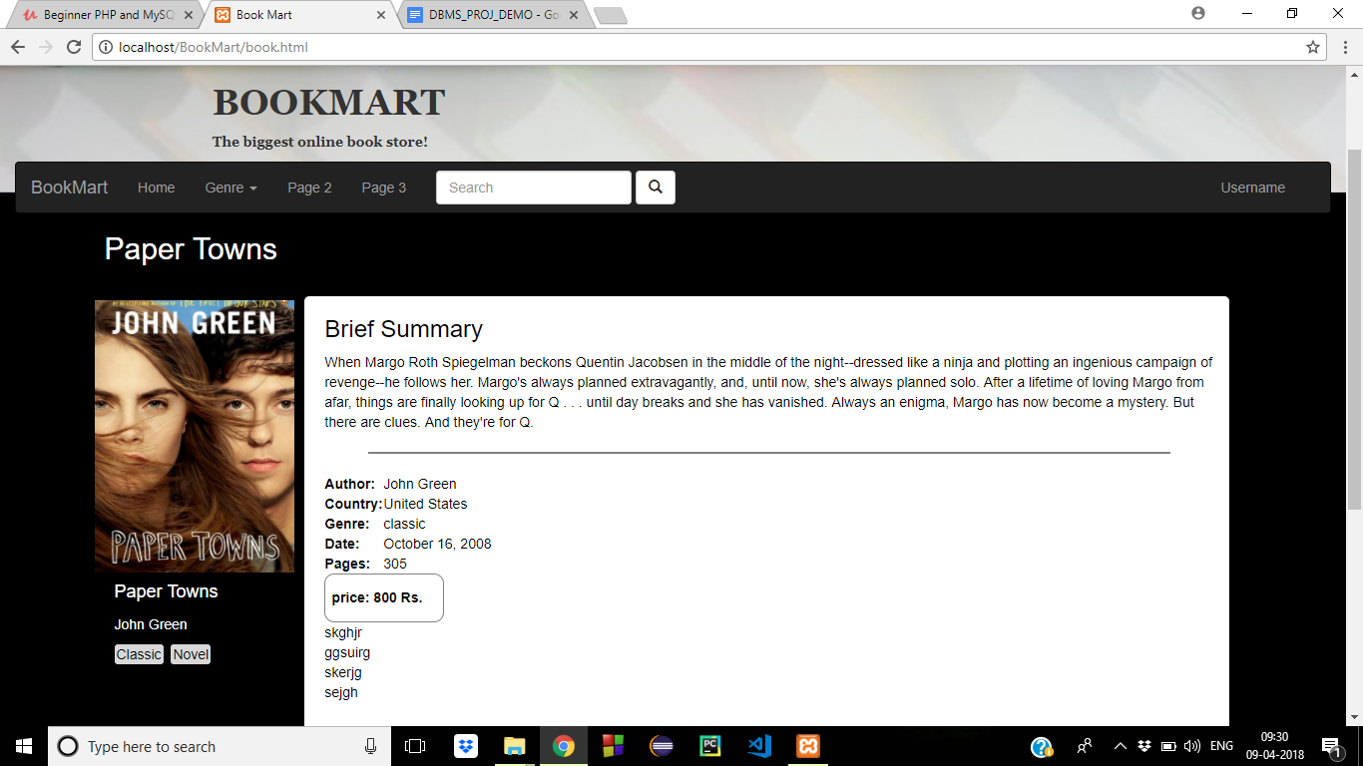

**Orders** - It shows a list of the previous orders that a user has made. The data of each order is extracted from the ‘buys’ table in the Database. Each order depicts its name, author, date of purchase, buying price, seller name, delivery status.

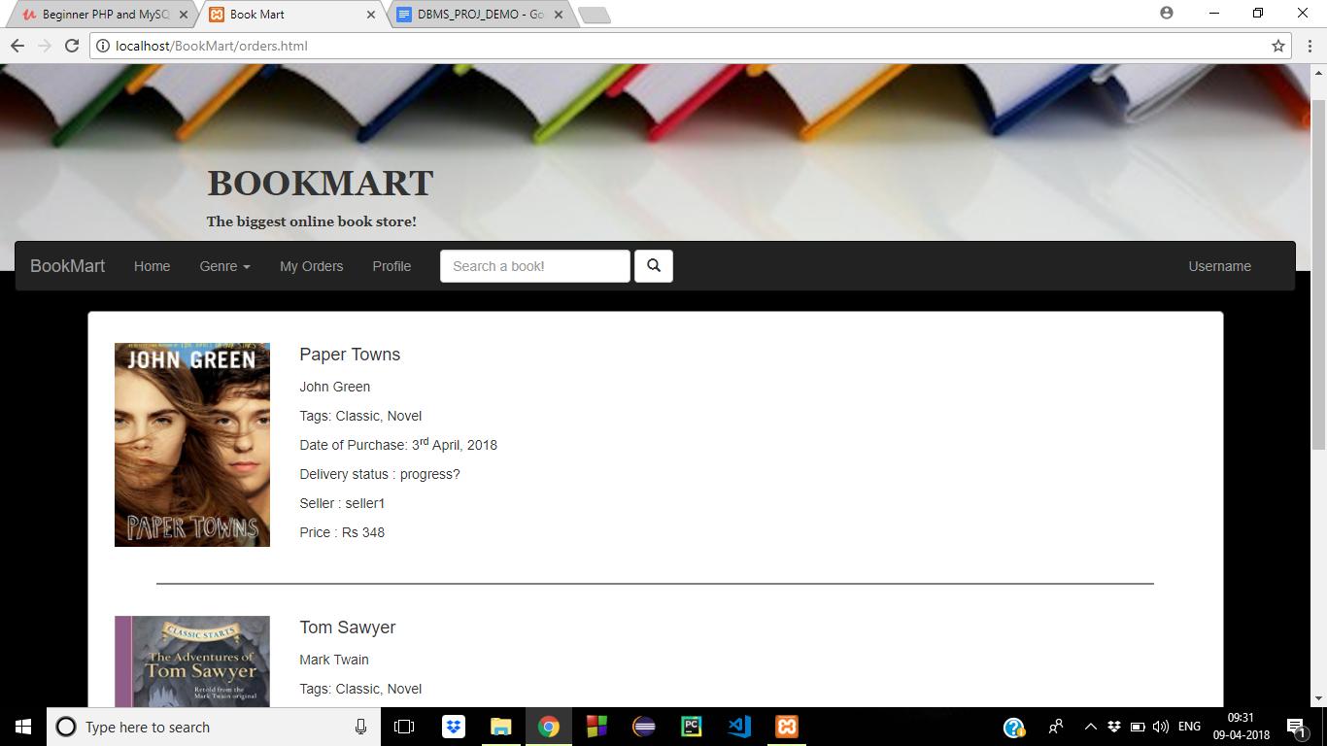

**Profile -**

Only shows information of the particular user like username, address, stars/rating, points in wallet from the ‘customer’ table.

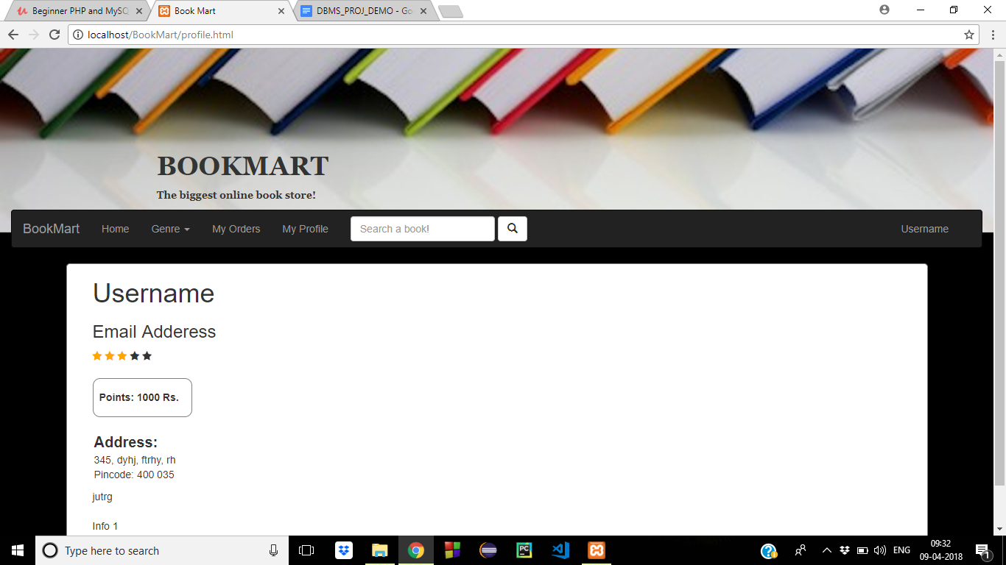

**README FILE:**

This project is made by:

Shloka Sapru - 51

Sarah Sonje - 57

Nikita Tare - 58

Make sure you have XAMPP installed on the PC.

To execute the file, open the ‘bookmart.php’ page first. Click on login and use the following details to login:

For customer - username: user1

Password: password

For seller - username: asdfg

Password: password

And select the respective field for user/seller login.

You have now logged into the pages and can navigate around the site