3x3x3: PLL Recognition Guide
EPLLs
Category 0: Two 3x1 Blocks
solved: 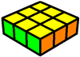
I hope you can recognize this.

Category 1: One 3x1 Block
Ua: 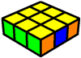 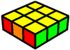 Ub: 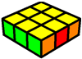 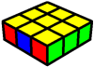
When the block is on the left:
-It's Ub when an opposite edge colour is on the right
-It's Ua when an adjacent edge colour is on the right
When the block is on the right:
-It's Ua when an opposite edge colour is on the left
-It's Ub when an adjacent edge colour is on the left

Category 2: No 3x1 Blocks & At Least One Opposite Edge
Ua: 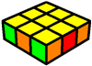 Ub: 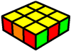 H: 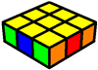
-It's Ua when an opposite edge colour is on the right
-It's Ub when an opposite edge colour is on the left
-It's H when an opposite edge colour is on each side

Category 3: No 3x1 Blocks & No Opposite Edge
Ua: 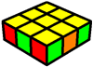 Ub: 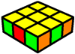 Z: 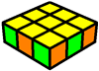 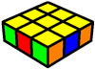
When there are no opposite edges:
-It's Ua when a checker pattern is only on the left
-It's Ub when a checker pattern is only on the right
Otherwise:
-It's Z

Diagonal CP
Category 1: Two Blocks
V: 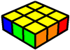 Y: 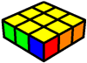 Na: 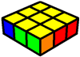 Nb: 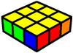
-It's V when the blocks are both on the inside
-It's Y when the blocks are both on the outside
-It's Na when the inner corner is part of a left block
-It's Nb when the inner corner is part of a right block

Category 2: One Block
V: 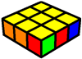 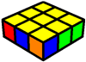 Y: 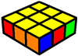 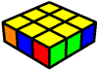
-It's V when there’s a block on the outside
-It's Y when there’s a block on the inside

Category 3: No Blocks
V: 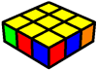 Y: 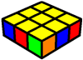 E: 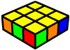 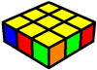
-It's V when there’s a checker pattern on the inside
-It's Y when there’s a checker pattern on the outside
-It's E when there’s no checker pattern at all

Adjacent CP – Two Blocks
Category 1: One 3x1 Block & One 2x1 Block
Ja: 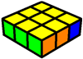 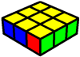 Jb: 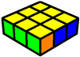 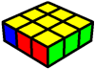
When the 3x1 block is on the left:
-It's Ja when the 2x1 block is on the inside
-It's Jb when the 2x1 block is on the outside
When the 3x1 block is on the right:
-It's Jb when the 2x1 block is on the inside
-It's Ja when the 2x1 block is on the outside

Category 2: One Outer 2x1 Block and One Inner 2x1 Block
Ja: 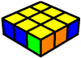 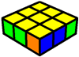 Jb: 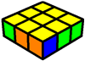 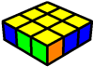
- It's Ja when the 2x1 block on the outside is on the left
- It's Jb when the 2x1 block on the outside is on the right

Category 3: Two Inner 2x1 Blocks
Aa: 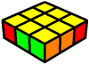 Ab: 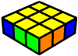
-It's Aa when the outer corner on the right is opposite
-It's Ab when the outer corner on the left is opposite

Adjacent CP – Headlights, One Block
Category 1: Inner Block
T: 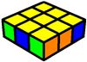 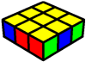 Ra: 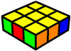 Rb: 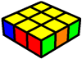
When the edge in between the headlights is adjacent:
-It's Ra when the block is on the right
-It's Rb when the block is on the left
Otherwise:
-It's T

Category 2: Outer Block
Aa: 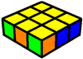 Ab: 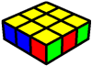 Ga: 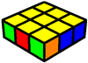 Gc: 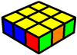
When only three unique colours are visible:
-It's Aa when the block is on the right
-It's Ab when the block is on the left
Otherwise:
-It's Ga when the block is on the right
-It's Gb when the block is on the left

Adjacent CP – No Headlights, One Block
Category 1: One 3x1 Block
F: 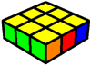 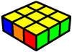
-It's F

Category 2: Inner Block
Ga: 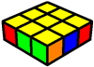 Gc: 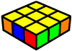 Gb: 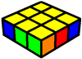 Gd: 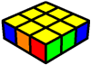
When the corner beside the block is adjacent:
-It's Ga when the block is on the left
-It's Gc when the block is on the right
Otherwise:
-It's Gb when the block is on the left
-It's Gd when the block is on the right

Category 3: Outer Block & Opposite Corner
Gb:  Gd: 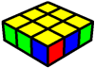 Aa: 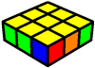 Ab: 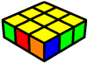
When only three unique colours are visible:
-It's Gb when the block is on the right
-It's Gd when the block is on the left
Otherwise:
-It's Aa when the block is on the left
-It's Ab when the block is on the right

Category 4: Outer Block & Adjacent Corner
Ra: 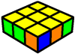 Rb: 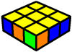 T: 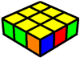 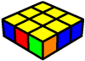
When only three unique colours are visible:
-It's Ra when the block is on the left
-It's Rb when the block is on the right
Otherwise:
-It's T

Adjacent CP – Headlights, No Blocks
Category 1: Opposite Edge In Between Headlights
Gb: 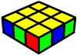 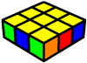 Gd: 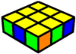 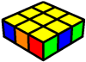
When only three unique colours are visible:
-It's Gb when the block is on the left
-It's Gd when the block is on the right
Otherwise:
-It's Gb when the block is on the right
-It's Gd when the block is on the left

Category 2: Adjacent Edge In Between Headlights
Ra: 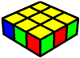 Rb: 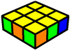
Ga: 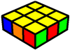 Gc: 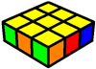 Aa: 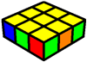 Ab: 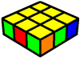
When only three unique colours are visible:
-It's Ra when the headlights are on the left
-It's Rb when the headlights are on the right
Otherwise:
-It's Ga when the headlights are on the right and there is a checker pattern
-It's Gc when the headlights are on the left and there is a checker pattern
-It's Aa when the headlights are on the right and there is no checker pattern
-It's Ab when the headlights are on the left and there is no checker pattern
Adjacent CP – No Headlights, No Blocks
F: 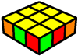 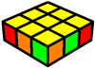
Ga: 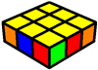 Gc: 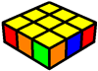 Ra: 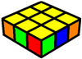 Rb: 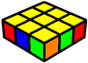
When only three unique colours are visible:
-It's F
Otherwise:
-It's Ga when an opposite outer corner is on the right
-It's Gc when an opposite outer corner is on the left
-It's Ra when an opposite inner corner is on the right
-It's Rb when an opposite inner corner is on the left

