# **Features & user’s stories**

|  |  |
| --- | --- |
| Feature | Search bar |
| Description | Enables users to search in the whole website. |
| user’s story | When user wants to search for specific property to buy or rent he could easily write what exactly he wants in the search bar and easily press enter. |
| As developer | Developer’s role is to update the data base so when users search he could find the latest update |



|  |  |
| --- | --- |
| Feature | Follow us |
| Description | Enables users to follow the company in the social media sites. |
| user’s story | When user wants to know more about the company and follow its social media accounts he would choose which site they want to follow the company and login to their accounts and follow the company’s page. |
| As developer | Developer’s role is to put the link of the company’s profile in the ‘follow us’ bar. |



|  |  |
| --- | --- |
| Features | Navigation bar |
| Description | Enables users to reach any page of the web site. |
| user’s story | In the navigation bar there is **“Home”** button take the user to the home page. |
| user’s story | In the navigation bar there is **“Properties”** button take the user to the page where all the properties available. |
| user’s story | In the navigation bar there is **“Rent”** button take the user to the page where all the properties available just for rent. |
| user’s story | In the navigation bar there is **“Buy”** button take the user to the page where all the properties available just for buy. |
| user’s story | In the navigation bar there is **“Contact us”** button take the user to the page where he could fill the form which make him contact directly with the company. |
| As developer | Developer’s role is to link the pages with their button. |



**Home Page**

|  |  |
| --- | --- |
| Feature | Slider |
| Description | The slider is just a feature that grabs the user’s attention. |
| user’s story | When user open the web site he will find the slider in the home page which make him excited to navigate through the site. |
| As developer | Developer’s role is to design the slider. |

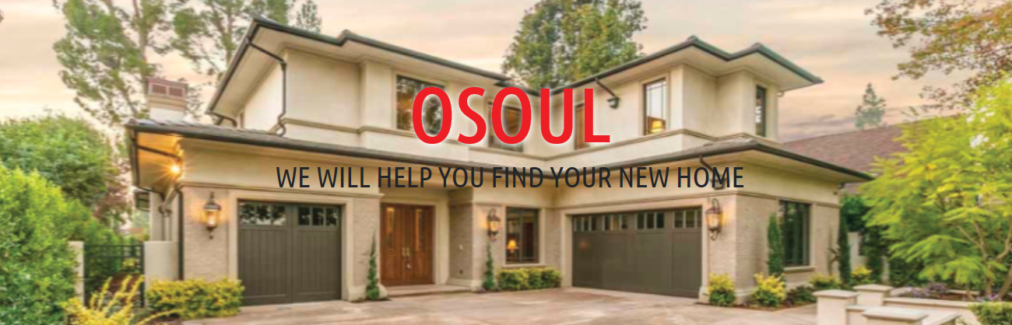

**Properties Page**

|  |  |
| --- | --- |
| Feature | Multiple choices properties |
| Description | Enables users to see all properties that showed to rent or buy. |
| user’s story | When user wants to know more choices of properties and choose the suitable for him. |
| As developer | Developer’s role is to update the database of properties. |

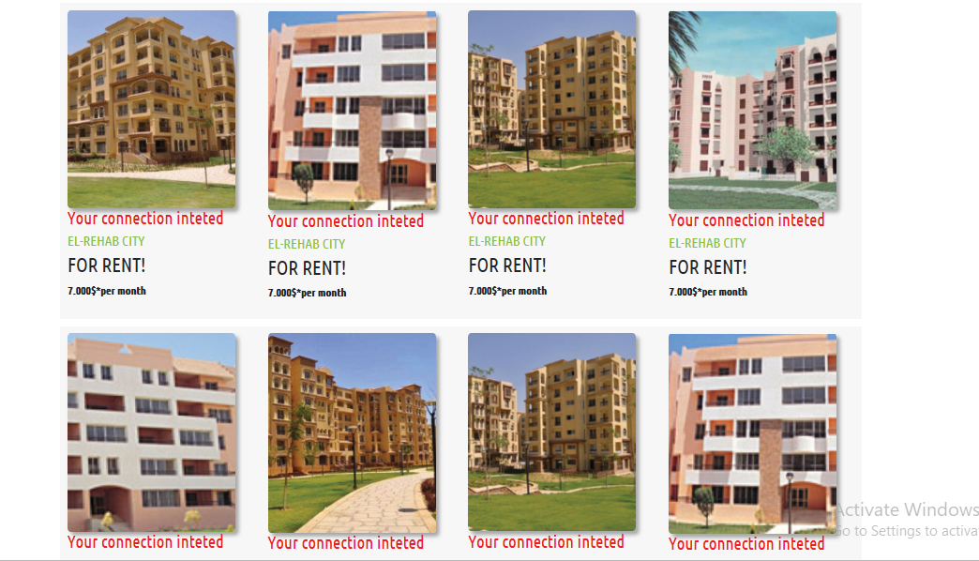

**Rent Page**

|  |  |
| --- | --- |
| Feature | Multiple choices properties |
| Description | Enables users to see properties that showed just for rent. |
| user’s story | When user wants to know more choices of properties which that can be Rent. |
| As developer | Developer’s role is to update the database of properties that can be rent. |

**Buy Page**

|  |  |
| --- | --- |
| Feature | Multiple choices properties |
| Description | Enables users to see properties that showed just for sell. |
| user’s story | When user wants to know more choices of properties which that can be Buy. |
| As developer | Developer’s role is to update the database of properties that can be Buy. |

**Contact us Page**

|  |  |
| --- | --- |
| Feature | Multiple choices properties |
| Description | Enables users to send his information to the country to contact him. |
| user’s story | When user wants to contact with the company and reach the property that he want he will fill the form . |
| user’s story | When user fill the form he will press “send” Button. |
| As developer | Developer link the form to the database and send it to the responsible in company who will contact with the customer. |

