# Department of Computing

**CS-213: Advanced Programming**

**Class: BSCS 7AB**

# Lab 4: Introduction to Node.js

**Date: 26rd September, 2019**

**Time: 10:00-01:00pm & 02:00-05:00pm**

# Instructor: Dr. Sidra Sultana

**Lab Engineer: Ms. Ayesha Asif**

**Sarah Tayyab**

**212902**

**BSCS-7A**

# 

# Lab 4: Introduction to Node.js

**Lab Tasks**

**Task 1:** Download Node.js from the official Node.js web site: [https://nodejs.org](https://nodejs.org/).

**Task 2:** Once you have downloaded and installed Node.js on your computer, let's try to display "Hello World" in a web browser.

var http = require('http');

http.createServer(function(req,res){

res.writeHead(200,{'Content-Type':'text/html'});

res.end('Hello World\n');

}).listen(8080);

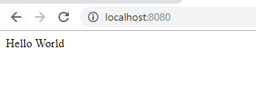

Hint:

Create a Node.js file named "myfirst.js", and add the code.

Save the file on your computer: C:\Users\Your Name\myfirst.js

The file you have just created must be initiated by Node.js before any action can take place.

Start your node.js command line interface, write node myfirst.js and hit enter

**Task 3:** Create a module that returns the current date and time. Save the code in a file called "myfirstmodule.js".

exports.myDateTime=function()

{return Date();};

**Task 4:** Use the module "myfirstmodule" of date and time in a Node.js file.

var http = require('http');

var dt= require('./myfirstmodule');

http.createServer(function(req,res){

res.writeHead(200,{'Content-Type':'text/html'});

res.write("The date and time are:" + dt.myDateTime());

res.end(':(\n');

}).listen(8080);

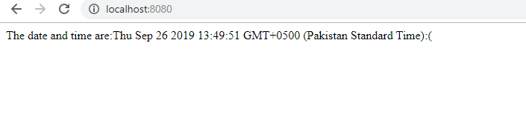

**Node.js as a Web Server**

**Task 5:** The HTTP module can create an HTTP server that listens to server ports and gives a response back to the client. Use the createServer() method to create an HTTP server.

var http = require('http');

var dt= require('./myfirstmodule');

http.createServer(function(req,res){

res.writeHead(200,{'Content-Type':'text/html'});

res.end();

}).listen(8080);

**Task 6:** Add an HTTP Header

Hint: If the response from the HTTP server is supposed to be displayed as HTML, you should include an HTTP header with the correct content type like:

**res.writeHead(200, {'Content-Type': 'text/html'});**

The first argument of the res.writeHead() method is the status code, 200 means that all is OK, the second argument is an object containing the response headers.

var http = require('http');

http.createServer(function(req,res){

res.writeHead(200,{'Content-Type':'text/html'});

res.end('Hello World\n');

}).listen(8080);



**Node.js as a File Server**

The Node.js file system module allows you to work with the file system on your computer. To include the File System module, use the require() method:

var fs = require('fs');

Common use for the File System module:

* Read files
* Create files
* Update files
* Delete files
* Rename files

**Task 7:** Create a Node.js file that reads the HTML file, and return the content.

Html file:

<html>

<body>

<p>Read this file</p>

</body>

</html>

Js file:

var http = require('http');

var fs= require('fs');

http.createServer(function(req,res){

fs.readFile('read.html', function(err, data) {

res.writeHead(200, {'Content-Type': 'text/html'});

res.write(data);

res.end();

});

}).listen(8080);

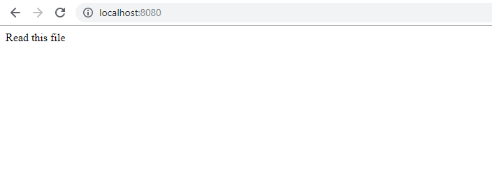

**Task 8:** Create a new file using

* appendFile() method

var fs= require('fs');

fs.appendFile('newfile.txt', 'I Love me!', function(err, data) {

if (err) throw err; });

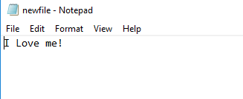

* open() method

var fs= require('fs');

fs.open('newfile.txt', 'w', function(err, data) {

if (err) throw err; });

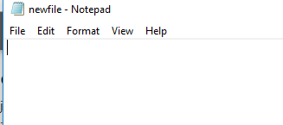

* writeFile() method

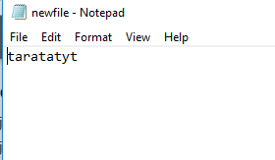

**Task 9:** Append "This is my text." to the end of the file "mynewfile1.txt".

var fs= require('fs');

fs.appendFile('newfile.txt', 'append sarah', function(err, data) {

if (err) throw err; });

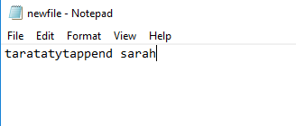

**Task 10:** Replace the content of the file "mynewfile3.txt".

var fs= require('fs');

fs.writeFile('newfile.txt', 'hahahaha sarah', function(err, data) {

if (err) throw err;

});

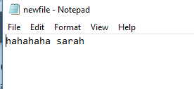

**Task11:** Delete "mynewfile2.txt".

var fs= require('fs');

fs.unlink('newfile.txt', function(err, data) {

if (err) throw err;

});

**Task 12:** Rename "mynewfile1.txt" to "myrenamedfile.txt".

var fs= require('fs');

fs.rename('sarahfile', 'sarahhhfile.txt', function(err, data) {

if (err) throw err;

});

