Sarah Twomey

CS4330

Checkers Data Model Concept

**getPlayers**: Decides if the game with be played by two humans, two computers or one human and one computer.

**namePlayers**: two input strings for the names of the players if they are human.

**getOrder**: the first name string inputted with be player 1 with the black chips. If it is two computer, computer 1 will be player 1.

**generateBoard**: black checkers will be placed on spaces 0-7 and red checkers will be placed on 24-31.

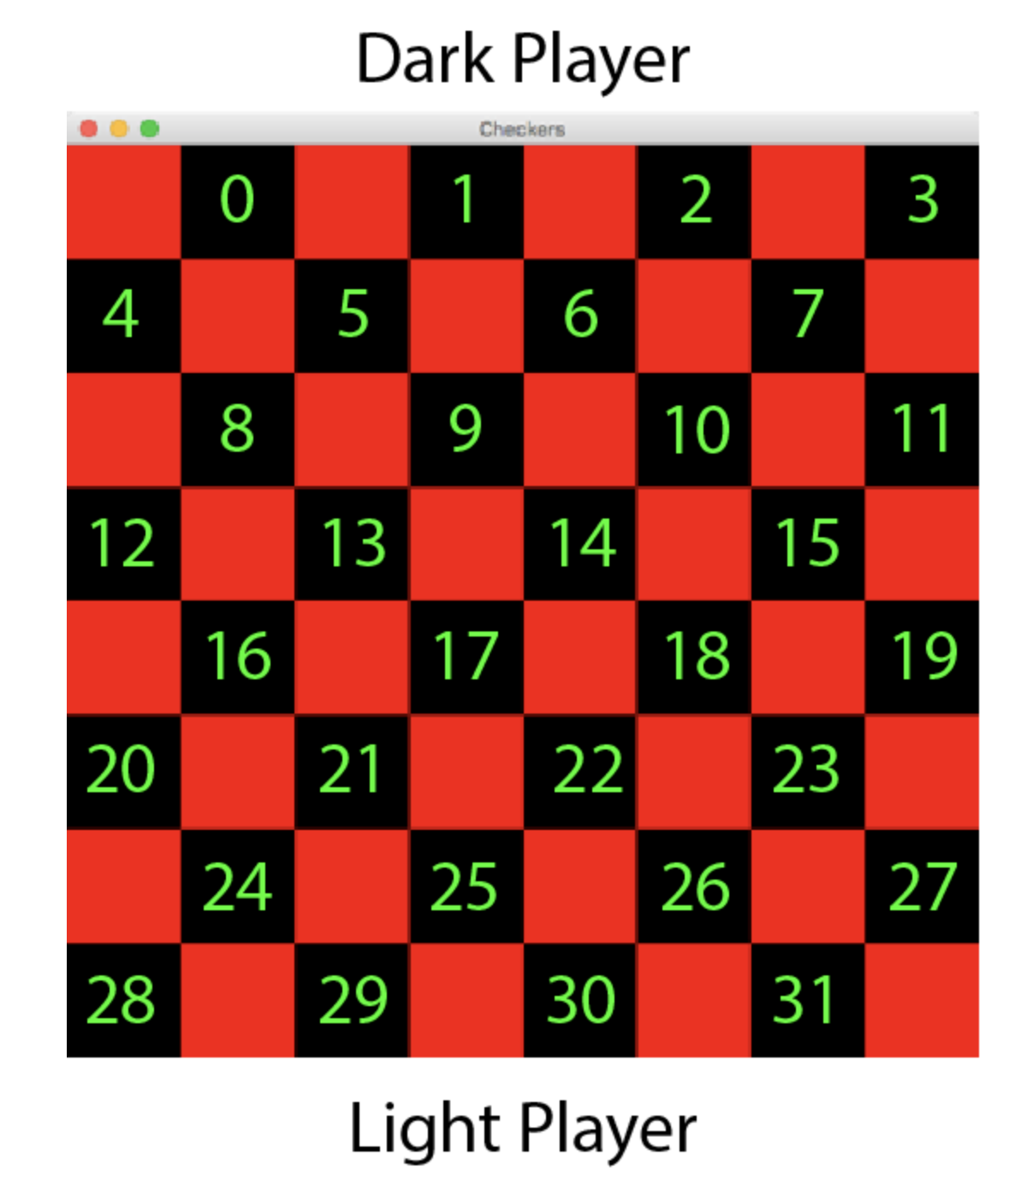

**checkTurn**: a Boolean value that is true when it is player one’s turn and false when it is player two’s turn that is incremented after each turn.

**validMove**: checks to see that the space the checker is trying to go is A) a valid diagonal move and B) if it is occupied by another checker. If there is another checker on that space it will not allow it to go there.

**getPoint**: if a player hops over an opponent’s checker, the checker will be removed and a point will be granted to the player.

**endGame**: the game will end when one player runs out of checkers, the other player will be the winner. If neither player can do anything else to finish the game, a tie will be awarded to both players.