TMA02

General (PT3) comments

Sarah,

Another very good TMA, even if the result is a little lower than on TMA01. You seemed very comfortable with the practical aspects of the work, for example in Part 2. That sort of understanding will also be important in TMA03 and the EMA, so do make sure that you are comfortable with the practical content of TM352 as you work through Block 3.

In general, you covered what was expected well. I have made specific comments in the script on each of the questions. There are also some general points that might also apply for TMA03 and the EMA.

First, exploit opportunities to show 'understanding'. You did that well in the discussion of how virtualisation allows cloud providers to make full use of hardware capabilities. TMA03 and the EMA will probably also expect you to show evidence of understanding. So as you work through Block 3, keep the TMA and EMA in mind and look out for how the module materials apply to the specific situations in TMA03 and the EMA. Some students find that discussing concepts in the forums and online tutorials can help formalise their understanding and clarify concepts in their own mind.

Second, make sure that you are completely comfortable with the technical concepts, and if necessary do some extra research or study. For example, in Part 3 you needed a good grasp of CIDR notation and of the AWS facilities; some of that needed some reading of AWS documents. In Block 3 and in preparing the EMA, try to fill any gaps that you are uncertain on. That will also be good preparation for TM470, the ICT project module.

Finally, it was good to include some references. At level 3, it is assumed that you can use referencing, even if it is not asked for explicitly in a TMA.

As in TMA01, the copy of your script (file with "_marked" added to the end of the file name) includes more detailed comments, with an explanation of the marks. Let me know if something is not clear.

You have built a very good basis for your continuous assessment score; all the best for Block 3!

Mike

Note for assignment handling: Submitted late with prior agreement

Question 1

There are multiple risks and benefits that should be considered when contemplating migration from a traditional hosting arrangement to the cloud. Major benefits of hosting in the cloud include the elasticity of the resources and infrastructure provided by cloud providers, increased system resilience and reliability due to the virtual nature of the machine instances running in the cloud, and reductions in costs relating to hosting activities. Risks associated with cloud computing are generally concerned with the subject of data, particularly personal data and data protection. ✓ good little introduction

It could be argued that, in the right circumstances, one major benefit of adopting a cloud based infrastructure for hosting purposes is the reduction in the costs associated with hosting activities ✓ . This would be of particular benefit to Megamax, as their current IT department is at capacity, meaning that to provide the new portal and order processing application they would have to recruit additional staff members. Cloud hosting would lead to a reduction in time spent by existing staff on deployment activities, such as solving issues, writing deployment code and configuring servers. The cloud takes away the need for these tasks to be carried out in-house ✓ depends to some extent on whether MM go for an IaaS, PaaS or SaaS service model , leading to increased productivity of the existing workforce, and the need to employ less additional staff to develop the new and expanded product offerings that Megamax propose. Savings in costs would also be achieved with the removal of the need to house physical machines on-site ✓ . Cost reductions here will come from savings on the utilities needed to run and house the machines, as well as savings of the cost of the servers and other network equipment themselves, including spares stored to omit single points of failure in the network ✓ . Virtualisation in the cloud means that if a resource fails it can easily be replaced with a new instance, saving the need to have back-up hardware yes and no … MM cannot "replace" failed hardware resources by a VM instance. If MM's one and only hardware server fails, then they have lost that server and virtualisation will not help. If MM have many servers, then they may be able to move VMs around and share VMs on the same hardware.

Cloud providers are able to offer hosting cheaply, as the virtualisation of the servers means that they are able to utilise the full power of their hosting machines ✓ . In-house servers are very often underutilised, and this underutilisation comes at a cost to the business. With the correct architecture in the cloud, Megamax could ensure they are not wasting money on underutilised resources ✓ . The virtualisation means that cloud based applications are highly scalable, again leading to cost reductions for the business ✓ explain how scaling helps reduce costs if workload is variable.

Another monetary consideration of cloud computing is that hosting costs will move from capital expenditure to operational expenditure ✓ . This will aid the finances of the business as they will not need to make large payments for any additional hosting infrastructure for the expanding software offerings, with the costs of the cloud hosting just being treated as another utility bill.

When considering cost implications once a move to the cloud has been undertaken, Megamax must ensure that they are not over-provisioning for the applications hosted there. With costs in the cloud calculated by the resources used, it would be easy to spend money that is not necessary by over estimating the demand for the resources. The usage should be monitored so that the correct setup is in place to avoid unnecessary costs. Thankfully cloud providers make this easy with a dashboard view, and so it should be easy for Megamax to monitor resources. ✓ One concern is that when demand is steady, scaling brings less of a benefit than when demand is highly variable. MM will need to monitor operations, which may require some training / expertise.

Risks of cloud computing include those surrounding the subject of data protection. Personal data in particular is subject to strict legislation, and as the data that Megamax collect regarding orders could be considered personal data, they must consider this legislation before making decisions regarding cloud hosting ✓ . Personal data is data that could be used to identify a living individual, either by itself, or in conjunction with other data that the company may hold ✓ . If Megamax outsource some of their IT provisions, it inevitably means that data will have to leave their premises and reside in databases on a cloud provider’s servers. It is the responsibility of Megamax to ensure that the Data Protection Act (DPA) is adhered to, as they are the data controller, and as such are responsible for the protection of the data ✓ . The cloud provide will be acting as the data processor on behalf of Megamax, but all responsibility for the following of legislation relating to the data will fall at the feet of Megamax ✓ . Cloud providers generally allow the tenant to choose which data centre their physical data resides in, allowing for control over the country, and therefore the legislation that would govern the data that has left their possession. In this way, Megamax will be able to adhere to the DPA by making sure the data is stored within the EEA ✓ .

Megamax must also consider that some of the personal data that they collect will be done so outside of the EEA, by their sales operations in North Africa and the Middle East. This will add additional complexity to the data storage solution as Megamax must ensure that they are adhering to the regulations in place within those regions in relation to data processing. ✓

A benefit of moving hosting, and data, to the cloud is that the cloud provider is likely to have very stringent security measures in place ✓ , meaning the hosting facilities actually prove more resilient to breaches, and protect the data more effectively than if it were to remain in-house. If Megamax had concerns about data leaving the premises, they may consider using an open source cloud product as opposed to a propriety solution, meaning that it could be hosted in-house, therefore reducing the risks of third party data processing ✓ . If the data does leave the premises, then it is the responsibility of Megamax to ensure the data stays protected.

I think it is clear that there are definite benefits and risks that should be considered when deliberating a move to cloud based hosting. It is a major change in practise for any company, and as such Megamax should carry out thorough research around the various points before settling on a cloud hosted solution with a particular provider.

**Word count: 993**

**Part 1**

Good to discuss benefits (mainly around costs) and risks (mainly around data protection). As there are 25 marks available for each of them, it makes sense to balance the text roughly evenly between the two.

Good summary of the scope for savings, touching on virtualisation.

For more marks on benefits, say a bit more about TCO and the kinds of costs that it includes (power, air conditioning, maintenance, resilience, …). Also make a clearer link between virtualisation, elasticity and potential cost savings.

Good to mention that there can be advantages on the data protection side, as reputable cloud providers should have some experience and facilities to help with the international issues and security.

On risks, good to refer to DPA and relate to MM's international plans outside the EEA.

For more 'risks marks'. it would have been good to say more on the responsibilities of data controller and data processor. There is also a risk that MM might not be quite aware of the requirements, so maybe some relevant training would be needed (a cost risk).

Good to mention the risk that cloud costings need monitoring.

(Benefits: 20/25; Risks: 20 /25)

Question 2

a)

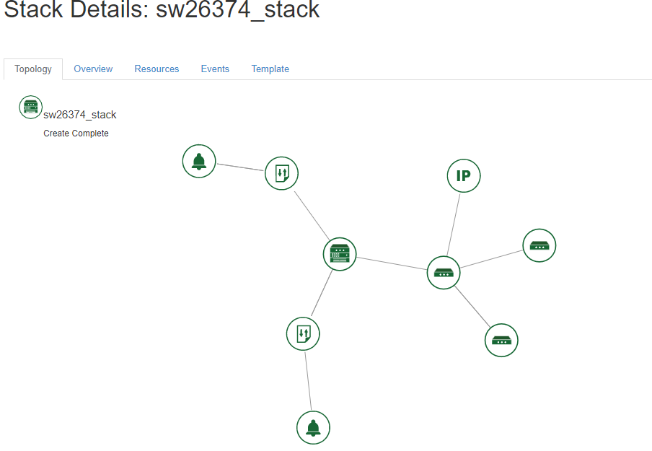

(a)

Good to show the stack topology after the stack has been created; stack named with your OUCU.

(3/3)

b)

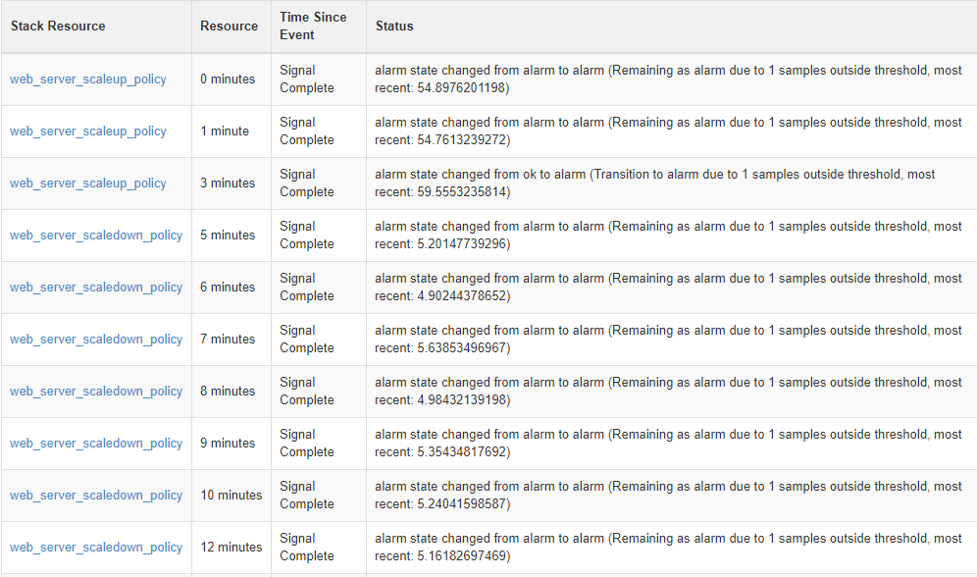

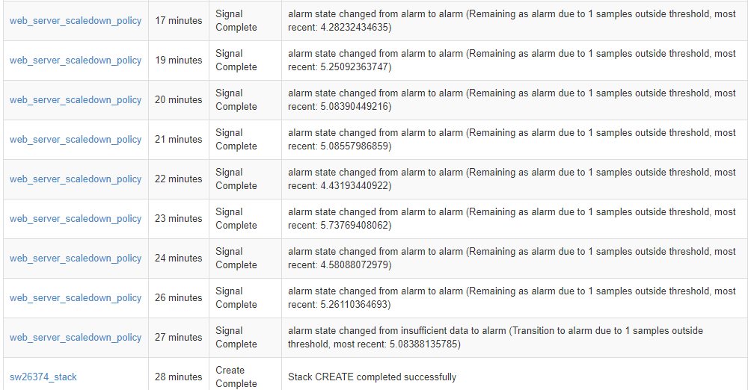

(b)

Good to show the scaling events, from the Stack creation event to the event indicating that the scaleup signal has been completed.

(3/3)

c)

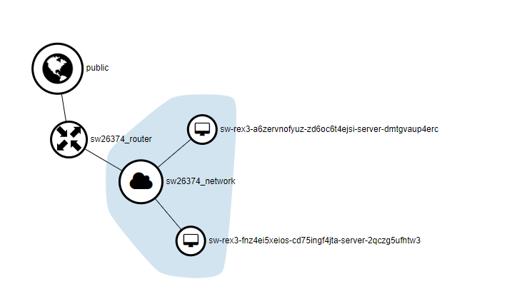

(c)

Good to show the network topology, with two VMs and suitable labelling.

(3/3)

d)

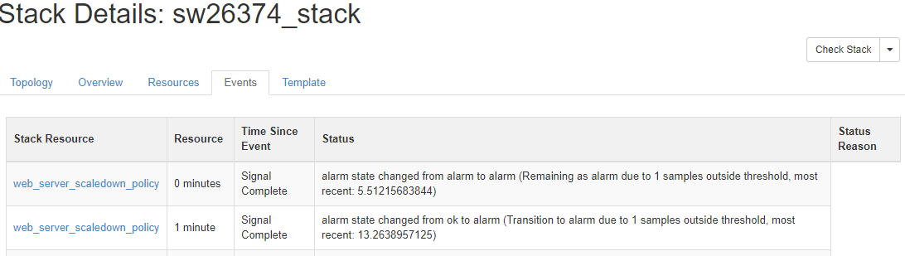

(d)

Good to show the scaling-down events after the load has been removed from the VM, but to be clear evidence, there also needed to be at least one of the scaleup events prior to the load being removed.

(2/3)

Question 3

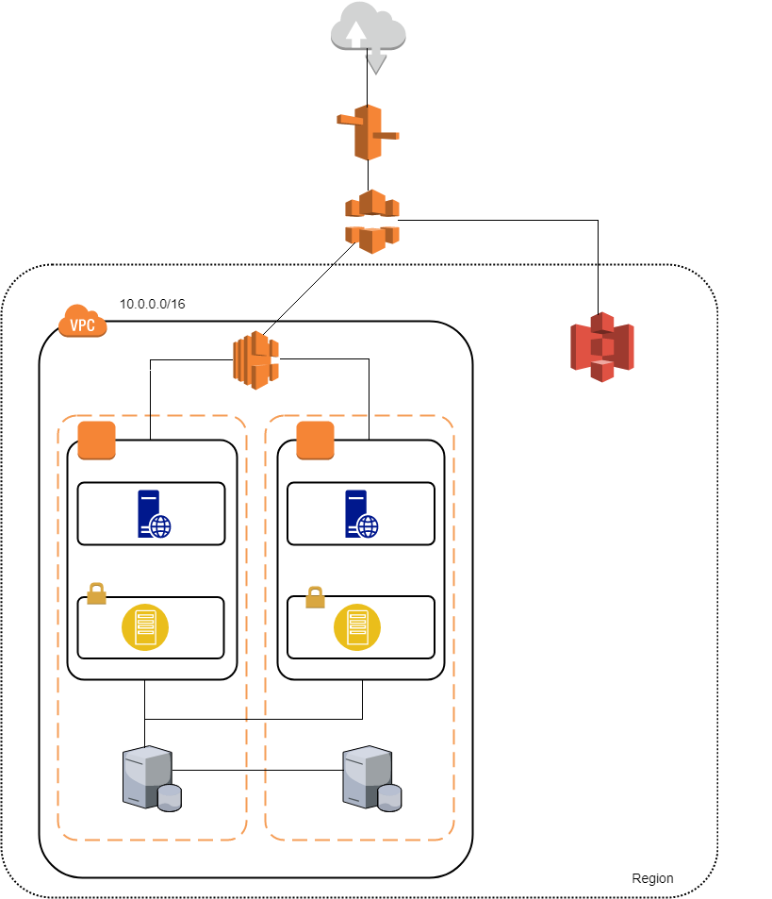

Firstly, I have only included a single region for the 3 different business units to all access ✓ (presumably, "Business Units" refers to Europe, North Africa and Middle East?). This is due to the fact that they should all be using a central database and have the ability to easily access sales information from the other business units, and this would be difficult to achieve using multiple regions specific to each geographical location, as regions are isolated from each other, making it difficult to share data across them. ✓ The added complexity of spreading over 3 Regions would not bring any extra benefit

I have included Amazon Cloudfront and Amazon S3 in the architecture as these would be useful for the file sharing facility of the portal ✓ . The storage of static content in S3 and the caching offered by Cloudfront means that the sales team will have shorter response times when retrieving templates and other information from the portal.

The diagram illustrates a Virtual Private Cloud(VPC), which will be private to Megamax as a tenant on the AWS. ✓

I have chosen to include a single EC2 instance in each availability zone to host both the portal and the order processing application. It seems logical that they are hosted on the same machine as they are closely linked in purpose ✓ The other approach would be to separate the applications so you can scale them independently of each other . To allay fears from Megamax that traffic on the order processing site may affect the portal access of their staff, a load balancer has been included on the architecture. This will allow Megamax to set parameters at which the application should horizontally scale, meaning that when the number of requests gets to a point where the application has been slowed down, a new instance can be spun up, and the load shared until demand is reduced again. The load balancer will distribute requests, and therefore load across the instances ✓ . Within the EC2 instance there is a private subnet containing an app server that will host the services for the order application and portal, and a public subnet containing a web server that will host the application and portal code ✓ but check what is in what: the EC2 instances (VMs) will be on the subnets, not the other way round .

The diagram illustrates resources spread across two different availability zones within the region. This ensures that if resources in one availability zone fail, instances in another availability zone are able to handle the incoming requests, meaning there will be no down-time of the applications (Amazon, 2018). ✓

**Word count: 367**

**Part 3**

Good diagram, showing key elements (though the arrangement of EC2 instances and subnets and servers seems wrong). Good to explain why you have 2 availability zones, and outline what most of the elements do. Ideally also say something about the database and its backup.

For more marks, include more detail on the IP addressing. You used 10.0.0.0/16 for the VPC (which is fine), but the TMA also asked for IP addresses for the various servers and instances. It is easiest to do that by specifying CIDR address ranges for the AZs and subnets. For example, if the two AZs get IP blocks 10.0.0.0/24 and 10.0.1.0/24, then you could subdivide the IP address in each AZ to have for example, the public subnets as 10.0.0.0/27 and 10.0.1.0/27, and the private subnets at 10.0.0.32/27 and 10.0.1.32/27. Then you can allocate sample IP addresses within those ranges. For more details, see <http://docs.aws.amazon.com/AmazonVPC/latest/UserGuide/VPC_Subnets.html> .

Also provide a secure link for MM and the third party service providers, for example a VPN (see here for a scenario: https://docs.aws.amazon.com/AmazonVPC/latest/UserGuide/VPC_Scenario3.html)

( 20 /38)

**References** ✓ good to keep the referencing habit!

ICO.org (n.d) Cloud Computing Guidance for Organisations [online]. Available at <https://ico.org.uk/media/for-organisations/documents/1540/cloud_computing_guidance_for_organisations.pdf> (Accessed 03/03/2018)

Froehlich. A (2015) Cloud Computing : 8 hidden costs, *Information Week*, 8th May [Online] Available at <https://www.informationweek.com/cloud/platform-as-a-service/cloud-computing-8-hidden-costs/d/d-id/1321375> (Accessed 05/03/2018)

Amazon (n.d) Regions and Availability Zones [online]. Available at <https://docs.aws.amazon.com/AWSEC2/latest/UserGuide/using-regions-availability-zones.html>  
(Accessed 04/03/2018)