TMA03

General (PT3) comments

Sarah,

Well done on tackling TMA03 and sticking with TM352 so far! The technical aspects of Q2 were particularly challenging, and you addressed them well; I only had some comments on FR2.1.

You also did very well on the non-coding questions of TMA03. But be careful to cover all the details; you missed out some relatively easy marks in Q4(b) because the features table did not include potential obstacles. The question asked for a similar format as Q1(a).

The EMA, like TMA03, is not only coding, and there are important marks to be had for descriptive answers to some of the questions. So do not get stuck in some aspect of the coding, and leave time for the non-coding work.

In the EMA, include some references. At level 3, it is assumed that you can use referencing, even if it is not asked for explicitly in a TMA or EMA – and keeping in practice will also help with TM470, the ICT project module.

Finally, Chris Thomson, another TM352 tutor, made some useful recordings which will also be relevant for the EMA. They are based on TMA03 Q2, so please do not share them with others who might have an extension on TMA03. I have added his notes with links to the videos in a separate zip-file. There are two recordings:

* Illustrating using chrome://inspect to help track down problems
* Illustrating development of the TMA03 solution.

Chris has based himself on the index_v2.js published in the forum, and has stayed close to that, even though it has weaknesses; specifically:

* It does not wait for DeviceReady (may lead to things not quite working all the time)
* It does not handle the dates correctly: in line 268, I think it should be var d = new Date(start_time); otherwise it uses today's date.
* The address handling is suspect: it seems strange that address is defined as a global variable, and then passed around the functions as parameter - and defining the parameter in the function as "address" really invites confusion between the global scoped variable "address" and the local scoped variable "address". Also when calling updateMap(address); in line 207, I think the code should use the hire_address returned from the match.

Nevertheless, the recordings and Chris's feedback notes are helpful for understanding both TMA03 and the EMA.

As before, the copy of your script (file with "_marked" added to the end of the file name) includes a few more detailed comments, with an explanation of the marks. Let me know if something is not clear. And don't forget to check out the EMA online tutorials, as recordings if not live!

Well done on completing the continuous assessment part of TM352; I hope you enjoy the EMA project!

Mike

Question 1

a.

|  |  |  |  |
| --- | --- | --- | --- |
|  |  |  | **Possible obstacle** |
| **FR1** | Register | OU user can register for the app using the OU user name | Access to the OU user name database might not be available, they may not wish to share this information with another app, or there may be no api available to access the information. |
| **FR2** | Request ride | The user can request a ride share by submitting relevant details to the app | Lack of access to the internet from the mobile device, for any number of reasons, would stop the app connecting to the server and sending the request. |
| **FR3** | Send ride alert | If two users are on the same train, an alert will show indicating the match | The app might not have permissions to send push notifications, meaning that the user may not get immediate notification of the ride availability. |
| **FR4** | Cancel ride request | The user shall be able to cancel any ride shares that they have requested | If the request is not cancelled in good time the ride volunteer may not receive their request before they expect to meet the other person, meaning they wasted time waiting for their ride companion, when the ride isn’t needed. |
| **FR5** | Take picture | The user is able to take a picture with their device and send with their ride request | The device being used may not be compatible with the camera plugin , due to its version of the Android OS being outdated for instance. |

(a) A good set of functional requirements, with relevant and convincing 'obstacles'

(10/10)

b. The code in the index.html file so far is as follows, with the changes that I have made high-lighted in blue.:

<body>

<div class="app">

<h1>Taxi Sharing</h1>

<div data-role="controlgroup" data-type="horizontal">

<div>

Name

<input id="name" type="text" />

</div>

<div>

Start

<input id="time" type="text" />

</div>

<div>

End

<input id="time2" type="text" />

</div>

<div>

Pickup Address

<input id="addr" type="text" />

</div>

</div>

<div data-role="controlgroup" data-type="horizontal">

<button type "button" id="register">Register</button>

<button type="button" id="volunteer">Volunteer</button>

<button type="request" id="request"> Request</button>

<button type="button" id="cancel">Cancel</button>

<button type="button" id="start">Start</button>

<button type="button" id="stop">Stop</button>

</div>

</div>

</body>

(b) Good adaptations to index.html. GUI elements are sufficient to meet the requirements, with no unnecessary elements and elements corresponding to the requirements. Ideally, add callback functions to link with the JS file – they were included in the index.js. Sensible arrangement of input fields and buttons.

(10/10)

c. The body of the index.html file is now as follows:

<body>

<div class="app">

<h1>Taxi Sharing</h1>

<canvas style="width:100%;height:50%;" id="map_canvas">

</canvas>

<div data-role="controlgroup" data-type="horizontal">

<div>

Name

<input id="name" type="text" />

</div>

<div>

Start

<input id="time" type="text" />

</div>

<div>

End

<input id="time2" type="text" />

</div>

<div>

Pickup Address

<input id="addr" type="text" />

</div>

</div>

<div data-role="controlgroup" data-type="horizontal">

<button type "button" id="register">Register</button>

<button type="button" id="volunteer" Volunteer</button>

<button type="request" id="request" Request</button>

<button type="button" id="cancel">Cancel</button>

<button type="button" id="start" >Start</button>

<button type="button" id="stop" Stop</button>

</div>

</div>

</body>

After building the app, the interface showing in the app is:

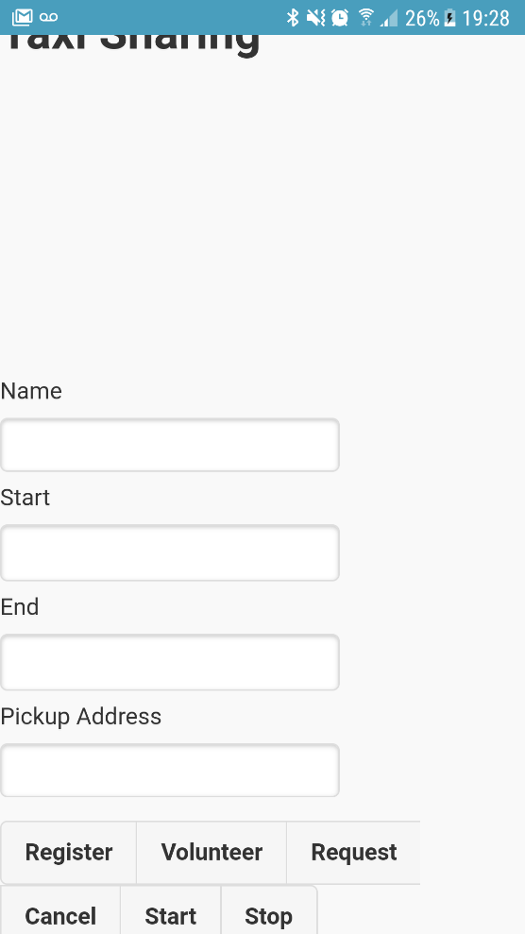

(c) Good to add canvas code and provide a screenshot.

(5/5)

Question 2

Code for FR 1.2

this.volunteer = function () {

var oucu = get_name_value('name', 'user1');

address = get_name_value('addr', "Open University")

var start_time = get_name_value('time', format(new Date()));

var end_time = get_name_value('time2', 1);

// compute the date of the next end_time hours

var d = new Date();

d.setHours(d.getHours() + end_time);

var ends = format(d);

$.post('http://137.108.93.222/openstack/taxi/orders', {

OUCU: oucu,

start: start_time,

end: end_time,

type: 0,

address: address

}, function (data) {

var obj = $.parseJSON(data);

if (obj.status == "fail") {

alert(obj.data[0].reason);

} else {

alert('Taxi has been volunteered');

}

});

}; 4/4 marks for this FR

4/4 marks for this FR

Code for FR 1.3

this.request = function () {

var oucu = get_name_value('name', 'user1');

var address = get_name_value('addr', "Open University")

var start_time = get_name_value('time', format(new Date()));

// Post the details of start time, the address and the type to the orders API

$.post('http://137.108.93.222/openstack/taxi/orders', {

OUCU: oucu,

start: start_time,

type: 1,

address: address

}, function (data) {

var obj = $.parseJSON(data);

if (obj.status == "fail") {

alert(obj.data[0].reason);

} else {

alert('Taxi share has been requested');

}

});

};

4/4 marks for this FR

Code for FR 2.1

var oucu = get_name_value('name', 'user1');

$.get('http://137.108.93.222/openstack/taxi/matches?OUCU=' + oucu,

function (data) {

var obj = $.parseJSON(data);

if (obj.status == "fail") {

alert(obj.data[0].reason);

} else {

if (obj.data.length > 0) {

var parsedData = $.parseJSON(obj.data)

var add = parsedData[0].hire_address

$.get('http://nominatim.openstreetmap.org/search/' + add + 'format=json&countrycode=gb',

function (result) {

let parsedAdd = $.parseJSON(result)

updateMap(parsedAdd[0]);

});

}

}

});

4/5 marks for FR2.1. You should be able to work with obj from the 4th line in your image above, there is no need to parse that again to produce parsedData in line 9. Instead, line 10 could be

var add = obj.data[0].hire_address;

If you then do:

alert(“Match address= “ + add);

you should get the address of the match (which is then input to Openstreetmap).

The Openstreetmap lookup is probably better done as part of FR2.2, because you are beginning to manipulate the ‘logical’ matching address to display the map marker.

You can do the OSM in FR2.1, BUT: there is a ? missing before the format=json&… As a result the OSM does not reply with a json object but with HTML, which then does not work later on with FR2.2. The call to OSM should have been:

$.get('http://nominatim.openstreetmap.org/search/' + add + '?format=json&countrycodes=gb'

As OSM responds with a JSON object, you do no need to parse it, and can use result[0] directly.

Code for FR 2.2

if (address != undefined) {

// FR2.2

var meetingLocation = new plugin.google.maps.LatLng(address.lat, address.long);

map.addMarker({

'position': meetingLocation,

'title': "Pickup point"

}, function (marker) {

marker.showInfoWindow()

});

}

Screenshot of the app running, showing pickup point on the map

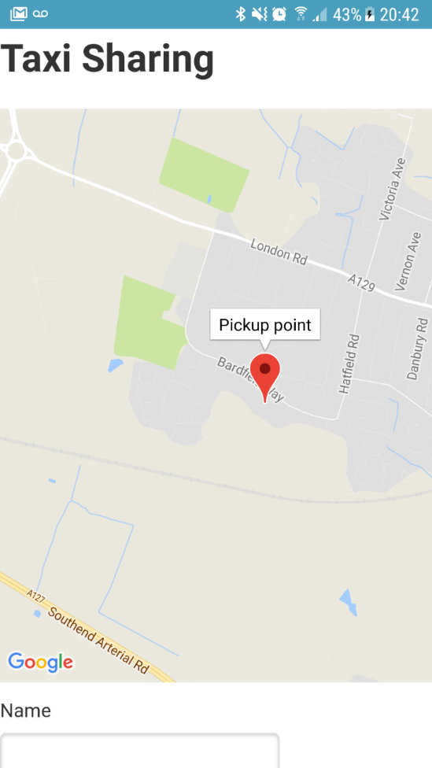

5/5 marks for FR2.2 code, and 2/2 for providing the screenshot - though I confess that I could only get the marker to work with your www if I made the changes n FR2.1 above.

Good set of code for the four FRs, but see comments on FR2.1 and FR2.2. Good to include screenshots of running app.

(19/20)

Question 3

1. **FR4 –** When requesting or offering a ride share, the user shall be able to add an image taken with their device’s camera, so that each party in the ride share are able to identify each other.

The following market research was carried out to determine whether the enhancement was useful:

|  |  |
| --- | --- |
| **App** | **Feature Present?** |
| Aya carpooling | Y |
| BlaBla Car | Y |
| Cab with me | Y |

The rationale behind including this additional feature in the app is to improve the user experience, and the ease with which they can achieve the outcome they want from the app. Including an image will ensure that users of the app are able to identify each other easily. Based on the research I carried out, the feature is already widely used in other apps, and therefore I think it would enhance the functionality of my app in this case.

(a) Good to specify the requirement and describe why the features can be valuable to the user. Good to provide evidence of some market research (specifically, to compare with the user experience offered by other apps).

(6/6)

1. My first port of call when selecting an appropriate plugin was the official Cordova plugins store. I felt that this was the most suitable place to find the plugin as they are well documented, meaning implementation will hopefully be straightforward, and it is easy to search and sort possible plugins to find the most suitable. Within the store I selected only plugins that support the Android platform, and then sorted by number of downloads to get an idea of popular features that the community are adding to their apps. One choice of plugin that I considered was that of a spinner, to indicate when the app was busy calling the API’s. I have experienced slow response times myself while testing the app, and thought this would be a good feature for user experience, but wasn’t certain whether this would be considered an enhancement, rather than a requirement. I then settled on using the camera plugin as the ability to add a picture is mentioned in the original description of the app, and it felt like a useful feature for the app to include.

(b) Good to consider a range of Cordova plugins, identify which plugin seems to be most suitable and to outline the rationale for your choice.

(6/6)

1. The user would use this feature to add an image when they submitted a request or volunteered for a taxi share. The image would enable the users to identify other users that they have matched with in the app. The code I used to implement this feature is:

Index.html

<button type="button" id="photo" onClick="app.taxiShare.takePhoto()">Add Photo</button>

<img style="width:50%;height:20%;" id="photo_image" />

Index.js

this.takePhoto = function () {

var cameraSuccess = function (imageData) {

var image = document.getElementById('photo_image');

image.style.display = "block";

image.src = imageData;

};

var cameraError = function () {

console.err("Problem in getting the camera picture");

};

navigator.camera.getPicture(cameraSuccess, cameraError, { quality: 50 });

}

The code in index.html defines two new elements, the first of which is a button that opens the camera on the device. The second is a blank image tag, that is used to display the image once it has been taken with the camera. The code in index.js is triggered when the button is clicked. It accesses the camera in the device using an API exposed by the plugin that has been used. If it successfully takes a picture it is set as the source of the new photo_image element. If there is a failure while taking the picture an error is logged to the console stating this.

(c) Good to include the code for integrating the plugin, to outline how the code works and how the user would use the features provided by the plugin.

(6/6)

1. The app runs as expected, and I am able to take a picture with the app using the ‘Add Photo’ button. Although this part of the functionality worked ok, I am unable to submit the request including the image to the server, as the API would need to be amended for this to be possible. For this reason, I wasn’t able to fully implement the FR4.

(d) Good to summarise the results of testing the enhanced app and to include a screenshot.

(2/2)

Question 4

a.

|  |  |  |  |  |  |
| --- | --- | --- | --- | --- | --- |
| **App** | Add Text | Add image | Add video | Plan Upcoming trip | Share to social media |
| Travel Diary  (e250 Apps) | Y | Y | Y | N | N |
| Travel Diary  (Just Rose Travel Diary) | Y | Y | N | N | N |
| VOLO – Your Travel Journal | Y | Y | N | N | Y |
| journi | Y | Y | N | N | Y |

(a) It would have been good to describe it briefly (one sentence) in this first section.

Good little features table, with a good number of features and competitors. Did you include your app as a row in the table?

For a perfect score here, also identify some feature gaps that your app would fill. (I am guessing it is the ability to plan a trip?)

(4/5)

b.

|  |  |  |
| --- | --- | --- |
| **FR1** |  | The app facilitates the addition of an entry to a travel journal. |
|  | FR1.1 | A user can enter a text entry of varying length, to record details of a particular day of travelling/holidaying |
|  | FR 1.2 | A user can upload multiple images to the journal entry to accompany the text |
|  | FR 1.3 | A user can upload short video clips to the journal entry to accompany the text |
| **FR2** |  | The app shall allow a user to share any diary entry via email, or on social media platforms |
| **FR3** |  | The app can facilitate the planning of upcoming trips, using the planner feature |
|  | FR 3.1 | A user can upload email confirmations for travel arrangements, booked excursions etc in a central place |
|  | FR 3.2 | Routes can be planned using a map to plot points |

(b) Good set of requirements, which look feasible.

For more marks, also identify obstacles, as in Q1(a)

(7/10)

c.

The proposed app would be used by travellers/holiday-makers who want to plan and keep a record of trips they have taken. It would also allow them to plan upcoming trips using a planning feature, that would facilitate the creation of travel itineraries. Users can create trips, and then within the trip, daily entries can be created of the activities they carried out that day. The entry can include text, images and short video clips. Users would then be able to share diary entries via email, or social media platforms.

(c) Good description of app for potential users, covering its purpose and key features

(5/5)

d.

Some wireframes showing an initial layout are shown below. The first is the main dashboard area where users can see the individual trip journals that they have created, as well as adding a new journal entry for a trip, or creating a new trip. The second screen shows the journal entry screen, and would be accessed by clicking the + icon for the trip that we wanted to add to.

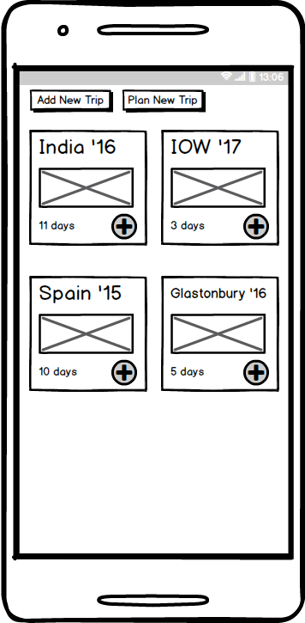

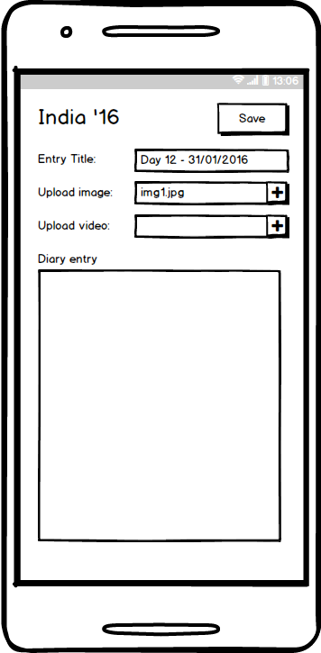

(d) Good set of wire frames, making good use of the screen space and taking account of the form factor. UI elements are appropriate and support the functional requirements

(8/8)

1. Feedback regarding the concept and initial design of the application were very positive, and both interviewees said that they would be very likely to download and use the app if it were created. One interviewer “interviewee” said “It sounds really good, I would definitely download it”, and another said “I have actually been looking for something like this and haven’t been able to find anything good, it would be really useful”. Feedback on the initial wireframes was generally positive, with it seeming clear how to interact with the app. I did however receive suggestions for improvements to the app. The first suggested including the ability to add a map point to a diary entry, and the second that it was missing a way on the dashboard to navigate to future trips that were already in the planning stage. There is a button to create an upcoming trip, but no way to access these trips to view plans. Overall the response seemed very positive to the app.

(e) Good summary of your survey, including quotes and the overall conclusion, summarising the views of the interviewees.

(7/7)