Sarah Walker TM356 TMA03

Question 1

1. The idea of this design is loosely described by comparing it to ‘pillow talk’, although this design is specifically attempting to facilitate the sharing of good-night messages between couples who are geographically separated rather than in the same place.
2. One task the user will carry out is that of recording and saving a message, with the possibility to review that message to determine its suitability. The tasks that the recipient of the messages will undertake include listening to the message, with the option of retaining the message if required.
3. The user experience relies on the recipient of the message being notified if there are no messages available for them to receive. It also relies on the user being able to easily retrieve available messages, as well of the sender of the message being able to record and review it in an efficient manner.

**Word count: 146**

Question 2

1. There are parts of the sleepyWhispers interactions that would fall under the web type of interface, as they are carried out on a PC or mobile. These interactions are the recording of the messages. I think the interface type that best describes the interactions concerning the retrieval of the sleepyWhispers messages is that of a wearable interface, although I don’t think it strictly fits in to this category. I have chosen this interface as I believe it fits in to the category of an interaction that integrates into a wider human activity, namely the activity of going to bed. The interface components of the photo frame and pillow are everyday objects in the home and are unobtrusive to the user and their everyday activities, they simply provide an enhancement to existing objects. Although a pillow is not technically wearable as a garment, I believe it could fall under the category of a smart textile, as the speaker is integrated in to the pillow.
2. The sleepyWhispers interaction could also have been achieved using a mobile interface. A smartphone could be used to record the message via an app, and the message receiver could also play the messages using the application. They could still be spoken using the speakers in the device, and the option to download the message could also be provided by the application. Due to the mobile nature of the device being used the same ‘pillow talk’ type experience could still be achieved as the messages could be played while the user is in bed, or in any other location they may choose.

**Word count: 266**

Question 3

The interaction design project that I am working on is the design of an interface which enables the control of various smart devices throughout a users’ home. Its purpose is to provide one central location where the user can control and configure several types of devices, which could include light bulbs, smart plugs, central heating devices or home security devices. Initial requirement gathering activities concluded that currently there is not a ‘one app fits all’ when it comes to the control of certain devices, and I aim to provide a solution for this.

The requirements that I have identified so far are that the interface should provide a list of the smart devices that are installed in the user’s home and allow each of these devices to be selected to provide options for its control. Further requirements are the needs to be able to change the state of the device, between on and off, to be able to set the brightness of smart bulb devices, and to be able to set up timers and scheduled actions for the bulbs, so that they do not always have to be turned on or off manually.

**Word count: 193**

Question 4

The overall concept of the interaction design is the control of the state of smart home devices, as well as being able to configure properties of the devices.

The anticipated environment where the interaction may take place is variable, and could either be inside the user’s home, office or other inside environment, or in an outside area which could be changeable.

The concepts and objects of the interaction are smart devices, specifically light bulbs, plug switches, security devices such as burglar alarms, CCTV cameras and smart doorbells.

The actions that can be carried out are selecting a device, viewing and changing the state of the selected device, setting timers that change the state of the device at a designated time, and configuring other device settings, such as the dimness and colour of the light produced by a smart light bulb.

The user experience goals are that the interface allows efficient navigation between various devices, that it is easy to determine the current state of the device and change it as efficiently as possible. Where devices with multiple configurable options are concerned the user experience depends on the interface being precise and uncluttered, and providing indications of what actions can be performed without the need for lengthy instructions.

**Word count: 207**

Question 5

The interface type that best fits the interactive product is a mobile interface. The product needs to be accessible to the user in multiple locations, meaning that a mobile interface will be best able to facilitate this need. The choice of this type of interface means there is not an abundance of screen space to provide detailed instructions on how the users tasks can be achieved, but by ensuring the use of standard mobile controls it should not take the user long to develop an accurate mental model of how the interface works. The anticipated users of the interface should be experienced mobile devices users, and so should have the ability to use the interface even with minimal instructions provided.

**Word count: 120**

Question 6

The storyboard that I have created is shown below

1.

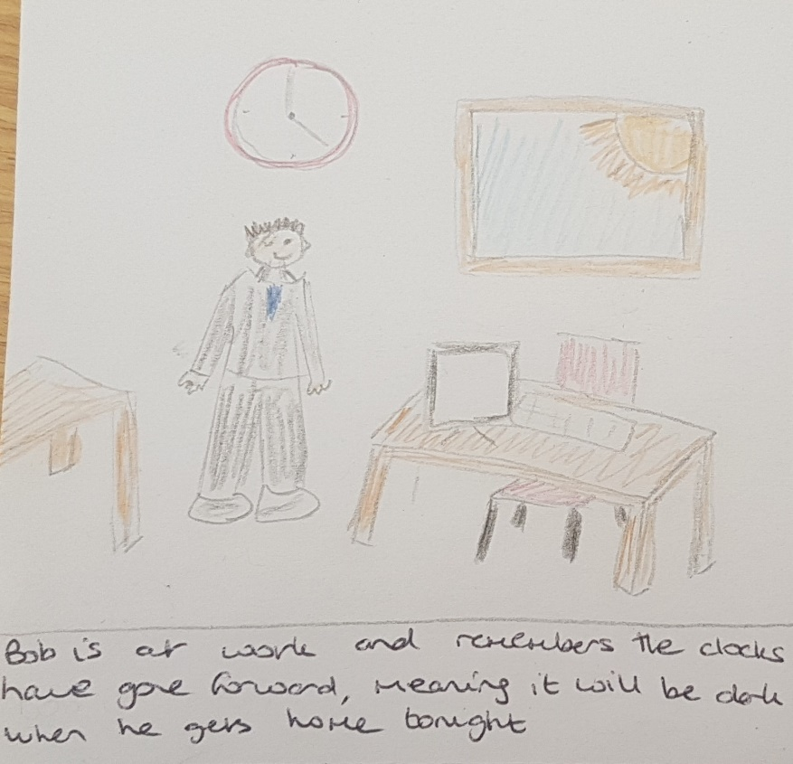

2.

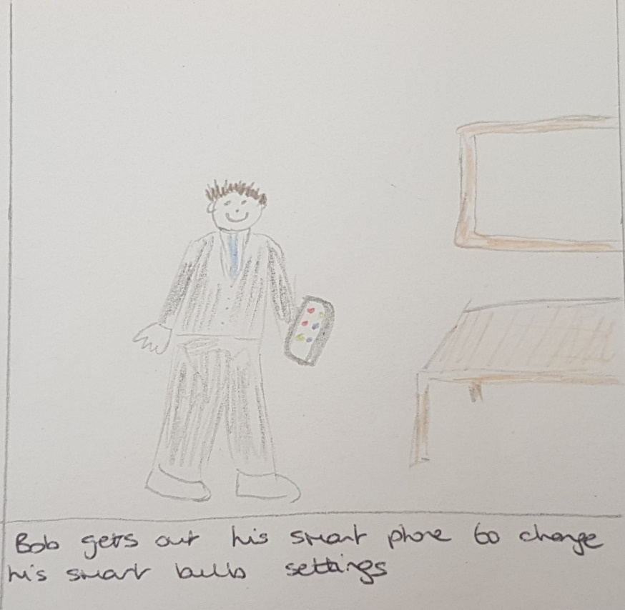

3.

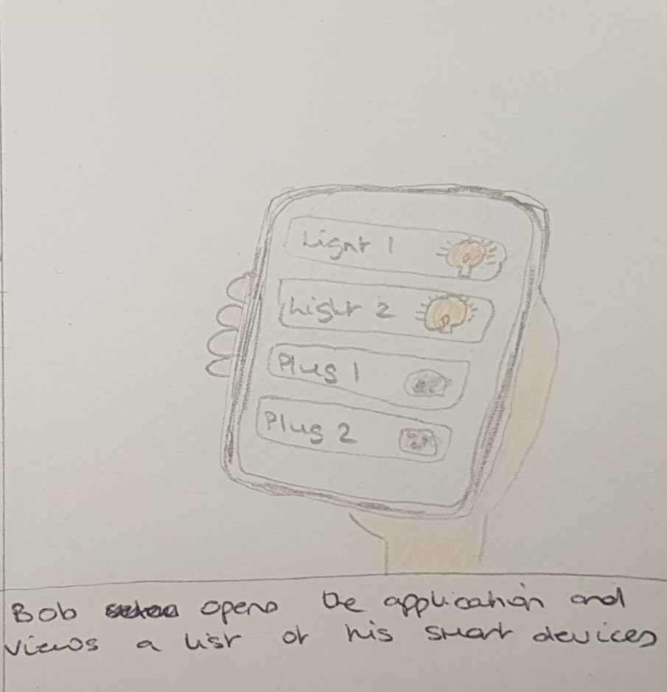

4.

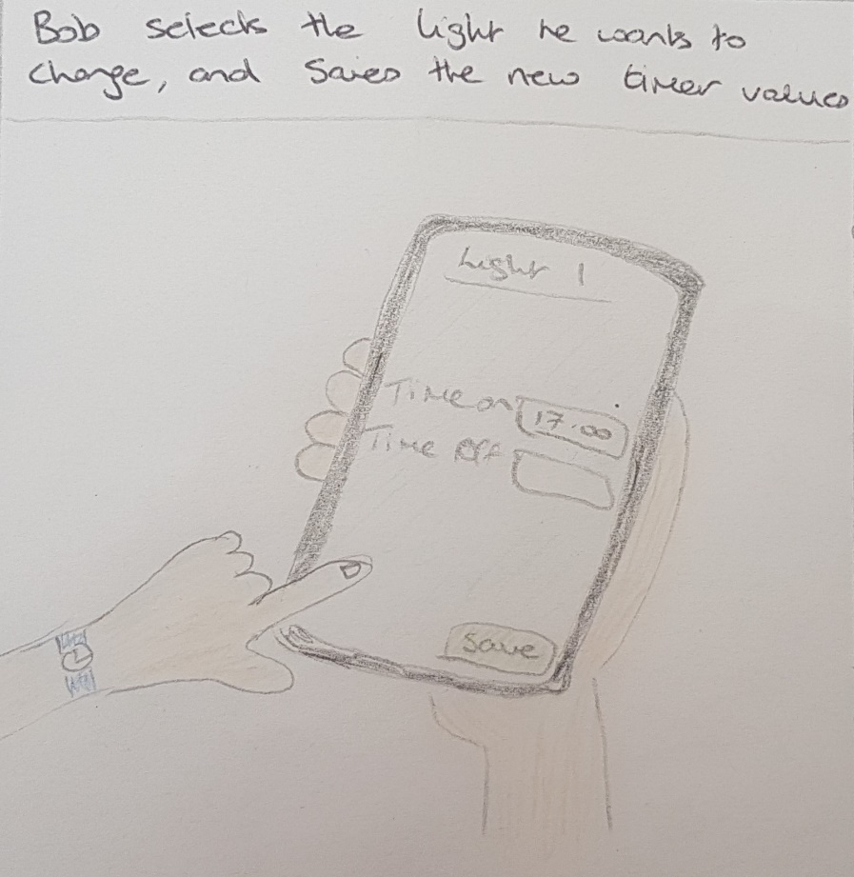

5.

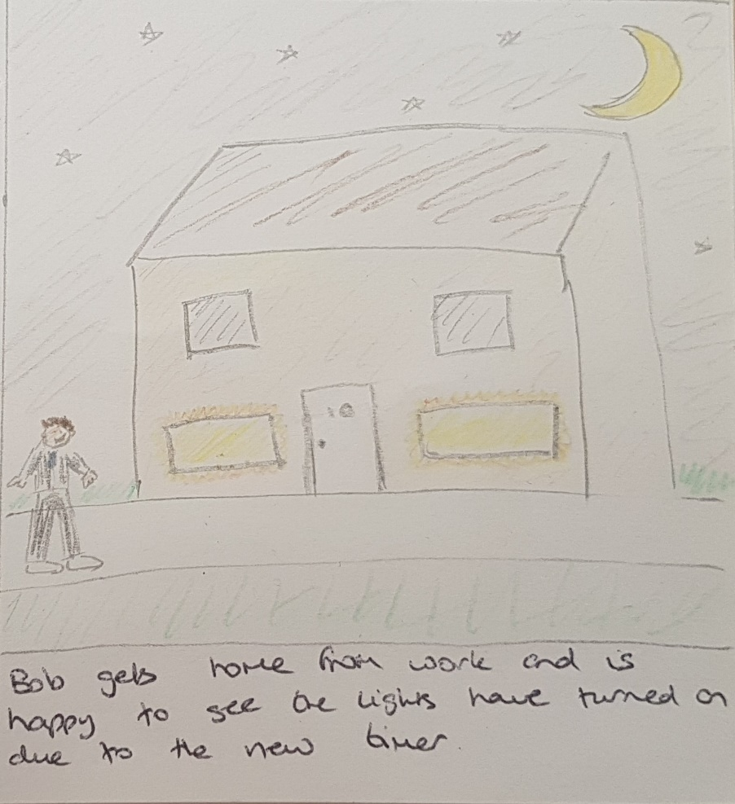

Question 7

The user is first provided with a list of the devices they have connected to the application. They must select a device using the touch screen of the device to then view the available actions for that device.

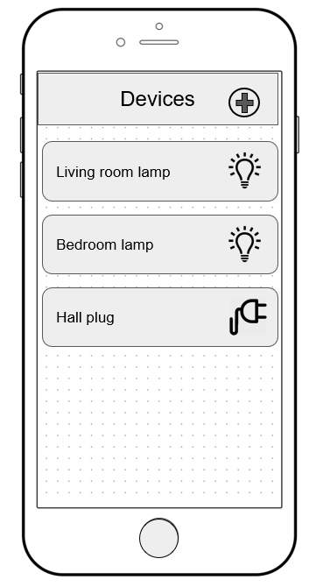

If selecting a light bulb, the user is shown an interface demonstrating the current state of the lightbulb, which is indicated with an icon. The user can tap the icon to turn the light on or off. There is also a slider control to adjust the brightness of the light, which can be slid to different values using the touch screen. There is a colour scale slider also controlled by touch which can be moved to change the colour of the light. On the lower half of the screen a list of device timers is shown, and the user can touch the edit button for any timer to adjust the parameters on another screen.

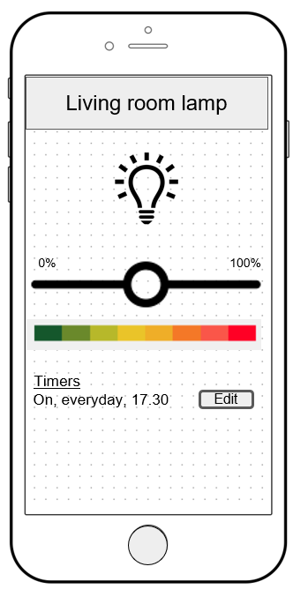

On the edit timer screen the user is able to toggle whether the light should be on or off, enter the time in the provided text box control, and select the days of the week the timer should apply by selecting the calendar icon in the text box.

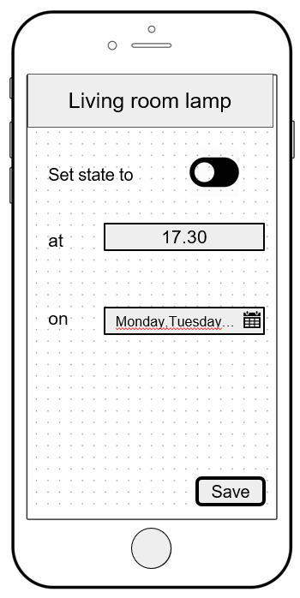

The user can select the days of the week the timer applies by checking or unchecking the relevant checkbox. Once all the required days are selected the save button saves the choices and closes the modal. Then the time can be saved with the save button on the timer screen.

