Sarah Walker B4050530 TM356 TMA04

Question 1

I think that this website does comply with the heuristic of using “progressive disclosure to hide advanced features”. I would consider the information contained on the vegan diet page as quite brief and to the point, meaning that there is not too much advanced information contained in the page. The page does however contain lots of hyperlinks that can be clicked on to take the user to further information about subjects provided on the page. In this way, the user is able to find information they require by viewing the vegan diet page but is able to explore more advanced topics if needed.

The use of collapsible menu items at the top of the page is also an example of the pages’ use of progressive disclosure, as they hide menu options that the user may not be interested in while viewing the vegan diet page but are expandable should the user require these features.

**Word count: 154**

Question 2

1. To test learnability of the website, users should be selected that have not used the website prior to the evaluation. If users have already visited the website, then they already have prior knowledge of how to navigate and find information and could be considered to have already ‘learnt’ how to use it. Including these users in the evaluation would skew the results and make them less reliable. Considering that the NHS website will be used by a wide variety of users the test users should be representative of this diversity, especially when considering those with differing accessibility needs.
2. In my opinion, the most effective method to evaluate whether the usability goal was being met would be within a testing lab, logging interaction data while users undertake a number of specified tasks using the website. This could be done with video recording equipment to capture the interactions. Asking users to carry out the same tasks numerous times would ensure that data can be compared for each time the task is undertaken, and assessment of the level of learnability of the website could be made. Testing within a lab setting will ensure other factors that might affect the users’ ability to carry out tasks can be controlled, and the users cannot be distracted. If the environment is not controlled for the evaluation, then we would be unable to conclude that the results of the tests were not due to extraneous factors.
3. The data collected would include quantitative values, such as the time it takes each user to carry out the specified tasks, and the number of errors that the user makes during each attempt. In collecting these values, it will be easy to statistically analyse the findings of the evaluation and demonstrate any correlations. By recording these values each time an individual user is asked to repeat a task, it will be possible to determine whether there is an improvement in time and error rate with each repetition, and in turn deduce whether the tasks are easier to carry out the longer the user spends using the website. This deduction will allow conclusions to be drawn on whether the interface has good learnability or not. Given the potentially large number of test users that could be used for evaluation, quantitative evaluation seems the most efficient way to analyse the learnability, rather than collecting qualitative data that would be laborious to analyse.

**Word count: 402**

Question 3

The interaction design project that I am working on is the design of an interface which enables the control of various smart devices throughout a users’ home. Its purpose is to provide one central location where the user can control and configure several types of devices, which could include light bulbs, smart plugs, central heating devices or home security devices. Initial requirement gathering activities concluded that currently there is not a ‘one app fits all’ when it comes to the control of certain devices, and I aim to provide a solution for this.

The requirements that I have identified so far are that the interface should provide a list of the smart devices that are installed in the user’s home and allow each of these devices to be selected to view their current state and configuration, and to provide options for its control. Further requirements are the need to be able to change the state of the selected device, for instance turning a switch on and off, to set scheduled events for the devices, for example turning lights on at specific times.

The application should provide theses functions as consistently as possible across all screens to provide the most cohesive user experience possible and should also provide good perceivability of the functions that are available to the various devices.

**Word count: 220**

Question 4

1. The first question that I need to address during the evaluation is whether the user can carry out the tasks that they require using the application, and whether they are able to carry them out efficiently. The second question I will address is whether the interfaces for the various devices types are consistent, as there will be common functionality shared across the interfaces for controlling the various device types. The third question that I will address is whether the interface has good learnability, to determine whether it’s easy for users to reach their goals without prior use of the application.
2. I have decided to user the think-aloud method for my evaluation, carried out in a make-shift testing lab setting, which will be a quiet office space at work. I am taking notes of the evaluators comments and my observations using a data collection form that I have created. The form defines four tasks that the users will carry out while thinking aloud. I feel that this method would be appropriate for the questions I am addressing, as it allows the user to vocalise any frustrations or issues they experience. In this way I hope to capture the cause of any issues, and not just details of the issues themselves. As this is an initial evaluation I feel that this method would provide enough feedback for me to revise the prototype to then carry out further evaluation. The laboratory environment allows the user to speak openly and is quiet to enable me to take notes. It also allows me the control needed to instruct the user in which tasks to carry out. I aim to use between 3 and 5 users for the evaluation, as I feel this number will provide me with enough insight to identify obvious initial usability issues. The users will be colleagues, and a mixture of smart home device users and non-users.
3. The data that I collect will be qualitative as I feel this is the most appropriate considering the number of users that I will be using for evaluation, and the methods I am using. The data I plan to collect is comments made by the evaluation participants, as well as my own observations of them using the prototype. The comments and observations will be collected by me in writing, using a form that I have prepared for the purpose.
4. As I will be involving users in my evaluation, an ethical issue to consider is that of informed consent. This means that I will need to gain agreement from each participant to take part in the study and must ensure that the participants are informed of what data I will be collecting, what it will be used for and how it will be stored. To ensure the users are aware of these points I will give a brief verbal introduction before the evaluation begins explaining them and will gain verbal consent to continue. I must also adhere to the Data Protection Act by ensuring any of the information that I collect is anonymised if it is shared.

I must also ensure that any findings of the evaluation can be deemed valid by selecting appropriate participants for the testing and selecting appropriate tasks to be evaluated. I must also ensure when giving instructions to the user I do not include how to actually carry out the task, but simply instruct them what to do. This will ensure that my results are as accurate as possible.

1. The prototype that I will be using for the evaluation is a low fidelity prototype which was created using Microsoft PowerPoint. It uses the hyperlinking technique to link the slides together to simulate interactivity. The prototype aims to provide the expected functionality of the application, but not the final look and feel.

The user is firstly presented with a list of grouped devices, in the case of the prototype the devices have been grouped by location in the home. Tapping on the group name then provides a screen of the same layout, listing the devices in that group by name.

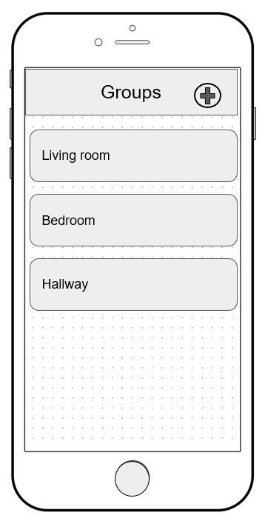

The device can be selected from this list, and the user is taken to a more detailed screen, where the state of the device can be changed, and other settings configured. The prototype includes settings screens for the smart bulb and a smart plug.

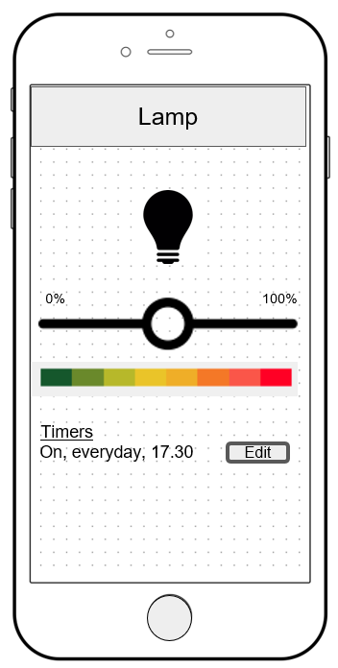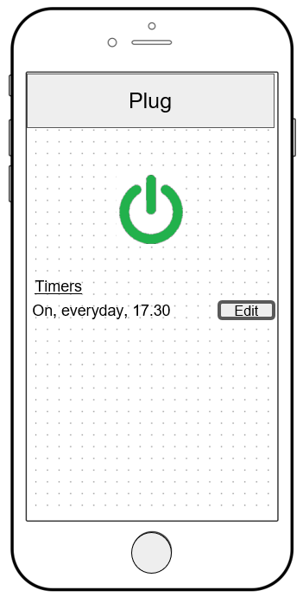

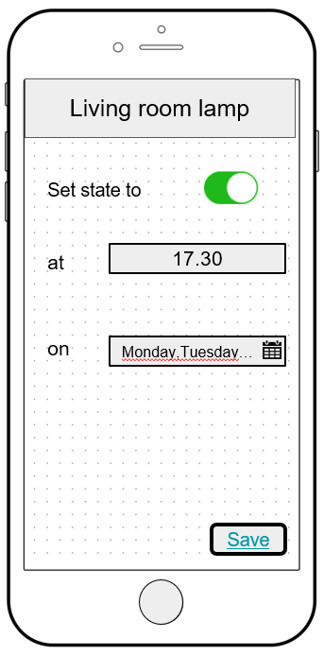The prototype also simulates the functionality of setting a timer for a device.

f.

|  |  |  |
| --- | --- | --- |
| Evaluators Name:  Participants Name:  Session Date: | | |
| **Task Description** | **Participant’s remarks** | **Observer’s comments** |
| Determine current state (on/off) of ‘main light’ in living room |  |  |
| Turn on lamp in living room |  |  |
| Turn on switch in hall |  |  |
| Change timer details for a light device in living room |  |  |

**Word count: 739**

Question 5

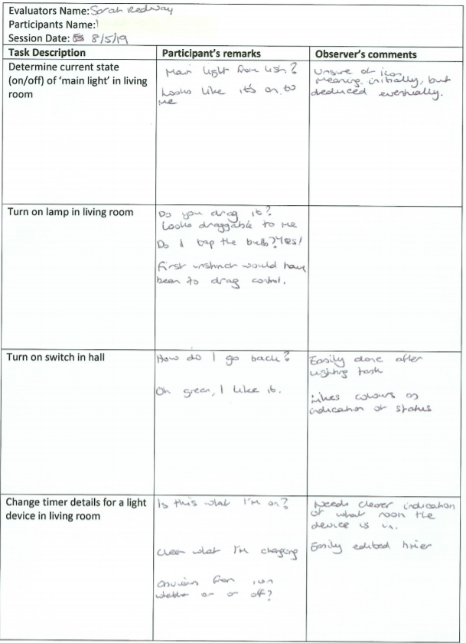

1. To begin analysis of the data I firstly collated the comments that I had collected into a single document that I could refer back to during the analysis process. I then reviewed this document, looking for any commonality between issues identified during the evaluation sessions, and determined potential usability and user experience issues from these common observations. Due to the nature of the evaluation there was no quantitative analysis to be carried out.
2. The main usability defects that were identified were related to effectiveness and efficiency. The first issue became apparent during navigation between evaluation tasks, as there was no way for the user to navigate back in the application. To increase efficiency, I would include a back button to allow easy navigation.

Another usability issue that was experienced by multiple users is that they became confused as to which device group the device they were currently editing belonged to, which reduced their efficiency as they had to navigate back to the device group screen to be reminded of where in the app they were. I would rectify this issue by including a breadcrumb or subheading on the page to indicate which group they were currently editing.

A final issue that occurred was that when trying to turn on the smart bulb the user used the slider intended to turn the brightness up, and did not attempt to tap the bulb icon as intended to change the state. Users did eventually carry out the task in the correct way, but the initial confusion has made me consider whether the interface is appropriate. Once this task was achieved however, users were able to carry out the subsequent task of turning on a plug without issue, which indicates that after an initial learnability issue, the application is intuitive to use, and offers consistent means of controlling the various devices types. For this reason, I would leave the interface untouched and reconsider following further evaluation.

1. One issue that I experienced with the method is that the users had to be encouraged repeatedly to express their thoughts as they were carrying out the tasks. I had to rely on my own observations when issues cropped up to be able to deduce the problem that the user was experiencing. I also had issues with the prototype running on my phone, as it would only display in landscape mode, and so could have provided a more realistic user experience if I could have rectified that issue. The users did run into a few issues because of this and I had to jump in to get them moving with tasks again, which means I could have let some bias creep into the evaluation by being more helpful than necessary.

If carrying out the evaluation again I might use a more diverse group of users to get a more rounded view, as the users available to me were all of similar age, ability and technological experience. More diverse users may have offered some additional insights.

I think the evaluation worked well in establishing some initial areas for improvement in the application. The issues identified were experienced by multiple if not all users in some cases, and so I can safely assume the issues identified are legitimate and require attention.

**Word count: 545**