Kirk, A & Scott, P (2018) *The Guardian* [Online]. Available at <https://www.telegraph.co.uk/news/2018/01/02/no-time-leftovers-astonishing-scale-food-waste-uk-around-world/>(Accessed 28 February 2019)

Mosley, M (n.d) *Is it safe to eat food past its sell-by date?* [Online] BBC. Available at <https://www.bbc.co.uk/programmes/articles/2V5HNS9srK9bXpLyhxLg8Lx/is-it-safe-to-eat-food-past-its-sell-by-date>/(Accessed 28 August 2019)

Reed, S. (2011). *A Mycologist Reaps the (Glowing) Fruit of His Labor*. [online] Science | AAAS. Available at: https://www.sciencemag.org/careers/2011/11/mycologist-reaps-glowing-fruit-his-labor [Accessed 28 Aug. 2019].

Ward, C. (2017) *Jump Start Responsive Web Design*, Victoria, SitePoint

Vuejs.org. (2019). *Vue.js*. [online] Available at: https://vuejs.org/ [Accessed 6 May 2019].

cli.router.org. (n.d.). *Named Routes*. [online] Available at: <https://router.vuejs.org/guide/essentials/named-routes.html> [Accessed 15 Jun. 2019].

Holmes, S. and Harber, C. (2019). *Getting MEAN with Mongo, Express, Angular, and Node, Second Edition*. [S.l.]: Manning Publications.

Holmes, S. (2019). *Simon Holmes - web developer, engineer, architect, author*. [online] Simonholmes.com. Available at: http://www.simonholmes.com/ [Accessed 9 Jul. 2019].

Ambler, S.W. (n.d.), ‘Customer Tests as Requirements Artifacts’; available at <http://www.agilemodeling.com/artifacts/acceptanceTests.htm> (accessed 06/06/2019).

Harber, C. (2019). *DistortedThinking.Agency is a web agency specialising in creating rich internet applications that are engaging and easy to use*. [online] DistortedThinking.agency. Available at: http://www.distortedthinking.agency/ [Accessed 9 Jul. 2019].

CSS-Tricks. (2019). *A Complete Guide to Flexbox | CSS-Tricks*. [online] Available at: https://css-tricks.com/snippets/css/a-guide-to-flexbox/ [Accessed 5 Jun. 2019].

CSS-Tricks. (n.d). *About | CSS-Tricks*. [online] Available at: https://css-tricks.com/about/ [Accessed 9 Sep. 2019].

Pluralsight.com. (n.d.). *Teach | Pluralsight*. [online] Available at: https://www.pluralsight.com/teach [Accessed 16 Apr. 2019].

w3cschools (n.d) *JavaScript encodeURIComponent() Function* [online] Available at <https://www.w3schools.com/jsref/jsref_encodeuricomponent.asp> [Accessed 1 Jul 2019]

Post, T (2017) *Stack Overflow* [online] Available at <https://meta.stackoverflow.com/questions/280478/why-not-w3schools-com> [Accessed 1 Jul 2019]

Mozilla (n.d) *Mozilla eb docs* [online] Available at <https://developer.mozilla.org/en-US/docs/Web/JavaScript/Reference/Global_Objects/encodeURIComponent> [Accessed 1 Jul 2019]

Edamam. (2019) *Recipe Search API Documentation*. [online] Available at: https://developer.edamam.com/edamam-docs-recipe-api [Accessed 11 Apr. 2019].

Law Stack Exchange. (2018). *Do the GDPR and Cookie-Law regulations apply to localStorage?*. [online] Available at: https://law.stackexchange.com/questions/30739/do-the-gdpr-and-cookie-law-regulations-apply-to-localstorage [Accessed 9 Sep. 2019].

Watson, M. and Meah, A. (2012). Food, Waste and Safety: Negotiating Conflicting Social Anxieties into the Practices of Domestic Provisioning. *The Sociological Review*, 60, pp.102-120.

Caniuse.com. (2019). *Can I use... Support tables for HTML5, CSS3, etc*. [online] Available at: https://caniuse.com/#search=grid [Accessed 6 Jun. 2019].

Caniuse.com. (2019). *Can I use... Support tables for HTML5, CSS3, etc*. [online] Available at: https://caniuse.com/#search=flexbox [Accessed 6 Jun. 2019].

Food2Fork. (2019). *Recipe API | Food2Fork*. [online] Available at: https://www.food2fork.com/about/api [Accessed 11 Apr. 2019].

Bigoven. (2019). *Documentation | BigOven API*. [online] Available at: http://api2.bigoven.com/web/documentation [Accessed 11 Apr. 2019].

Holland, B. (2018). *Visual Studio Code Can Do That? — Smashing Magazine*. [online] Smashing Magazine. Available at: https://www.smashingmagazine.com/2018/01/visual-studio-code/ [Accessed 16 Apr. 2019].

Vuejs.org. (2019). *Installation — Vue.js*. [online] Available at: https://vuejs.org/v2/guide/installation.html [Accessed 5 May 2019].

Docs.npmjs.com. (2019). *About npm | npm Documentation*. [online] Available at: https://docs.npmjs.com/about-npm/ [Accessed 25 May 2019].

Marketplace.visualstudio.com. (2019). *Vetur - Visual Studio Marketplace*. [online] Available at: https://marketplace.visualstudio.com/items?itemName=octref.vetur [Accessed 5 May 2019].

npm. (2019). *axios*. [online] Available at: https://www.npmjs.com/package/axios [Accessed 5 Jun. 2019].

Gore, A. (2018). *7 Vue.js Backends Compared*. [online] 7 Vue.js Backends Compared. Available at: https://vuejsdevelopers.com/2018/05/07/vue-js-backends-express-laravel-firebase-wordpress-django-rails/ [Accessed 12 Jul. 2019].

Expressjs.com. (2019). *Express - Node.js web application framework*. [online] Available at: https://expressjs.com [Accessed 11 Jul. 2019].

npm. (2019). *express-generator*. [online] Available at: https://www.npmjs.com/package/express-generator [Accessed 11 Sep. 2019].

Heroku.com. (2019). *About Heroku | Heroku*. [online] Available at: https://www.heroku.com/about [Accessed 6 Aug. 2019].

Docs.mongodb.com. (n.d.). *Install MongoDB Community Edition on Windows — MongoDB Manual*. [online] Available at: https://docs.mongodb.com/manual/tutorial/install-mongodb-on-windows/ [Accessed 30 Jul. 2019].

**Appendix**

**Work diary**

**Time spent:** 2 hours

**Work**: Set up working environment, git repo

**Comments**: Took less time than anticipated but will probably need more setup like node later down the line. Next work is finishing wireframes

**Time spent:** 4 hours

**28/03/2019**

**Time spent:** 3 hours

**Work**: React tutorial, setting up prettier and es lint as per tutorial, super long

**Comments**: took ages. Time wasted as after all that pretty sure I’ll go down a different route, should have just read comparison rather than trying to program along and then decide!

**04/07/2019**

**Work :** Recipe details page

Used vue router documentation – inc in literature review

Realised API doesn’t have method … gah!

Used <https://www.w3schools.com/jsref/jsref_encodeuri.asp> for URI encoding W3schools for documentation – resource

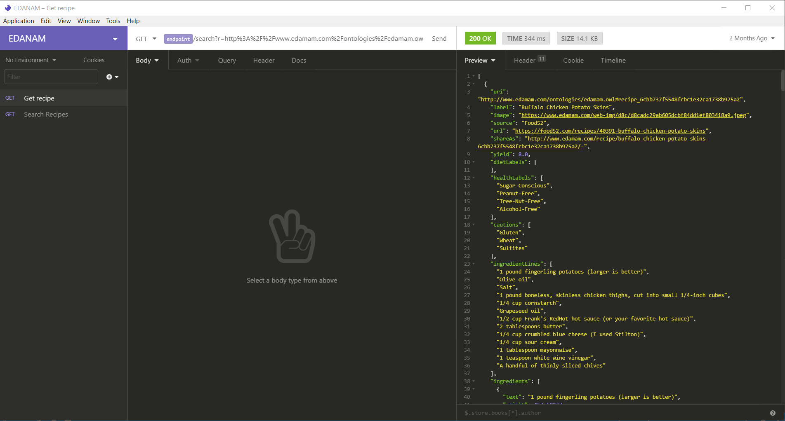

|  |  |
| --- | --- |
| **Test Number** |  |
| T001 | Not much happens when I click sign up, but do get a message saying an account has been created. Should I be taken to another page afterwards? |
| T002 | Not clear if loading once I press log in button. Get a message saying I have been logged in by I stay on login. |
| T003 | Error is display so appears I can’t log in, says ‘Request failed with status code 401’ which doesn’t mean much to me |
| T004 | Results as expected |
| T005 | No message is shown if there are no items, just a blank page. List of ingredients does show correctly once one is added. |