TM352 TMA01 Sarah Walker B4050530 28/11/2017

General (PT3) comments
Sarah,
Well done on a very good TMA. The TMA indicates that you have a good understanding of the concepts of Block 1. In Block 2 (and later), it will also be important to be as clear as possible in your own mind about concepts, and express that in the TMAs.
There was an opportunity to collect a few more marks by being more specific, for example, by saying more about HTTPS, and by applying the discussion more clearly to the context of MegaMax (MM), for example whether MM should use an IDE. In future TMAs, there will be questions that ask you to discuss technology in a specific context; make sure that you explain how the technology applies in the given scenario, and do not just explain the technology itself.
Although it is not asked for explicitly in the TMA, at Level 3 you should use some citations and references. No need for word-for-word quotations (they tend to burn word count), but certainly do include citations to some good, respectable sources. SOAP and REST would, for example, have given you the opportunity to reference some good reliable sources.
The copy of your script (file with "_marked" added to the end of the file name) includes more detailed comments, with an explanation of the marks. Many of my comments are in the nature of a discussion with you, rather than corrections, so do not be put off if there are a lot of comments! Let me know if something is not clear.
You are obviously off to a very good start; all the best for Block 2!
Mike
Note for assignment handling: Submitted late with prior agreement

Part 1
A web service is a means by which resources on a server can be requested by a client across a network, such as the internet ✓ be clearer: the web service is the resource that is accessed . This involves a request message being sent from a node in a network, such as a client, software application or browser, to a server make clearer that web services are intended for computer-to-computer interactions, rather than human-to-computer interactions . Upon receipt of this request the server provides said resource, and replies with a response message ✓ . To allow this communication across a network the messages must be sent in a particular format, adhering to a particular protocol or set of standards, so that messages can be read and understood. Adhering to these standards also ensures that web services are platform independent ✓ , and can be used by any number of different clients. Web services can be used to provide requested data, write data received in the request message to data storage or to amend data received and return it back via the response message. ✓
One method used to exchange such messages is by means of the Simple Object Access Protocol (SOAP). SOAP is a standard ✓ which uses Extensible Markup Language (XML) to send and receive messages to and from a SOAP web service. ✓ SOAP specifies the structure and the encoding that the messages must be sent in to ensure proper communication. A single end point, or URI, on a server is exposed ✓ , which provides a set of operations ✓ that can be utilised to perform a task. This set of operations is described by a WSDL file, which also specifies the kind of response that can be expected when performing certain operations. ✓ the WSDL also specifies the request message format The response from a SOAP web service is sent in XML format ✓ .
An alternative to approach to SOAP is to use a RESTful service ✓ . This method differs from SOAP in that it is implemented using web standards such as HTTP and URI, and existing web protocols, without the need for any additional protocols ✓ . Rather than providing a single endpoint and variety of operations at this endpoint, as SOAP does, every resource provided by a REST service has its own unique URI.
In my opinion the most appropriate type of web service for Megamax to employ would be a RESTful service. ✓ This is due to the fact that it already uses well known standards and protocols in its implementation, meaning it would be simpler and less complex to develop than a SOAP service ✓ SOAP messages are intrinsically more complex so programming would be more tricky and more processing is needed to run both the client and the web service . REST services are also more flexible as they can return data in other formats than XML, such as JSON, which is much more light-weight ✓ , and could mean that the performance of the app is better ✓ without the need to parse XML from the response into an object ✓ . REST services are also more secure as they can be monitored by firewalls ✓ the key point here is that the firewall sees the URIs of the individual resource accessed and the HTTP method, due to the fact that they operate on HTTP, which is not the case for a SOAP service.
Word count: 469
Part 1
Good to outline your understanding of "web service", making clear that it is a specific piece of functionality that can be accessed via the internet.
For more marks make clear that web services are designed to be accessed by a different program rather than a human. For example, a web service might be accessed by a Java client such as in NetBeans activities 5 and 9, or by some JavaScript code embedded in a HTML page and executed by the browser.
Also explain what web services mean for MM in general: the web services can be accessed by the sales force regardless of where they are, and regardless of which device they use, making sales order entry more efficient.
Good to mention SOAP and REST, pointing out some of the differences between these approaches. Good to say SOAP is a standard; for more marks, make clear that REST is an 'architectural style' and not a standard.
Good to make a clear recommendation on which is better for MM, and to justify the recommendation.
( 12+18=30 / 35)

Part 2
i)
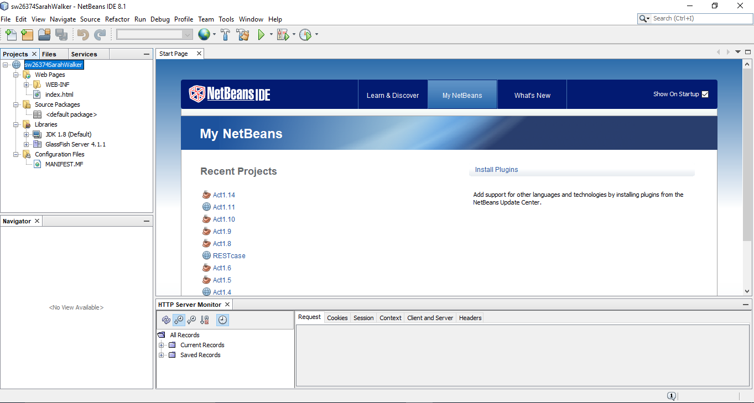
In this snapshot you can see that a new web application project has been created using in NetBeans IDE. The IDE has created all of the necessary filed for a basic web application ✓ , and we are ready to add our own web service to the project. ✓
ii)
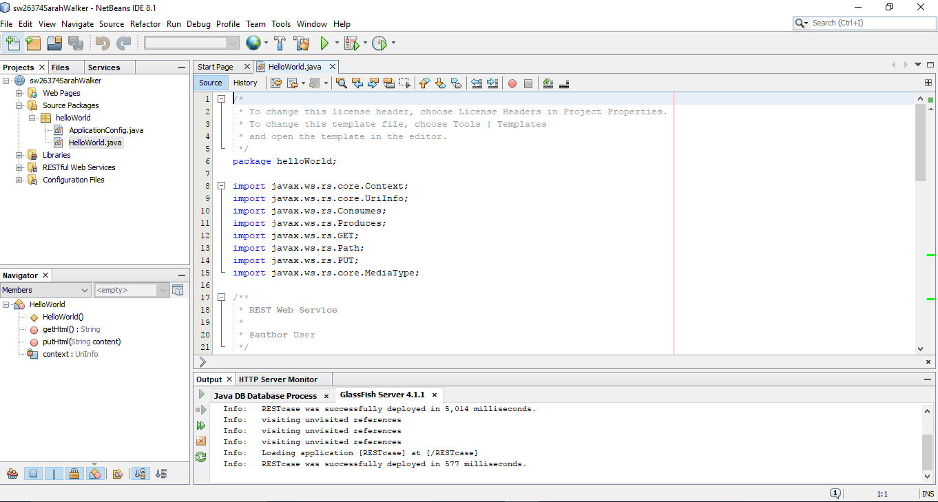
In this snapshot you can see that a RESTful web service named HelloWorld has been added to the web project ✓ , an operation made easy by the NetBeans IDE by simply right-clicking on the project and selecting the required menu option ✓ . The IDE has added two files to the project for us, the HelloWorld.java which will contain the code for the REST resources ✓ , and the ApplicationConfig.java which among other things specifies the path that will need to be used to access the web service. The path to the service is configurable by changing the ApplicationPath annotation in this file.
iii)
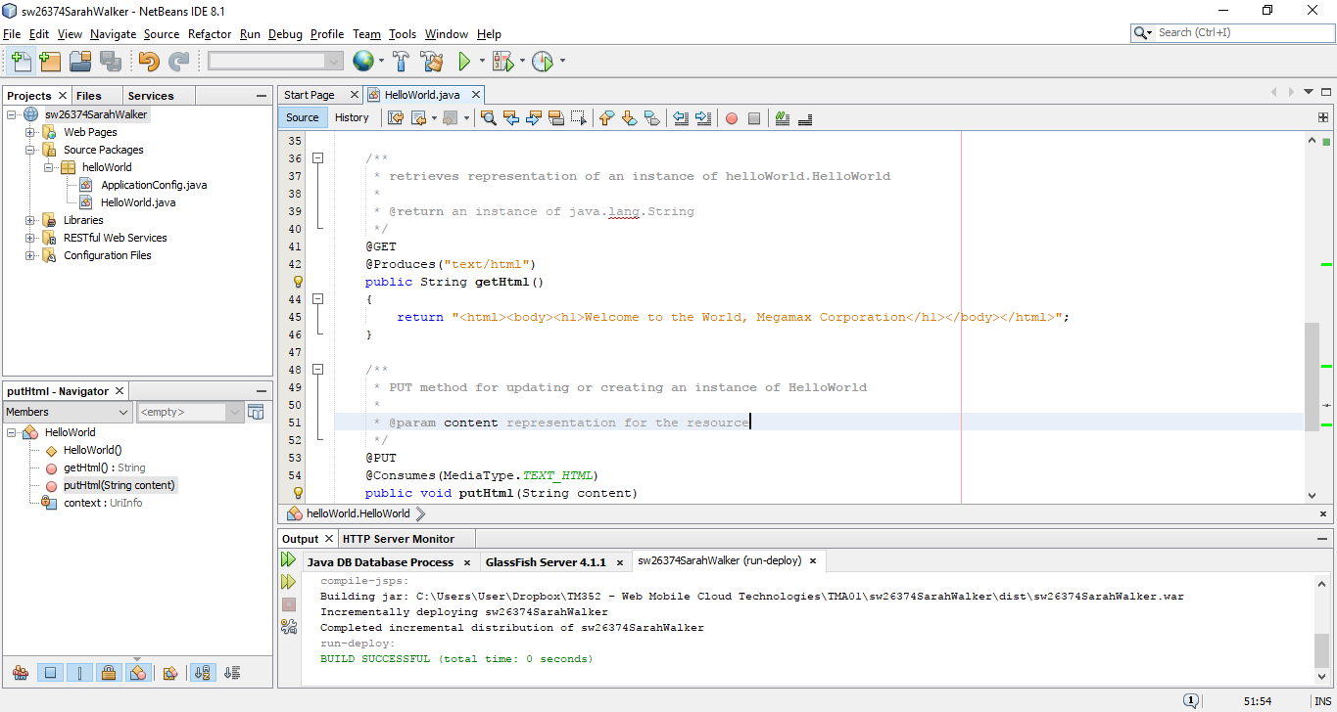
The final snapshot demonstrates how the web service can be tested in NetBeans using the ‘Test RESTful services’ function ✓ . A resource called getHTML() has been added to the service, which returns a simple HTML string that will be rendered on the page when the GET method on the service is called ✓ in a real web service, MM would replace this by the code to display an order, or to receive and process a new order input by the sales person (for example). The web application has been deployed using the Glassfish server, which is integrated with NetBeans, and the endpoints specified can then be tested in the browser window that opens. Upon creation, the MIME output type of the web service was set to text/html, and we have provided a method that will return a simple HTML string, but it would also be possible to set a different MIME output type and return data in the form of JSON from the service.
Now that the web service has been deployed, we could write a client application opportunity here to relate this more to MM that would be able to request a resource from the URI http://localhost:8080/sw26374SarahWalker/webresources/helloWorld , and use the returned response in some way, probably displayed within a web page.
Word count: 318
Part 2
Good summary of how you implemented the web service.
Very good explanation of what is going on in each of the three steps of the method.
For more marks, relate it back to MM, for example, comment on whether MM would benefit from an IDE such as NB, or explain that MM would run the web service on a server somewhere, while the sales staff would access the application from their mobile devices. Obviously, in real life the web service would be more complex and there might be several web services.

Good to include three screen shots as evidence that you completed the activity.
( 27 /30)

Part 3
When transporting data across a network there are a number of threats that can jeopardise the integrity, security and safety of the data, and as such security measures should be implemented throughout the various application layers to ensure safety. These measures include good coding practises, such as authentication and authorisation processes, and encryption of sensitive or confidential data during transportation. ✓ ideally explain the concepts authentication, authorisation and confidentiality
There are many reasons that an unwanted user might want to access your application, including to steal confidential information, take over computer hardware for nefarious reasons or to attempt to misuse trust in your application to gain information for themselves, to name a few. Good computer security means protecting against these threats to maintain data integrity and confidentiality, and system availability.
The security of an application may be put under threat by external parties, but it is also possible for the intended users of the system to create security issues. A means of preventing this is to ensure that users are only authorised to amend the application in acceptable ways ✓ . This can be achieved by assigning users to a particular group within the system, ensuring only those in certain roles can perform certain functions ✓ . Implementation of a login process ensures that users can be authenticated ✓ , and can only perform their permitted functions, as well as ensuring that unauthorised users are unable to gain access to, and manipulate, the application.
One method to ensure that data confidentiality is maintained is to encrypt ✓ sensitive information for travel across the network. This entails encoding messages using a key to encrypt the message at one end of the communication, and then a key to decrypt the message at its destination. There are many means by which to encrypt data, some more secure than others, but by using a secure protocol for data transmission the encrypting of data is taken care of on our behalf. ✓
Using the https protocol to transport data to and from your application will increase the security of its communications, and ensure that sensitive data cannot be intercepted and so remains confidential. Using https also ensures that the client and server are authenticated properly ✓ server yes; client not necessarily (client authentication is optional in SSL handshake, and needs a client certificate and key pair), and we can be sure that we are communicating with the entities we believe we are. https works by communicating across a secure channel, with the server providing a certificate to the client, meaning the client is able to authenticate the server ✓ . After this a means by which the message will be encrypted is ascertained, and the message is encrypted using said encryption method. In this way we can be sure that when the Megamax is communicating order and client information across the network, it is sending it to its own server ✓ .Say more about how HTTPS might be implemented: first there is the SSL/TLS 'handshake', which uses asymmetric encryption to authenticate the server and to agree the "Master Secret". Then the Master Secret is used as symmetric key to encrypt and decrypt the actual message exchange. (The reason for using this hybrid approach is that asymmetric encryption is slower than symmetric, so asymmetric is used only to agree the key; that key is then used for symmetric encryption of the bulk of the message exchange.)
Make clear how this approach provides confidentiality (by encrypting the actual HTTP message), and how it authenticates the server, so the client knows it is talking to the correct server. To authenticate the client, either the client also needs a certificate, or (more usually) you work with a password; you could also use basic or digest authentication which would then be encrypted within the ordinary HTTPS mechanism.
In conclusion, the issue of web application security is an important subject to consider, but with some assessment of the risks and implementation of good coding practises and secure protocols, is not too difficult to ensure the application, its data and its users remain safe from threats.
Word count: 492
Part 3
Good to discuss authentication, authorisation and confidentiality, but for more marks explain how they might impact MM in the sales application. It would also be good to explain the three concepts explicitly.
Good to suggest HTTPS. For more marks, explain the basic concepts of HTTPS and SSL/TLS more clearly, along the lines of figure 7 in Part 5.
( 11+ 15 =26 /35)

