Exercise: Your Class Portal

Your assignment for the next class is to create the basic file structure for your portal, build a portal page that links to an exercise page as well as an updated blog. Your opening portal page (index.html) might reflect some aspect of your survey answer, “What is something unique about yourself?”

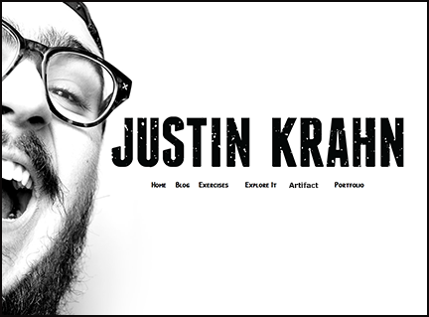

In this exercise you will create the structure of your portal page that links to the projects and exercises you’ll create in this class. Use the htmlref.html as your code guide.

NOTE: The portal can be continually modified as you learn new techniques and create a more personal “style” for your pages. As part of the midterm evaluation, the portal will be graded for file management and creativity.

Please title the folders and files exactly as you see them below. Notice the difference between files and folders.

Start by creating a folder called my portal (use your name, this will be your root directory) and is important for file organization and future FTP. Keep all your files on your memory stick. The contents of the portal folder will be uploaded onto the server but not the folder itself.

Use TextWrangler or Notepad++ to create the index.html page (This will be your “creative” portal page that includes the following links: Blog, Exercises, Connect It!, Explore-It!, CSS Zen Garden and Contact. Note: the contact will be the link mailto:your e-mail address

Include an original artwork, photos or design of your choice on your portal index page. Initially, your portal must reflect something unique about yourself. Again, I expect your portal will evolve as you gain more skill and imagine the endless possibilities.

You will also incorporate a separate html page for your daily blog. Incorporate the newest blog entry you’ve written and, as you update, make sure the latest entry is at the top. Your blog should include something related to web, design or your creative interests. Maybe it’s a link to a cool web site, or just your thoughts on your current web project…anything that’s related to web and design. You must have a post on each Monday and Friday until the last week of class. This is an ongoing assignment that will be graded as part of the exercises. I will randomly check the blogs for currency.

You can link your email directly from the contact button by using this tag.
(<a href=”mailto:youremail@ucdavis.edu>email me!</a>)

Create an exercise folder
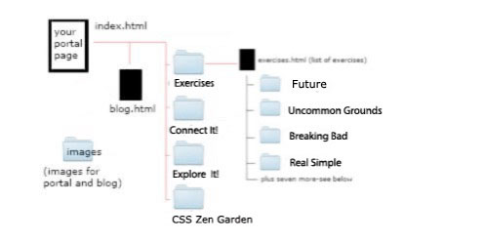
Create a new file that will be saved as index.html inside your exercise folder. This file contains a list of your exercises and will eventually link to all of your exercises (use and ordered list <ol> to begin a list and <li> for each list item). There must be navigation at the top of this page that allows the viewer to go to all the other pages in your portal including the portal start page. How would you do this? Maybe it’s already done and you can copy/paste?

Here is the preliminary list of your exercises:I may be changes along the way so be flexible with the list and don’t make it all image based (too hard to add or change).

1. Futuristic
2. Uncommon Grounds
3. Breaking Bad
4. Blood Diamond
5. Type Hierarchy
6. Sushi 101
7. Real Simple
8. Image Map/Navigation
9. Midterm
10. Napa Style
11. Audio/Video

If you haven’t already done so, add the following folders to your root directory:
images, html, contect_it, explore_it and zen_garden

Remember, no spaces or special characters in the names of folders or files for the web!

I recommend that you also include an index.html page inside each of the project folders with an image or text that, for the time being, says it’s under construction.

Add links from your portal page to each of the secondary index pages exerises, blog, Connect It!, Explore It! and Wordpress ie(<a href=”connect_it/index.html”>Connect It!</a>)

Once constructed, test thoroughly!

Upload the entire structure to your website.

Host: design117.com
Login: your username@design117.com
Password: your password

Check linking from our gallery page to make sure everything works..troubleshoot if necessary!

Use the basic code structure of your html.reference exercise as a starting point for the index and any other html pages. Include the <!DOCTYPE html> statement at the top of each page

To have all links open in a new window use <base target=_blank /> directly after the closing bracket of the body tag (</body><base target=_blank />)

Be sure the following is completed for the next class: file structure complete and uploaded on server, you have your first version of your portal page with links to blog, exercises and three projects. You must have a current blog and your futuristic design exercise and uncommon grounds (we created in lclass) should be linked on the exercise page.

