Evolutionary rescue under temperature stress: the role of mutations improving life-history traits in hoverflies, a species with multiple life stages.

Abstract
Climate change increases temperature extremes worldwide and threatens the persistence of many insect populations. As ectotherms, insects depend on environmental temperatures for their development stages and physiology, making them highly vulnerable to climate-driven stress. This study investigated whether beneficial mutations that improve the performance during specific life stages and especially egg hatching and adult fecundity can enable the evolutionary rescue, the process by which type of adaptation prevent extinction in deteriorating environments.
Here we developed a stochastic population model that simulates two life stages (egg and adult) and two genotypes (wildtype and mutant) under constant temperature stress. Mutation occurs in eggs, generating mutants with higher hatching rates or fecundity. We examined how varying mutation rate, hatching rate, and fecundity influence the probability of rescue.
Our simulations reveal that the population survival under thermal stress depends more on the life stage specific fitness, especially egg hatching rate and adult fecundity than on mutation rate. These findings suggest that adaptation during key life stages may determine whether insect species persist in a warming world. The model provides a conceptual foundation for predicting population resilience and guiding conservation strategies in the context of climate change.

Introduction
Climate change is altering ecosystems globally, with rising temperatures and more frequent extremes driving species decline. For many species populations, especially those with limited dispersal or small effective sizes, adaptations must occur quickly to avoid extinction (Gonzalez et al., 2013). This scenario known as evolutionary rescue, has now become a central concept in eco-evolutionary dynamics, describing situations where adaptive mutations spread rapidly enough to counteract the population decline (Bell, 2017; Orr & Unckless, 2008).
Insects are especially affected by thermal stress because their physiology and survival rates depend on the ambient temperature. High temperatures can reduce egg viability, shorten adult lifespan, disrupt larval development and lower adult fecundity (Colinet et al., 2015; Deutsch et al., 2008). These effects can lead to population collapse if the environment changes faster than population can adapt.
Hoverflies (Syrphidae) are among the most abundant and ecologically important pollinators in temperate ecosystems (Doyle et al., 2020). Their lifecycle includes multiple developmental stages such as egg, larva, pupa, and adult each with distinct thermal sensitivities. Laboratory and field studies have shown that the hoverfly eggs and pupae are particularly sensitive to temperature fluctuation (Daňková et al., 2023), where the adults show behavioural thermoregulation and can adjust reproductive timing.
With their short generation time and ecological importance, hoverflies provide an ideal model system for exploring evolutionary rescue dynamics under temperature stress. Understanding how beneficial mutations can promote population persistence has direct relevance for biodiversity conservation and pollination service under global warming.
Many models of evolutionary rescue consider the population as a single homogeneous stage and focusing on total population size and mutation rate. However in many species selection acts differently across life stages (Cotto et al., 2017). Early stages like eggs, often experience high mortality and environmental stress while later stage determine reproductive outcomes.
In insects, dormancy or diapausing eggs may buffer populations from unfavourable conditions, but dormancy also slows reproduction and limits adaptation speed. Adults in contrast, directly determine fecundity and mutation supply through reproduction. Therefore, the mutations that enhance the hatching success or fecundity could have out of proportion effects on evolutionary rescue probability.
We constructed a simplified stochastic population model inspired by hoverfly biology to test how life stage specific mutations influence evolutionary rescue under temperature stress. Here we focused on two life stages eggs and adults and investigated how variation in 1. Mutation rate, 2. Mutant hatching rate and, 3. Fecundity affect the probability of population rescue.

Model and Methods
This model was entirely coded in R. To answer our question, we modeled evolutionary rescue in a haploid species with two genotypes (wildtype and mutant) in discrete generations. The life cycle of the modeled species consisted of two stages: eggs and adults. First adults hatch from eggs, reproduce once, and die within the same generation, while eggs can stay dormant and survive into the next generation.

Single-Generation Simulation
Each generation starts with initial populations of wildtype and mutant eggs. The transition to the next generation follows four stochastic steps (Figure 1):
- Hatching: A binomial draw determines the number of eggs of each genotype that hatch into adults, using genotype-specific hatching rates $hZ_w$ and $hZ_m$. The remaining eggs represent the dormant fraction that does not hatch in the current generation.
- Reproduction: The new wildtype and mutant adults produce a number of offspring drawn from a poisson distribution determined by the genotype-specific fecundity $f_w$ and $f_m$.
- Mutation: A fraction of newly produced wildtype eggs convert to mutant eggs according to a Poisson-distributed number of mutation events with rate $mut_rate$.
- Egg survival: Eggs experience genotype-specific survival to the next generation, modeled with binomial draws using probabilities $pZ_w$ and $pZ_m$.
The function returns the number of surviving eggs of each genotype, which constitute the starting population for the next generation. Model parameters are listed in Table 1.
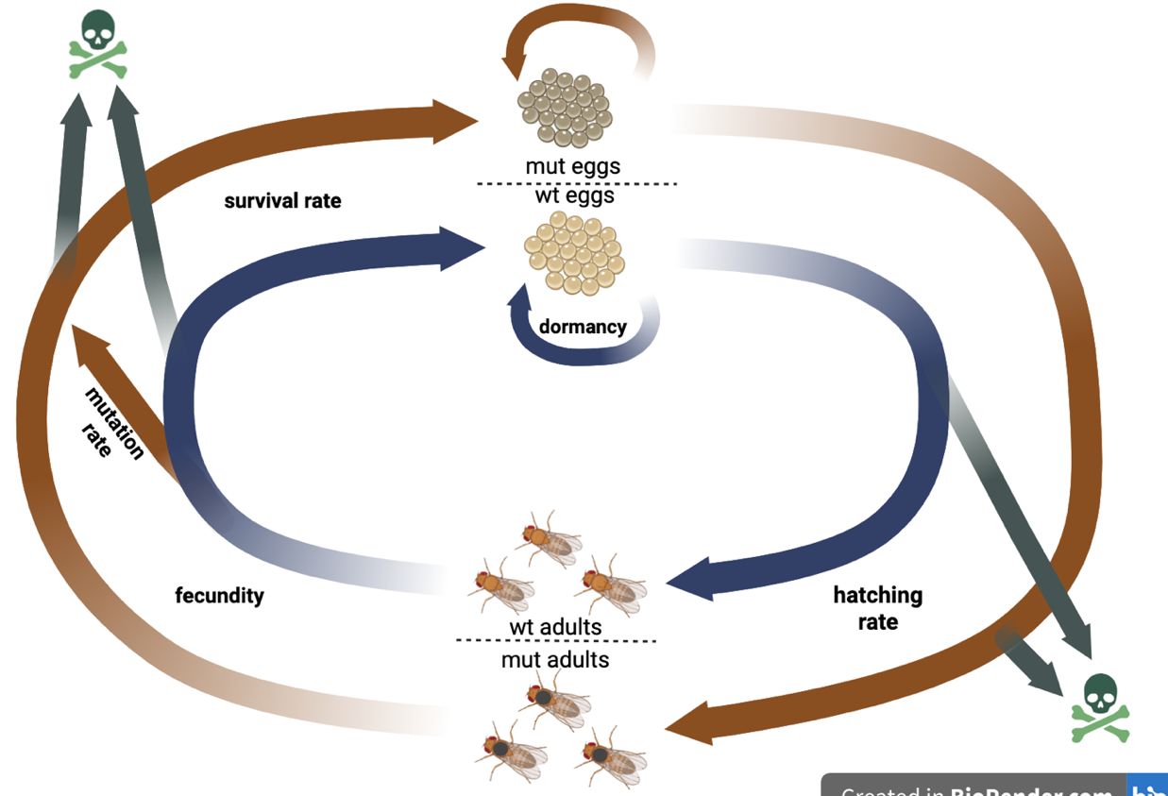

Figure 1: Diagram illustrating the processes simulated in our model within a single generation. The blue
arrows represent the trajectory of the wildtype genotype and the red arrows oft the mutant genotype.

Table 1: Parameters used in our model with their descriptions
Parameters | Description
Z_w, Z_m | Initial population of wildtype and mutant eggs
f_w, f_m | Fecundity wildtype and mutant (eggs per adult)
hZ_w, hZ_m | Hatching rate
pZ_w, pZ_m | Egg survival to next generation
mut_rate | Mutation rate
t_max | Maximum generations simulated

Multi-Generation Simulation
To model the population dynamics over multiple generations, the previous single-generation function was iterated for up to $t_max$ generations. Simulations terminated early if the population went extinct $(N\left(t\right)=0)$ or exceeded 100 times the initial population size, which would signify guaranteed rescue. This multi-generation function was repeated over a specified number of independent rounds to record the probability of extinction and rescue. A run was classified as extinction if the final population reached zero and as rescue if it was higher than zero.

Parameter Exploration
To investigate how different parameters influence evolutionary rescue, we systematically varied one parameter at a time while holding all others constant. and recorded its effect on rescue probability. (Baseline values: $Z_init_w = 100, Z_init_m = 11, f_w = 3, f_m = 3.1, hZ_w = 0.5, hZ_m = 0.51, pZ_w = 0.5, pZ_m = 0.51, mut_rate = 0.001, t_max = 200)$.
The following parameter ranges were explored:
- Mutation rate: 0-0.02
- Wildtype and mutant fecundity: 1-6
- Wildtype and mutant hatching rate: 0-1
For each parameter combination, rescue probability was estimated from multiple replicate simulations.

Two-Parameter Heatmap Analysis
Finally, three-dimensional heatmaps were created to investigate the effect of two parameters on the rescue probability. Two heatmaps were generated to estimate rescue probability across parameter combinations:
- mutant hatching rate x mutant fecundity
- wildtype fecundity x mutant fecundity

Results
To investigate how mutations affecting life-history traits influence evolutionary rescue under temperature stress, we first analysed how life-history traits (hatching rate, fecundity, and mutation rate) individually impact rescue probability in our model. We then explored how combinations of parameters interact to increase the probability that the population gets rescued.

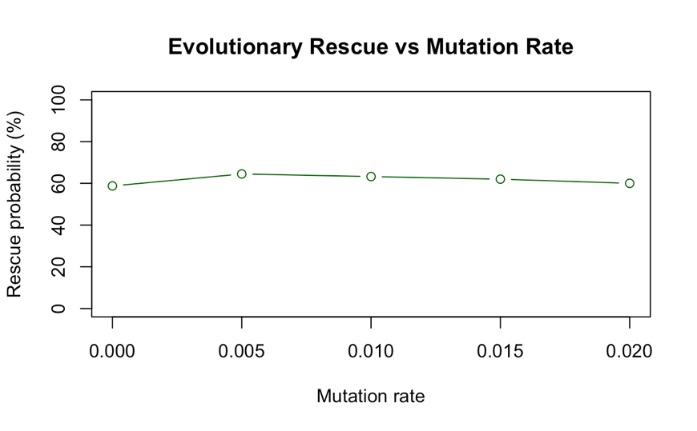
Effects of mutation rate
Firstly, to study the effect of mutation rate on rescue probability, simulations of our model were run for multiple rounds with different mutation rates with values between 0 and 0.02, which seemed like a realistic interval to investigate. When all the other parameters were set at safe values the same for both genotypes (Baseline parameters: $Z_init_w = 100, Z_init_m = 50, f_w = 3, f_m = 3, hZ_w = 0.5, hZ_m = 0.5, pZ_w = 0.5, pZ_m = 0.5)$, and a third of the initial population were mutant individuals the rescue probability turned out to be around 75% for all mutation rates in the studied interval. For decreasing fractions of mutant individuals in the initial population, the rescue probability also decreased, however staying flat for all mutation rates. At 20% of the initial population being mutant the rescue probability remained at 66%, decreasing to 59% when 5% of the initial population was mutant and at 58% when 0 individuals were initially mutant. In Figure 2, the rescue probability of 60% is shown, when the mutation rate is varied at an initial mutant population of 10%. However, the lower the initial mutant individual numbers the more likely that the rescue of the population was performed by the wildtype genotype.
Figure 2: Rescue probability stayed constant with a varying mutation
rate. With the fraction of initial mutant population being 10%.
Parameter combination: (Z_init_w =100, Z_init_m = 11, f_w = 3,
f_m = 3, hZ_w = 0.5, hZ_m = 0.5, pZ_w = 0.5, pZ_m = 0.5,
t_max = 200)
Rescue probability was also stable at around 75.5% when the fitness parameters were slightly higher for the mutant genotype (Baseline parameters: $Z_init_w = 100, Z_init_m = 5, f_w = 3, f_m = 3.1, hZ_w = 0.5, hZ_m = 0.51, pZ_w = 0.5, pZ_m = 0.51)$. These findings suggest that mutation rate does not influence rescue probability in our model and that an initial population of mutant individuals is needed for the mutant genotype frequency to increase because mutation rate will not increase it.

Effect of wildtype and mutant fecundities
Since mutation rate seems to have little impact on evolutionary rescue in our model, we studied other parameters associated with life-history traits. The effect of wildtype fecundity on rescue probability was tested by varying the fecundity in an interval of 1 to 6. As shown in Figure 3, this resulted in an increased rescue probability starting from a fecundity value of 2.5 at around 65%, once it reached 3.5 rescue was guaranteed. When mutant fecundity was varied in the same interval (1-6), it resulted in a 58% rescue probability from a fecundity value of 1, increasing it from a fecundity of 2.5 reaching 100% at 3.5 (Figure 3). To test this, all the other parameters were set slightly higher for the mutant genotype (Baseline parameters: $Z_init_w = 100, Z_init_m = 11, f_w = 3, f_m = 3.1, hZ_w = 0.5, hZ_m = 0.51, pZ_w = 0.5, pZ_m = 0.51, mut_rate = 0.001)$.
Figure 3: Rescue probability is increased to a 100% when wildtype and mutant fecundity are increased. Parameter
combination: (Z_init_w = 100, Z_init_m = 11, f_w = 3, f_m = 3, hZ_w = 0.5, hZ_m = 0.5, pZ_w = 0.5, pZ_m = 0.5,
mut_rate = 0.001,t_max = 200)
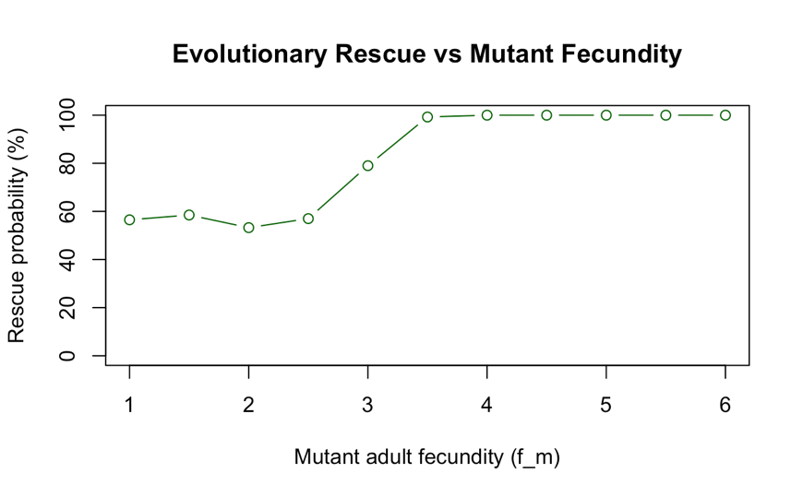
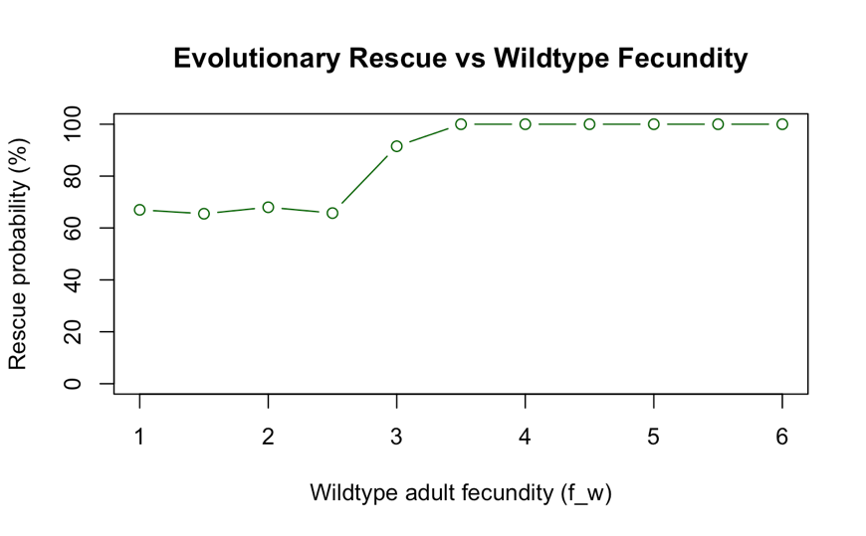

Effect of wildtype and mutant hatching rates
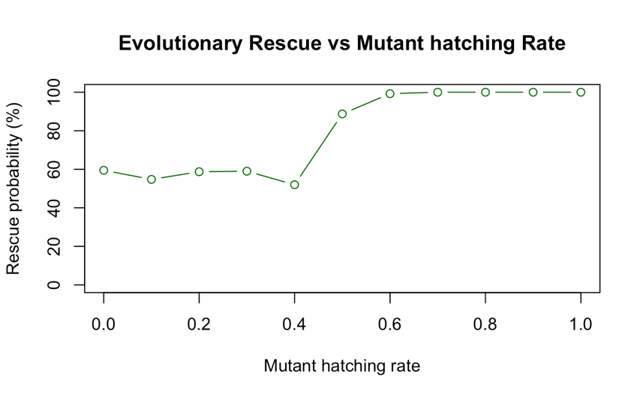
To evaluate the impact of wildtype and mutant hatching rate on rescue probability, the same parameter combination as previously was chosen, and the hatching rates were varied in between 0 and 1. As shown in Figure 4, we found that the rescue probability is at around 65% when the wildtype hatching rate is between 0 and 0.4 increasing up to a 100% when it reaches a value of 0.6. For the mutant hatching rate, the rescue probability stays at around 55% until the hatching rate also exceeds 0.4 increasing up to a guaranteed rescue from 0.6 on (Figure 4).
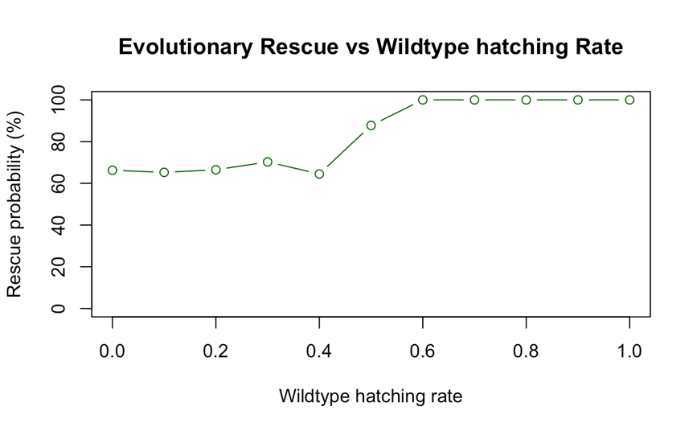
Figure 4: Rescue probability is increased to 100% when wildtype and mutant hatching rate are increased. Parameter
combination: (Z_init_w = 100, Z_init_m = 11, f_w = 3, f_m = 3, hZ_w = 0.5, hZ_m = 0.5, pZ_w = 0.5, pZ_m = 0.5,
mut_rate = 0.001,t_max = 200)

Effect of both mutant hatching rate and fecundity
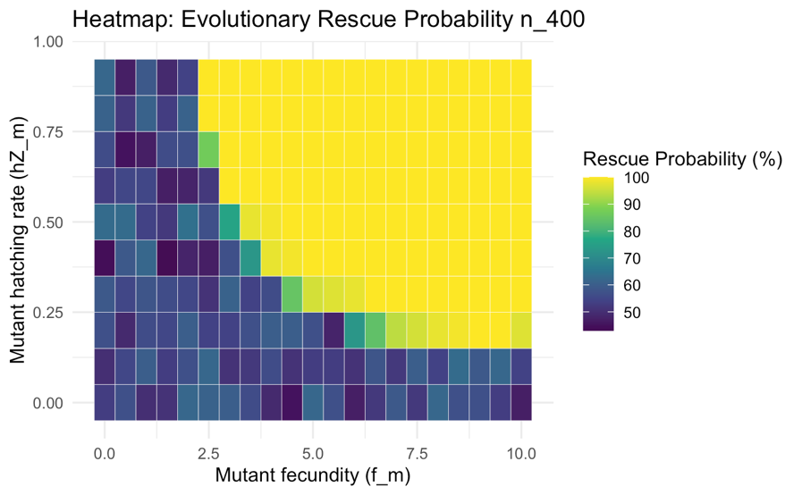
The three-dimensional heatmaps allowed us to explore how two life-history traits interact to influence evolutionary rescue. When looking at the combined effect of both mutant hatching rate and mutant fecundity, rescue probability was observed to be increased when both traits were high (Figure 5). However, both traits need to be above a certain threshold. If one of the parameters is lower than that, the rescue probability will stay at a 50%.
Figure 5: Heatmap showing how rescue probability is increased when
varying mutant fecundity and hatching rate. Parameter combination:
(Z_init_w = 100, Z_init_m = 11, f_w = 3, f_m = 0-10, hZ_w = 0.5, hZ_m =
0-1, pZ_w = 0.5, pZ_m = 0.5, mut_rate = 0.001, t_max = 200)

Effect of wildtype and mutant fecundity
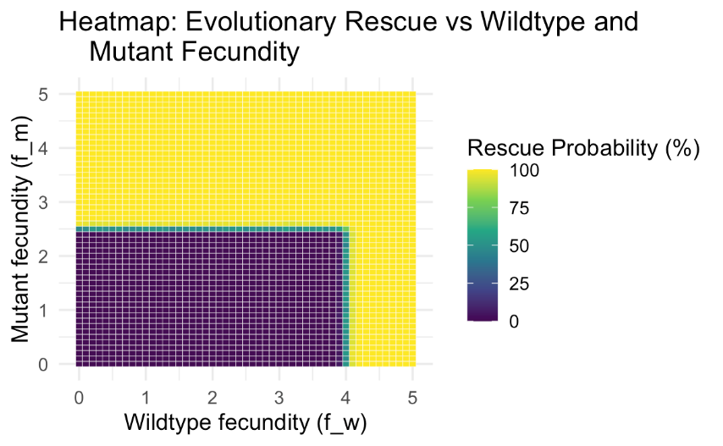
A similar pattern was found when studying the interaction between both wildtype and mutant fecundity (Figure 6). Both parameters are needed to be higher than a certain value to achieve guaranteed rescue $(f_w < 4, f_m < 2.5)$. The mutant fecundity value needed to achieve evolutionary rescue seems to be lower than the wildtype genotype one, probably because of the fitness advantage granted by increasing the rest of the mutant genotype parameters, since the parametrical combination chosen was one with higher mutant parameter values.
Figure 6: Heatmap showing how rescue probability is increased when
varying mutant and wildtype fecundity. Parameter combination:
(Z_init_w = 100, Z_init_m = 50, f_w = 0-5, f_m = 0-5, hZ_w = 0.5,
hZ_m = 0.55, pZ_w = 0.4, pZ_m = 0.55, mut_rate = 0.001,t_max = 200)

Discussion
Our model shows that life-stage-specific fitness traits are central in determining evolutionary rescue under environment stress. Populations can persist through adaptive mutation even when mutation supply is limited, provided those mutations strongly enhance critical life stage change such as egg hatching or adult reproduction. This result supports and extends previous theoretical work showing that evolutionary rescue probability increases with the strength of selection on beneficial mutations.
Our findings suggested that mutation rate had almost no effect on rescue probability, which remained 60-70% across the tested mutation rate range. In contrast, mutations increasing fecundity and hatching rate had a strong positive effect on evolutionary rescue. Rescue probability reached a 100% once mutant fecundity exceeded 3.5 or when mutant hatching rate surpassed 0.6, highlighting the dominant role of life-history trait improvements over increased mutation rate. Furthermore, the heatmaps showed that single trait improvements are not always sufficient. Evolutionary rescue was most likely when both fecundity and hatching rate were elevated, demonstrating a synergistic effect.
Hoverflies experience strong seasonal and thermal pressures. Their eggs often exposed to fluctuating temperatures, while adult face heat stress during reproduction. A mutation that improves egg hatching or survival at high temperatures could therefore be deciding the persistence. This framework highlights that conservation strategies should not only focus on average species level fitness but also on life stage vulnerabilities for instance by protecting cooler microhabitats for egg deposition or ensuring food availability for adults to maintain fecundity.
Our model shows valuable insight into evolutionary rescue but simplifies real population dynamics. We only include two life stages: eggs and adults, while ignoring larval and pupal stages that may respond differently to temperature stress. The temperature stress was constant rather than fluctuating, and only a single beneficial mutation was considered without accounting for standing genetic variation. Ecological factors such as density dependence, resource limitation and migration were also excluded in our model. These simplifications were necessary for clarity and computational efficiency but should be addressed in future models to show more realistic ecological and evolutionary dynamics.
Despite these simplifications the model established a strong foundation for understanding how life stages specific traits influence the evolutionary rescue, and it can be refined further to capture more realistic ecological and genetic properties.
Future extensions of this model should be including additional life stages such as larvae and pupae to capture the full developmental response to temperature stress. Introducing fluctuating or extreme temperature regimes would better represent real climatic conditions, especially in the face of climate change. In our model we only included one mutation, which increased fitness for the mutant genotype in all life-history traits studied. However, this is not very realistic, since there are often multiple mutations involved in adaptation in nature, and fitness benefits often come with trade-offs in other life-history traits. Also, including multiple mutation types could reveal how genetic diversity influences evolutionary rescue. Adding ecological factors like density dependence, competition and migration would further improve the prediction accuracy. Finally applying this framework to other insect species could identify general patterns of adaptation and persistence under climate change.

Author Contributions
- Sarai Verdú Cruz: Model design, R simulation code, Data analysis, Literature review, Presentation design, Report writing
- Charith Meegamuwage: Model design, R simulation code, Data analysis, Literature review, Presentation design, Report writing

Acknowledgments
We would like to express our sincere gratitude to our supervisor, Claudia Bank, for her continuous guidance and support throughout this research practical. We are also grateful to the assistants Franziska Andrea Brenninger, Russell Jackman Jasper, Ana-Hermina Ghenu, and Julio Antonio Ayala Lopez for the help and encouragement they provided. Their base R code and the short lecture inputs significantly strengthened our skills in tools such as RStudio and GitHub and helped us improve our overall scientific workflow.
We further thank Ana-Hermina Ghenu and Damian Vogt for reviewing our report and offering valuable feedback. Finally, we extend our appreciation to all students of the 2025 Theoretical Ecology Practical for sharing their thoughts and comments on our project. Thank you all.

Declaration of Authenticity
We hereby declare that this report was completed independently and that all sources of information have been properly cited. Artificial intelligence tools (ChatGPT by OpenAI) and QuillBot were used extensively to refine language and improve readability.

References
Bell, G. (2017). Evolutionary Rescue. Annual Review of Ecology, Evolution, and Systematics, 48(1), 605–627. https://doi.org/10.1146/annurev-ecolsys-110316-023011
Colinet, H., Sinclair, B. J., Vernon, P., & Renault, D. (2015). Insects in Fluctuating Thermal Environments. Annual Review of Entomology, 60(1), 123–140. https://doi.org/10.1146/annurev-ento-010814-021017
Cotto, O., Wessely, J., Georges, D., Klonner, G., Schmid, M., Dullinger, S., Thuiller, W., & Guillaume, F. (2017). A dynamic eco-evolutionary model predicts slow response of alpine plants to climate warming. Nature Communications, 8(1), 15399. https://doi.org/10.1038/ncomms15399
Daňková, K., Nicholas, S., & Nordström, K. (2023). Temperature during pupal development affects hoverfly developmental time, adult life span, and wing length. Ecology and Evolution, 13(10), e10516. https://doi.org/10.1002/ece3.10516
Deutsch, C. A., Tewksbury, J. J., Huey, R. B., Sheldon, K. S., Ghalambor, C. K., Haak, D. C., & Martin, P. R. (2008). Impacts of climate warming on terrestrial ectotherms across latitude. Proceedings of the National Academy of Sciences, 105(18), 6668–6672. https://doi.org/10.1073/pnas.0709472105
Doyle, T., Hawkes, W. L. S., Massy, R., Powney, G. D., Menz, M. H. M., & Wotton, K. R. (2020). Pollination by hoverflies in the Anthropocene. Proceedings of the Royal Society B: Biological Sciences, 287(1927), 20200508. https://doi.org/10.1098/rspb.2020.0508
Gonzalez, A., Ronce, O., Ferriere, R., & Hochberg, M. E. (2013). Evolutionary rescue: An emerging focus at the intersection between ecology and evolution. Philosophical Transactions of the Royal Society B: Biological Sciences, 368(1610), 20120404. https://doi.org/10.1098/rstb.2012.0404
Orr, H. A., & Unckless, R. L. (2008). Population Extinction and the Genetics of Adaptation. The American Naturalist, 172(2), 160–169. https://doi.org/10.1086/589460

