Minutes of Meeting

29th Aug

~~Customer Management showing all customer data.~~ Customer Profile page – show only self-customer-related info + Update

Visa Request Management

Draft Visa

Visa Processing

Invoicing & Payments – only customer related – no creations – only view

WPS – only customer related

View & Download scenario – for all documents everywhere in the software

Download all documents option in the candidate (tested as a customer in -> visa request management, visa processing management)(Working)

Salary certificate scenario

Create WPS – Upload WPS

In invoice – VAT number of customer

and Heading not the same

And Description

Upload further VRs if the WPS of the previous month is approved only. Otherwise lock it from creating further VRs.

<><><><><><<>

Approval single for each candidate - verification scenario- hold for sending visa processing- later update then send.

Passport Expiry date - 6 months min - in VRs creation.

Excel sheet upload - check passport Expiry dates - reject the whole file //Will add this restriction when then upload their previous data

Also, update candidate details after excel upload, while document uploading.

medical charges will not be "check box". It is a sort of necessary rate, which will be applied/not applied by the selection at the time of VR creation

as a customer -> update profile ma ->email editable ni hogi

as a customer -> visa request management -> add candidate -> there should be check box in VR for VIP medical charges. When selected, it should fetch charges and it may be Editable too.

as a customer -> visa request management -> add candidate -> update candidate not working (Cant Recreate)

as a customer -> visa request management -> add candidate ->basic and allowance issue in update

as a customer -> visa request management -> add candidate -> after add candidate sometime docs missed in update modal (Showing Properly)

as a customer -> visa request management -> update status and update payment status not working. (Basic Flow user cant Update)

as a customer -> **Visa request management -> Edit action button -> open edit modal -> Year Inside Rates missing (Inside Rate Not Missing even 2 year whole rates were missing but not mentioned here)**

as a customer -> visa request management -> customer detail page -> open candidate detail page -> download all button not working -> and also show -> preparing for download (30% out of 100%) (There is not any button that take you to customer detail from visa request management) Also there is chrome that tracking downloading progress so we don't have to do that.

as a customer -> draft visa request -> import via excel crashed + remaining flow untested

as a customer -> visa processing management -> customer detail page -> open candidate detail page -> download all button not working (Working)

as a customer -> visa processing management -> status update -> stay auto-filled after updating once.

As a customer -> visa processing management -> status update -> updating same status multiple time

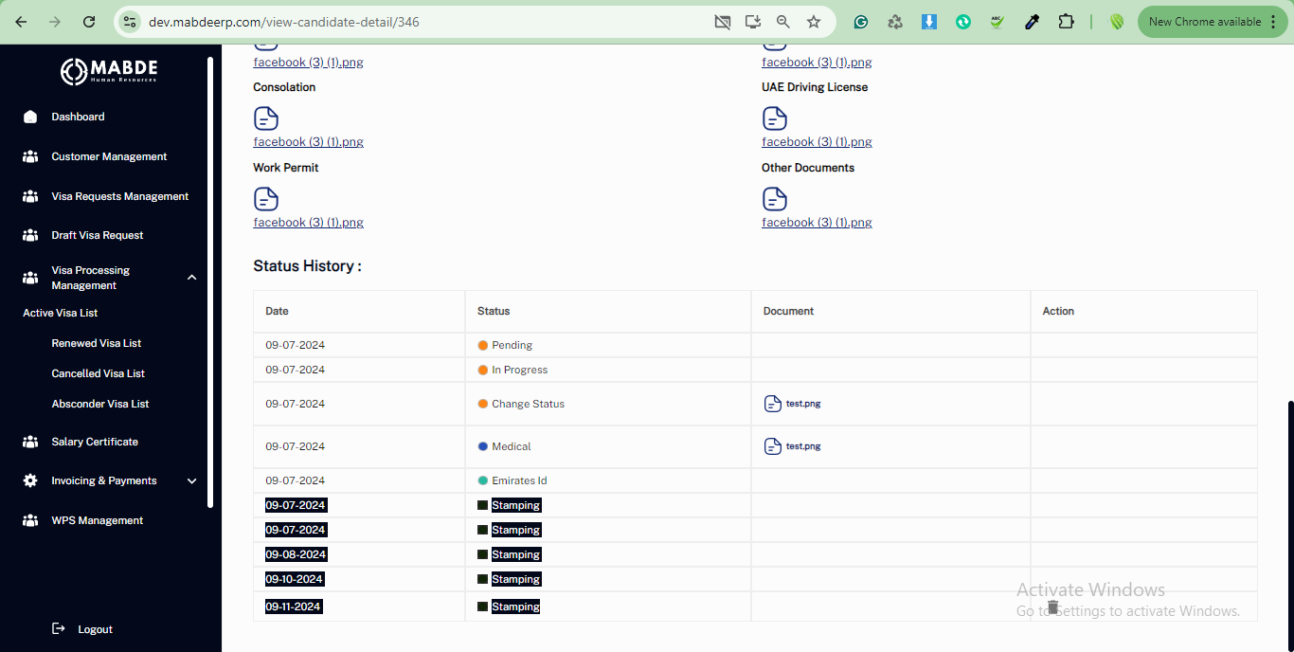

as a customer -> Active visa list-> renew -> docx is mandatory -> submitting without uploading docx + same for cancel and absconder

as a customer -> Renew visa list -> pay invoice -> payment popup -> due amount is not auto fetching in amount (Because Partial Payment is allowed)

as a customer -> renew detail page -> delete status history option missing (As discussed it will only happen in candidate status)

as a customer -> Renew visa list -> invoice not opening (Only Paid Will be Open)

as a customer -> absconder visa list -> pay invoice -> payment popup -> due amount is not auto fetching in amount (Because Partial Payment is allowed)

as a customer -> cancel visa list -> show currency with overstay charges (Whole Software is working on single currency AED its understood )

show currency with all the rates on all pages listing (Whole Software is working on single currency AED its understood )

as a customer -> Active visa list -> is any visa cancelled or absconded still appearing in the Active visa list

as a customer -> if a candidate is rejected in “visa request management “ but still appears in ”Active visa list”

Notifications -> title and content is unclear + action button not working

As Admin -> creating monthly invoices -> with 0 balance

As a customer -> monthly invoice listing -> update payment status is given but not working (Customer Cant Update payment status )

As a customer -> monthly invoice listing -> view invoice permission given but not opening (open if amount is greater than 0 popup shown)

As a customer -> invoice page -> invoice pdf heading issue -> showing “invoice” instead of “Performa invoice” heading for the unpaid invoice.( Backend)

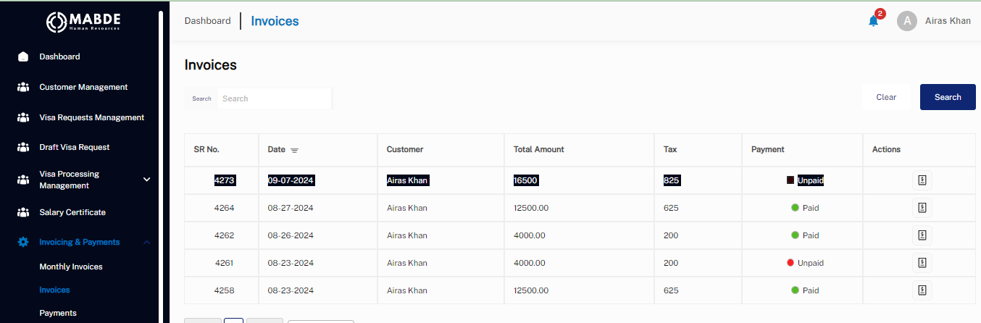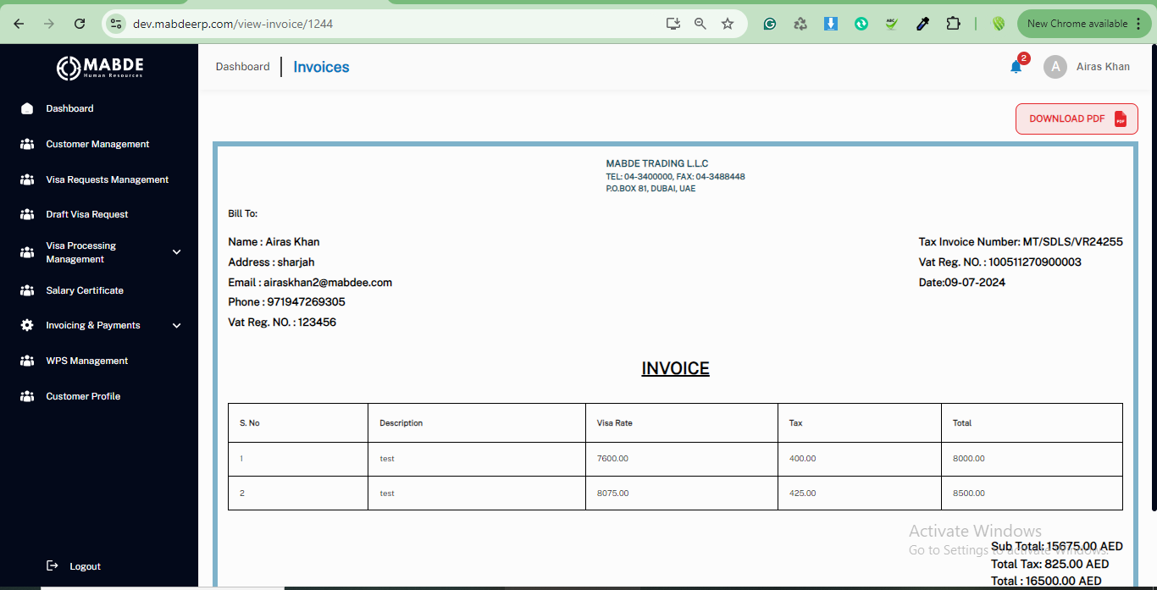

As a customer -> invoice page -> total due amount is not auto-populating in the payment popup.(Because Partial Payment is allowed)

As a customer -> payment page -> candidate name, invoice number, processed by missing (Improve)

As a customer -> WPS -> update status not working.(Customer Can't do that)

QA 2nd Sep

**P1**

In customer creation page – please give PROMPT for unsaved data, if clicked somewhere else or closing the tab.

Download all attachments – ZIP file download will happen – for each candidate – folder must have candidate name also.

Approve button on candidate detail page

Once approved – do not make it clickable – show Update Status button after approved or reject.

Without payment status approved (PAID) – VR cannot go in processing

Profile icon – open it and show options for change password and logout

Notifications icon not working – please take it a new page – it will show all the notifications (dynamic) as we discussed, recent first. Pagination will also be applied. Red pointer to be shown when new notifications are received.

By default, monthly service charges check should be selected.

VIP medical service charges – it is necessary – not option – for adding rate in customer

Agent update – not working properly

Profile view – profile update – for each customer login

Candidate Detail necessary – for customer – agent – admin

Not possible after visa is in progress stage

Will again get eligible for edit – once visa status is active – **only few fields would be editable then**

**Visa sequence in visa processing is wrong**

**P2**

Email correction/improve – Check duplicate email before last step