**System Design Document**

**For**

**Nova Initia**

**CS 491/SE 451**

**Spring 2021**

Sarai Toloza

Jacob Gattuso

Hailey DeNys

Yara AlRashidi

Emily Nunez

|  |  |
| --- | --- |
| Version/Author | Date |
| Version 3.0 ST | 04/13/2021 |
|  |  |
|  |  |
|  |  |
|  |  |

**TABLE OF CONTENTS**

1. INTRODUCTION 3
   1. Purpose and Scope 3
   2. Project Executive Summary 3
      1. System Overview 3
      2. Design Constraints 3
      3. Future Contingencies 3
   3. Document Organization 3
   4. Glossary 4
2. SYSTEM ARCHITECTURE 4
   1. System Software Architecture 4
      1. User Interface 4
      2. Database
3. HUMAN-MACHINE INTERFACE 4
   1. Inputs 5
   2. Outputs 5
4. DETAILED DESIGN 5
   1. Hardware Detailed Design 6
   2. Software Detailed Design 6
   3. Internal Communications Detailed Design 7
5. EXTERNAL INTERFACES 7
   1. Interface Architecture 7
   2. Interface Detailed Design 8
6. SYSTEM INTEGRITY CONTROLS 8

**SYSTEM DESIGN DOCUMENT**

*Overview*

*The System Design Document describes the system requirements, operating environment, system and subsystem architecture, files and database design, input formats, output layouts, human-machine interfaces, detailed design, processing logic, and external interfaces for Nova Initia.*

# 1 INTRODUCTION

## 1.1 Purpose and Scope

The System Design Document describes the system requirements, operating environment, system and subsystem architecture, files and database design, input formats, output layouts, human-machine interfaces, detailed design, KNN algorithm, and external interfaces for Nova Initia.

## 1.2 Project Executive Summary

This section describes the Nova Initia system from a management perspective and an overview of the framework within which the conceptual system design was prepared.

### 1.2.1 System Overview

The goal for the Nova Initia system is to provide a patient with three nose options given by the k nearest neighbors (KNN) algorithm. The three images that the algorithm outputs are the three closest people that have similar facial structure as the patient and the patient will choose a nose that they like the most. The patient will be able to see a 3D image of their face with their current nose, and then after their measurements go through the algorithm, they will be able to see a 3D image of the new nose on their face with the help of the Blender application. Finally, the system will aid the surgeon by giving them a rolling average accuracy during the nose replacement procedure.

The following diagram (Figure 1) gives an overview of the methodology of the system:

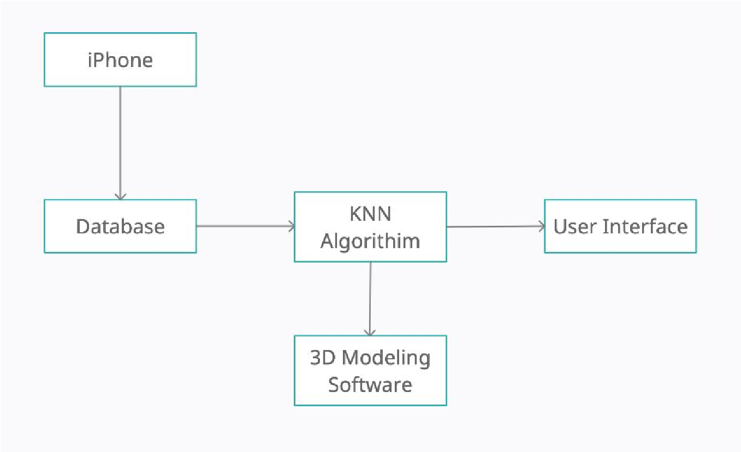

Figure 1: Overview of the methodology of the entire system

1.2.2 Design Constraints

There are regulatory constraints that the system must conform to. The system will require a certificate from the FDA; because the system promises a medical-grade result to the patient, it needs to be approved by the FDA for surgeons to upload the design into their clinics. Being FDA approved will mean that this surgical “equipment” is reliable and compliant. We also need a patient’s permission to scan their faces to improve our database of faces.

The software in its current implementation is designed specifically for iPhones and does not work on any other devices.

1.2.3 Future Contingencies

#### 1.3 Document Organization

This document is designed to give the reader the idea of the system design of Nova Initia. The following sections will provide information on the system’s external and user interfaces, the system’s architecture, software designs, and its integrity.

## 1.4 Glossary

FDA - Food and Drug Association

KNN- K Nearest Neighbors

# 2 SYSTEM ARCHITECTURE

## 2.1 System Software Architecture

### 2.1.1 User Interface

* The user interface will consist of a login page and main page to navigate various enhancements to the app. This will be written in HTML, CSS and Javascript.
* This interface will use React API to implement microservices that will be used to display files from blender.
* The landing page will have a navigation bar, a container for the 3D model, and a form for the user to input patient information and upload a scanned image to the application.
* Upon uploading a 3D scan for the new patient, the user will be prompted to execute the algorithm and a 3D model from blender will appear in the left container.
* The interface will include a calendar for scheduling rhinoplasty procedures, as well as an archive of previous patients with their before and after results.
* The interface will be accessible through a webpage in order to be implemented into the original rhinoplasty application created by the customer.

### 2.1.2 Database

* The iPhone is used to download Bellus3D, the scanning application, from the App Store.
* The application is then used to scan the patients’ and volunteers’ faces to create a database. The scan is then sent as an object file to the Digitized Rhinoplasty web application.
* The Digitized Rhinoplasty Application is used to plot the needed points on the patients’/volunteers’ faces. After positioning the specified points on the nose the JSON files are exported from the application.
* The JSON files are read by read_in.py using Pandas, after the code is run the user is prompted to enter the file name on the console. After entering the file name of the desired file, the program creates data frames and generates a .CSV file of the final data frame into the same directory where the file is being run from. The naming convention uses the patient’s original file name and “_df” added at the end.

# 3 HUMAN-MACHINE INTERFACE

#### 3.1 Inputs

* Each volunteer, with assistance from a Nova Initia team member, will input their face scan into the Bellus3D application.
* The input to the Digitized Rhinoplasty application is the scanned image as an object.
* The system operator will input the patient’s name, ID number, and a 3D scan of the patient's face as a JSON file.
* The Blender application takes in old and new points into Blender via .XLSX file as well as the patient's 3D .OBJ file.

## 3.2 Outputs

* The Machine Learning Algorithm will update the SQL database with the changed points of the patient's nose.
* The system will then pull the .JSON files from SQL and convert them to .XLSX files so that Blender may interact with it.
* The system shall allow Blender to output the new nose .OBJ file when it finishes executing the script in Blender.
* The measurements of change in nose shape are output to an XML file for the surgeon and can be displayed in the UI.

# 4 DETAILED DESIGN

## 4.1 Hardware Detailed Design

The only hardware component needed for Nova Initia is an iPhone with iOS 11.1 or later. The Bellus3D application will only work with the stated phones to ensure the scan is high definition. Reference Figure 1 in order to see how the scanning application is connected to the Nova Initia system.

## 4.2 Software Detailed Design

* The user will scan their image and upload it to the digitalized app and add all needed points.
* Then it will allow the user to upload the JSON file and that file will turn into a CSV file, that CSV file will be used for blender.
* The UI will allow the user to login and upload JSON files of patients.
* The UI will already have all of the users data uploaded & the measurements after going through the algorithm.
* Patients' 3D face scans will be analyzed, and data points will be collected.
* The KNN algorithm will input the K number of patients that are closest to the facial structure of the user.
* The user will input the K number for example 3 or 4 depending on the similarities they have with the database and the patient will then choose a nose that fits their liking.
* Blender will show the new nose on the patient's face.

## 4.3 Internal Communications Detailed Design

We will be using a k-NN Algorithm, first the k-NN algorithm is triggered, then the current patient’s csv file is read and the 14 needed points are pulled. Each point pair is put into the euclidean distance and ratio functions to find the ratio of the distance between the points. The next step in the algorithm is to compare the patient’s face to the database of face ratios. We decided to have k be dependent on each individual patient and how many similar faces can be found within some tbd radius of the current patient. After k similar faces are found, the current patient chooses the nose they believe suits them best and the chosen nose is sent to blender along with the current patient file.

## 5.1 Interface Architecture

The external system used by the Nova Initia system is an SQL server. The system communicates with the SQL server to create its database of faces. Users are able to access the face database through queries. The user will be able to execute the machine learning algorithm, compare before and after 3D models of the patient's face, and display measurements for the surgery.

## 5.2 Interface Detailed Design

The external system used by the Nova Initia system is a SQL server. The system communicates with the SQL server to create its database of faces. Users are able to access the face database through queries. The surgeon will decide what kind of query one would like in order to access information. The options include: pulling stored patient data, saving input patient face measurements, and saving the system created incision data.

# 6 SYSTEM INTEGRITY CONTROLS

The integrity controls for this application are designed to manage the integrity of the data. The Nova Initia system will have access to the patient’s facial point data. The system will save the data after the measurements have been calculated by the surgeon. Only Verified Nova Initia personnel will be able to interact with the system and have access to all the data and be authorized to make modifications to the data.

To ensure that the system is safe from common threats of modern information systems the following levels of control will be implemented:

* Input controls ensure accuracy of data entered into the application. This is implemented within the Nova Initia system or the database schema, or both, by assigning input control types, such as value limit controls, completeness controls, data validation controls, and field combination controls. Data is only entered by verified Nova Initia personnel.
* Internal security or access controls to restrict access of sensitive data to only the surgeon, this does not include the patient.
* Ability to identify all audit information by user identification, network terminal identification, date, time, and data accessed or changed.
* Output controls are concerned with the output of the data calculated after the patient picks a nose. The output controls will appear on the display GUI.