**System Requirements Specification**

**Nova Initia**

**CS 491/SE 451**

**Spring 2021**

Sarai Toloza

Jacob Gattuso

Hailey DeNys

Yara AlRashidi

Emily Nunez

|  |  |  |  |  |
| --- | --- | --- | --- | --- |
| Name | Date | Reason For Change | Initials | Version |
| Initial Release | 09/02/2021 | Initial Release | YA-JG-HD-  ST-EN | 1.0 |
| V2 | 04/03/2021 | Revision based on feedback | HD-JG | 2.0 |

Contents of this Document

1. Introduction

1.1 System to be Produced …………………………………………….4

1.2 Applicable Standards …………………………………………….. 4

1.3 Definition, Acronyms, and Abbreviations …………………..4

1. Product Overview

2.1 Assumptions ………………………………………………………....4

2.2 Stakeholders …………………………………………………………..5

2.3 Event Table …………………………………………………………...5

2.4 Use Case Diagram …………………………………………………...6

2.4.1 Use Case Descriptions ………………………………………….…6

1. Specific Requirements

3.1 Functional Requirements…………………………………………...8

3.2 Interface Requirements …………………………………………….9

3.3 Physical Environment Requirements …………………………...9

3.4 Users and Human Factors Requirements…………………….10

3.5 Documentation Requirements……………………………………10

3.6 Data Requirements………………………………………………….10

3.7 Resource Requirements…………………………………………….10

3.8 Security Requirements………………………………………………10

3.9 Quality Assurance Requirements…………………………………11

1. Supporting Material ……………………………………………………………..11
2. **Introduction**
   1. System to be Produced

The system being produced will be software that takes in the input of a scanned patient's face using a camera and will be added into the patient database. It will then use a k-nearest neighbor algorithm that will give the patient k options for their new nose. This will be done by taking the patient's facial structure points and comparing them to the points of other people in the database. The closest three people that have a similar facial structure to the patient, will be the nose options for the patients. When a patient chooses one, the selection will be sent to Blender by the means of nasal points. Blender will then output a 3D image of the patient with the nose they’ve picked, showing their current versus the new nose they’ll have after the surgeon has performed the rhinoplasty. Finally, if the patient likes their chosen nose, the exact incisions will be output for the rhinoplasty surgeon to give the patient their new nose.

* 1. Applicable Standards
* Data Standards: The only people that will be able to access the patient data will be the surgeon, otherwise the patient data is secured
* Information Standards: The user guide for the application will be posted in the readme file
  1. Definitions, Acronyms, and Abbreviations
* k-NN: k-nearest neighbor

1. **Product Overview**
   1. Assumptions

The first assumption about this product is that the software will run on Windows 10.0 and Mac OS 10.15.6 or later operating systems. The second is that the surgeon will access the program as a local software.

The third assumption is about the software needed to run with the application. The user must have Blender installed on their system with the openpyxl module installed to Blender’s python directory. (If openpyxl is not installed there is a tutorial on the github called “Installing openpyxl to Blender”)

* 1. Stakeholders

1. Plastic surgeon: this user wants to get the most accurate measurements of their patient’s new nose in order to give them the most accurate look according to what the algorithm outputs.
2. Patient: this user will be interested in using this system in order to see themselves with their chosen new nose taken from a similar face in the application database.
3. Customer: the customer wants the software to be produced for plastic surgeons to assist them in picking and determining the measurements for the best new nose for a patient.
4. Hospitals: this technology will be a great investment for hospitals to increase patient flow and enhance overall practice.
5. Private Clinics: this system will help the surgeons and consultants in beauty and health clinics by providing their patients an approximation of the nose the patient wants
   1. Event Table

|  |  |  |  |
| --- | --- | --- | --- |
| Event Name | External Stimuli | External Responses | Internal data and state |
| Scan patient face | Face is scanned using Bellus3D application | A 3D scan is developed and sent to the surgeon | Surgeon receives the scan |
| Input new patient face | Surgeon uploads the patients face scan | Click upload | Surgeon sets points on the face and adds it to database |

* 1. Use Case Diagram 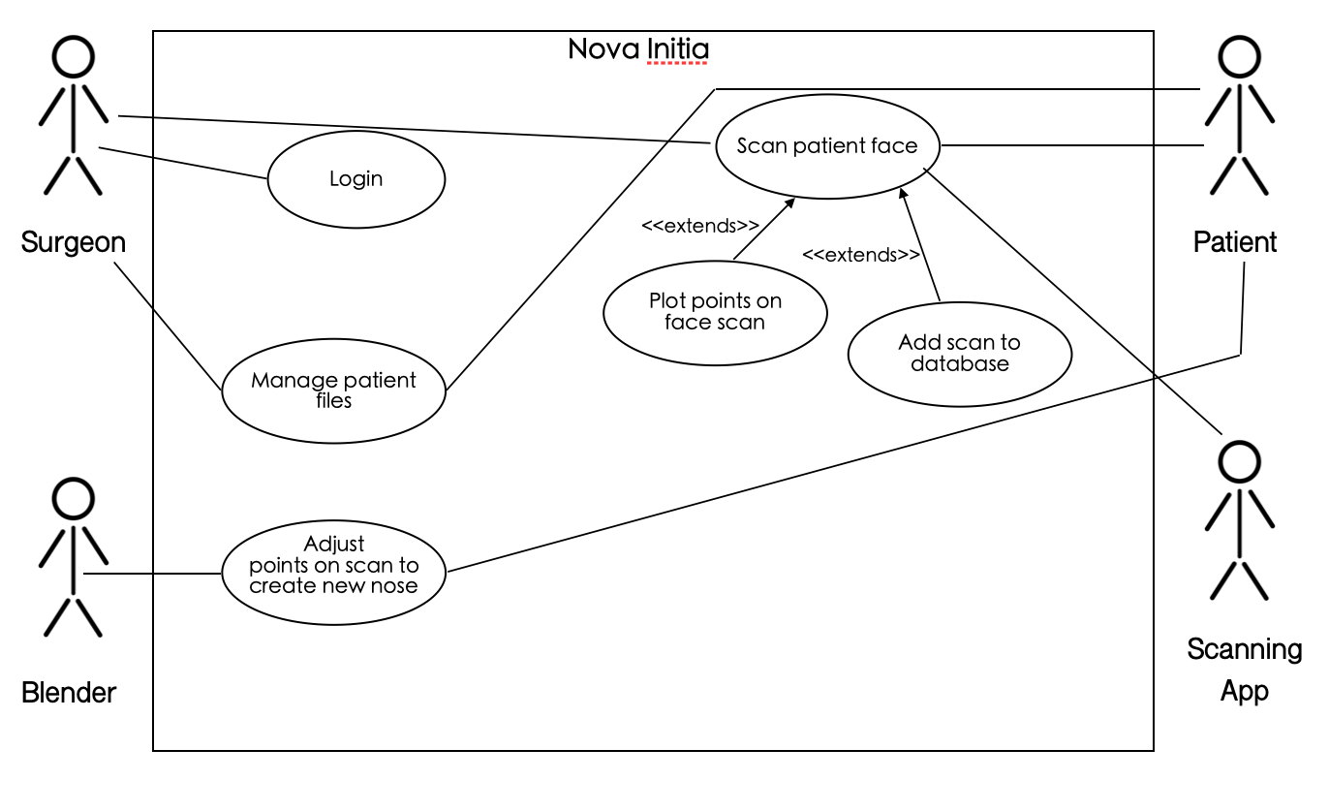

*FIGURE 1: Use-Case Diagram for the system*

* + 1. Use Case Descriptions
       1. Scenario 1: Manage Patient Files

Description: A surgeon would like to add new content or create a new file for a patient

Actors: Patient, Plastic Surgeon

Precondition: The patient has an interest and an appointment with the surgeon in order to change their nose.

Trigger Condition: The surgeon has logged in

Steps:

1. The surgeon has successfully logged in
2. A new patient arrives in the clinic
3. The surgeon inputs the new patients’ information into the system
4. End of use case
   * + 1. Scenario 2: Login

Description: The surgeon has purchased this system and creates or logs in to their account

Actors: Plastic surgeon

Precondition: The doctor is a certified plastic surgeon

Trigger Condition: The surgeon has launched the system

Steps:

1. The system prompts the surgeon for a username and password
2. The surgeon inputs username and password
3. The system verifies the surgeons’ input (ALT1)
4. The surgeon enters the Nova Initia environment
5. End of use

ALT 1: Step 3: The system fails to verify surgeon information

3.1: The system displays an error message

3.2: The user inputs the correct information

3.3: The use case continues at step 1

* + - 1. Scenario 3: Adjust points on scan to create a new nose

Description: The patient will be directed to Blender where they will be able to see the different facial points that need to be moved in order to create the new nose

Actors: Blender, Patient, Surgeon

Precondition: The surgeon has Blender installed in their computer

Trigger Condition: Surgeon chooses to open up the Blender application

Steps:

1. The surgeon chooses a patient
2. The surgeon chooses the option to look at the patient image
3. Blender shows original and endpoints of each variable on the patients face
4. The surgeon moves the original points to the new points displayed
5. End of use case
   * + 1. Scenario 4: Scan Patient face

Description: The surgeon will use a face-scanning app in order to scan the patient and the image turns out to be a 3D image of the patient.

Actors: Patient, Scanning app

Precondition: The surgeon has the application installed on their device

Trigger Condition: The surgeon takes the camera and scans the patients face

Steps:

1. The patient wants to undergo a rhinoplasty procedure
2. The surgeon opens the face app
3. The surgeon scans the patient’s face
4. Extend <<Plot points on face scan>>
5. Extend <<Add scan to database>>
6. End of use case

**3. Specific Requirements**

3.1 Functional Requirements

3.1.1 The system shall create a 3D image of the new nose on the patient's scanned face.

3.1.2 The system shall display the 3D image of the patient's face with a new nose.

3.1.3 The surgeon shall mark points on the patient's face upon upload using the rhinoplasty web application.

3.1.4 The system shall use the k-NN algorithm to pick the k nearest neighbors.

3.1.5 The system shall display k options for the patient to choose from.

3.1.6 The system shall send the patient’s choice to blender.

3.1.7 The system shall create the patient’s new face in blender.

3.1.8 The system shall output the incisions for the surgeon to make on the patient’s face to give them their new nose.

3.2 Interface Requirements

3.2.1 The system shall display a login screen

3.2.2 The system shall display a home screen

3.2.3 The system shall display a preview a 3D face with facial points

3.2.4 The system shall allow input of new patient data

3.2.5 The system shall output new user data to database

3.2.6 The system shall execute Blender for manual face manipulation

3.2.7 The system shall execute the k-NN algorithm when the user triggers it

3.2.8 The system shall allow the user to input images

3.2.9 The system shall output the patient “before image” to Blender

3.3 Physical Environment Requirements

3.3.1 The system shall only be installed in a plastic surgery clinic

3.3.2 The user shall have at least 4.7.3 version of eclipse installed

3.3.3 The user shall have at least 2.90.1 version of Blender installed

3.4 User and Human Factors Requirements

3.4.1 The system shall only accept a certified surgeon that specializes in rhinoplasty as a user

3.4.2 The patient shall be over the age of 18

3.4.3 The patient shall have the consent of a parent or guardian if under the age of 18

3.5 Documentation Requirements

3.5.1 The documentation will be online through the application’s GitHub.

3.5.2 The intended audience shall be doctors and patients.

3.5.3 Doctors shall have previous background in surgical procedures.

3.5.4 The patient shall receive the same feedback as the doctor as well as a blended image of their expected output.

3.6 Data Requirements

3.6.1 Data collected from calculation shall be compared to the faces of the database.

3.7 Resource Requirements

3.7.1 The system’s database shall be updated with the patient’s new nose after successful completion of surgery.

3.8 Security Requirements

The only authorized users for Nova Initia are licensed rhinoplasty surgeons and the developers of the system. The plastic surgeon will be required to verify their license by providing their certification to the system developers before accessing the system.

3.8.1 The system shall only allow access to authorized users.

3.8.2 The system shall save patient data in a secure SQL database.

3.8.3 The system shall isolate patient data from each individual patient file

3.8.4 The system shall backup every time new patient data is uploaded.

3.9 Quality Assurance Requirements

3.9.1 The system shall detect errors when running and troubleshoot based on the error.

3.9.2 The system shall verify the user ID and password before logging in.