Personal Statement
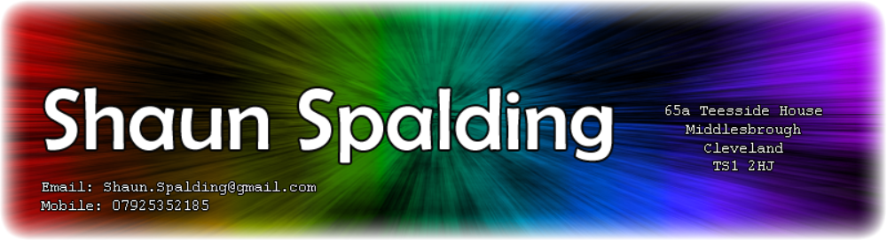Enthusiastic and passionate gamer with a love for all things game and computer related. Broadly experienced in computer use and highly technically competent. Versatile and multi-talented in technical fields. Learns new things rapidly and is always looking to improve on past work. Considered friendly and personable by his peers and able to contribute effectively to team projects.
Skills & Proficiencies
Through the use of a large number of software packages for projects both academic and personal I have developed the following technical competencies:
Competency | Packages used | Available Evidence*
Graphical Editing | Photoshop, Flash | Riddle Game, CV Header
XHTML and CSS | Notepad, Dreamweaver | Personal Website, Riddle Game
Basic PHP | Notepad | Personal Website – Blog feed
Visual BASIC Programming | VB5 – VB6 | Available on Request
C++ Programming | Visual C++Express 2008 | Available on Request
Flash Animation | Adobe Flash | On Website
3D Modelling | 3D Studio Max | Available on Request
3D Animation | 3D Studio Max, Soft Image XSi | http://www.youtube.com/watch?v=LjK9wasJTUU
Games Level Editing | Valve Hammer, UnrealEd | Available on Request
Games Scripting | Valve Hammer, Game Maker 7 | Available on Request
*All evidence listed is available at www.ShaunSpalding.co.uk , www.StuffmadebyGreyfox.co.uk or is available on request via email.
Interests & Hobbies
- Gaming (PC, all consoles & handheld, enjoy all game genres. member of a number of online gaming communities.
- Riddles and Puzzles (I maintain an online riddle game on my website, was 8th in world to finish www.Notpron.com)
- Games Design (Game Maker 7 projects, Online riddle, C++ project)
- Games Level Design (Source Engine, Left 4 Dead & Half life 2, Online riddle)
- 3D Modelling & Animation (3D Studio max, producing game assets for university course and personal projects)
- 2D Animation (Bear cartoon series on website)
- Virtual World Creation (I run a Dungeons and Dragons campaign for fellow students in which I manage the existence of an entire fantasy world. Including towns, geography, dungeons and creatures.)
- Programming (I’ve developed a number of game related tools in Visual Basic and am working on an ambitious game project in C++)
- Technology and Computing in general (Web design, Digital Art, general browsing of games and computing related blogs and websites)
Work Experience
Bookworm, Retford – Sales Assistant | 2005
- Interacted directly with customers
- Assisted customers with locating relevant books
- Ordered stock via database use
- Memorized book locations by category

Education
University of Teesside | 2008 - Present
- Honours Degree – BA Creative Digital Media
  - Year one - Average Module Mark: 62%
Queen Elizabeth’s High School – Sixth Form | 2006 - 2007
- 3 x A Levels
  - Computing (Grade B)
  - Physics (Grade C)
  - General Studies (Grade C)
- 1 x AS Level
  - Mathematics (Grade C)
Queen Elizabeth’s High School | 2001 - 2005
- 10 x GCSEs
  - ICT (A)
  - Physics (A)
  - Biology (B)
  - Chemistry (B)
  - Mathematics (B)
  - English Language (A)
  - English Literature (B)
  - German (C)
  - Design & Tech – Graphic Products (C)
  - Design & Tech – Electronics (B)
References
Available on Request.

