Shaun’s Online Riddle

Though not often considered a part of mainstream gaming there are many, many different games available on today’s internet playable with nothing more than a browser. From interactive flash games to puzzles, riddles and alternate reality games (ARG). Puzzle games and riddles entertain players by setting them a goal, providing them with what they need to think their way to it and then making them feel good and smart for finishing it. Riddles of all kinds often require a lot of lateral thinking on behalf of a player, there are many internet riddle games that have players search for clues in the source code of a html page, find a hidden button or hidden page, manipulate the URL, find something hidden in a picture, there are so many different possibilities for puzzles and riddles born from very simple web pages. And with search engines available to fill in the gaps of any external knowledge a player might need and lack for a puzzle, the possibilities become endless.

When done right, web riddle games can be very addictive. They pull players in and make them work for hours deciphering different codes and finding clues just to get to the next level. But when done wrong it’s very easy for this type of game to lose a player’s interest. Getting the difficulty curve wrong, or not making your riddle fair, or simply not making it interesting enough are all things that ruin a lot of online riddles today. Over the next few pages, I’ll walk you through the design process of the important first few levels of an online riddle game built by me that starts with a simple web page: [www.shaunspalding.co.uk/riddle/begin.htm](http://www.shaunspalding.co.uk/riddle/begin.htm) and then leads you to many more. A game where the only rule is to make progress by any means necessary.

Level 1: Let us begin. ([http://www. shaunspalding.co.uk/riddle/begin.htm](http://www.stuffmadebygreyfox.co.uk/riddle/begin.htm))

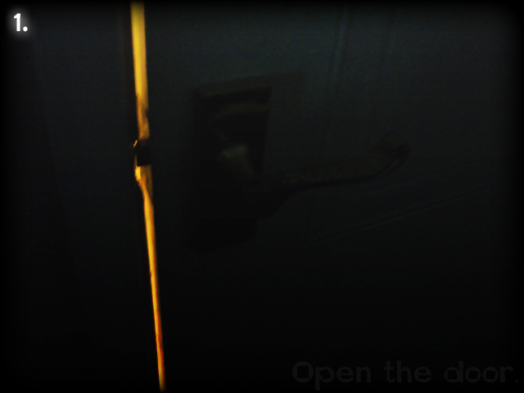Level one is a very simple looking html web page. A black background with an image in the middle. The page has the title “Let us begin.” The image has a number 1 in the corner indicating immediately that there are multiple levels to the riddle, and that they will most likely contain images. The picture is of a door handle in a darkened room with light shining through the crack and there is some dark but very readable text in the bottom right that reads “Open the door.” When the player clicks on the door handle they are sent to level 2. That’s it, dead simple. With a game concept that’s potentially quite confusing the first level is crucial to drawing in players who have no idea what this game is about. Without the text for example, some may see a picture and think “Now what?” get bored and load up COD4 instead. But when given the instruction to open the door, and with the picture being focused straight on to the part of a door that opens; the player’s mouse -the tool they use to interact with anything in a browser (and many, many games) - is drawn over the door handle where they see their mouse icon change to a hyperlink icon and instinctively they click. They are pleased to be brought to level 2. They have accomplished something and it doesn’t matter how small that accomplishment is, because they have been allowed to *begin* playing. The first level doesn’t give you an introduction to the riddle or what the game is about, but when you reach level 2 you suddenly understand the aim of the game is progress through levels. Why you progress, or what you are progressing towards is the mystery that is key to the atmosphere that helps keep players interested. “What is this game about? How many levels are there? What happens at the end?” Even the dumbest player can reach level 2, and everyone who reaches level 2 will have an instinctive urge to try and reach level 3. A game can fail so easily when it neglects to welcome the player into its world. Which is much of what level 1 is all about. Opening a door to a mysterious light beyond. Who knows what you’ll find? Well I already told you, level 2. So let’s take a look at the next step!

Level 2: The way is blocked. (http://www. shaunspalding .co.uk/riddle/thisis/level2.htm)

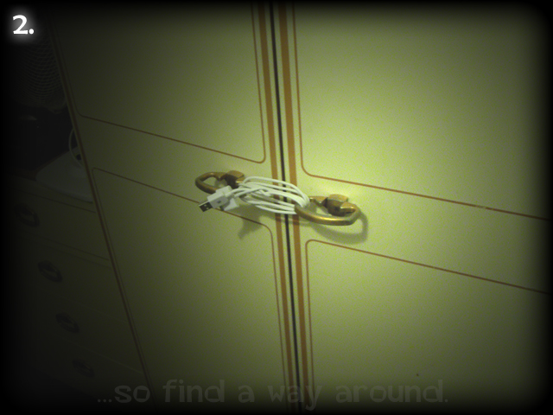Again, what is found on level 2 is a simple black webpage with a picture in the middle and the title “The way is blocked.” The picture is purposely similar to that of level 1, it contains a door, but it is tied up and blocked! The image asks you to “find a way around.” It is revealed to the player at this point that the game isn’t going to be a simple matter of point and click. The level is asking you to think and be creative. You need to reach level 3. How can you do it? Well after a little thinking it should become apparent, if there’s no links to click to find a new page, I need a URL. The crafty player sees the current URL which ends with /thisis/level2.htm . It is inevitable they will eventually try to change ‘level2.htm’ to ‘level3.htm’ which is the solution. Some players will think they cheated their way past a level, but when they try ‘level4.htm’ they are shown a page that says “Nope! Not this time!” which reveals to the player that they were *supposed* to alter the URL. After some testing, I had cases of some players just trying to click everything in the picture, then getting bored and giving up. Not desirable! In light of this I added a link on the page in very clear text to a ‘hints’ page that gives help with the first six levels of the game to get people into it. As a result, even easily bored players with low attention spans still stand a chance at being drawn in. After clicking about the place and not getting anywhere, they scratch their heads and go “Huh, how do you beat this?” they see a link named “Hints” and are quick to click it in search of answers. The little nudge on the hints page reads:

*“****Level 2:****It's sealed tight, you need to find another way around. There's nothing to click.  
A link isn't the only way to change what page you’re on. You're on Level 2. How can you get to****Level 3?****just try it!”*

Ah ha! This hint is enough to get the player thinking about how their browser works and will usually get anyone to level 3. And all the while they still feel great for finding their way there, even though in reality you lead them there. An illusion that I feel is essential to all games of a linear nature. On reaching level 3 some knowledge stays in the player’s brain. “To reach the next level, instead of clicking I may have to do something to the URL.”. As a result the player is given a new tool to approach the game with other than just clicking things. These first few levels are built with two purposes, to draw people into the game by making them feel clever and to introduce the concepts the players will need to understand to beat the higher levels. Level 1 requires no effort, Level 2 requires very little effort, and so naturally Level 3 will continue to slowly up the ante:

Level 3: Something Is Missing... ([http://www. shaunspalding.co.uk/riddle/thisis/level3.htm](http://www.stuffmadebygreyfox.co.uk/riddle/thisis/level3.htm))

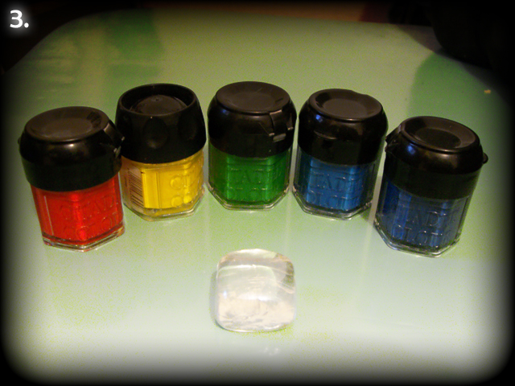Level 3 introduces another gameplay concept to the riddle, that of solving a puzzle to find a word or phrase that will help them progress. After level 1 the player is immediately drawn to clicking on things in the picture that catch his eye. The small white crystal in the middle of this colourful picture does just that. The lighting has been set up specifically to focus the player’s attention on this object. The player clicks it and a username and password box pops up with the title “Rainbow!”. It is obvious to the player what the objective of this level is. To find a username and password that will allow them to progress! But how? Well they are given two clues, the title of the page “Something is missing...” a picture of five colours in the order of the rainbow, and the word “Rainbow!” itself. The colours of the rainbow are common knowledge even to school children (in fact especially so), and to those whom it isn’t, someone nearby they can ask will easily be able to tell them. There are seven colours in the traditional rainbow: red, orange, yellow, green, blue, indigo and violet. You are told that something is missing and you can see that something is missing from this rainbow. There is no orange or violet! TWO colours are missing, and you need TWO words to get to the next level. It soon clicks with players and they gleefully progress to level 4 with the username orange, and the password violet. The hints page is linked again here and gives another nudge for anyone having trouble:

“***Level 3:****Something is missing. Two things actually, since you need a username AND password. Think about it. What isn't there, that should be?* “

This has proven to be enough to stop players from thinking in the wrong direction for too long. Though sometimes it can’t be avoided! Players can get really involved in these riddles and think of a solution that realistically is far too complicated to be the final answer (And if it was, shame on me for making such an unfair boring riddle). For example, one player thought that since he sees paint pots, what is MISSING is a paint*brush*. Players will typically try a few weird theories like this, and then the actual one will ‘click’ in their heads so to speak. When this happens I think the difficulty balance is just about right for a level. But enough about rainbows, we move on to a sinister looking level 4.

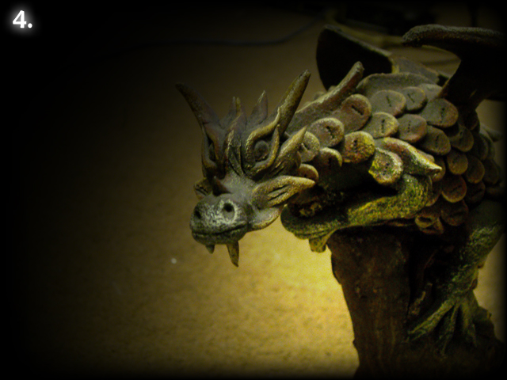Level 4: The Source Code knows its weakness... ([http://www. shaunspalding.co.uk/riddle/missing/picture.htm](http://www.stuffmadebygreyfox.co.uk/riddle/missing/picture.htm) user: orange / pass: violet)

Level 2 set the precedent that not every level is a clicking level. I would undermine this concept if level 4, straight after level 3, was also a click-on-something level, so this level has nothing to click on. And because of level 2 players won’t spend too long trying it. The dragon in the picture of this level is depicted as a personification of the level in the page title. “The Source code knows its weakness.” The player has been given its task. Find the ‘source code’ and use it to defeat the level. The technically proficient among players already understand the term ‘source code’ and know straight where to go from here. They right click on the page and hit “view source” or similar and are given the source HTML code from which the web page is built from. Hidden in this source code is a comment line that gives the player a clue. The source code is a fantastic way of hiding clues in a game like this and it’s a concept I wanted to introduce as early on as I could without throwing players in at the deep end. A link at the bottom of the page reads “But what’s the “Source Code””. The link takes the player to [www.google.com](http://www.google.com) and performs a search for “How to view the source code of a web page?” Many search results are returned that give very simple explanations on how to view a web page’s source code with a simple right click. This google link technique again introduces a concept that will remain in a players mind as a tool for playing the game from that point onwards. A reminder that they are on the internet, and anything they don’t know about, they can search for! Searching for information is one of the most basic uses of the internet and yet so few players would have thought to do so when they didn’t know what ‘source code’ was until that is, searching for information was introduced as being *part* of the game, *fundamental* to the game in fact. After finding the source code of the page the player is given the final hurdle of interpreting the clue it gives you. In the middle of the very short source code (thanks to the very simple design of these web pages) sticking out are the middle lines:

<img src="dragon1.jpg" border="0">

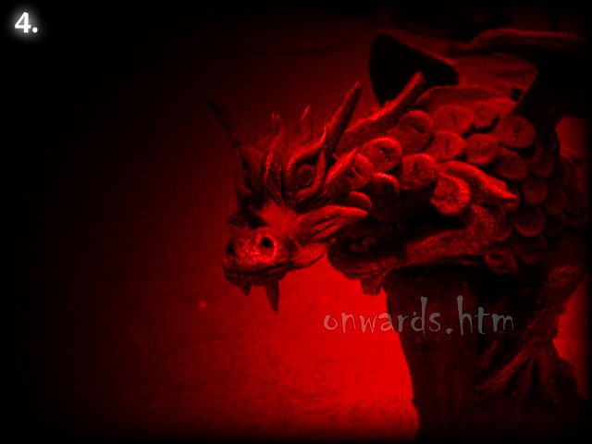<!--The title lied. I have no idea how to defeat dragon1. dragon1 is unstoppable. I heard dragon2 is easy though. -->

So the player is searching for dragon2! Wait... what’s a dragon1? Why does it have a one on the end? This question makes the player search for a dragon1 that can be swapped for a dragon2. It’s not in the URL, but... The picture! The Source Code shows that the picture on the page is dragon1.jpg. The URL of the page also suggests that there is a missing picture. The player will put dragon2.jpg into the URL (Or will possibly view the dragon1 picture separate from the page, and then change the 1 to a 2) and will be greeted with a dark red picture of the same dragon, with the text “onwards.htm” in slightly faded but very obvious and readable text. It becomes apparent that onwards.htm is the next level, so players put onwards.htm in place of picture.htm and are greeted with level 5. Success! The toughest problem here is some players that can understand they need to see dragon2.jpg but have no idea how to do that and don’t know they can put it into the URL. Because of this, level 4 is not perfect. But I’m working on it!

Through this design process here is what I feel I have accomplished in these first four levels of my ‘game’.

* I have drawn in players using a gentle learning and difficulty curve and by providing a simple measure of advancement to create satisfaction in beating levels.
* I have created a dark mysterious atmosphere with no discernable plot and therefore infinite possibilities for the ‘ending’. At the same time I have created an obvious goal that players can understand easily and enjoy.
* I have designed puzzles from the perspective of the player. Thinking from what you first see on the page, through to finding the clues, the interpretation of those clues, and the ultimate logical solution. This makes sure the game is fair, the players stand a chance and don’t simply get bored and frustrated.
* I have introduced the concepts necessary to play the game fairly quickly yet gently and effectively over a span of four almost ‘tutorial’ like levels.
* I have created something that is hopefully fun and interesting, that a wide audience of gamers can play and enjoy.

There are at present 30 levels in my riddle and I am adding more as I get inspiration. It is far from complete; it is far from entirely original in style and even mechanics. As I said, there are hundreds of riddle games on the web. But what I have strived for in the creation of this strange project; is solid, fun and fair design above all else.

[www. shaunspalding.co.uk/riddle/begin.htm](http://www.stuffmadebygreyfox.co.uk/riddle/begin.htm)

-Shaun Spalding