LearnLens AI
AI-Powered Study & Document Assistant using Retrieval-Augmented Generation (RAG)

Submitted as part of the course
Large Language Models (LLMs) & Retrieval-Augmented Generation (RAG)

SARA KHAN NEHALUDDIN

MCA (Master of Computer Applications)

MC-2530

P.G. Department of Computer Science,
SNDT Women's University, Juhu Campus.
Academic Year: 2025–2026

GitHub Link:
https://github.com/sarak12357/LearnLens-AI.git

Table of Contents

Executive Summary
LearnLens AI is an end-to-end Retrieval-Augmented Generation (RAG) application that turns uploaded learning material into an interactive study workspace. It combines document processing, semantic embeddings, FAISS retrieval and Llama 3.1 generation to provide grounded question answering, smart summaries and AI-generated practice quizzes through a Streamlit interface.
Core pipeline: Upload Document → Extract Text → Chunk → BGE Embeddings → FAISS Retrieval → Prompt + Context → Llama 3.1 via Groq → Response
- Session-state handling to prevent stale chat, summary or quiz data after document changes.
- Modular Python service architecture using Streamlit, LangChain, BGE, FAISS, Llama 3.1 and Groq.
- Easy, Medium and Hard multiple-choice quizzes with validation and retry logic.
- Short, Medium and Detailed AI-generated summaries.
- Document-grounded Q&A with expandable retrieved sources.

Key Project Highlights
1. Project Overview
2. Problem Statement
3. Objectives
4. Target Users
5. Dataset Description
6. Data Processing and Preprocessing
7. System Architecture
8. Data Flow / RAG Pipeline
9. Methodology
10. Embedding Model
11. Vector Database
12. Large Language Model and Inference
13. Prompt Engineering
14. Application Features
15. Technology Stack
16. Project Structure
17. Error Handling and Session Management
18. Screenshots of Running Application
19. Challenges and Solutions
20. Limitations
21. Future Scope
22. Conclusion

1. Project Overview
LearnLens AI is an AI-powered study and document assistant designed to convert static learning material into an interactive knowledge base. Users can upload PDF or TXT learning materials such as books, textbooks, notes and research-oriented documents, and then interact with the content through question answering, automatic summarization and AI-generated quizzes.
The core of the application is Retrieval-Augmented Generation (RAG). Instead of using a language model only as a general chatbot, LearnLens first retrieves relevant information from the uploaded document and supplies that information to the language model as context. This improves grounding and makes the generated response more closely connected to the user's own learning material.

2. Problem Statement
Students frequently work with long textbooks, notes and PDF documents. Locating a specific explanation, revising an entire document, or creating practice questions manually can be time-consuming. General-purpose chatbots may also answer from pretrained knowledge rather than from the exact document being studied. The problem is therefore to build a learning assistant that can understand user-provided material, retrieve relevant content and use an LLM to produce useful study-oriented outputs.

3. Objectives
- Build an end-to-end RAG application for educational documents.
- Allow users to upload PDF and TXT learning materials through a simple interface.
- Extract and divide document text into retrieval-friendly chunks.
- Generate semantic embeddings and index them in a vector database.
- Retrieve document passages relevant to a natural-language user query.
- Generate document-grounded answers using an LLM.
- Provide multiple summary depths for quick revision.
- Generate multiple-choice quizzes with configurable question count and difficulty.
- Maintain conversation history and display retrieved source passages.
- Provide a professional Streamlit interface suitable for local and cloud deployment.

4. Target Users
The primary target users are students and self-learners who work with digital study material. The same architecture can also be adapted for teachers, researchers, trainees and professionals who need to search, summarize or revise document-based knowledge.

5. Dataset Description
LearnLens uses user-provided learning documents as its working dataset. The application supports PDF and TXT files. During development and testing, literary books and educational material such as programming-related documents were used to verify question answering, summarization and quiz generation.
Because the application builds a knowledge base from the document selected by the user, it is not restricted to one fixed dataset. This makes the system reusable across different subjects while keeping each interaction grounded in the active uploaded material.

6. Data Processing and Preprocessing
After a document is uploaded, its textual content is extracted. PDF text extraction is handled using PyPDF-compatible document loading, while TXT material can be read directly. The extracted content is converted into LangChain document objects and then split into smaller overlapping chunks using RecursiveCharacterTextSplitter.
Chunking is necessary because passing an entire large document to an LLM for every query would be inefficient and would introduce large amounts of irrelevant context. Overlap between adjacent chunks helps preserve information that crosses chunk boundaries. Empty or invalid content is rejected, and retrieved passages are also checked to reduce duplicate context before answer generation.

7. System Architecture
The system follows a modular architecture. Streamlit provides the user interface and coordinates the workflow. Service modules handle document loading, text splitting, embeddings, FAISS vector-store creation, retrieval, LLM communication, summarization and quiz generation.
[ INSERT SCREENSHOT HERE: System Architecture Diagram ]

8. Data Flow / RAG Pipeline
The complete RAG flow is: Dataset / Uploaded Document → Document Loader → Text Extraction and Validation → Chunking → Embedding Generation → FAISS Vector Store → User Query → Retriever / Similarity Search → Relevant Chunks → Prompt Template → Llama 3.1 through Groq → Generated Response.
[ INSERT SCREENSHOT HERE: RAG Flow Diagram ]

9. Methodology
Document Upload: The user uploads a supported PDF or TXT file from the Streamlit sidebar.
Text Extraction: The document loader extracts textual content and preserves useful metadata such as the document name.
Chunking: The text is divided into smaller overlapping sections so that retrieval can operate on focused passages.
Embedding Generation: Each chunk is converted into a dense semantic vector using BAAI/bge-small-en-v1.5.
Vector Indexing: The chunk embeddings are indexed in FAISS.
Retrieval: A user question is semantically matched against the indexed chunks and the most relevant passages are returned.
Context Construction: Relevant, non-duplicate passages are combined into a context block.
LLM Generation: The context and user query are inserted into a controlled prompt and sent to Llama 3.1 8B Instant through Groq.
Response Display: The final answer is shown in the Streamlit interface together with expandable retrieved sources.
Study Tools: The same uploaded material is also used to generate summaries and structured multiple-choice quizzes.

10. Embedding Model
The project uses BAAI/bge-small-en-v1.5 through the Hugging Face embedding integration. The model converts text chunks and user queries into numerical vectors that represent semantic meaning. It was selected because it provides a good balance between retrieval quality and computational efficiency and can run on CPU for a lightweight student project. Embeddings are normalized before similarity search.

11. Vector Database
FAISS (Facebook AI Similarity Search) is used as the vector database. FAISS stores the generated document embeddings and performs similarity search when a user submits a query. It is well suited to this project because it is fast, local, simple to integrate with LangChain and does not require a separate hosted database service.

12. Large Language Model and Inference
The generation model used by LearnLens is Llama 3.1 8B Instant. The model is accessed through the Groq API. Groq is used as the inference provider, while Llama is the actual language model. This combination provides fast interactive generation for question answering, summarization and quiz creation. The API key is loaded from an environment variable using python-dotenv and should never be committed to the public GitHub repository.

13. Prompt Engineering
Prompt engineering is used to control the behavior of the LLM. For document Q&A, the prompt instructs the model to answer the exact user question, use only information supported by the retrieved material, avoid irrelevant context and return a clear final answer. If sufficient information is not available, the system is instructed to state that the information could not be found in the uploaded material.
For summaries, different instructions are used for short, medium and detailed output. For quizzes, the prompt requires structured JSON containing a question, exactly four options and one correct answer. Difficulty-specific instructions distinguish direct factual questions from questions requiring deeper understanding or interpretation.

14. Application Features

14.1 Ask AI
Ask AI is the primary RAG question-answering workspace. The user types a natural-language question, relevant chunks are retrieved from FAISS and the LLM generates a grounded answer. Conversation history is preserved during the session and the user can expand the retrieved sources for transparency.

14.2 Smart Summary
Smart Summary generates a study-friendly summary of the active document. The user can choose Short, Medium or Detailed depth, allowing the feature to support quick revision as well as more comprehensive review.

14.3 AI Quiz
The AI Quiz feature creates multiple-choice questions from the uploaded material. The user can choose 3, 5 or 10 questions and select Easy, Medium or Hard difficulty. Generated JSON is parsed and validated before display. The application checks that questions contain four distinct options and that the correct answer maps to one of those options. Valid questions can be retained across retries so the requested question count can be completed reliably.

14.4 Conversation and Document State
Conversation history can be cleared through a confirmation dialog to prevent accidental deletion. When a new document becomes active, document-specific state such as old chat, summary and quiz content is reset so that results from one document are not incorrectly displayed for another.

15. Technology Stack
Component | Technology | Purpose
Programming Language | Python | Application and AI pipeline logic
User Interface | Streamlit | Interactive web application
RAG Components | LangChain | Document, embedding and retrieval integration
PDF Processing | PyPDF | Text extraction from PDFs
Text Splitting | RecursiveCharacterTextSplitter | Chunk creation with overlap
Embeddings | BAAI/bge-small-en-v1.5 | Semantic vector representation
Vector Database | FAISS | Similarity search over document chunks
LLM | Llama 3.1 8B Instant | Answer, summary and quiz generation
Inference Provider | Groq | Fast hosted LLM inference
Environment Config | python-dotenv | Secure API-key loading
Version Control | GitHub | Source-code repository and project submission

16. Project Structure
LearnLens-AI/
app.py
requirements.txt
README.md
.gitignore
data/
screenshots/
services/
book_loader.py
embeddings.py
llm_service.py
quiz_service.py
rag_service.py
summary_service.py
text_splitter.py
vector_store.py
utils/
vector_store/
The project separates UI/orchestration from service-level logic. This modular structure improves maintainability and makes each part of the RAG pipeline easier to test, explain and replace.

17. Error Handling and Session Management
The application validates uploaded content, checks for empty prompts and catches errors during LLM, summary and quiz generation. Streamlit session state is used for conversation history, quiz answers, quiz results and document-specific state. Confirmation is required before deleting chat history, and changing the active document resets stale study outputs.

18. Screenshots of Running Application
Insert the screenshots already captured in the project's screenshots folder in the spaces below. Use the clearest screenshot for each feature.Home / Document Upload Screen
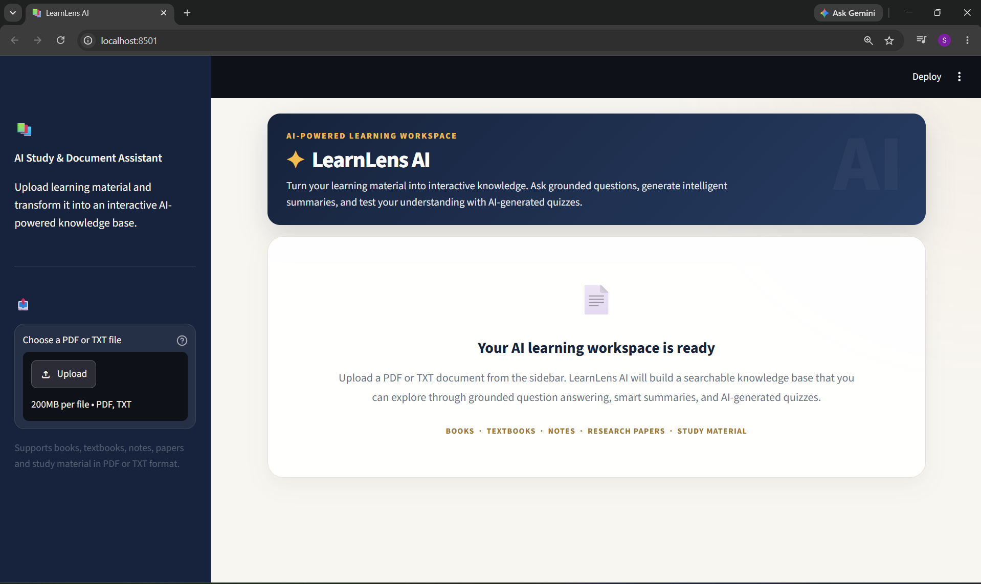

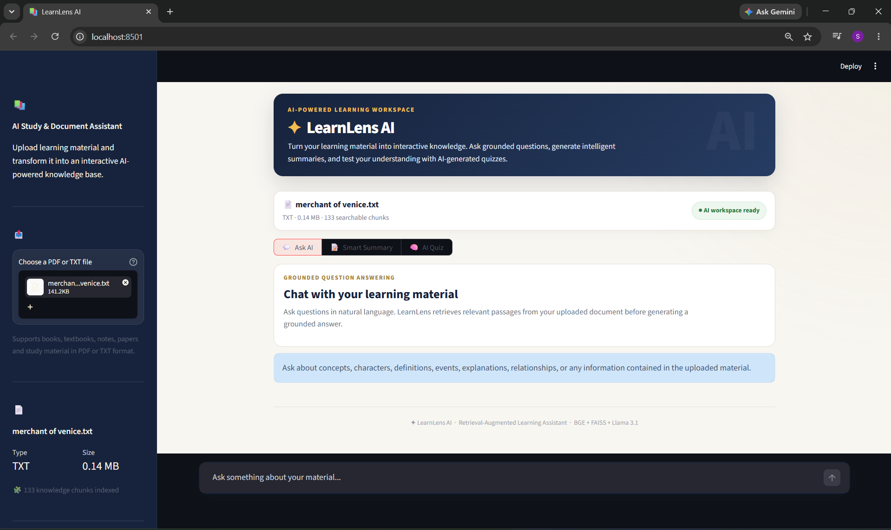

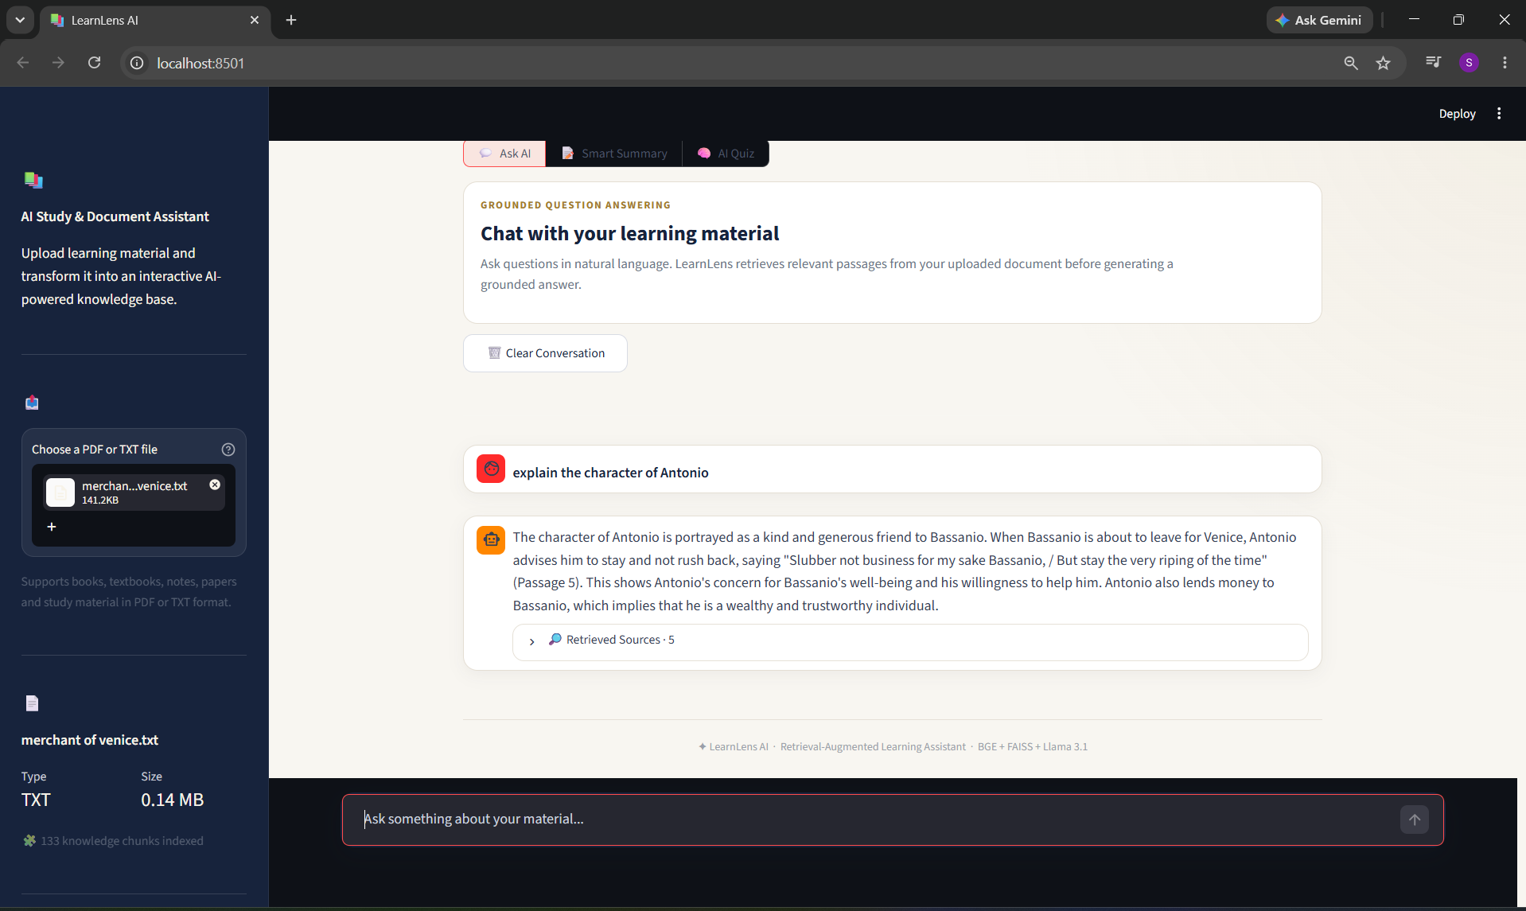
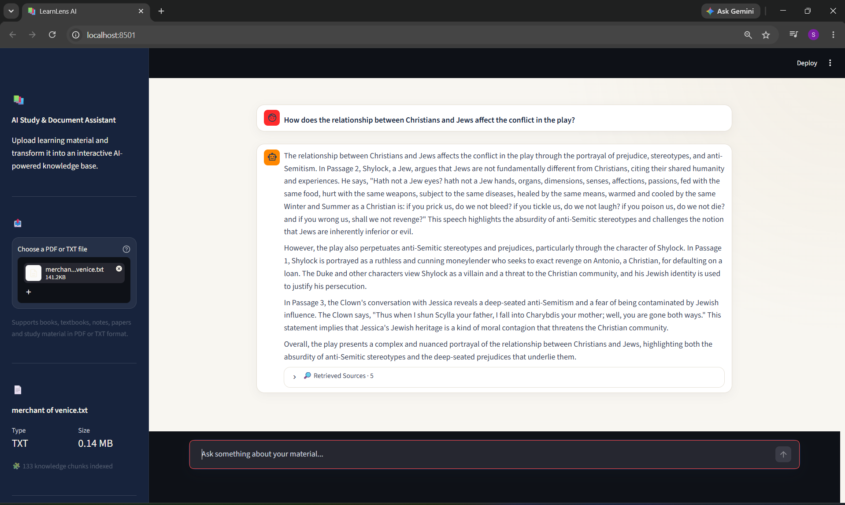
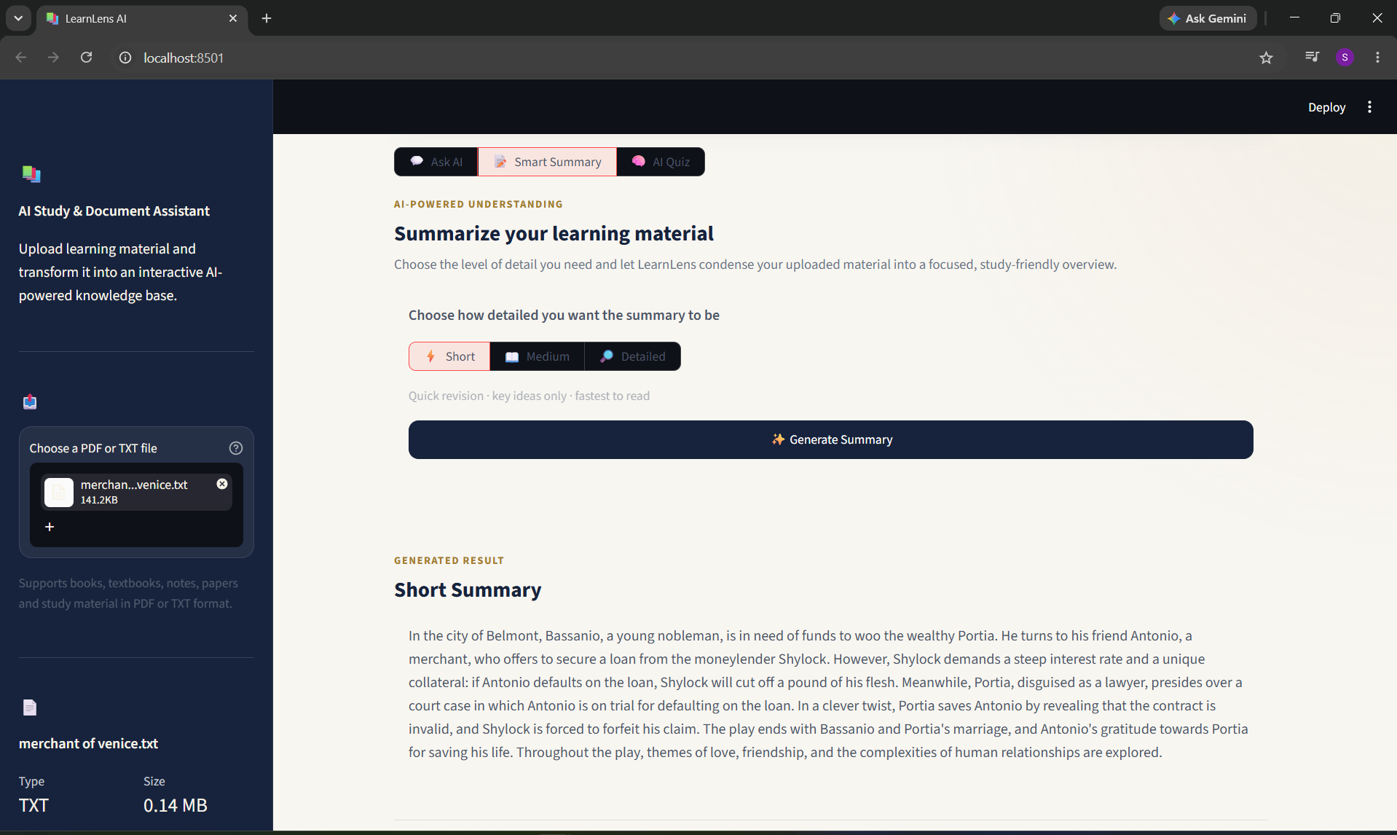
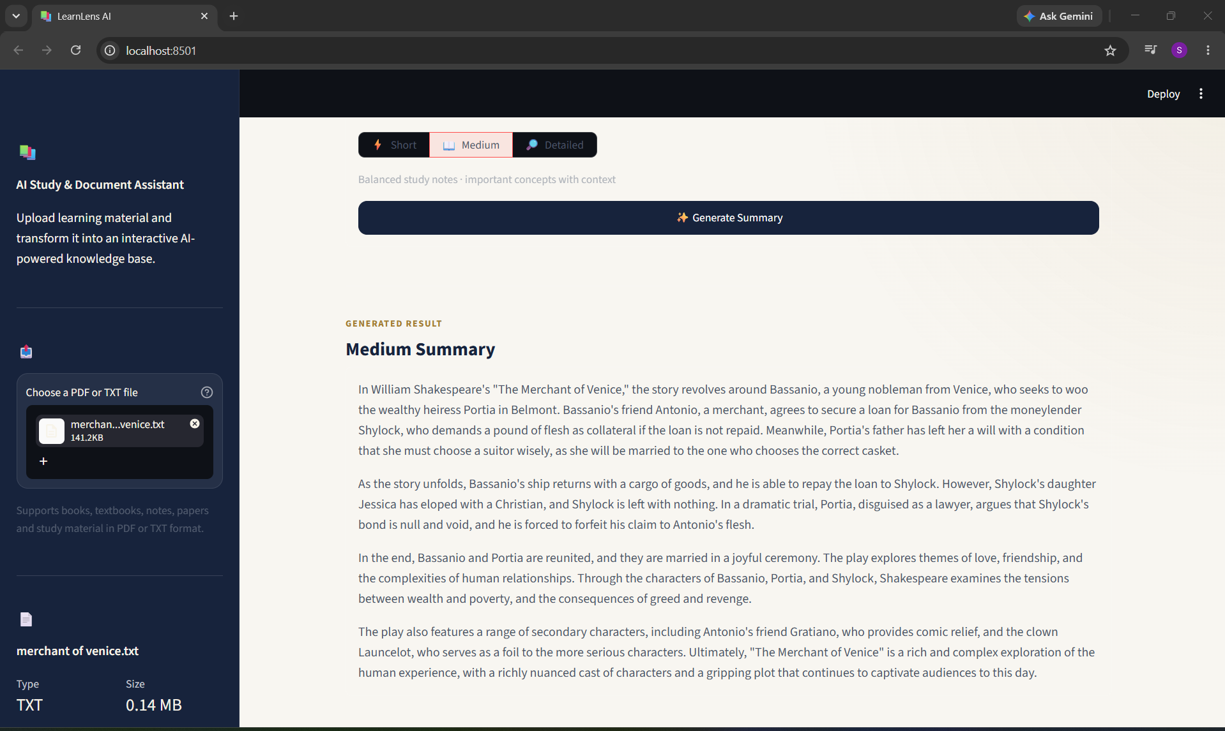
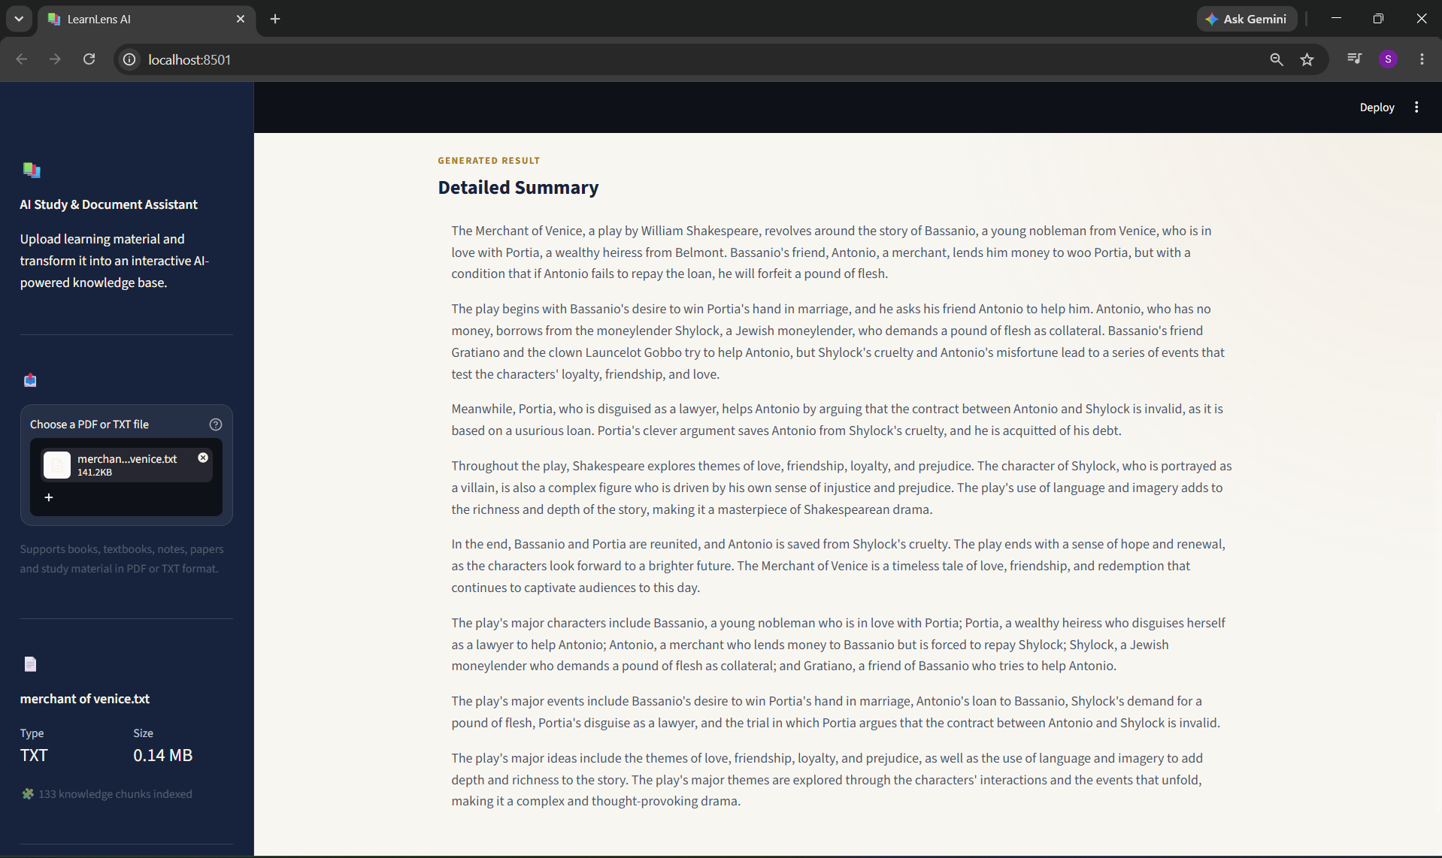
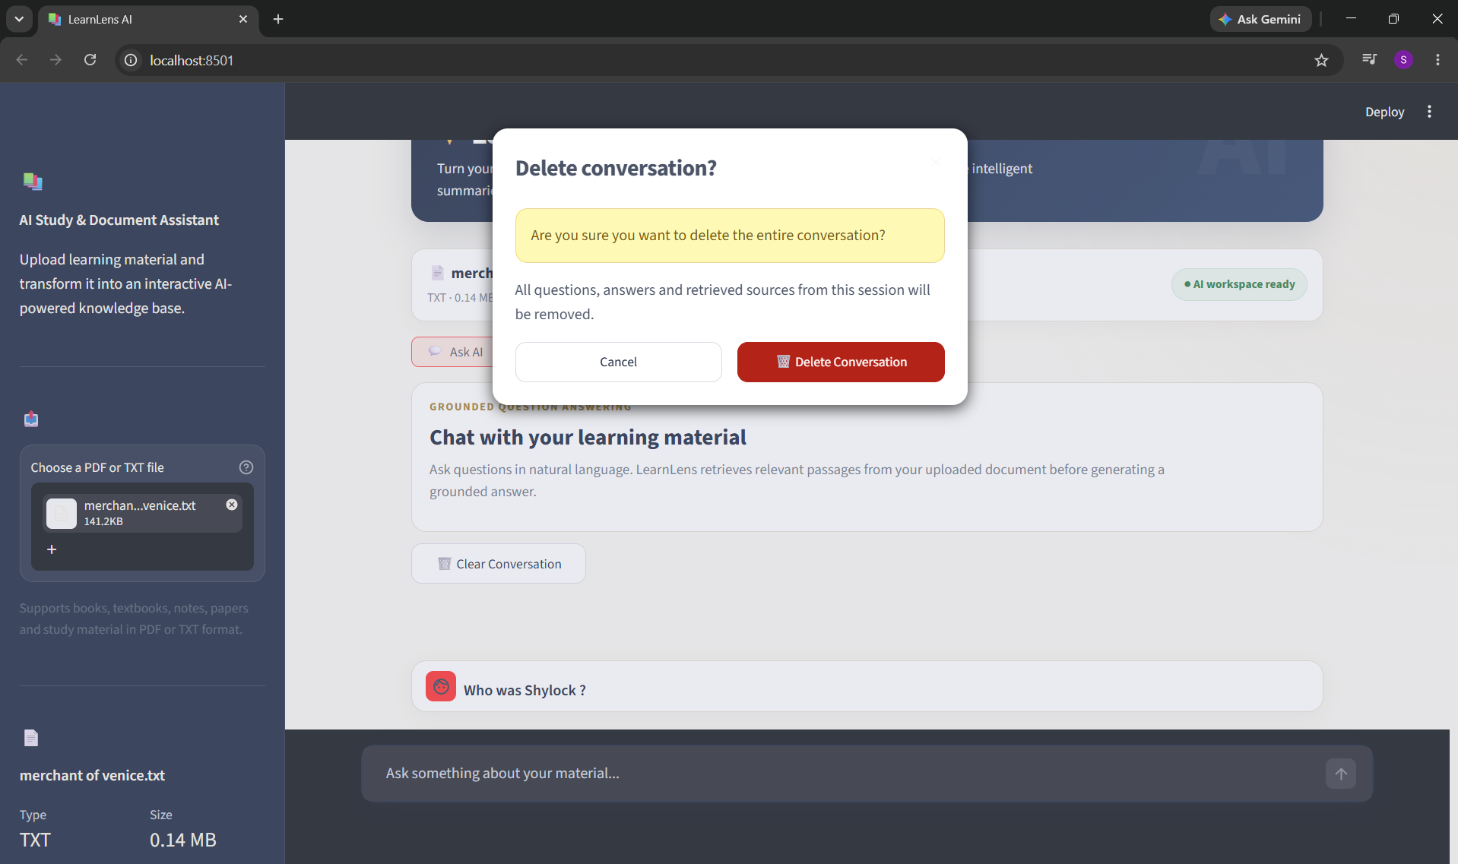
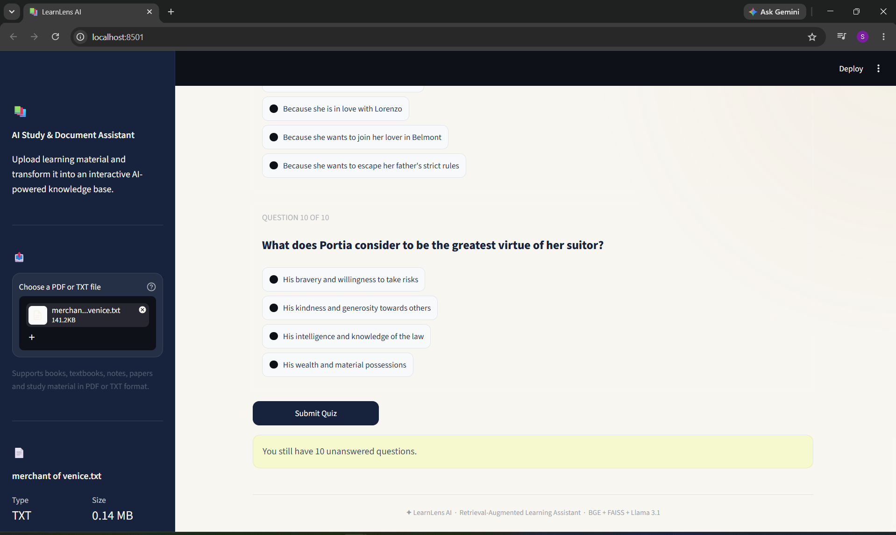
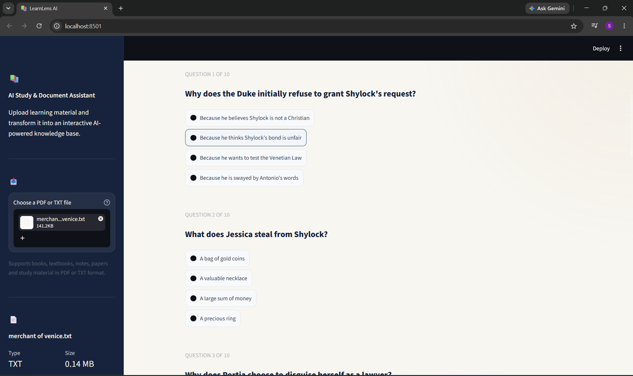
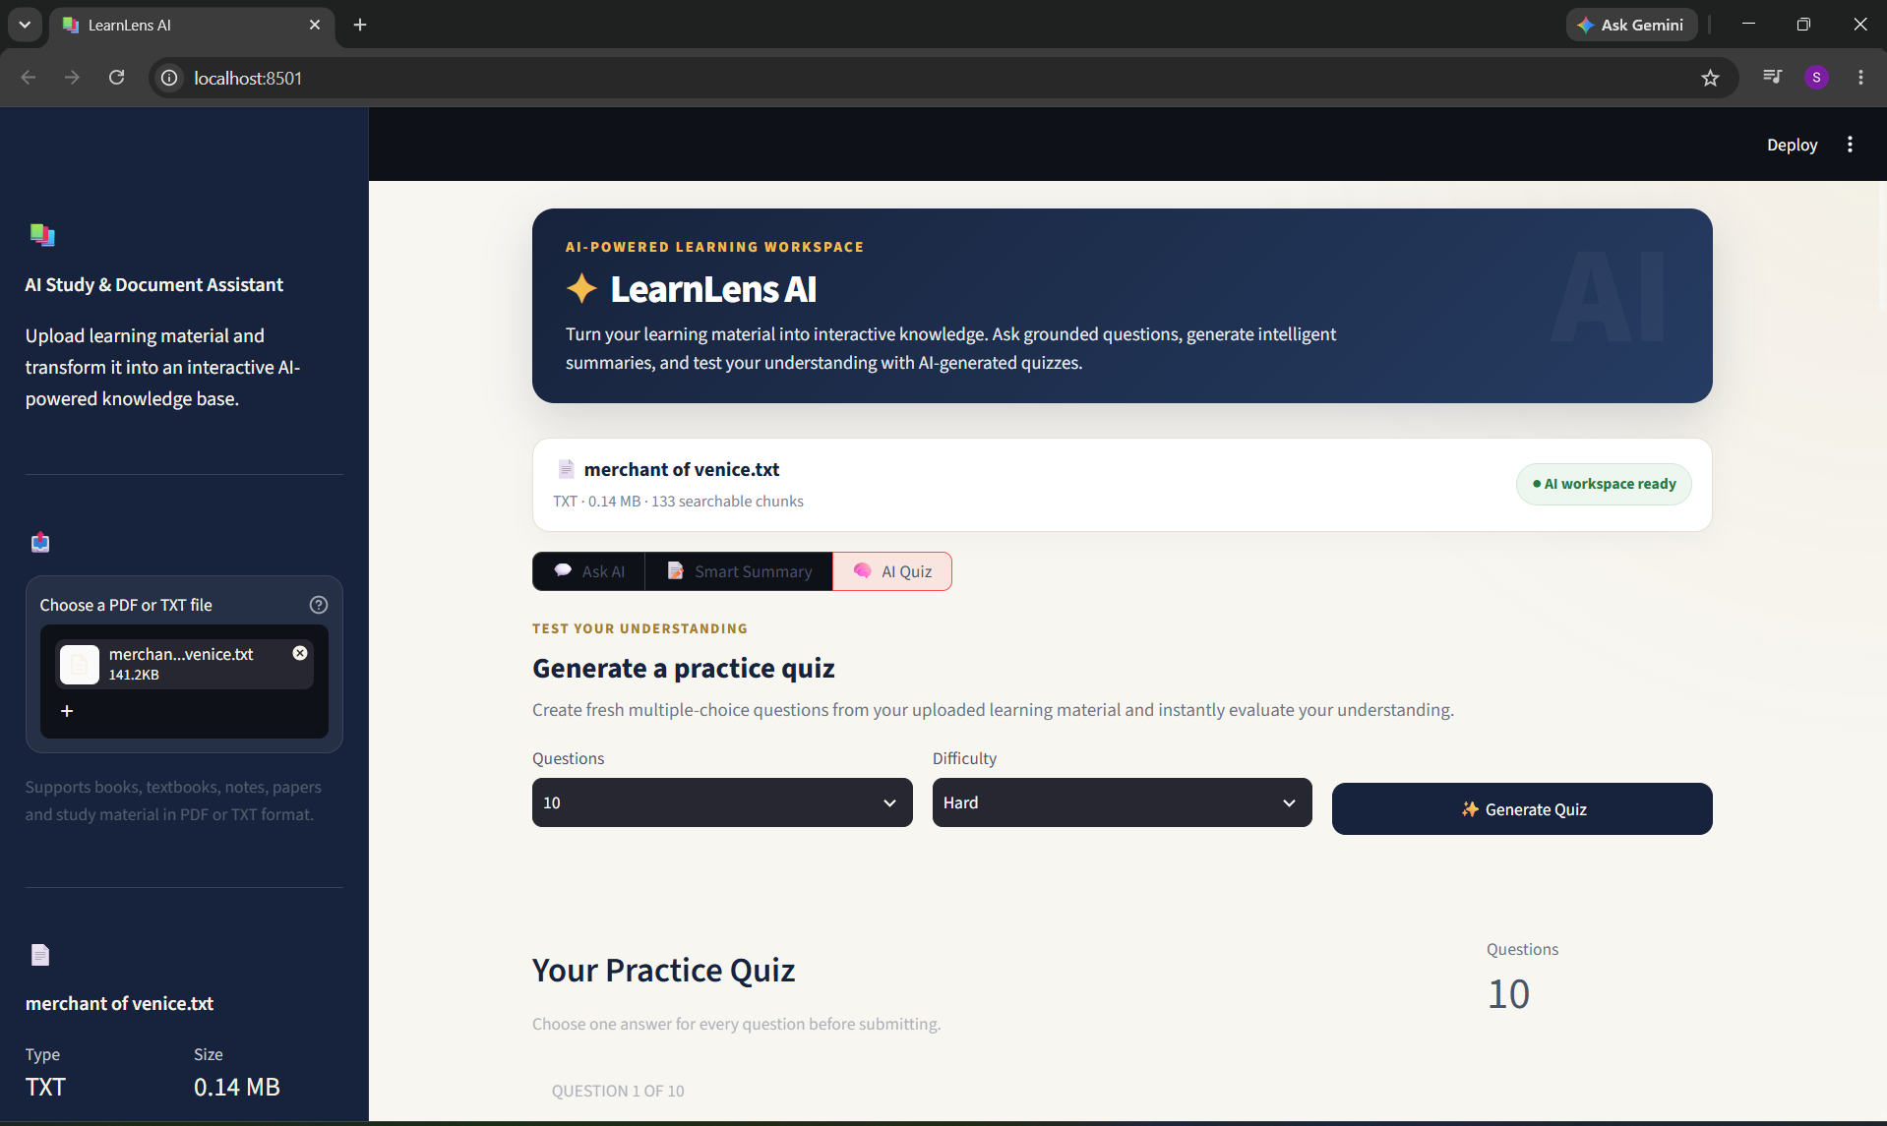

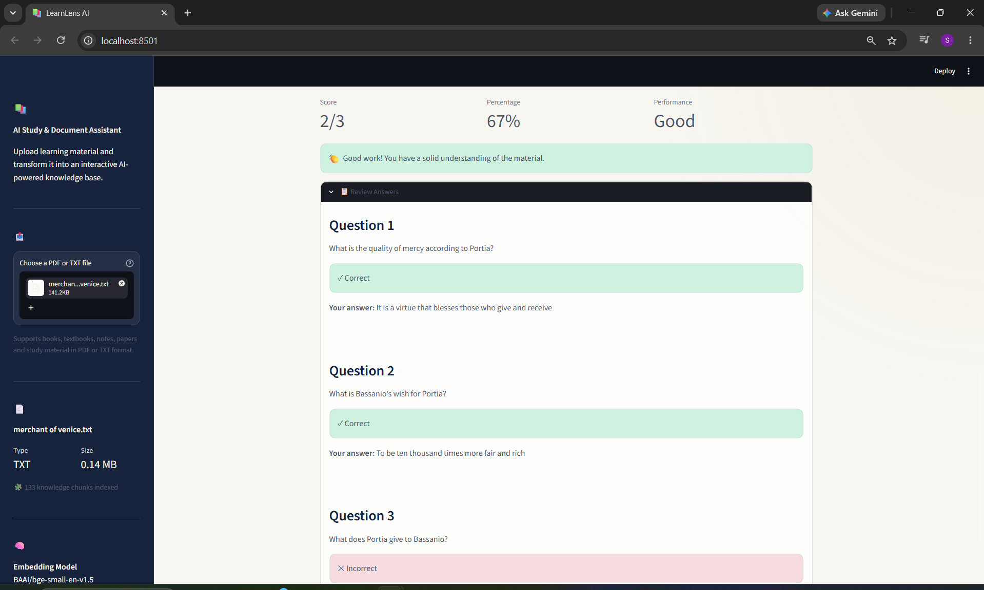
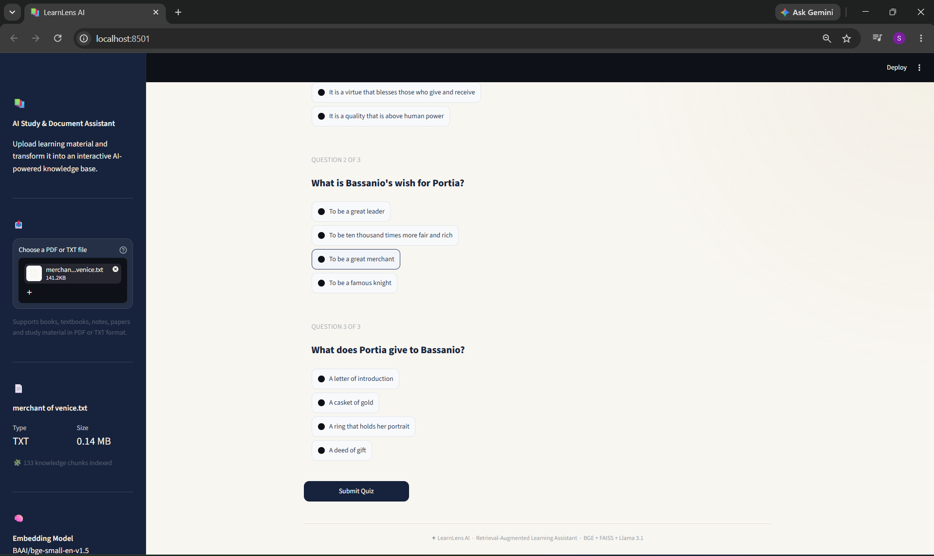
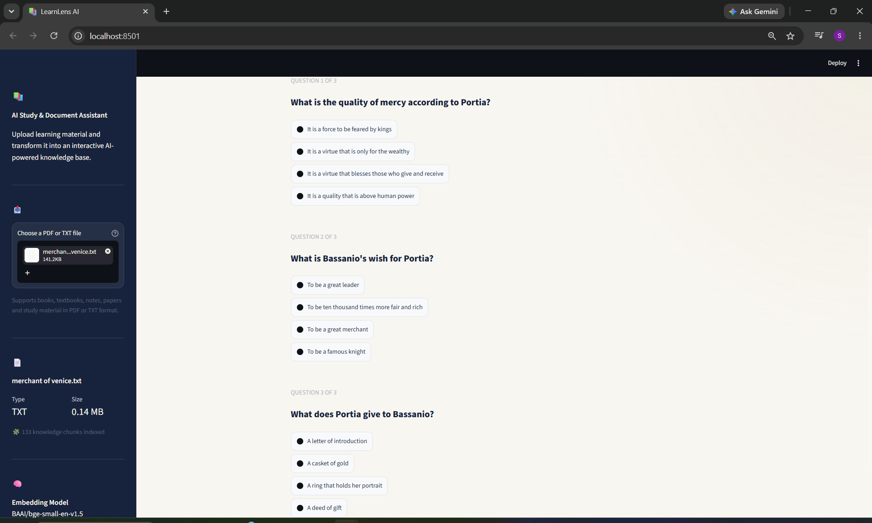
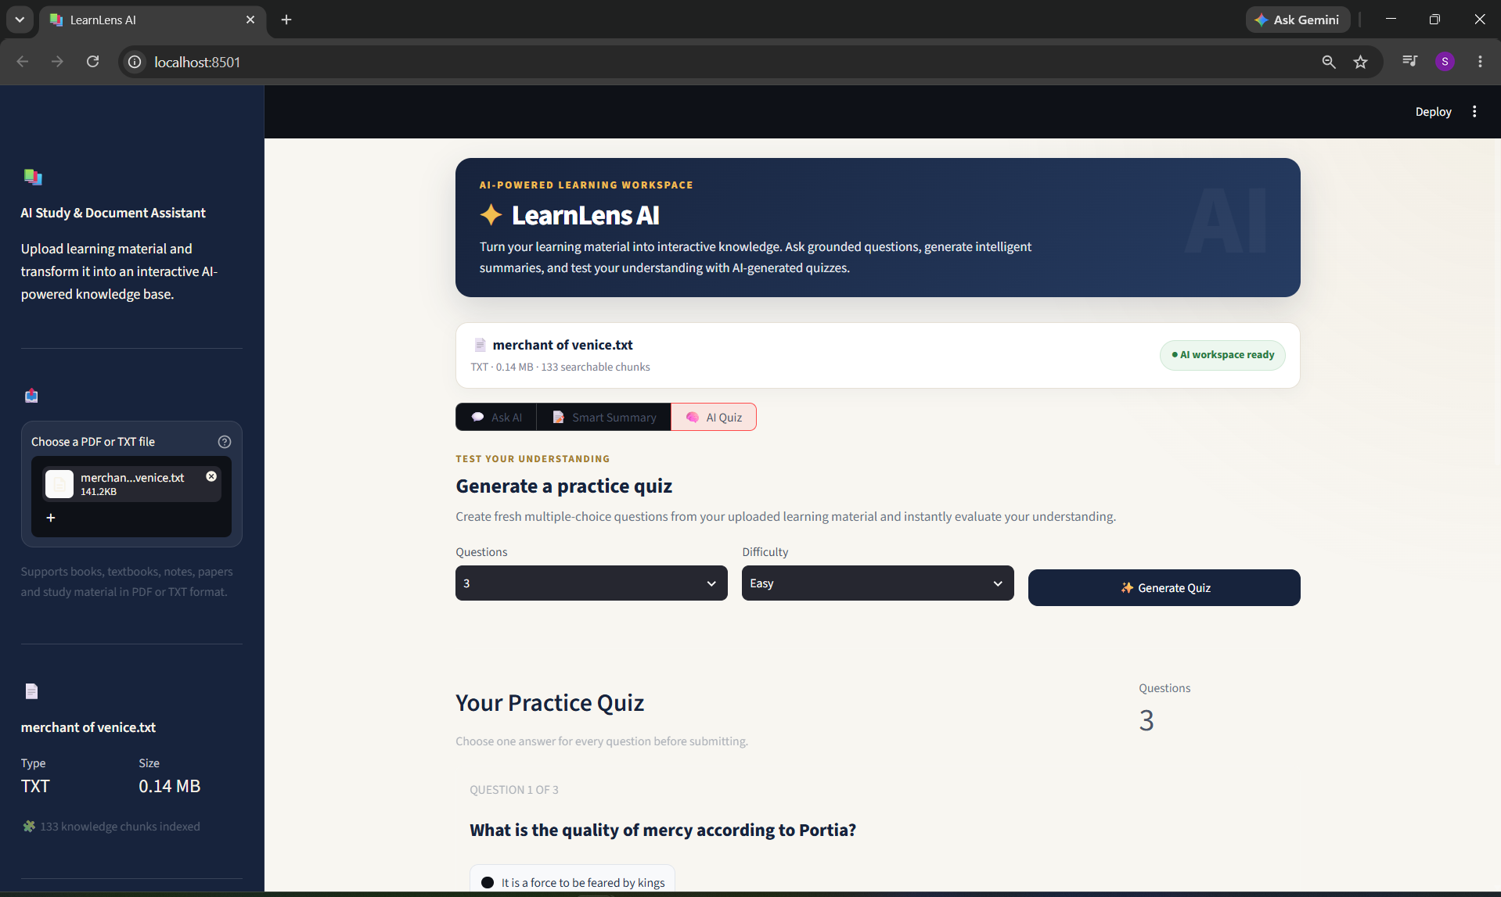
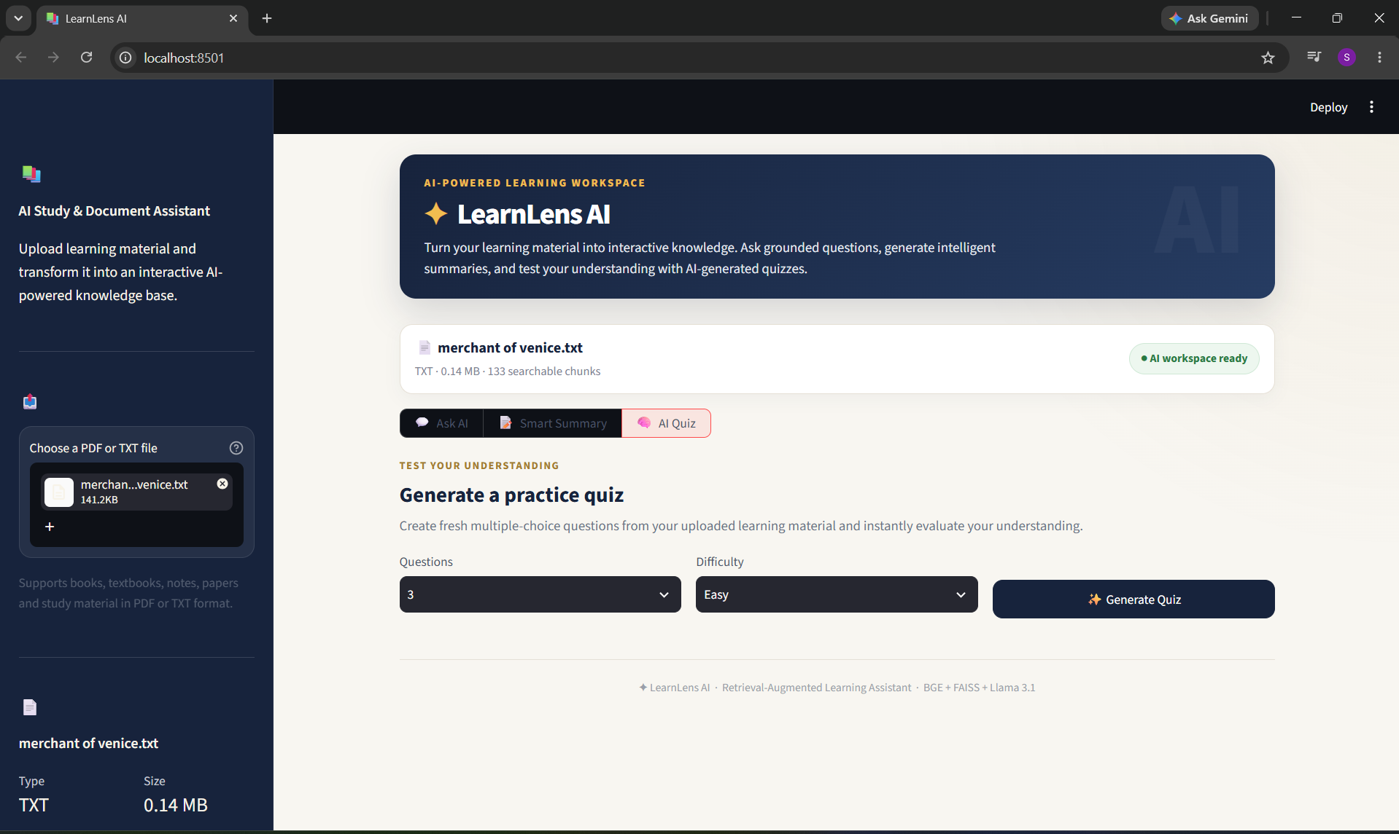

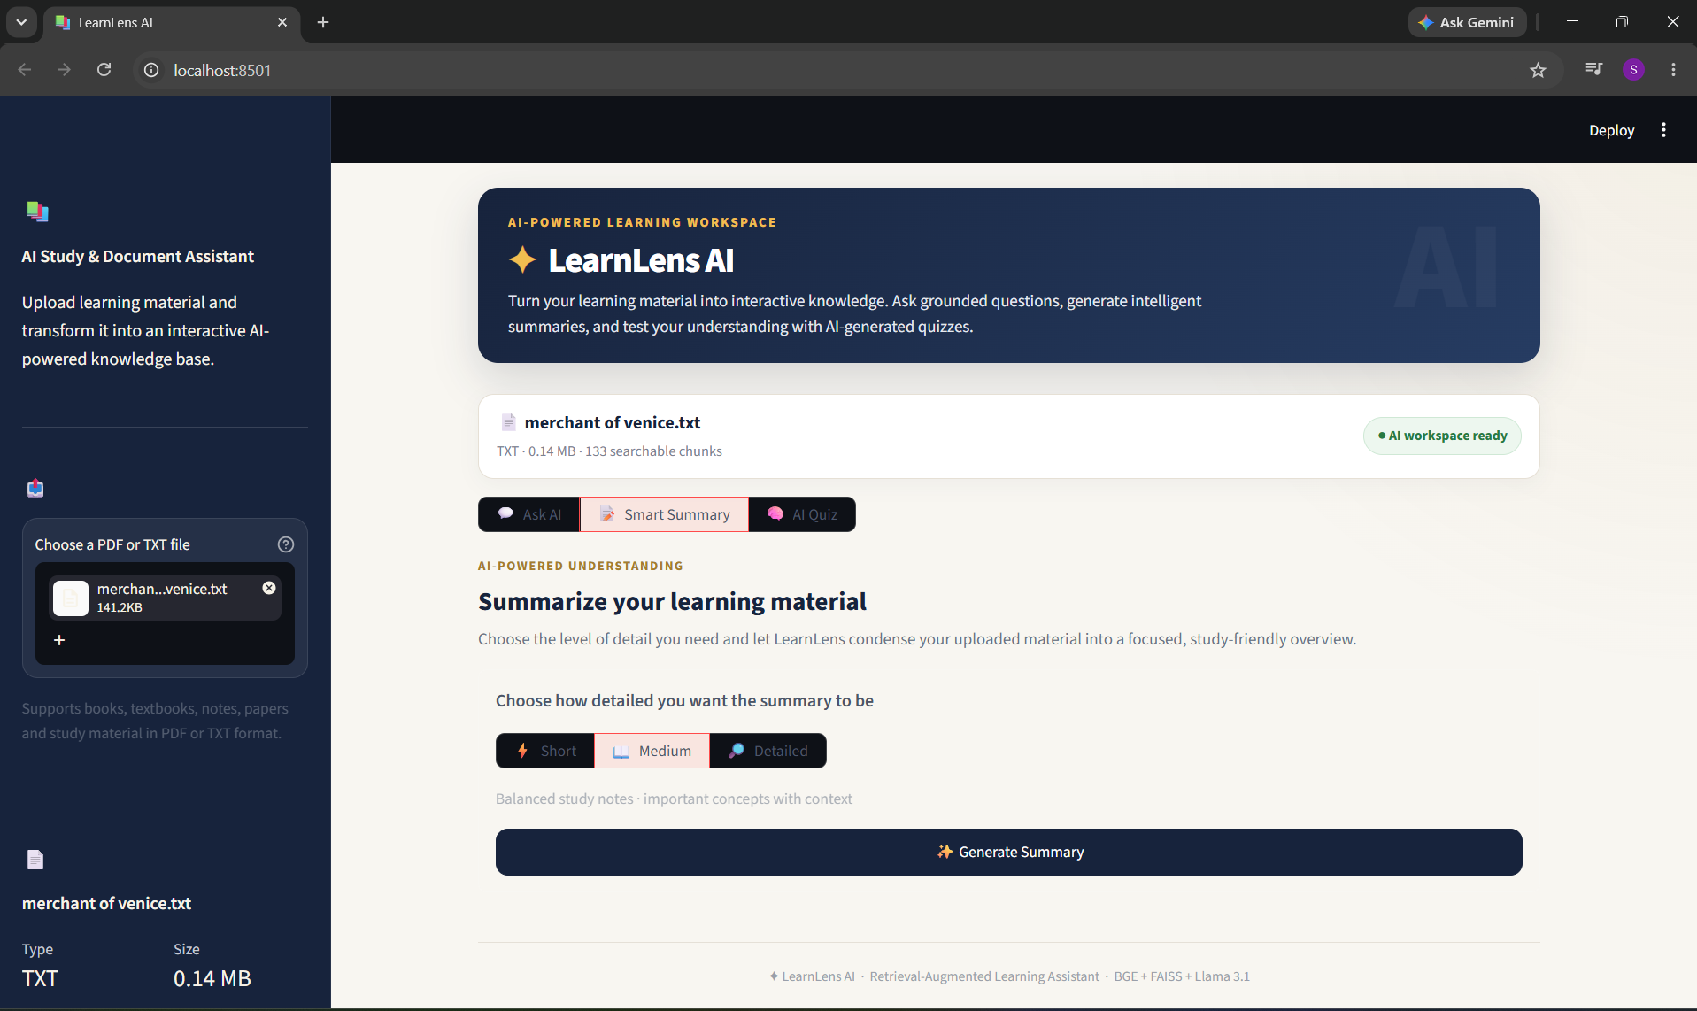

19. Challenges and Solutions
Retrieval quality: Some early answers were inaccurate or overly broad because the most useful passage was not always retrieved. Retrieval count, chunking strategy, duplicate removal and prompt instructions were refined to improve focus.
Chunk boundaries: Dialogue and related explanations could be split across chunks. Chunk size and overlap were adjusted so more contextual information could remain together.
Quiz consistency: LLM-generated quizzes sometimes returned repeated questions, invalid answer formats or fewer valid questions than requested. The quiz service was strengthened with JSON extraction, normalization, validation, duplicate detection and retry logic.
Streamlit session state: Old chat or quiz content could remain after changing documents. Document-specific state-reset logic was added.
User interface clarity: Early versions made the main question input difficult to locate and some quiz text had poor contrast. The interface was redesigned to emphasize Ask AI and improve readability of Summary and Quiz sections.
API security: The Groq API key is stored in environment configuration rather than hard-coded or uploaded to GitHub.

20. Limitations
- Answer quality depends on the quality of document extraction and retrieval.
- Text-only PDF extraction may not correctly process image-only or scanned PDFs without OCR.
- The current application focuses on PDF and TXT rather than all possible document formats.
- LLM outputs are probabilistic, so generated summaries and quizzes may vary between runs.
- FAISS is currently used as a local vector store rather than a persistent multi-user cloud database.
- The application currently focuses on one active document workflow rather than a large multi-document knowledge base.

21. Future Scope
- Add DOCX, PPTX, HTML and web-page ingestion.
- Add OCR for scanned PDFs and handwritten/image-based notes.
- Support multiple documents in one searchable knowledge base.
- Add metadata-aware retrieval and page-level source citations.
- Add a reranking model to improve retrieval precision.
- Add flashcards, study plans and progress tracking.
- Add user authentication and persistent conversation history.
- Add response/export downloads and richer reporting.
- Deploy with scalable persistent vector storage for multi-user use.

22. Conclusion
LearnLens AI demonstrates a complete end-to-end Retrieval-Augmented Generation application for learning materials. The project combines document ingestion, preprocessing, recursive chunking, BGE embeddings, FAISS vector search, prompt engineering and Llama 3.1 generation through Groq in a Streamlit interface.
By combining retrieval with generation, the application goes beyond a generic chatbot and uses the user's own document as an external knowledge source. The resulting system provides document-grounded question answering, flexible summaries and dynamically generated practice quizzes in one study workspace.

