Social Media App

”Aurora”



Sara Källqvist

Front End Development

Sundsgårdens Folkhögskola

2022-01-14

Background

Aurora is the Latin word for dawn, and also the name of the Roman Goddess of Dawn. According to Roman mythology, Aurora renews herself every morning and announces the arrival of the Sun.

Theme

Aurora is a social media app where users can share their nature photography, connect with other users and be inspired by nature photography.

Technical Requirements

The requirements given from our teacher were the following. I have sorted them according to MoSCoW, I prioritised the mandatory requirements and chose a lower priority for the non-mandatory requirements, based on the estimated time it would take me to solve them.

**MUST**

* A user should be able to create an account - username and email
* A user should be able to log into the app - username and email
* A user should be able to share pictures in the app - loading saved pictures with useEffect
* Shared pictures can be liked by other users - does not need to be saved
* A user should be able to create a bio with short information about them - React router to navigate in the app

**COULD**

* Shared pictures can be commented by users
* Be able to add tags to the shared pictures

**WON’T**

* Handle saving the information either in local storage or in some other way

Features

These are the different features I wanted for the app

**Essential features**

* Starting page with carousel images
* Log-in button in navigation bar
* Navigation bar should be on the top of the site and contain icons only
* User personal page with short bio and published photos
* Explore page with different user´s pictures
* Pictures can have different orientation, landscape and vertical in a grid
* Publish photo should be accessible from navbar
* Search function in navbar for tags, locations and user names

**Non-essential features**

* Possibility for user to follow others
* Professional accounts
* Private messaging between users
* Ability to add geo-tags
* Ability to add hashtags

Product Backlog

Site map

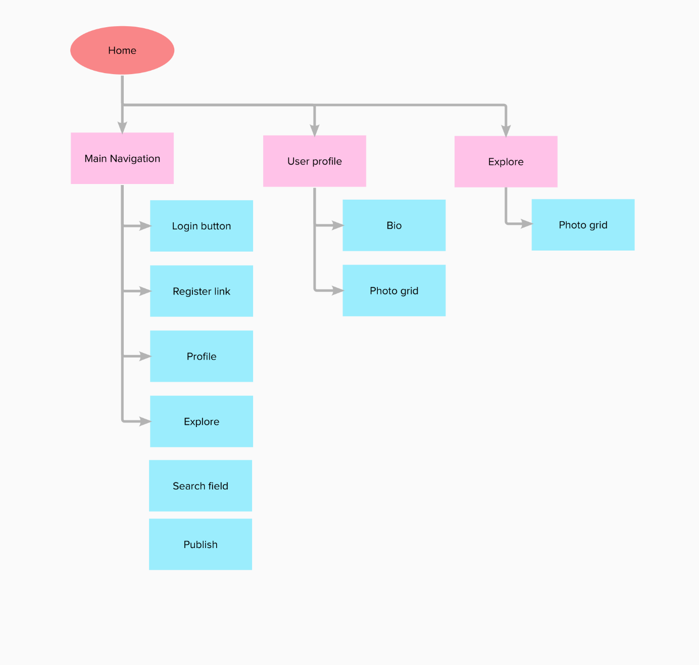

Time plan/schedule

|  |  |  |  |  |  |  |  |  |
| --- | --- | --- | --- | --- | --- | --- | --- | --- |
| Activity | January 14 | January 15 | January 16 | January 17 | January 18 | January 19 | January 20 | January 21 |
| Plan project |  |  |  |  |  |  |  |  |
| Design |  |  |  |  |  |  |  |  |
| Gather images and icons |  |  |  |  |  |  |  |  |
| Code navbar |  |  |  |  |  |  |  |  |
| Code landing page |  |  |  |  |  |  |  |  |
| Code login/register page |  |  |  |  |  |  |  |  |
| Code user profile |  |  |  |  |  |  |  |  |
| Code publish photo |  |  |  |  |  |  |  |  |
| Code like feature |  |  |  |  |  |  |  |  |
| Hand in assignment |  |  |  |  |  |  |  |  |
| Handle/code remaining tasks |  |  |  |  |  |  |  |  |
| Present project |  |  |  |  |  |  |  |  |
|  |  |  |  |  |  |  |  |  |