**MongoDB -Tasks1**

1. Find all the information about each products?

Answer **:**

**db.product.find();**

**Screenshot** :

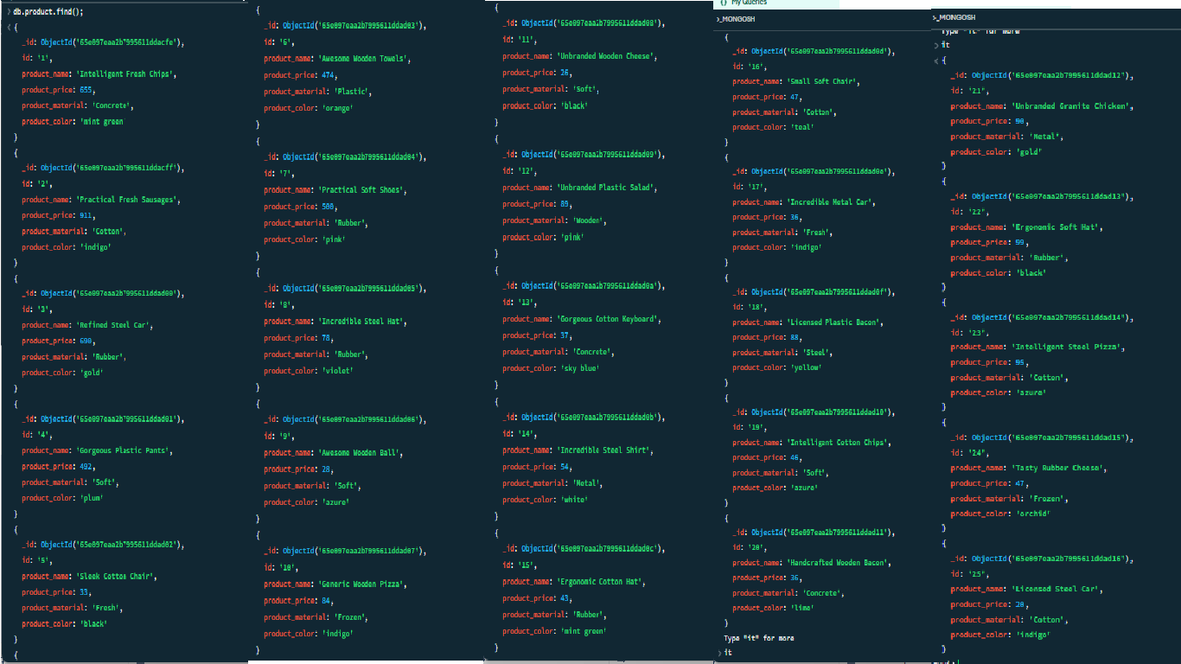

1. Find the product price which are between 400 to 800?

Answer **:**

**db.product.find({‘product_price’:{$gt:400, $lt:800}});**

**Screenshot** :

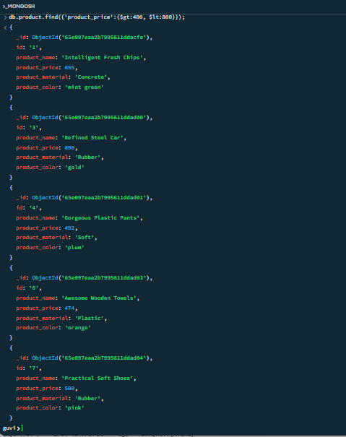

1. Find the product price which are not between 400 to 600?

Answer :

**db.product.find({$not : {$gt:400, $lt:800}});**

**Screenshot** :

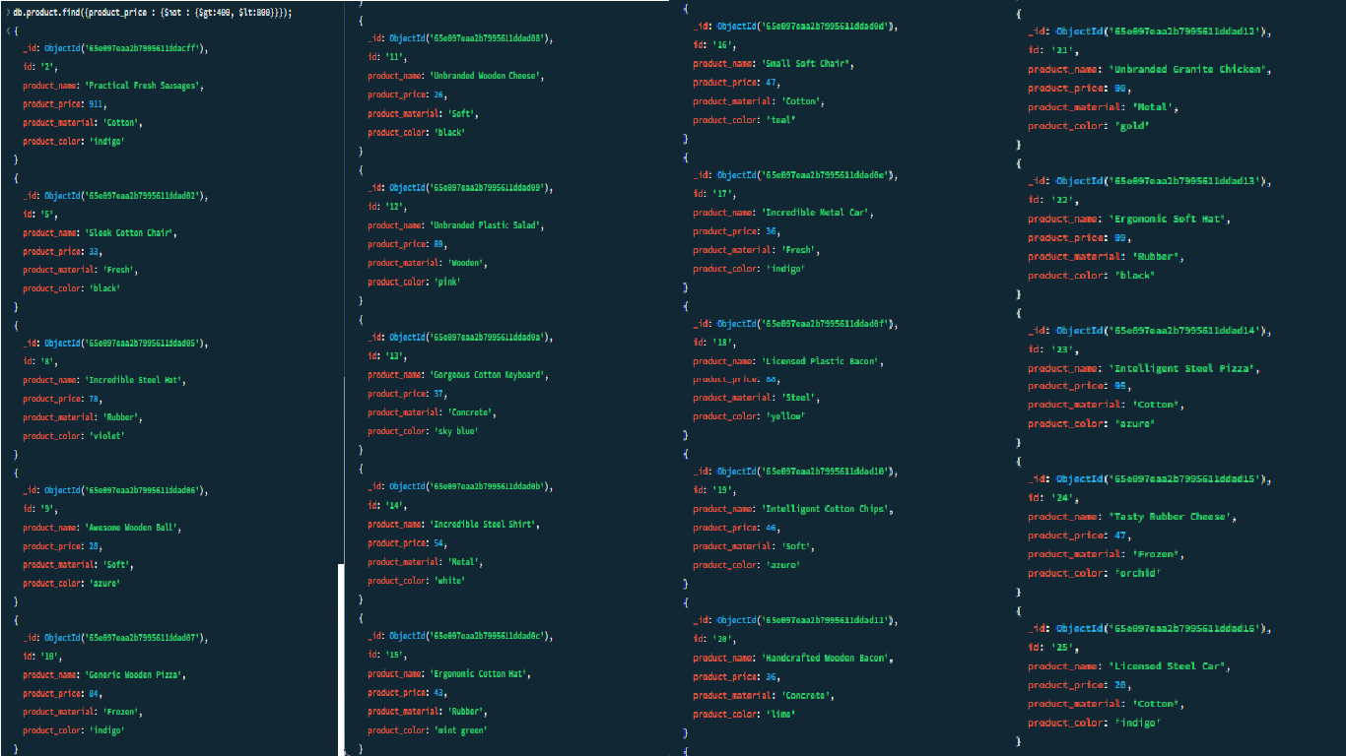

1. List the four product which are greater than 500 in price?

Answer **:**

**db.product.find({‘product_price’ : {$gte:500}}).limit(4);**

**Screenshot** **:**

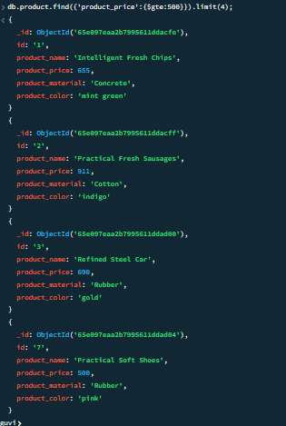

1. Find the product name and product material of each products?

Answer **:**

**db.product.find({}, {‘product_name’ : 1, ‘product_material’ : 1});**

**Screenshot** **:**

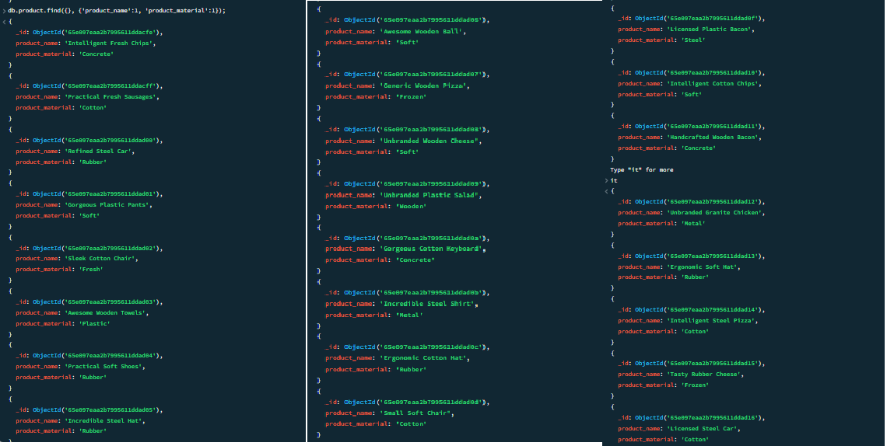

1. Find the product with a row id of 10?

Answer **:**

***Method-1* 🡪 db.product.findOne({‘id’ : ‘10’});**

***Method-2* 🡪 db.product.find({‘id’ : {$eq : ‘10’}});**

**Screenshot** **:**

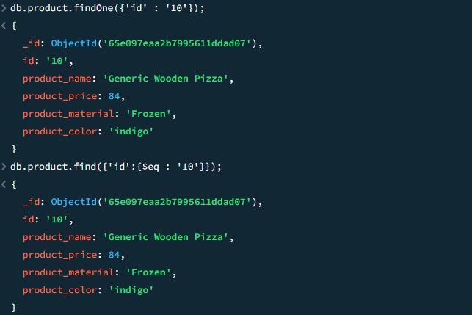

1. Find only the product name and product material?

Answer **:**

**db.product.find({}, {‘_id’ : 0, ‘product_name’ : 1, ‘product_material’ : 1});**

**Screenshot** **:**

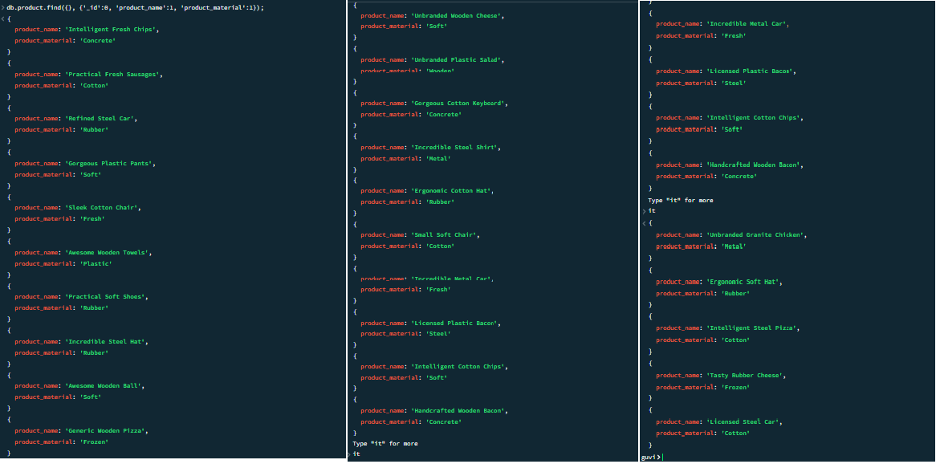

1. Find all products which contain the value of soft in product material?

Answer **:**

***Method-1* 🡪 db.product.find({‘product_material’ : ‘Soft’});**

***Method-2* 🡪 db.product.find({‘product_material’ : {$eq : ‘Soft’}});**

**Screenshot** **:**

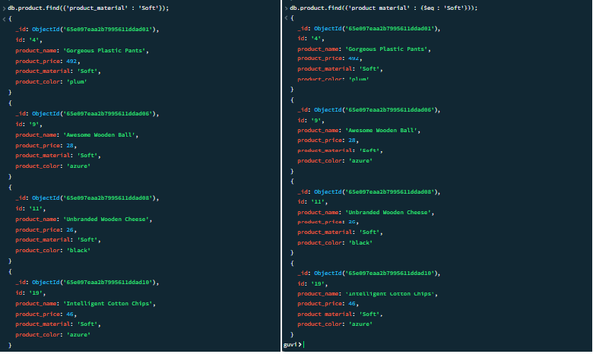

1. Find products which contain product color indigo  and product price 492.00?

Answer **:**

***Method-1* 🡪 db.product.find({‘product_color’ : ‘indigo’, ‘product_price’ : 492.00});**

***Method-2* 🡪 db.product.find({$and : [{‘product_color’ : ‘indigo’}, {‘product_price’ : 492.00}] });**

***Method-3* 🡪 db.product.find({$and : [{‘product_color’ : {$eq : ‘indigo’}}, {‘product_price’ : {$eq : 492.00}}] });**

**Screenshot** **:**

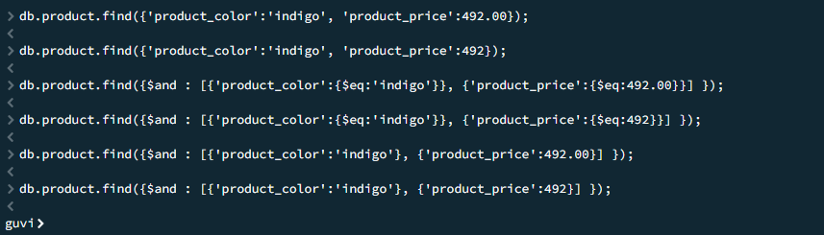

1. Delete the products which product price value are same?

Answer **:**

***Method-1* 🡪**

**db.product.aggregate([**

**{ $group: { _id: "$product_price", count: { $sum: 1 },**

**docs: { $push: "$_id" } } },**

**{$match: { count: { $gt: 1 } } }])**

**.forEach(function(doc) {**

**db.product.deleteOne({_id: {$in: doc.docs.slice(1)}});**

**});**

***Method-2* 🡪 db.product.deleteMany({$or : [{‘product_price’ : {$eq : 47.00}}, {‘product_price’ : {$eq : 36.00}}] });**

(I done deleteMany manually as per mongodb day-1 taught lessons)

**Screenshot** **:**

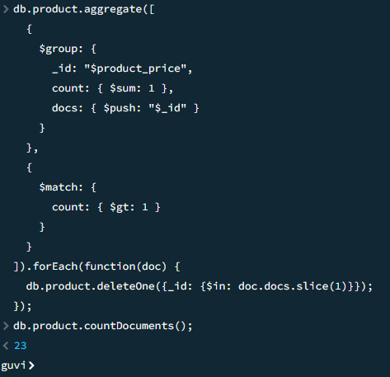

------------ End -----------