**MongoDB : Task2**

**Zen Class Database Collections :**

**Screenshot :**

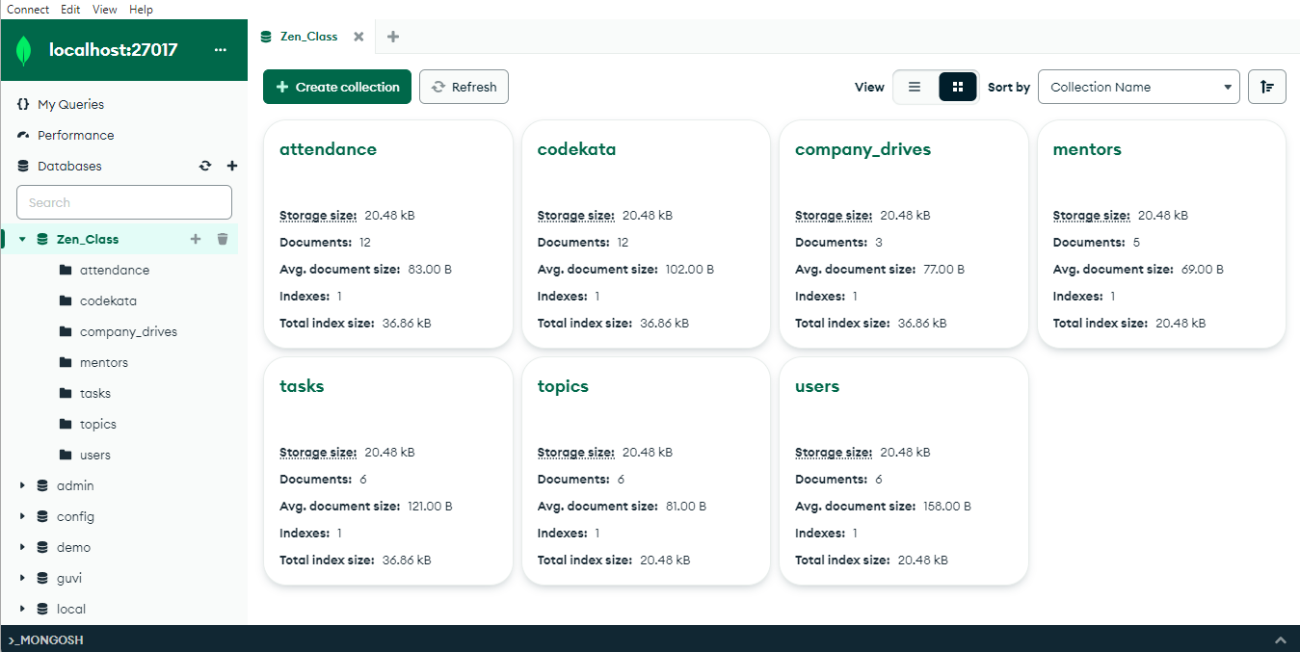

**Question & Answers :**

1. **Find all the topics and tasks which are thought in the month of October?**

**Answer :**

**db.topics.aggregate([**

**{**

**$lookup: {**

**from: "tasks",**

**localField: "_id",**

**foreignField: "topic_id",**

**as: "taskInfo"**

**}**

**},**

**{ $unwind: "$taskInfo" },**

**{**

**$match: {**

**"topic_taught_date": {**

**$gte: new Date("2020-10-01"),**

**$lt: new Date("2020-11-01")**

**},**

**"taskInfo.task_taught_date": {**

**$gte: new Date("2020-10-01"),**

**$lt: new Date("2020-11-01")**

**}**

**}**

**},**

**{**

**$project: {**

**_id: 0,**

**topic_name: 1,**

**topic_taught_date: {**

**$dateToString: { format: "%Y-%m-%d", date: "$topic_taught_date" }**

**},**

**task_name: "$taskInfo.task_name",**

**task_taught_date: {**

**$dateToString: { format: "%Y-%m-%d", date: "$taskInfo.task_taught_date" }**

**}**

**}**

**}**

**]);**

**Screenshot :**

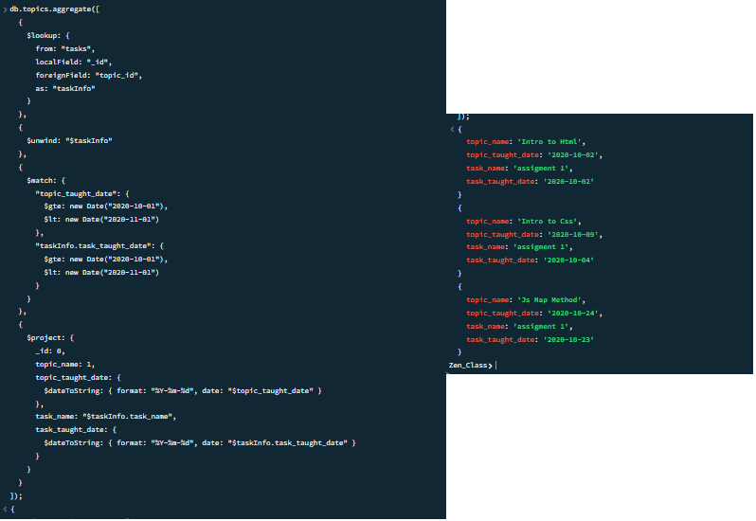

1. **Find all the company drives which appeared between 15 oct-2020 and 31-oct-2020?**

**Answer :**

**db.company_drives.aggregate([**

**{ $match : {**

**drive_date: {$gte: new Date("2020-10-15"),**

**$lte: new Date("2020-10-31")}**

**}**

**},**

**{ $project: {**

**_id: 0,**

**drive_name: 1,**

**drive_date: {**

**$dateToString: { format: "%Y-%m-%d", date: "$drive_date" }**

**}**

**}},**

**{ $sort : {drive_date:1} }**

**]);**

**Screenshot :**

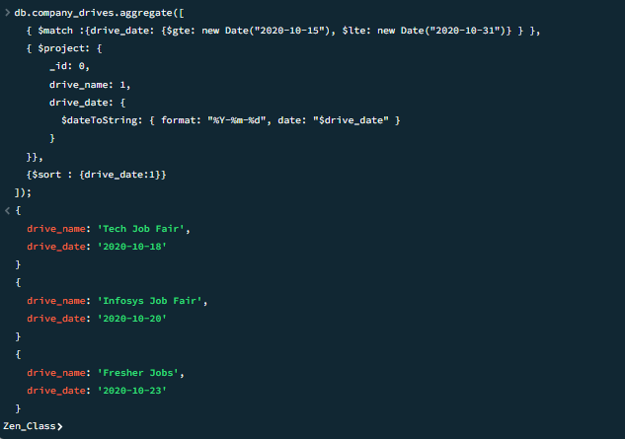

1. **Find all the company drives and students who are appeared for the placement?**

**Answer :**

**db.company_drives.aggregate([**

**{ $lookup: {**

**from: 'users',**

**localField: '_id',**

**foreignField: 'company_drive_id',**

**as: 'studentInfo'**

**}**

**},**

**{ $unwind: '$studentInfo' },**

**{ $match: {'studentInfo.company_drive_status': 'attended' } },**

**{ $project: {**

**_id: 0,**

**drive_name: 1,**

**drive_date: { $dateToString: { format: "%Y-%m-%d", date: "$drive_date" } },**

**student_name: '$studentInfo.name',**

**student_email: '$studentInfo.email',**

**drive_status: '$studentInfo.company_drive_status',**

**}**

**},**

**{ $sort: { drive_date: 1 } }**

**]);**

**Screenshot :**

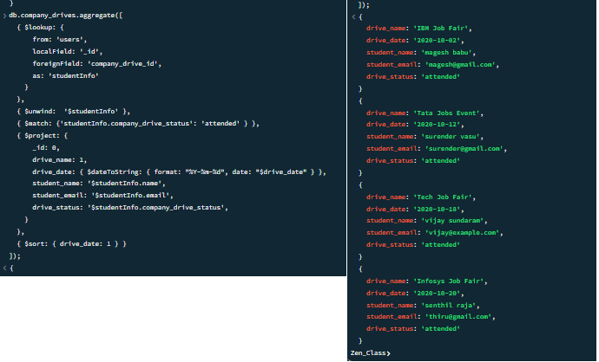

1. **Find the number of problems solved by the user in codekata?**

**Answer :**

**db.codekata.aggregate([**

**{ $lookup: {**

**from: 'users',**

**localField: 'user_id',**

**foreignField: '_id',**

**as: 'studentInfo'**

**}**

**},**

**{ $unwind: '$studentInfo' },**

**{ $group: {**

**_id: {**

**user_id: '$studentInfo._id',**

**User_Name: '$studentInfo.name'**

**},**

**total_problems_solved: { $sum: 1 }**

**}**

**},**

**{ $project: {**

**_id: 0,**

**User_Name: '$_id.User_Name',**

**total_problems_solved: 1**

**}**

**},**

**{ $sort: { total_problems_solved: -1 } }**

**]);**

**Screenshot :**

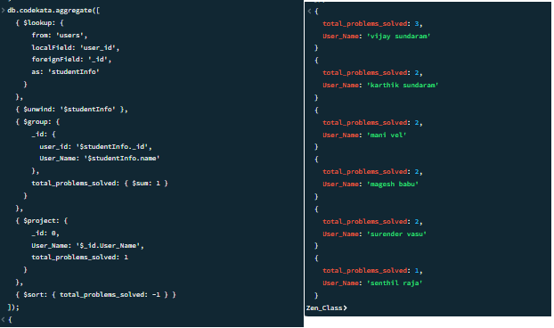

1. **Find all the mentors with who has the mentee's count more than 15?**

**Answer :**

**db.mentors.aggregate([**

**{ $match : { mentees_count : { $gt : 15} } },**

**{ $project : {**

**_id : 0,**

**mentor_name : 1,**

**mentees_count : 1**

**}},**

**{ $sort : { mentees_count : -1} }**

**]);**

**Screenshot :**

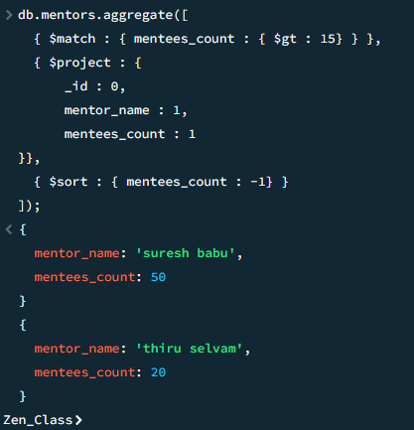

1. **Find the number of users who are absent and task is not submitted  between 15 oct-2020 and 31-oct-2020 ?**

**Answer :**

**db.users.aggregate([**

**{ $lookup: {**

**from: 'attendance',**

**localField: '_id',**

**foreignField: 'user_id',**

**as: 'attendanceInfo'**

**}**

**},**

**{ $lookup: {**

**from: 'tasks',**

**localField: '_id',**

**foreignField: 'user_id',**

**as: 'taskInfo'**

**}**

**},**

**{ $unwind: '$attendanceInfo' },**

**{ $unwind: '$taskInfo' },**

**{ $match:**

**{ $and: [**

**{ 'attendanceInfo.date': { $gte: new Date("2020-10-15"),**

**$lte: new Date("2020-10-31") } },**

**{ 'attendanceInfo.status': 'absent' },**

**{ 'taskInfo.task_status': 'not submitted' }**

**]**

**}**

**},**

**{ $group: {**

**_id: null, user_count: { $sum: 1 }**

**}**

**},**

**{ $project: {**

**_id: 0, task_status: "Not Submitted",**

**attendance_status: "Absent", user_count: 1 } } ]);**

**Screenshot :**

