Table 1.

Strain | Description | Reference
10403S | Wild Type | Ref 1
DP-L1552 | ∆plcA | Ref 3
DP-L3078 | ∆actA | Ref 15
DP-L6171 | ∆actA∆plcA | Ref 11
SK-L1000 | ActA(∆AB/AAAAA/GGG)∆plcA | This study
SK-L1001 | ActA(AAAAA/GGG)∆plcA | This study
SK-L1002 | ActA(∆31-165/GGG)∆plcA | This study
SK-L1003 | ActA(∆TM)∆plcA | This study

Table 2.
Oligo ID # | Oligo Name | Sequence
217182-1 | ActA2A_sk1 | ATA TAT GAA TTC GTT GGT CAT GAA CTA ACG CAT G
217182-2 | ActA2B_sk2 | TGC TGCTGCTGCTGC AAT TTC CGC TGC GCT ATC CG
217182-3 | ActA2C_sk3 | GAA ATT GCA GCAGCAGCAGCA GCC ATA GCG TCG TCG GAT A
217182-4 | ActA2D_sk4 | ATA TAT CTG CAG TTT GGT GCG GTC TTT ACA GGG
217182-5 | ActA4A_sk5 | ATA TAT GAA TTC GTG AGG ATG TCT GTG TGC GT
217182-6 | ActA8A_sk6 | ATA TAT GAA TTC TCC GCA GTG GAT GCT CAT TTT TA
217182-7 | ActA8B_sk7 | CGC TGC AAA TAT TATTAT GTC GGG
217182-8 | ActA8C_sk8 | CCC GAC ATA ATA TTT GCA GCG GAT AAA CCA ACA AAA GCA AAT AAG AGA AAA
217182-9 | ActA8D_sk9 | ATA TAT CTG CAG GAC TGC TTG TTT GTT TCT GCT TG
217182-10 | ActA10A_sk10 | ATA TAT GAA TTC GAT GCT TCT CGG TTT TAA TGC TC
217182-11 | ActA10B_sk11 | CAT TGC AAG AAT TAA CGT CGT ATG
217182-12 | ActA10C_sk12 | CAT ACG ACG TTA ATT CTT GCA ATG TAA AAA CAC AGA ACG AAA GAA AAA AGT G
217182-13 | ActA10D_sk13 | ATA TAT CTG CAG ATT ACA AAG AAA AAG ATT AAC CTC CCT T
* Underlined sequences indicate either EcoRI or PstI cut sites used for cloning

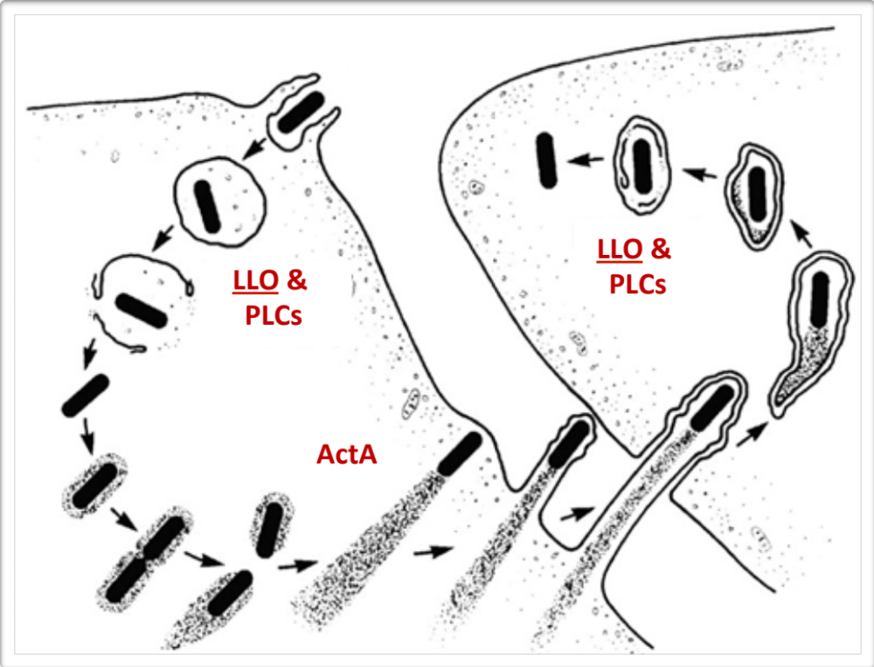
Figure 1. The Intracellular Life Cycle of Listeria monocytogenes^{[6,17]}. Bacterium is able to enter host cell and is localized in an entry vacuole/endosome. Upon secretion of increased levels of LLO and PLC’s, the bacterium is able to form pores and damage the entry vacuole sufficiently to escape to the cytosol of the host cell. Once in the cytosol, other virulence factors, such as ActA, are expressed at increased levels in order to hijack the host actin-polymerization machinery. Actin, ARP2/3, and Ena/VASP are recruited to the surface of the bug, where they bind to host-binding domains of ActA. The actin cloud surrounding the bacterium then begins polymerization to form a comet tail that propels the bacterium around the host cell, and to neighboring cells were the life cycle repeats.

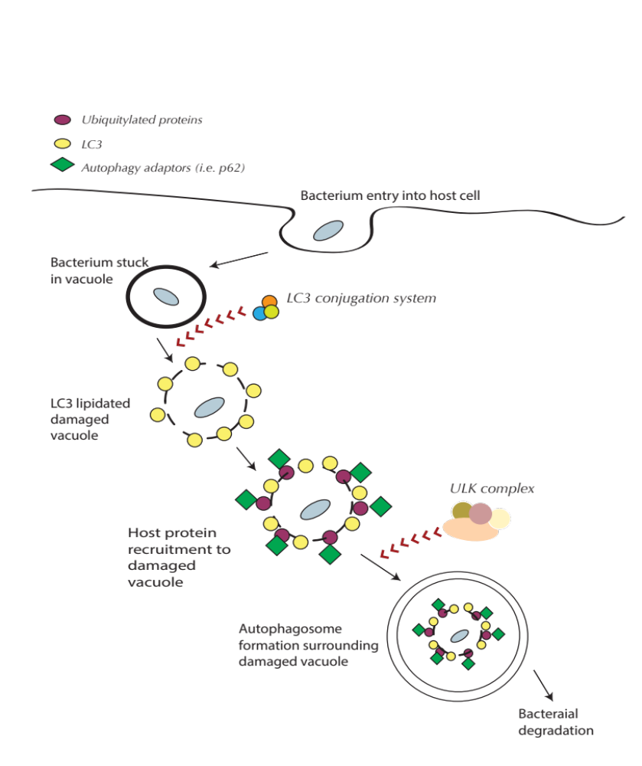
Figure 2. Autophagic targeting of L. monocytogenes ^{[Inspired by 10,14]} For a bacterium lacking ActA, the intracellular lifecycle proceeds as per usual, and forms pores in the entry vacuole. Bacterium lacking ActA, however, cannot escape and are localized within the damaged vacuole. Host cells recognize the damaged vacuole and begin recruiting the LC3 conjugation system to lapidated LC3 around the surface of the damaged vacuole. This, in turn, results in autophagy adaptor protein recruitment to ubiquitylated proteins surrounding the LC3+ damaged vacuole, which then recruits the ULK complex to form the double-membrane autophagosome around the structure. The damaged vacuole containing the bacterium is then degraded in the lysosomal pathway.

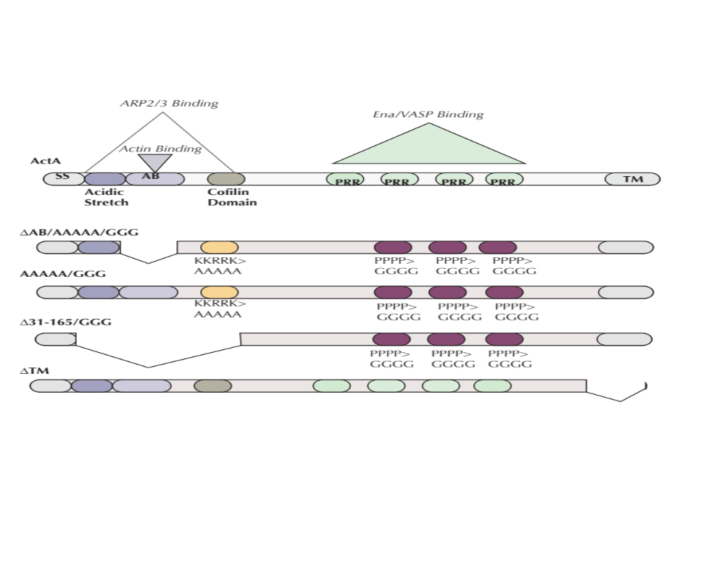
Figure 3. L. monocytogenes mutants in ActA generated and characterized in this study. ActA^{AB/AAAAA/GGG} ∆plcA (SK-L1000), ActA^{AAAAA/GGG} ∆plcA (SK-L1001), ActA^{∆31-165/GGG}∆plcA (SK-L1002), and ActA^{∆TM} ∆plcA (SK-L1003) depicted above, along with wild-type ActA configuration and host binding domains.

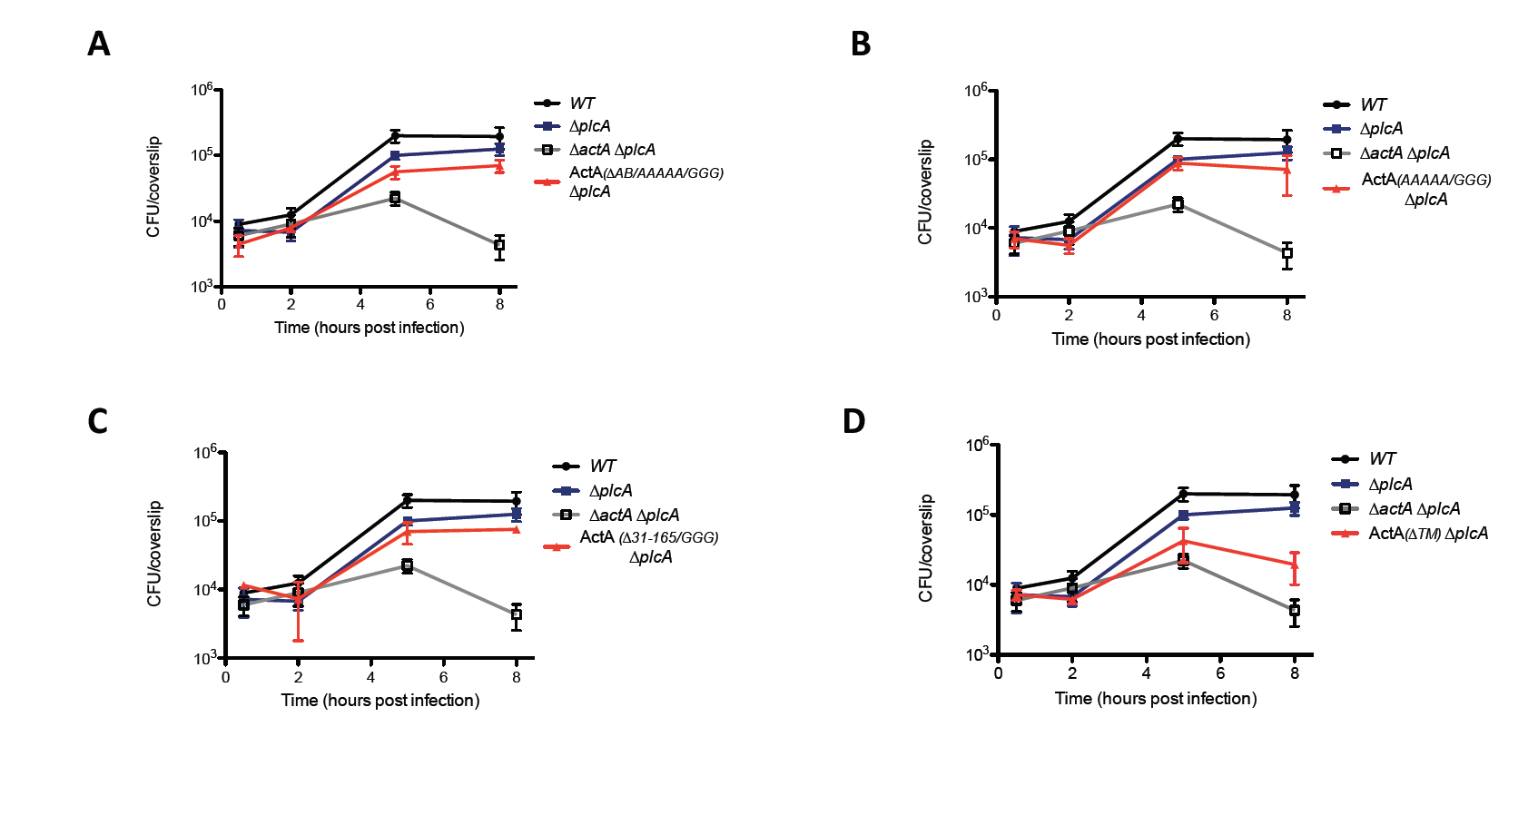
Figure 4. Intracellular growth kinetic of ActA^{AB/AAAAA/GGG} ∆plcA (SK-L1000) [A], ActA^{AAAAA/GGG} ∆plcA (SK-L1001) [B], ActA^{∆31-165/GGG}∆plcA (SK-L1002) [C], and ActA^{∆TM} ∆plcA (SK-L1003) [D] in BMDM. WT, ∆plcA and ∆actA∆plcA strains were also included as controls. Mean CFUs and standard deviations were calculated from 3 coverslips for each time-point.

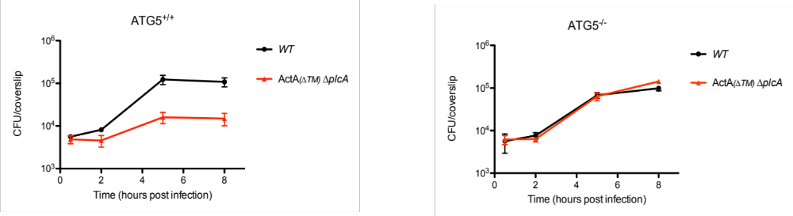

Figure 5. Intracellular growth kinetic of the ActA^{∆TM}∆plcA (SK-L1003) mutant in ATG5^{+/+} and ATG5^{-/-} macrophages. WT strain was used as a control. Mean CFUs and standard deviations were calculated from 3 coverslips for each time-point.

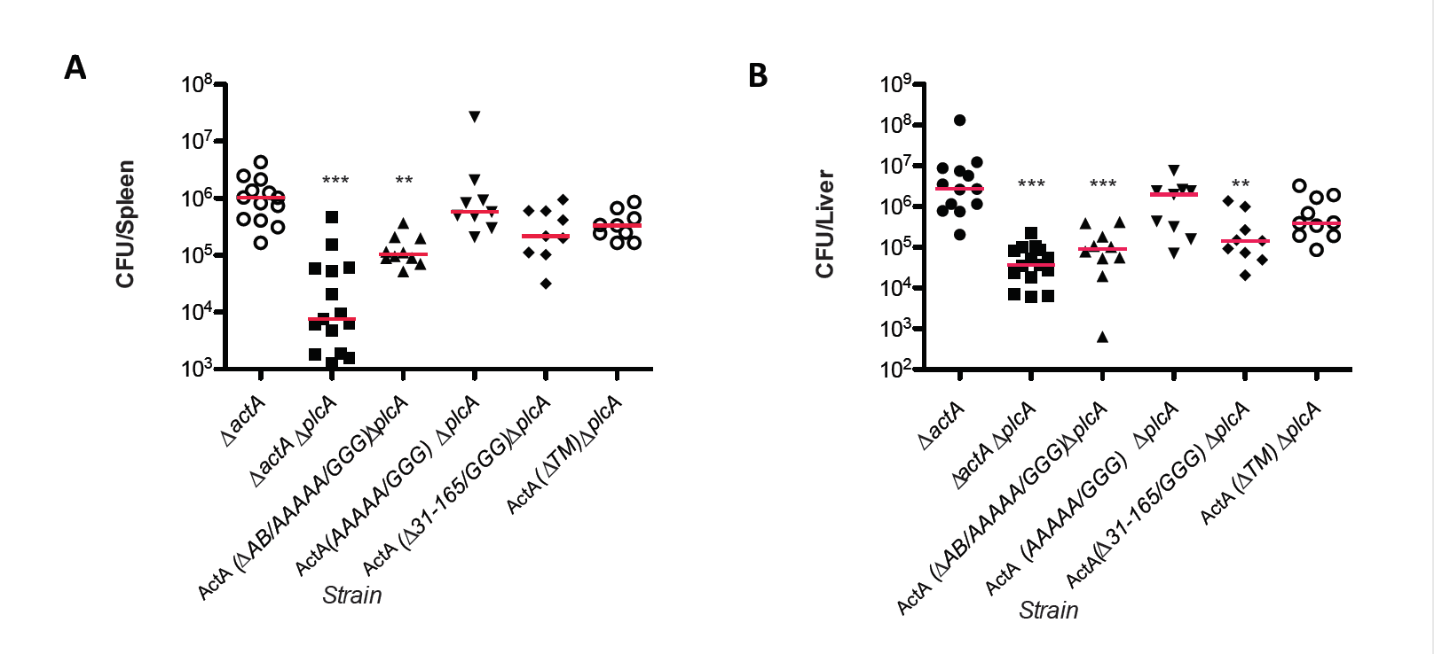
Figure 6. Virulence of ActA and PlcA mutants in vivo. CD-1 mice were infected intravenously with 5x10⁶ CFUs with SK-L1000 [ActA^{∆AB/AAAAA/GGG}∆plcA], SK-L1001 [ActA^{AAAAA/GGG}∆plcA], SK-L1002 [ActA^{∆31-165/GGG}∆plcA] and SK-L1003 [ActA^{∆TM}∆plcA]. Spleen[A] and liver[B] were harvested 48h post-infection in 0.1% NP40 solution, and CFUs were evaluated. ∆actA and∆actA∆plcA strains were also included as controls. Data was analyzed using a Kruskal-Wallis Dunn’s multiple comparison test (*, P<0.05, analysis compared to ∆actA).

