
  - IRS – Inflatable Restraint Systems

Test report  Prüfberichts | [Kommentare]
Date; author  Datum; Verfasser | Clique ou toque para introduzir uma data.; Escolha um item.

Customer  Kunde |  | Vehicle type / Platform  Fahrzeugtyp / Plattform |  | Product type  Produkttyp
Escolha um item. |  | Clique ou toque aqui para introduzir texto. |  | Escolha um item.
Task / Purpose  Aufgabe / Ziel |  | Result  Ergebnis
Sample description of task and purpose of tests. |  | According to functional requirements.  Deviation to functional requirements.
Development phase
Entwicklungs Phase
Application CV ☐ DV ☐ PV ☐ |  | Others ☐ |  | Core CV ☐ DV ☐
Requirement  Anforderung |  | Test period  Prüfzeitraum |  | ZF LIFETEC responsibility  ZF LIFETEC Verantwortung
☐ COP test plan ID 0000 | ☐ DVP&R | Click or tap to enter a date. - Click or tap to enter a date. |  | ☐ 1. 0 ☐ 2.1 ☐ 2.2 ☐ 3.0  Matrix sees attachment A.2  Matrix siehe Anhang A.2
☐ Customer Requirement  Kundenanforderung | ☐ Other  Weitere
Assessment  Bewertung |  | ZF LIFETEC Part Number  ZF LIFETEC Teilenummer |  | Customer Part Number  Kundenteilenummer
Airbag module ☐ A ☐ D ☒ w/o  Airbagmodul |  | Clique ou toque aqui para introduzir texto. |  | Clique ou toque aqui para introduzir texto.
Airbag environment ☐ A ☐ D ☐ w/o
Modulumgebung
A – according to functional requirements
D – deviation to functional requirements
w/o – without assessment
Distribution (Name)  Verteiler (Name) |  | Department  Abteilung | Date  Datum | Author (Name, Function)  Verfasser (Name, Funktion)
Portugal Engineering Center |  | Testing | Click or tap to enter a date.
 |  |  |  | Escolha um item.
 |  |  | Date  Datum | Released (Name, Function)  Freigegeben (Name, Funktion)
 |  |  | Click or tap to enter a date. |   Marina Sá / Lab. Coordinator

Content (Inhalt)

1. Task (Aufgabenstellung) 5
2. Test sequence (Versuchsumfang) – example Environmental simulation (Umweltsimulation) 6
2.1. Setup, test conditions, test execution (Aufbau, Versuchsrandbedingungen, Durchführung) 6
2.2. Test program, test parts (Versuchsprogramm, Versuchsteile) 6
2.3. Results, test analysis, recommendation (Ergebnis, Ergebnisanalyse, Empfehlung) 6
3. Test sequence (Versuchsumfang) – example Static deployment (Standversuche) 7
3.1. Setup, test conditions, test execution (Aufbau, Versuchsrandbedingungen, Durchführung) 7
3.2. Test program, test parts (Versuchsprogramm, Versuchsteile) 7
3.3. Results, test analysis, recommendation (Ergebnis, Ergebnisanalyse, Empfehlung) 8
4. Test sequence (Versuchsumfang) – example Component test (Komponententest) 10
4.1. Setup, test conditions, test execution (Aufbau, Versuchsrandbedingungen, Durchführung) 10
4.2. Test program, test parts (Versuchsprogramm, Versuchsteile) 10
4.3. Results, test analysis, recommendation (Ergebnis, Ergebnisanalyse, Empfehlung) 10
5. Summary (Zusammenfassung) 10
Attachments (Anlagen) 11
A.1 Bill of materials (Teileprotokolle) 11
A.2 Responsibility matrix (Verantwortungsmatrix) 12
Test facility description – La Laguna 28
A.3 Test facility description – Ponte de Lima 30
A.4 Test setup and mounting details (Test Aufbau und Montage Details) 33
A.5 Timing and deployment criterion definition (Zeit und Definition des Entfaltungskriteriums) 34
A.6 Margin inflator tank curves (Grenzgas Generator Kannenkurven) 35
A.7 Picture documentation (Fotodokumentation) 35
A.8 Test laboratory reports internally / externally (Testberichte Prüflabor Intern / Extern) 35
A.9 Other attachments (Weitere Anlagen) 35

Task (Aufgabenstellung)
The test sequence and individual tests are selected based on the product service life of the modules. This includes storage, shipping, installation, and product use including rest phases, maintenance, repair, and recycling. The test sequence defined is intended to trigger possible failure mechanisms., acc. To AK-LV01.

Test sequence (Versuchsumfang) – example Environmental simulation (Umweltsimulation)

Setup, test conditions, test execution (Aufbau, Versuchsrandbedingungen, Durchführung)

DROP TEST:

Test Method:
- Drop Height: 1 m ± 0.2
- Drop directions: Two directions of the three main axes (1 drop per module)
- Test temperature: RT (23 ± 5) °C

To perform this test, a steel plate with minimum dimensions of 1 m x 1 m x 10 mm is required. This steel plate must lie on a firm surface. The modules must be dropped onto this.

Mechanical SHOCK:

Test Method:
- Shock form: half-sine
- Amplitude: 40g
- Shock duration: 6ms
- Test Axis: X, Y and Z
- Impacts: 12 per temperature (36 per sample)
- Test Temperatures: 23 ±5, -35 ±2.5 and +85 ±2.5

The samples were mounted in the correct in-vehicle installation position with an assembly torque of 5.5Nm.

DUST TEST:

Test Method
- Time between blowing: 20 min
- Blowing time: 5s
- Blowing air pressure: 550 ± 50 Kpa
- Dust Type: Arizona Dust acc. SAE J 726 Coarse
- Amount of dust. 1 kg
- Test Duration: 5h
- Test current: by pulse generator, current load 100mA, pulse duration 10ms and, period 200ms

Vibration Stress WITH Temperature:
Frequency/Hz | PSD 𝑔2/Hz
8 | 0.035
50 | 0.035
80 | 0.001
200 | 0.0005
RMS = 1.34g
Test Method:
- Sign Type: random
- Test Axis: X, Y and Z
- Test Duration: 120h (24h at X axis, 24 hours at Y axis and 72h at Z axis)
- Test current: continuous current load 100 mA

Vibration Profile:
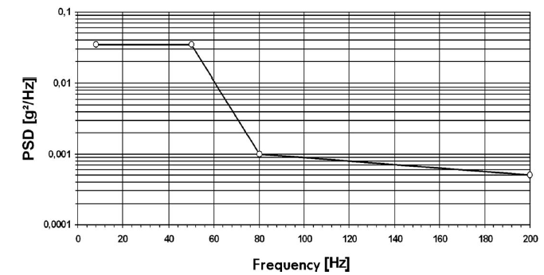

Temperature Profile:
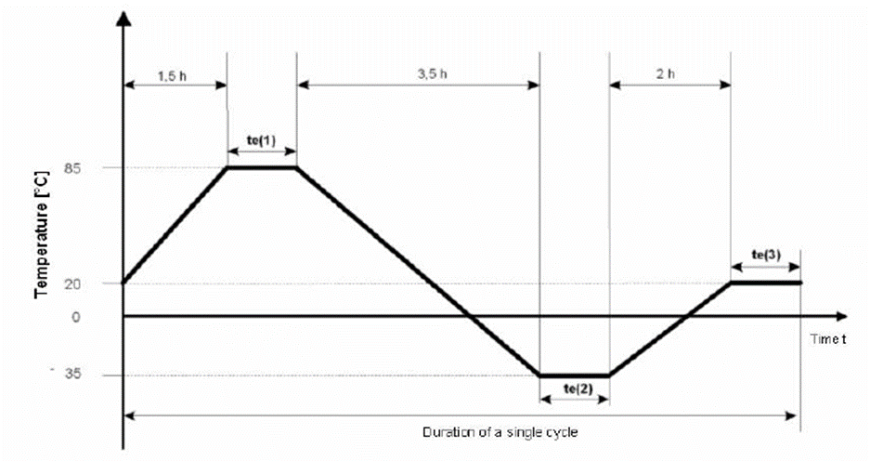
te(1) | 6h
te(2) | 6h
te(3) | 5h

The samples were mounted in the correct in-vehicle installation position with an assembly torque of 5.5Nm.

CLIMATIC CYCLE TEST:

Test Method:
- Cycle duration: 16h
- Nº of Cycles: 30
- Test duration: ~485h
- Test current: by pulse generator, current load 100 mA, pulse duration 10 ms and period 200 ms.

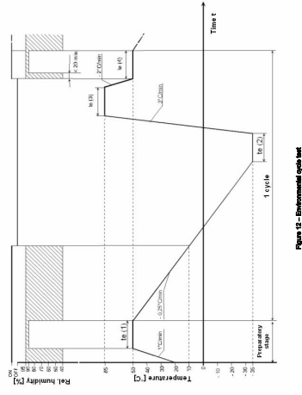

te(1) | 240 min
te(2) | 80 min
te(3) | 300 min
te(4) | 180 min

Phase | Segment | Initial Conditions |  | Final Conditions |  | Duration
 |  | Temperature (ºC) | Humidity (%) | Temperature (ºC) | Humidity (%)
Beginning | 0 | 20 | 50 | 20 | 50 | --:--:--
Lead Time | 1 | 20 | 50 | 50 | 93 | 00:30:00
 | 2 | 50 | 93 | 50 | 93 | 04:00:00
Cycle  x 30 | 3 | 50 | 93 | 10 | 40 | 02:40:00
 | 4 | 10 | 40 | -35 | NOT MONITORED | 03:00:00
 | 5 | -35 | NOT MONITORED | -35 |  | 01:20:00
 | 6 | -35 |  | 85 |  | 00:40:00
 | 7 | 85 |  | 85 |  | 05:00:00
 | 8 | 85 |  | 50 |  | 00:17:30
 | 9 | 50 |  | 50 | 93 | 00:18:00
 | 10 | 50 | 93 | 50 | 93 | 02:42:00
End | 11 | 50 | 93 | 23 | 50 | 01:00:00

SALT SPRAY TEST:

Solution Characteristics:
- Salt: Sodium Chloride (NaCl)
- Salt Purity: >99.7%
- Water dissolution conductivity: <20 μS / cm.
- pH solution: 6.5 <pH <7.2 at 20ºC±2ºC
- Salt solution mass fraction: 5%±1%
- Relative Density dissolution: 1,029 <ρ <1,036

Chamber Conditions:
- Test temperature: 30ºC to 35ºC
- Spray time: 2 hours.
- Collected volume: 1,0ml/h< V <2,0ml/h

Test Method:
- Stabilization time between sprays: 20 hours.
- Number of cycles: 3
- Test duration: 66 hours
- Test current: by pulse generator, current load 10 mA, pulse duration 10ms and period 200ms.

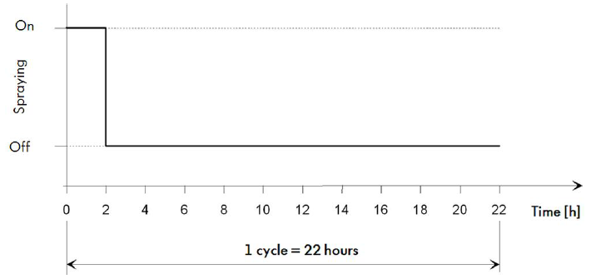

The samples were mounted on a specific way that represents the actual position of the module in the vehicle, below you can see the registration, on point A.4 of this report.

After the last cycle, the samples are removed from the chamber and immediately clean it with a moist sponge so that the changes of the metallic and other surfaces and load-bearing parts of the module can be evaluated after a subsequent drying time of 1 h at (55 ± 2) °C.

Test program, test parts (Versuchsprogramm, Versuchsteile)

Sample | Traceability

Results, test analysis, recommendation (Ergebnis, Ergebnisanalyse, Empfehlung)

Weight:

Sample | Weight Before Test (g) | Weight After Test (g) | Weight Changes (%)

Squib resistance:

Samples | Before Tests

Transit resistance measure table:

Samples | Before Tests | After Tests
Ignitor | 1 | 1

Tests Requirements:

The module must show no functional impairments after each test are completed. Any visible damage must be documented. The DUT must undergo the test program, even if it suffers visible damage. It is permissible to repair damage to the module that adversely affects its assembly so that the test program can be continued.

Drop test:

After the test, a visual inspection of each sample was carried out (see picture documentation).

Test results
Sample | Remarks | Assessment
 |  | To be evaluated by AE

Drop direction registration Table:

Samples | Tested Axis
 | X
 | -X
 | Y
 | -Y
 | Z
 | -Z

Mechanical Shock test:

After the test, a visual inspection of each sample was carried out (see picture documentation).
Test results
Sample | Remarks | Assessment
 |  | To be evaluated by AE

Impact Graphic X Axis at 23 ±5ºC

Impact Graphic X Axis at -35 ±2.5ºC

Impact Graphic X Axis at 85 ±2.5ºC

Impact Graphic Y Axis at 23 ±5ºC

Impact Graphic Y Axis at -35 ±2.5ºC

Impact Graphic Y Axis at 85 ±2.5ºC

Impact Graphic Z Axis at 23 ±5ºC

Impact Graphic Z Axis at -35 ±2.5ºC

Impact Graphic Z Axis at 85 ±2.5ºC

Dust test:

After the test, a visual inspection of each sample was carried out (see picture documentation).
Test results
Sample | Remarks | Assessment
 |  | To be evaluated by AE

Monitoring of test current:
Test Conditions
Amplitude | 100 mA
Duration Pulse | 10 ms
One Period | 200 ms
Duration Test | 5h

Sample | Monitoring current | Failure
 | Yes | No

Vibration stress WITH temperature:
After the test, a visual inspection of each sample was carried out (see picture documentation).
Test results
Sample | Remarks | Assessment
 |  | To be evaluated by AE

Vibration monitoring X axis

Vibration monitoring Y axis

Vibration monitoring Z axis

Temperature monitoring

Monitoring of test current:
Test Conditions
Amplitude | 100 mA
Duration Pulse | Continuous
One Period | 200 ms
Duration Test | 120h

Sample | Monitoring current | Failure
 | Yes | No

Humidity Resistance test:
After the test, a visual inspection of each sample was carried out (see picture documentation).
Test results
Sample | Remarks | Assessment
 |  | To be evaluated by AE

Monitoring of test current:
Test Conditions
Amplitude | 100 mA
Duration Pulse | 10 ms
One Period | 200 ms
Duration Test | 485h

Sample | Monitoring current | Failure
 | Yes | No

Temperature and Humidity monitoring

Salt Spray TEST:

After the test, a visual inspection of each sample was carried out (see picture documentation).
Test results
Sample | Remarks | Assessment
 |  | To be evaluated by AE

Monitoring of test current:
Test Conditions
Amplitude | 100 mA
Duration Pulse | 10 ms
One Period | 200 ms
Duration Test | 66h

Sample | Monitoring current | Failure
 | Yes | No

Characteristics of the solution collected:
Test duration (h) | Collected volume  (1,0ml/h<V<2,0ml/h) | Ph (6,5<Ph<7,2) | Density  (1,029<ρ<1,036)

At the end of the test, a control of the characteristics from collected solution was made to check if the solution is inside the parameters established in the standard.

Summary (Zusammenfassung)

No incidents to record. All tests were carried out according to spec.
Test Nr. | Test type | Overall rating | Remarks

End of test report (Ende des Versuchsberichtes)

Attachments (Anlagen)

A.1 Bill of materials (Teileprotokolle)

Customer Part Number (Left Hand)  Customer Part Number (Left Hand Driver)  Kunden Sach Nr. Links | Customer Part Number (Right Hand)  Customer Part Number (Right Hand Driver)  Kunden Sach Nr. Rechts

Designation  Benennung | Part No. LH  Teile-Nr. Links | Part No. RH  Teile-Nr. Rechts | Revision | Status | Supplier  Lieferant | Comment  Bemerkung
 |  |  | A | Choose
 |  |  | A | Choose
 |  |  | A | Choose
 |  |  | A | Choose
 |  |  | A | Choose
 |  |  | A | Choose
 |  |  | A | Choose
 |  |  | A | Choose
 |  |  | A | Choose
 |  |  | A | Choose
PR - Production Released; PD - Production Deviation; PV - Product Validation; DV - Design Validation; CV - Concept Validation; N/A - Not Applicable

A.2 Responsibility matrix (Verantwortungsmatrix)

Responsibility Matrix | Verantwortungsmatrix
1.0 Responsibility for the function of the airbag – module  The ZF LIFETEC responsibility covers only the ZF LIFETEC scope of supply. Development tests are normally conducted without module environment, consequently „Module Only“. Tests with module environment are performed as a service for the customer. The quantities for the release tests are defined in the TS21102110.  > „Module Only“ | 1.0 Verantwortung für die Funktion des Airbags – Moduls  Die ZF LIFETEC Verantwortung umfasst nur den ZF LIFETEC Lieferumfang. Entwicklungsversuche finden normalerweise ohne Modulumgebung, also „Module Only“ statt. Versuche mit Modul-Umgebung werden als Dienstleistung für den Kunden durchgeführt. Die Anzahl der Freigabeversuche ist in der TS21102110 definiert.  > „Modul Only“
2.1. Responsibility for the function of the airbag - module in the module environment with evaluation of the module environment  Development tests are conducted with and without module environment. The quantities for the release tests are defined in the TS21102110. ZF LIFETEC evaluates not only the ZF LIFETEC scope of supply, but also the module environment (parts of other suppliers) in the form of A / D - evaluations and makes suggestions for their optimization.  > Module within trim parts with evaluation of trim parts | 2.1. Verantwortung für die Funktion des Airbag - Moduls in der Modulumgebung mit Bewertung der Modulumgebung  Entwicklungsversuche finden sowohl mit, - als auch ohne Modulumgebung statt. Die Anzahl der Freigabeversuche ist in der TS21102110 definiert. ZF LIFETEC bewertet nicht nur den ZF LIFETEC Lieferumfang, sondern auch die Modulumgebung (Teile anderer Lieferanten) in Form von A / D. -Bewertungen und macht Vorschläge zu deren Optimierung.  > Modul in VKT mit Bewertung der VKT
2.2. Responsibility for the function of the airbag - module in the module environment without evaluation of the module environment  Development tests are conducted with and without module environment. The quantities for the release tests are defined in the TS21102110. ZF LIFETEC describes the behaviour of the module environment free of evaluation. Only the behaviour of the module (ZF LIFETEC scope of supply) is evaluated, the evaluation of the module environment is incumbent on the client. No suggestions on the optimization of the environment are made.  > Module within trim parts without evaluation of trim parts | 2.2. Verantwortung für die Funktion des Airbag - Moduls in der Modulumgebung ohne Bewertung der Modulumgebung  Entwicklungsversuche finden sowohl mit, - als auch ohne Modulumgebung statt. Die Anzahl der Freigabeversuche ist in der TS21102110 definiert. ZF LIFETEC beschreibt wertungsfrei das Verhalten der Modulumgebung. Bewertet wird nur das Verhalten des Moduls (ZF LIFETEC Lieferumfang), die Bewertung der Modulumgebung obliegt dem Auftraggeber. Es werden keine Vorschläge zur Optimierung der Umgebung gemacht.  > Modul in VKT ohne Bewertung der VKT
3.0 Responsibility for the function of the module + environment (Airbag - System responsibility)  ZF LIFETEC has the responsibility to assign changes to the module environment directly with the supplier as a cost responsible client (Analogous e.g.: changes of a firing channel tool).  > Airbag System – Responsibility | 3.0 Verantwortung für die Funktion des Moduls + Umgebung (Airbag - Systemverantwortung)  ZF LIFETEC hat die Verantwortung Änderungen der Modulumgebung direkt beim Lieferanten als Kostenverantwortlicher zu veranlassen (analog wie z.B. Änderungen an einem Schusskanalwerkzeug).  > Airbag System-Verantwortung

A.3 Test facility description (Prüfstandsbeschreibung) - Ponte de Lima-PEC

Test Equipment ZF LIFETEC PEC EVS Test Laboratory
Test equipment is subjected to regular calibration.

Equipment Name | Manufacturer | Type | Serial No. | Ident. Nr.
Digital multimeter | Keithley Instruments Inc. | 2110 | 1421274 | L0012.1S
Salt spray | ASCOTT Analytical Equipment | S2600iP | 3076 | L-5001-L
Dust chamber | DYCOMETAL | CETM 40/2200e | 3938/17 | L-5002-L
Cimatic chamber | ARALAB | 1500 EP45 | 2273 | L-5004-L(01)
Climatic chamber | ARALAB | 1500 EP45 | 2375 | L-5004-L(02)
Climatic chamber | DYCOMETAL | CKK-40 /2000 2P | 3935/17 | L-5005-L(01)
Climatic chamber | DYCOMETAL | CKK-40 /2000 2P | 3936/17 | L-5005-L(02)
Shaker A74 | IMV Corporation | EM10HAM-A74 | 51000417 | L-5007-L
Triaxial Accelerometer | PCB Piezotronics, Inc. | 356A33 | LW234014 | L-5007-L1-1
Triaxial Accelerometer | PCB Piezotronics, Inc. | 356A33 | LW234014 | L-5007-L1-2
Triaxial Accelerometer | PCB Piezotronics, Inc. | 356A33 | LW234014 | L-5007-L1-3
Triaxial accelerometer | PCB Piezotronics, Inc. | 356A33 | LW234169 | L-5007-L2-1
Triaxial accelerometer | PCB Piezotronics, Inc. | 356A33 | LW234169 | L-5007-L2-2
Triaxial accelerometer | PCB Piezotronics, Inc. | 356A33 | LW234169 | L-5007-L2-3
Uniaxial Accelerometer | PCB Piezotronics, Inc. | 352C03 | LW233906 | L-5007-L3
Uniaxial Accelerometer | PCB Piezotronics, Inc. | 352C03 | LW233907 | L-5007-L4
Uniaxial Accelerometer | PCB Piezotronics, Inc. | 352C03 | LW233908 | L-5007-L5
Uniaxial Accelerometer | PCB Piezotronics, Inc. | 352C03 | LW233909 | L-5007-L6
Uniaxial Accelerometer | PCB Piezotronics, Inc. | 352C03 | LW233910 | L-5007-L7
Uniaxial Accelerometer | PCB Piezotronics, Inc. | 352C03 | LW233911 | L-5007-L8
Climatic chamber - Shaker A74 | ARALAB | 8000 ECP45 | 2405 | L-5008-L
Oven | MEMMERT | UF750 | B817-0847 | L-5009-L
Drop test | ZF_PSS_Ponte de lima | Drop Test | - | L-5016-L
Multiparameter waterproof meter | Hanna Instruments | HI 98194 | 03060082991 | L-5017-L
Ignitor current Monitoring | VTI | MCI-16CH | 2004-01 | L-5022-L(01)
Ignitor current monitoring | VTI | MCI-16CH | 2004-02 | L-5022-L(02)
Shaker A30 | IMV Corporation | A30/EM3HM | 51001163 | L-5035-L
Climatic chamber | Weiss Technik | C/340/40/5 | 58226215590010 | L-5036-L(01)
Climatic chamber | Weiss Technik | C/340/40/5 | 10000000000763 | L-5036-L(02)
Oven | Heraeus | OMH 750 | 42751647 | L-5038-L(01)
Oven | Heraeus | OMH 750 | 42899727 | L-5038-L(02)
Ignitor current monitoring | VTI | SO130-ZF-mcee_48 | 2079-01 | L-5040-L
Climatic chamber- Shaker A30 | ACS Angelantoni Test Technologies | AV2200 (C) 5 | TT04257 | L-5041-L
Scale | Precisa Instruments | 320 XB | 0501730 | L-5046-L
Insulation tester | HIOKI | ST5520 | 171148982 | SL-50-515

A.4 Test setup and mounting details (Test Aufbau und Montage Details)

Drop Test:

Setup X axis

Setup -X axis

Setup Y axis

Setup -Y axis

Setup Z axis

Setup -Z axis

Mechanical Shock:

Clique ou toque aqui para introduzir texto. test fixture – ZF LIFETEC part number Clique ou toque aqui para introduzir texto.

Setup X axis

Setup Y axis

Setup Z axis
Airbag modules is fixed in test fixture by 4x M6 hex nut with Clique ou toque aqui para introduzir texto. torque.

Dust tEST:

Clique ou toque aqui para introduzir texto. test fixture – ZF LIFETEC part number Clique ou toque aqui para introduzir texto.

Setup

Airbag modules is fixed in test fixture by 4x M6 hex nut with Clique ou toque aqui para introduzir texto. torque.
Vibration Stress with Temperature:

Clique ou toque aqui para introduzir texto. test fixture – ZF LIFETEC part number Clique ou toque aqui para introduzir texto.

Setup X axis

Setup Y axis

Setup Z axis

Airbag modules is fixed in test fixture by 4x M6 hex nut with Clique ou toque aqui para introduzir texto. torque.

Humidity Resistance test:

Setup

Salt spray test:

Setup

A.5 Timing and deployment criterion definition (Zeit und Definition des Entfaltungskriteriums)
N.A.

A.6 Margin inflator tank curves (Grenzgas Generator Kannenkurven)
N.A.

A.7 Picture documentation (Fotodokumentation)

A.8 Test laboratory reports internally / externally (Testberichte Prüflabor Intern / Extern)
N.A.

A.9 Other attachments (Weitere Anlagen)
N.A.

