class Solution:

def hasPathSum(self, root, sum):

flagg=False

oursum=0

def overcalc():

print("main",calc(root,oursum,flagg))

def calc(root,oursum,flagg):

global res

# print("!",flagg,"!")

if flagg == True:

return True

if root is None:

return

oursum=oursum+root.val

if (oursum==sum and root.left is None and root.right is None):

flagg=True

res=True

# print("this worked","-----",flagg,"res=",res)

# print(root.val,"-----",oursum,"+++",sum," ")

calc(root.left,oursum,flagg)

calc(root.right,oursum,flagg)

oursum=oursum-root.val

# print(" ",res, " this is flag")

overcalc()

return flagg

Mistake: Global Variable Flag wasn’t changing. It was due to every time it took global Variable was called recursively.

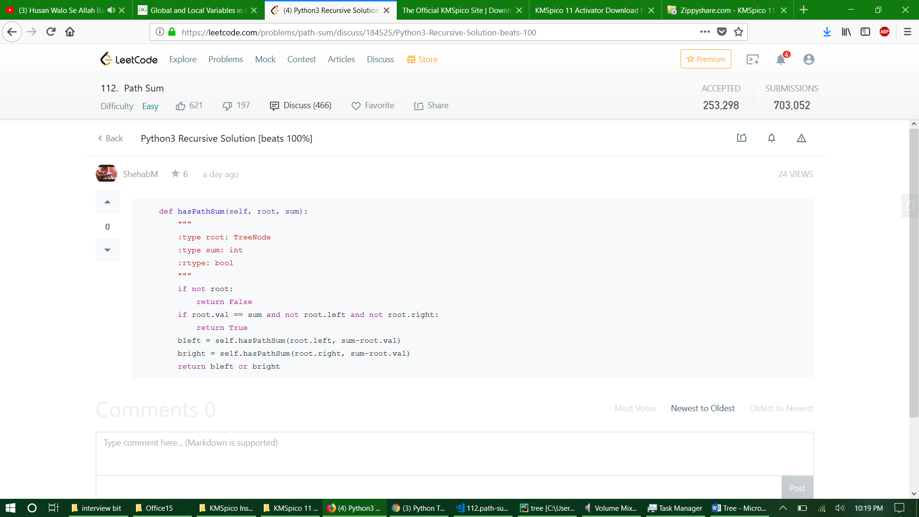

class Solution:

# @param A : root node of tree

# @param B : integer

# @return an integer

def hasPathSum(self, root, sum):

flag=False

flag2=None

if root is None:

return flag

def hhasPathSum(root,sum,flag):

global flag2

if root is None:

return

sum=sum-root.val

if sum == 0 and root.left is None and root.right is None:

flag2=True

# print("this worked")

hhasPathSum(root.left, sum,flag)

hhasPathSum(root.right, sum,flag)

try:

flag2

except NameError:

return flag

else:

return flag2

a=hhasPathSum(root,sum,flag)

if a is True:

a=1