Wiring Diagram: Compact Stair-Climbing UGV
TN-IMPACT 2026, Problem Statement TN126203. Rocker-bogie UGV with ESP32, six DC motors on three TB6612FNG drivers, and an FPV camera link.
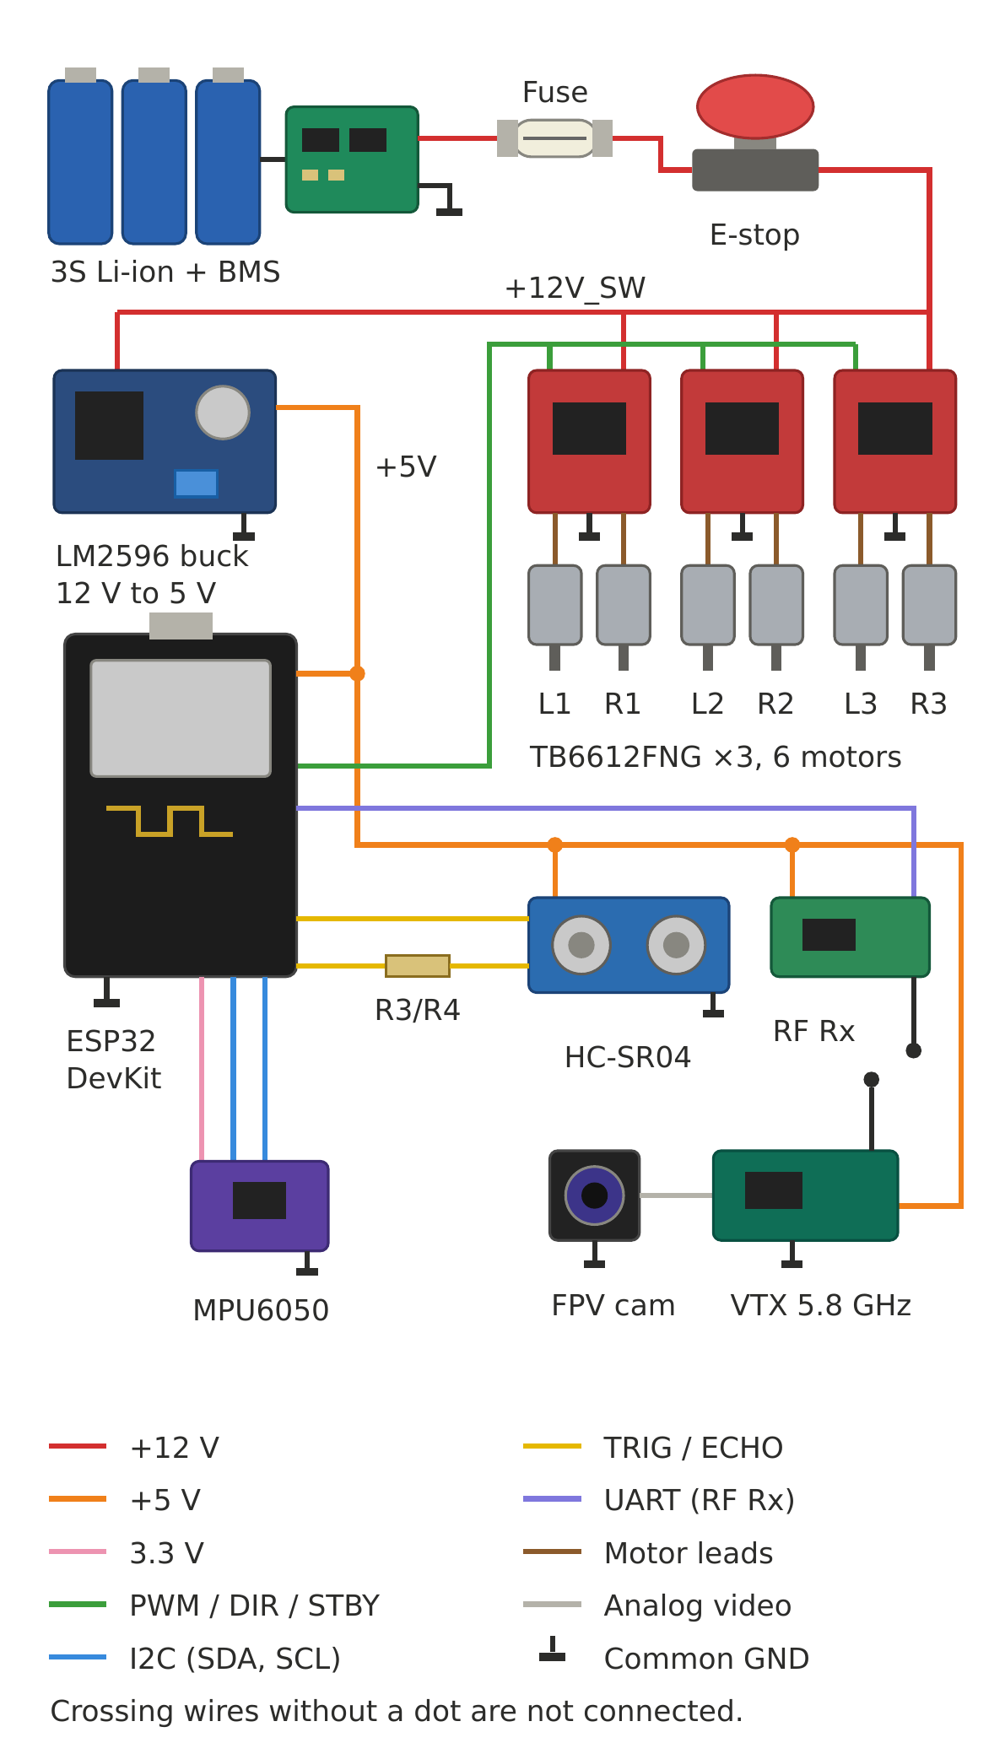

Parts list
Ref | Qty | Part | Notes
BT1 | 1 | 3S Li-ion pack with BMS | 12 V nominal
F1 | 1 | Inline fuse | Rate above motor stall current
SW1 | 1 | Latching emergency stop switch | In series with +12 V
U1 | 1 | LM2596 buck converter module | Set output to 5 V
C1 | 1 | 1000 µF, 25 V electrolytic | Across 12 V rail, near drivers
C2 | 1 | 220 µF, 10 V electrolytic | Across 5 V bus
R1 / R2 | 1 + 1 | 30 kΩ / 10 kΩ resistors | Battery divider to GPIO34
R3 / R4 | 1 + 1 | 10 kΩ / 20 kΩ resistors | HC-SR04 ECHO divider to GPIO18
MCU | 1 | ESP32 DevKit | MicroPython
DRV1–3 | 3 | TB6612FNG driver boards | Shared control lines
M1–M6 | 6 | DC gear motors | L1/R1, L2/R2, L3/R3
IMU | 1 | MPU6050 breakout | I2C, 3.3 V
US | 1 | HC-SR04 ultrasonic sensor | 5 V, ECHO needs divider
RF | 1 | RF receiver module | UART to GPIO16, 5 V
FPV | 1 + 1 | FPV camera + 5.8 GHz VTX | 5 V, independent of ESP32

ESP32 pin assignments
Signal | GPIO | Connects to
PWMA / AIN1 / AIN2 | 25 / 26 / 27 | All 3 drivers, channel A (left motors)
PWMB / BIN1 / BIN2 | 13 / 32 / 33 | All 3 drivers, channel B (right motors)
STBY | 14 | All 3 drivers
SDA / SCL | 21 / 22 | MPU6050
TRIG | 5 | HC-SR04
ECHO | 18 | HC-SR04 via R3/R4 divider
UART2 RX | 16 | RF receiver data output
ADC | 34 | Battery divider (R1/R2)

Build notes
- Join all grounds at one point. This keeps motor noise away from the ESP32.
- The HC-SR04 ECHO pin outputs 5 V, so it must go through the R3/R4 divider before GPIO18.
- Each TB6612FNG channel handles about 1.2 A continuous. Check your motor stall current and size F1 to match.
- Add a 100 nF capacitor across each motor's terminals to reduce noise.
- C1, C2 and the battery divider (R1/R2) are listed above but not drawn in the pictorial diagram.
- Part values and GPIO numbers are suggested starting points. Verify them against your actual modules.

