# Week #4 Assignment – Satish Ramachandran

# Problem 1

'''

Week4 - Assignment problem #1

'''

import math

import matplotlib.pyplot as plt

x = 5

y = 5

learning_rate = 0.01

epsilon = 0.000001

iteration = 0

'''

Function is:

f(x,y) = z = -1 * math.sqrt(25 - (x - 2) ** 2 - (y - 3) **2)

'''

def func_z(x, y):

return (-1 * math.sqrt(25 - (x - 2) ** 2 - (y - 3) **2))

'''

Partial derivative w.r.t x

'''

def dz_dx(x, y):

return ((2 * (x - 2)) / (math.sqrt((25 - (x - 2) ** 2 - (y - 3) ** 2))))

'''

Partial derivative w.r.t y

'''

def dz_dy(x, y):

return ((2 * (y - 3)) / (math.sqrt((25 - (x - 2) ** 2 - (y - 3) ** 2))))

while True:

iteration = iteration + 1

plt.plot(x, y, 'o')

new_x = x - learning_rate * dz_dx(x,y)

new_y = y - learning_rate * dz_dy(x,y)

if (abs(x - new_x) < epsilon) and (abs(y - new_y) < epsilon):

print("Solution reached..")

x = new_x

y = new_y

plt.plot(x, y, 'o')

plt.waitforbuttonpress()

print('New x and y less than epsilon')

break

# More improvements could be made

x = new_x

y = new_y

print('Solution reached after ' + str(iteration) + ' adjustments')

print('Value of x is: ' + str(x))

print('Value of y is: ' + str(y))

print('Value of z is: ' + str(func_z(x, y)))

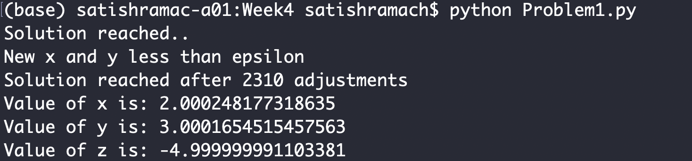

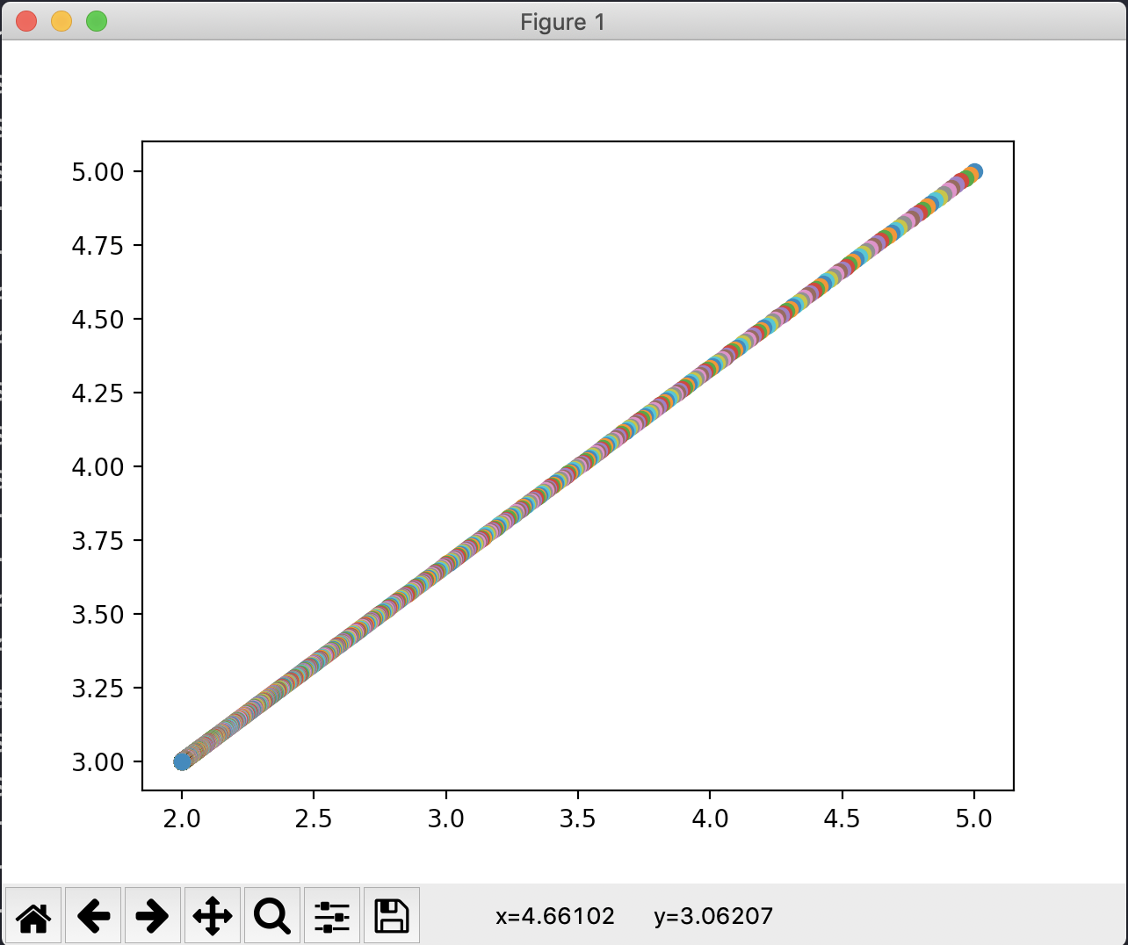

# Problem 2

'''

Week 4 - Problem 2

Solution using Scikit-learn and hand-coded Gradient descent method

'''

import numpy as np

import matplotlib.pyplot as plt

from sklearn import linear_model

from sklearn import preprocessing

### Generate the data ###

def generate_data(random_seed, n_samples):

train_x = np.linspace(0,20,n_samples)

train_y = 3.7 * train_x + 14 + 4 * np.random.randn(n_samples)

print("X data")

print("------")

print("Size: " + str(np.shape(train_x)))

print(train_x)

print("Y data")

print("------")

print("Size: " + str(np.shape(train_y)))

print(train_y)

return(train_x, train_y)

### SciKit Learn method

def scikit_method(x_data, y_data):

print("Using SciKit learn..")

linear_reg = linear_model.LinearRegression()

print("Dimensions: X: " + str(x_data.ndim) + ", Y: " + str(y_data.ndim))

# IMPORTANT: LinearRegression expects a 2-D array. So, add a dimension using

# reshape()

linear_reg.fit(x_data.reshape(-1,1), y_data.reshape(-1,1))

print("Slope : " + str(linear_reg.coef_))

print("Intercept: " + str(linear_reg.intercept_))

return (linear_reg.coef_, linear_reg.intercept_)

### Handcoded Gradient descent method

'''

Partial differentiation w.r.t slope

'''

def dy_dslope(slope, intercept, x_data, y_data):

return (-2 * sum((y_data - slope * x_data - intercept) * x_data))

'''

Partial differentiation w.r.t intercept

'''

def dy_dintercept(slope, intercept, x_data, y_data):

return (-2 * sum((y_data - slope * x_data - intercept)))

'''

Gradient Descent method

'''

def gradient_descent(x_data, y_data, learn_rate, epochs):

print("Gradient Descent method..")

slope = 0

intercept = 0

for iteration in range(epochs):

#print(iteration)

slope = slope - learn_rate * dy_dslope(slope, intercept, x_data, y_data)

intercept = intercept - learn_rate * dy_dintercept(slope, intercept, x_data, y_data)

return (slope, intercept)

'''

Function to descale a min_max scaled data

'''

def deScale_y(y_orig, scaled_y):

result_y = []

min_y = min(y_orig)

max_y = max(y_orig)

for each_scaled_y in scaled_y:

result_y.append(each_scaled_y * (max_y - min_y) + min_y)

return result_y

train_x_actual, train_y_actual = generate_data(42, 30)

train_x = preprocessing.minmax_scale(train_x_actual)

train_y = preprocessing.minmax_scale(train_y_actual)

s_slope, s_intercept = scikit_method(train_x, train_y)

gd_slope, gd_intercept = gradient_descent(train_x, train_y, 0.001, 4000)

print("RESULTS" + "\n" + "-------")

print("SciKit Learn : slope: " + str(s_slope) + " intercept: " + str(s_intercept))

sci_slope = s_slope[0][0]

sci_intercept = s_intercept[0]

result_scaled_y = train_x * sci_slope + sci_intercept

sci_descaled_computed_y = deScale_y(train_y_actual, result_scaled_y)

print("Gradient Descent : slope: " + str(gd_slope) + " intercept: " + str(gd_intercept))

result_scaled_y = train_x * gd_slope + gd_intercept

gd_descaled_computed_y = deScale_y(train_y_actual, result_scaled_y)

# Plot the results

plt.plot(train_x_actual, train_y_actual, 'o')

plt.plot(train_x_actual, sci_descaled_computed_y, '-o')

plt.plot(train_x_actual, gd_descaled_computed_y, '-o')

plt.show()

plt.waitforbuttonpress()

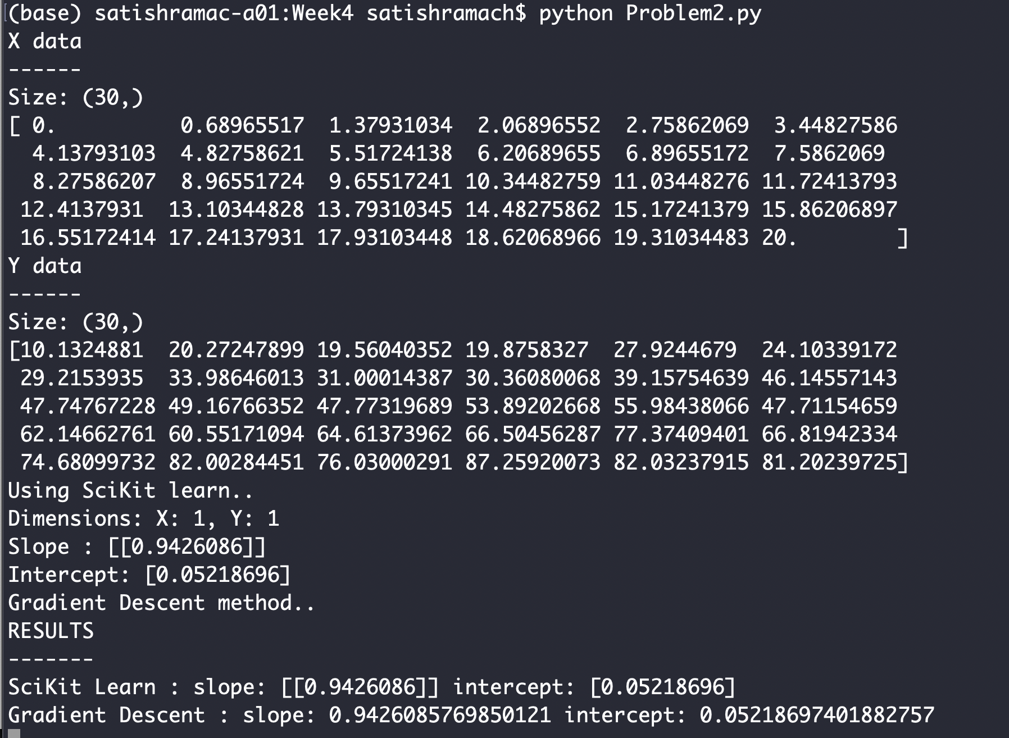

As can be seen, the SciKit derived values and Gradient Descent values are almost the same.

This is the plot of the deScaled values of Y based on the computed slope and intercept. Since both the values are extremely close, the plot line seems like just one.

