Week#5 – Satish Ramachandran

# Problem#1

NOTE: I’m fixing the derivative to remove the 2 from the numerator. Therefore, the new derivative functions that I’m using are:

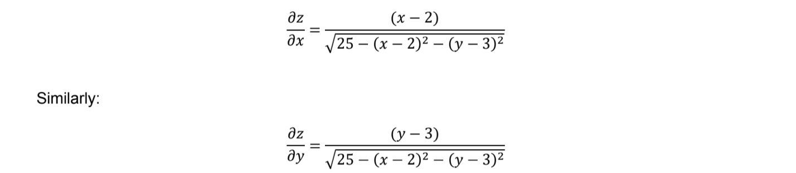

'''

Week5 - Assignment problem #1

Solving Week4's problem using Gradient Descent with Momentum

'''

import math

import matplotlib.pyplot as plt

learning_rate = 0.01

epsilon = 0.000001

'''

Function is:

f(x,y) = z = -1 * math.sqrt(25 - (x - 2) ** 2 - (y - 3) **2)

'''

def func_z(x, y):

return (-1 * math.sqrt(25 - (x - 2) ** 2 - (y - 3) **2))

'''

Partial derivative w.r.t x

NOTE: Fixing the derivative from Homework4

'''

def dz_dx(x, y):

return ((x - 2) / (math.sqrt((25 - (x - 2) ** 2 - (y - 3) ** 2))))

'''

Partial derivative w.r.t y

NOTE: Fixing the derivative from Homework4

'''

def dz_dy(x, y):

return ((y - 3) / (math.sqrt((25 - (x - 2) ** 2 - (y - 3) ** 2))))

'''

Plain Gradient Descent

'''

def plain_gradient_descent(x, y):

iteration = 0

while True:

iteration = iteration + 1

plt.plot(x, y, 'o')

new_x = x - learning_rate * dz_dx(x,y)

new_y = y - learning_rate * dz_dy(x,y)

if (abs(x - new_x) < epsilon) and (abs(y - new_y) < epsilon):

print("Solution reached..")

x = new_x

y = new_y

plt.plot(x, y, 'o')

plt.waitforbuttonpress()

plt.close()

print('New x and y less than epsilon')

return (x, y, iteration)

# More improvements could be made

x = new_x

y = new_y

'''

Gradient Descent with momentum

'''

def gradient_descent_momentum(x, y):

update_x = 0

update_y = 0

gamma = 0.9

iteration = 0

while True:

iteration = iteration + 1

plt.plot(x, y, 'o')

update_x = (gamma * update_x) + (learning_rate * dz_dx(x,y))

update_y = (gamma * update_y) + (learning_rate * dz_dy(x,y))

new_x = x - update_x

new_y = y - update_y

if (abs(x - new_x) < epsilon) and (abs(y - new_y) < epsilon):

print("Solution reached..")

x = new_x

y = new_y

plt.plot(x, y, 'o')

plt.waitforbuttonpress()

plt.close()

print('New x and y less than epsilon')

return (x, y, iteration)

# More improvements could be made

x = new_x

y = new_y

#First, try using Gradient Descent

x,y,iteration = plain_gradient_descent(5,5)

print('Plain Gradient Descent')

print('Solution reached after ' + str(iteration) + ' adjustments')

print('Value of x is: ' + str(x))

print('Value of y is: ' + str(y))

print('Value of z is: ' + str(func_z(x, y)))

#Try the GD, with momentum

x,y,iteration = gradient_descent_momentum(5,5)

print('Gradient Descent with Momentum')

print('Solution reached after ' + str(iteration) + ' adjustments')

print('Value of x is: ' + str(x))

print('Value of y is: ' + str(y))

print('Value of z is: ' + str(func_z(x, y)))

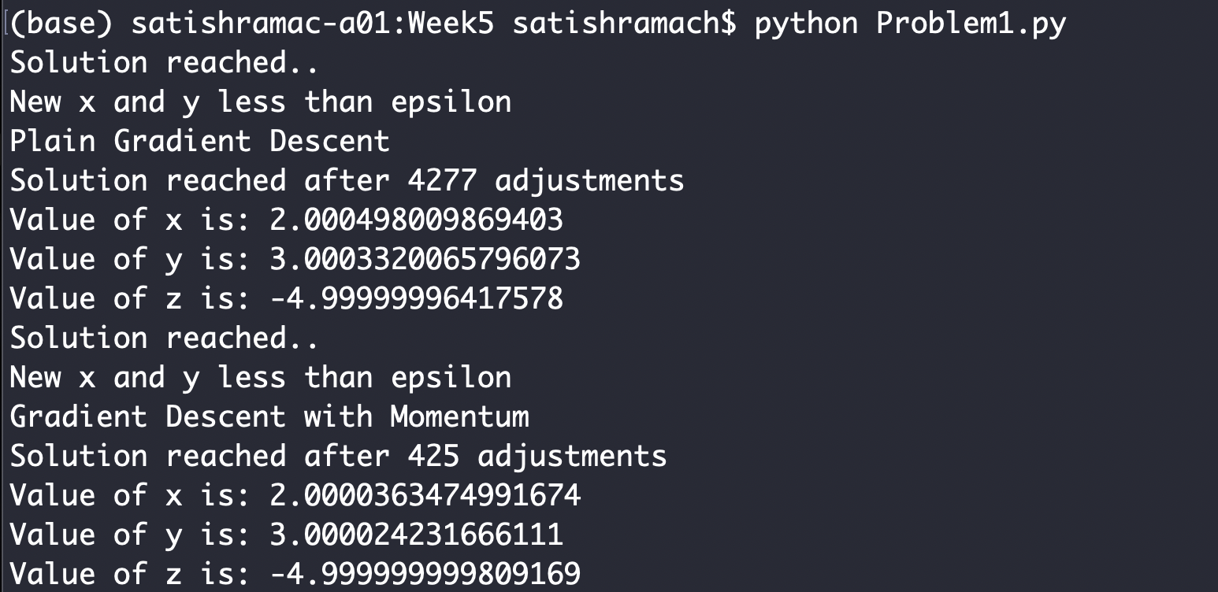

# Problem#2

Clearly, GD with momentum converges faster than the plain Gradient Descent algorithm. The number of iterations is 4277 vs 425, which means, it took the momentum based algorithm only 10% of the number of iterations.

The plot of the solutions also shows the same.

Without momentum:

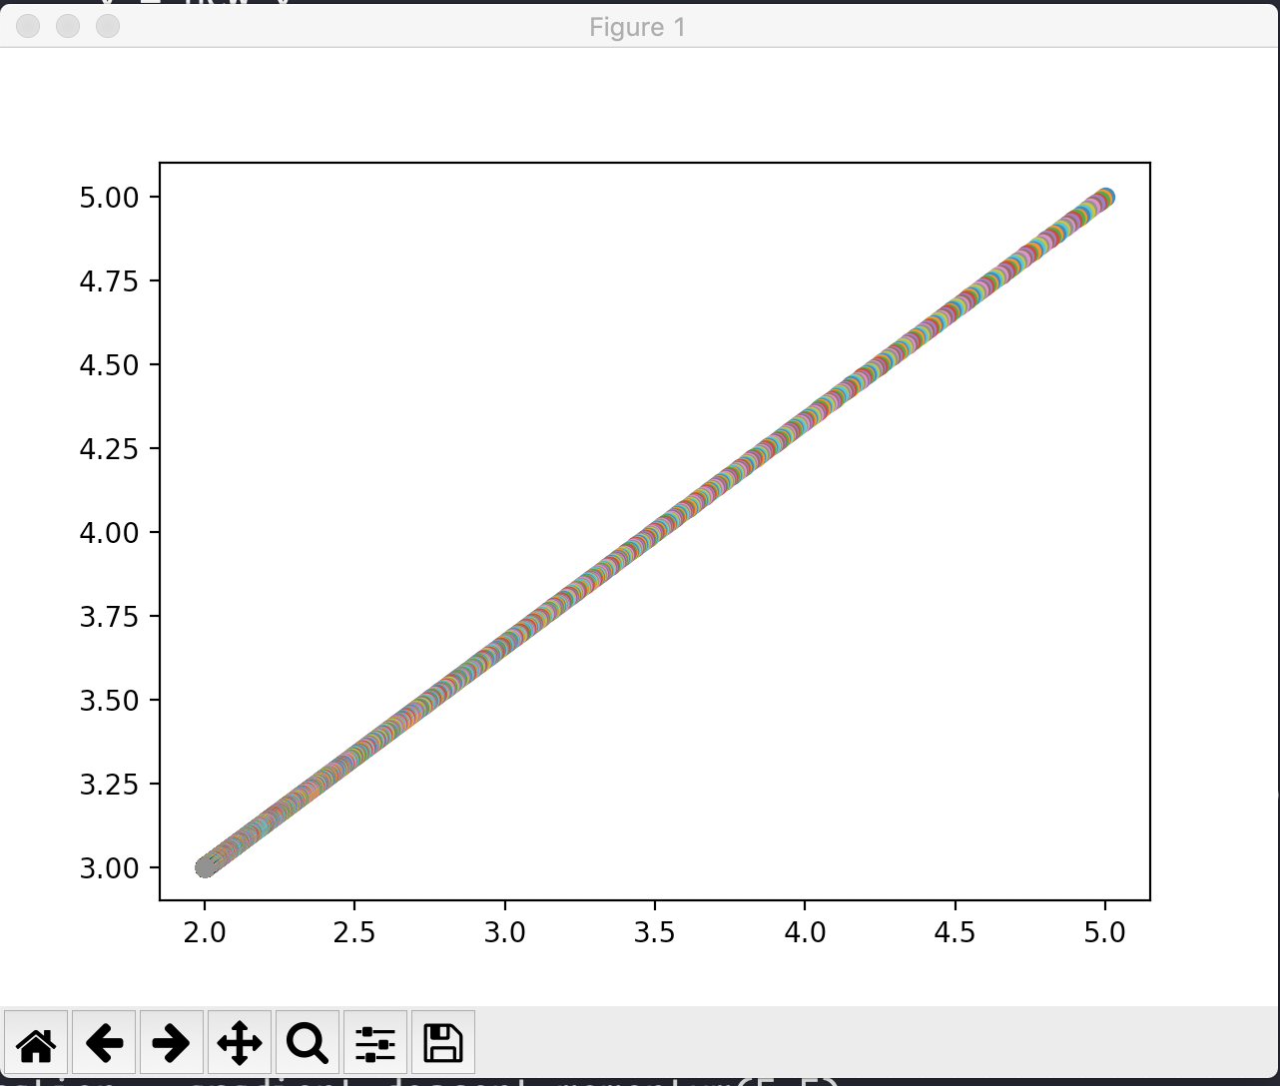

With momentum:

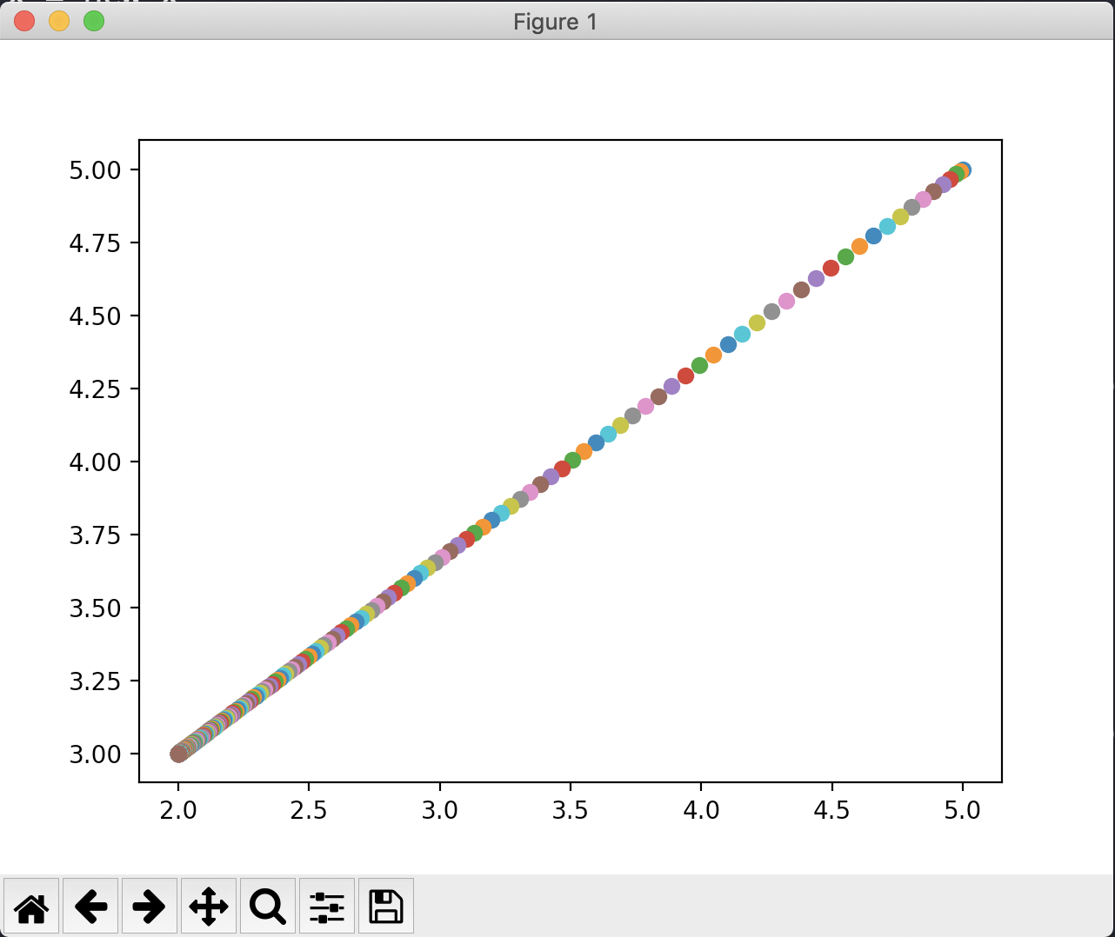

It can be seen that the increments became smaller as the solution was converging.