Week7 – Satish Ramachandran

# Problem #1

'''

Week#7 - Problem #1

LSTM - next number in series predictor

'''

import numpy as np

import matplotlib.pyplot as plt

from sklearn.model_selection import train_test_split

from keras.models import Sequential

#Using TensorFlow backend.

from keras.layers import LSTM

def create_dataset():

#Create 200 series of numbers, 8 in each

data_set = [[ [i+j] for i in range(8)] for j in range (200)]

print('Created dataset...')

print(data_set[0:3])

print(data_set[-3:])

#Create 200 target, one for each series created earlier

target_set = [(i+8) for i in range(200)]

print('Created target...')

print(target_set[0:3])

print(target_set[-3:])

np_ds = np.array(data_set, dtype=float)

np_target = np.array(target_set, dtype = float)

#Scale it so that the model trains accurately.

return np_ds/200, np_target/200

def create_train_test_set(data, target):

x_train, x_test, y_train, y_test = train_test_split(data, target, test_size=0.2,

random_state=4)

return x_train, x_test, y_train, y_test

def create_train_model(series_train, series_test, target_train, target_test):

model = Sequential()

# Add the LSTM

model.add(LSTM((1), batch_input_shape=(None,8,1), return_sequences=False))

#model.add(LSTM((1), return_sequences=False))

model.compile(loss='mean_absolute_error', optimizer='adam', metrics=['accuracy'])

# Dump model parameters

model.summary()

# Train the model

history = model.fit(series_train, target_train, epochs=800, validation_data=(series_test, target_test), verbose=0)

results = model.predict(series_test)

plt.title('normalized results over test data')

plt.scatter(range(40), results, c='r')

plt.scatter(range(40), target_test, c='g')

plt.waitforbuttonpress()

plt.close()

# Plot the loss Function

plt.title('loss function')

plt.plot(history.history['loss'])

plt.waitforbuttonpress()

#Create the dataset

series, target = create_dataset()

#Split into testing and training sets

series_train, series_test, target_train, target_test = create_train_test_set(series, target)

create_train_model(series_train, series_test, target_train, target_test)

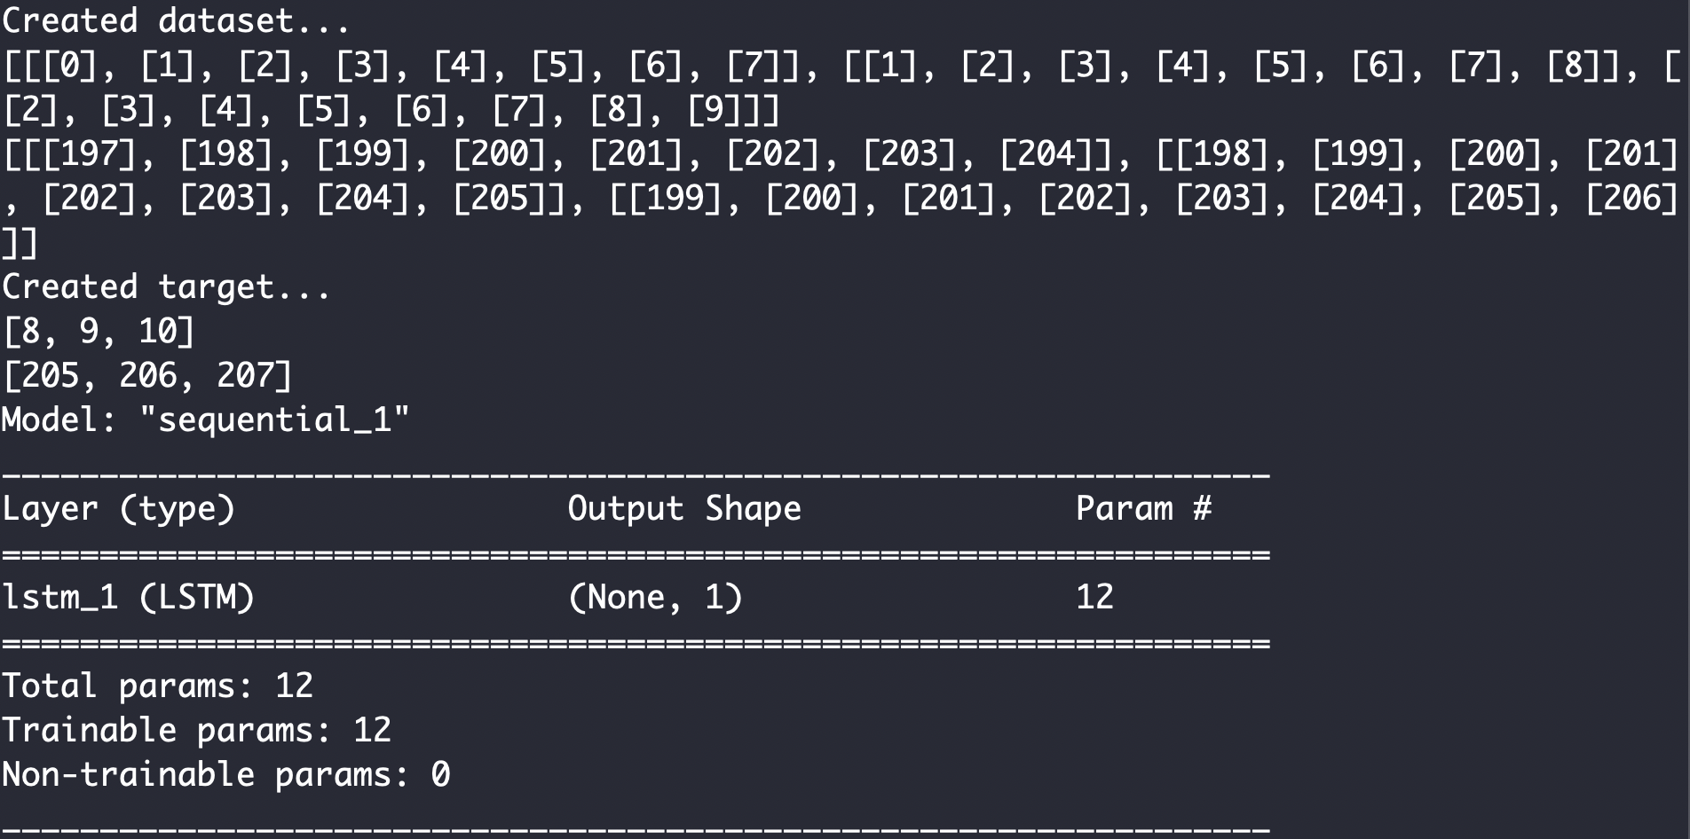

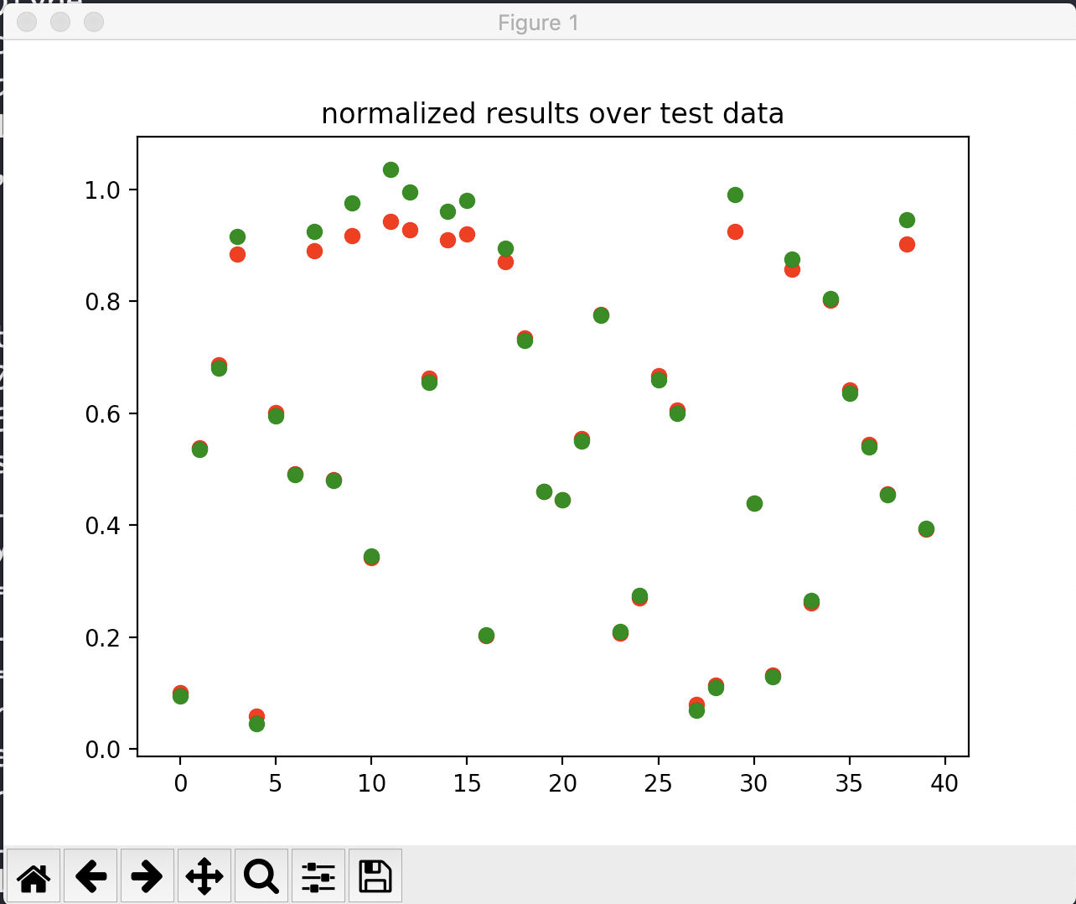

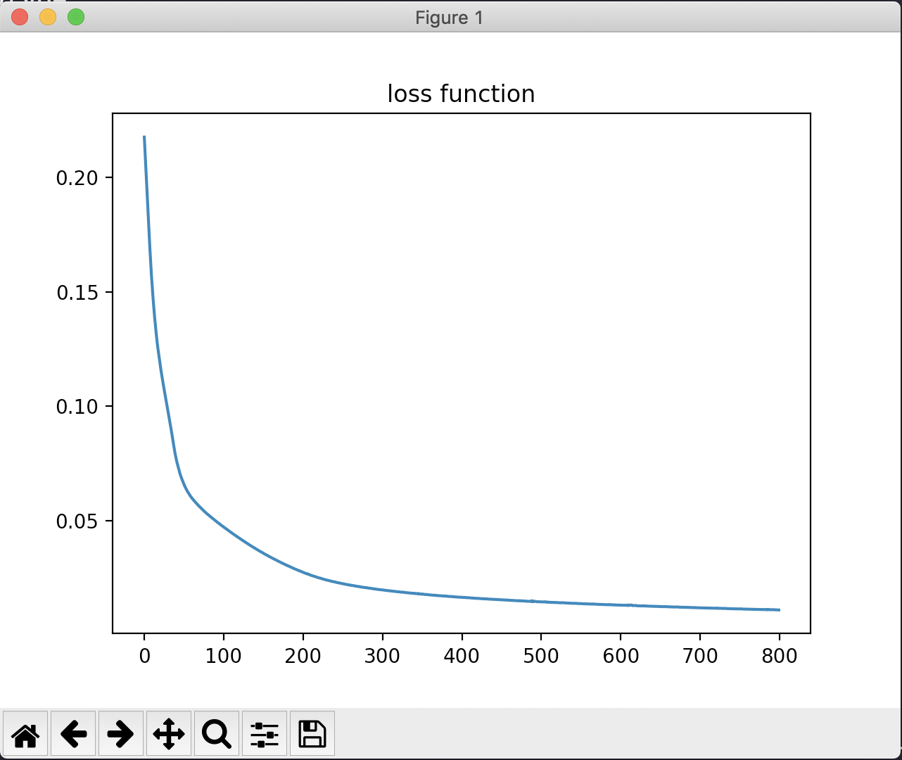

# Problem #2

'''

Week #7 - Problem #2

Source code already provided.

Just making minor modifications

'''

import numpy as np

import pylab as plt

# map cell to cell, add circular cell to goal point

points_list = [(0,1), (1,5), (5,6), (5,4), (1,2), (2,3), (2,7), (7,8)]

goal = 8

import networkx as nx

G=nx.Graph()

G.add_edges_from(points_list)

pos = nx.spring_layout(G)

nx.draw_networkx_nodes(G,pos)

nx.draw_networkx_edges(G,pos)

nx.draw_networkx_labels(G,pos)

plt.title('realized graph')

plt.show()

# how many points in graph? x points

MATRIX_SIZE = 9

# create matrix x*y

R = np.matrix(np.ones(shape=(MATRIX_SIZE, MATRIX_SIZE)))

R *= -1

R

# assign zeros to paths and 100 to goal-reaching point

for point in points_list:

print(point)

if point[1] == goal:

R[point] = 100

else:

R[point] = 0

if point[0] == goal:

R[point[::-1]] = 100

else:

# reverse of point

R[point[::-1]]= 0

R

# add goal point round trip

R[goal,goal]= 100

R

###########################################

Q = np.matrix(np.zeros([MATRIX_SIZE,MATRIX_SIZE]))

Q

# learning parameter

gamma = 0.8

initial_state = 1

def available_actions(state):

current_state_row = R[state,]

av_act = np.where(current_state_row >= 0)[1]

return av_act

available_act = available_actions(initial_state)

def sample_next_action(available_actions_range):

next_action = int(np.random.choice(available_act,1))

return next_action

action = sample_next_action(available_act)

def update(current_state, action, gamma):

max_index = np.where(Q[action,] == np.max(Q[action,]))[1]

if max_index.shape[0] > 1:

max_index = int(np.random.choice(max_index, size = 1))

else:

max_index = int(max_index)

max_value = Q[action, max_index]

Q[current_state, action] = R[current_state, action] + gamma * max_value

print('max_value', R[current_state, action] + gamma * max_value)

if (np.max(Q) > 0):

return(np.sum(Q/np.max(Q)*100))

else:

return (0)

update(initial_state, action, gamma)

# Training

scores = []

for i in range(700):

current_state = np.random.randint(0, int(Q.shape[0]))

available_act = available_actions(current_state)

action = sample_next_action(available_act)

score = update(current_state,action,gamma)

scores.append(score)

print ('Score:', str(score))

print("Trained Q matrix:")

print(Q/np.max(Q)*100)

# Testing

current_state = 0

steps = [current_state]

while current_state != goal:

next_step_index = np.where(Q[current_state,]

== np.max(Q[current_state,]))[1]

if next_step_index.shape[0] > 1:

next_step_index = int(np.random.choice(next_step_index, size = 1))

else:

next_step_index = int(next_step_index)

steps.append(next_step_index)

current_state = next_step_index

print("Most efficient path:")

print(steps)

plt.title('scores')

plt.plot(scores)

plt.show()

