By: Sara Malaeb

MSBA 370- DDM

Streamlit Individual Project

Sony MUSIC

# Introduction:

Sony music entertainment is introduced and the goal is to tackle the data provided by this company in order to come up with insights and decisions. Sony Music is an American global music company that is responsible for finding and recruiting artists. It manages the artists’ work and recordings aiming at increasing their albums sales. The company works with artists from different countries and produces many labels of different languages and genres. In this report, we examine the dataset and the situation of the company by that strengthening the value of the company and understanding the features that affect the sales of the labels.

# Current Situation:

The streamlit provided describes the dataset and shows plots that provides insights of the current situation.

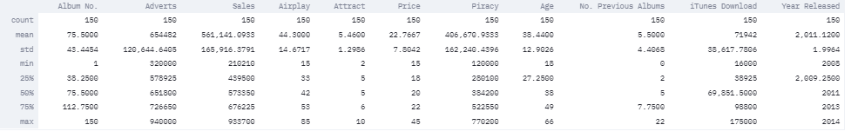

Figure 1-Data Described

Figure 1 shows a description of the dataset.

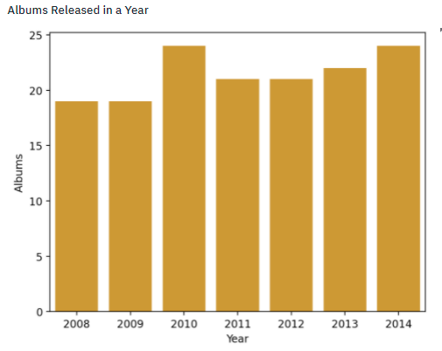

Figure 2-Albums Released in a Year

In figure 2, we can notice that the release of albums is slightly increasing through years with a peak in 2010 and 2014(current year of data).

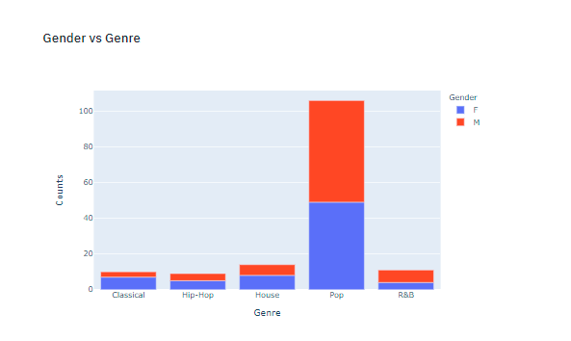

Figure 3-Gender vs Genre

The artists gender isn’t restricted to any genre; however, we can notice that females dominate the classical music while males dominate the R&B where most females and males equally go for pop songs.

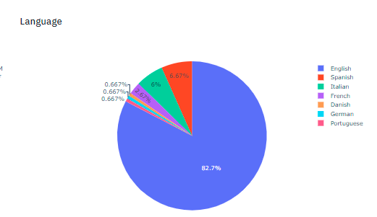

Figure 4-Language of Labels

In figure 4, we can notice that English songs dominate the music recordings having an 82.7% of the total.

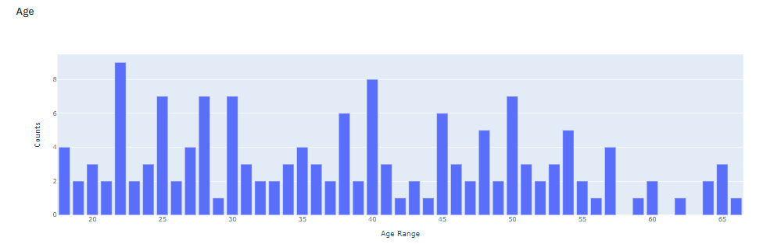

Figure 5-Age of Artists

The age of artists is distributed along the range; however, we can notice that Sony has more young artists aged between 20-30 and less artists older than 50 years.

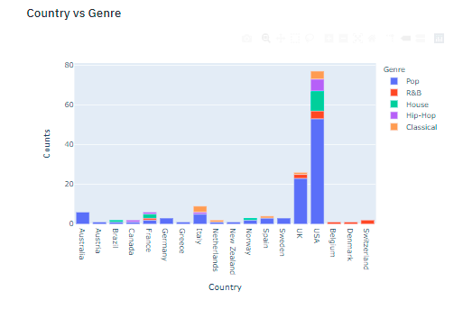

Figure 6-Country and Genre

In Figure 6, we can see that Pop music is the most favored by artists of most countries; however, some European countries such as Belgium, Denmark, and Switzerland don’t go for Pop music instead they favor R&B.

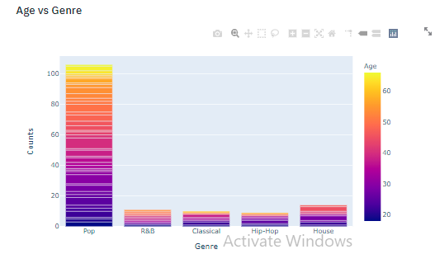

Figure 7-Age vs Genre

It is noticeable that most young artists go for Pop and even some older artists (above 60) also favor the Pop genre.

# Examination of the Plots and Insights:

From the section above we can notice that Pop is favored by most artists especially young artists that are recruited more by Sony with respect to older artists.

However, Sony lacks variety in the language and genre of the labels. We can notice that some European countries might favor other genre and languages which should be studied more and applied. R&B could help increase sales in European countries such as Switzerland and Belgium. This kind of music is shown to be favored by older artists that could also be more recruited.

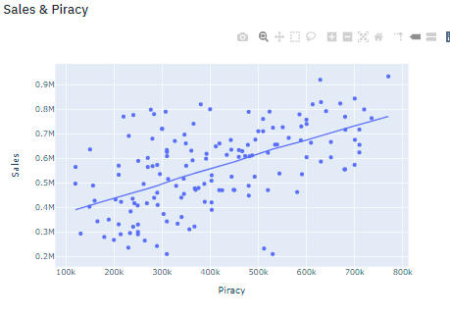

Figure 8-Sales & Piracy

However, what figure 8 shows that piracy which is hold into accounts the illegal downloads of the songs shows a positive effect on sales! Showing that the more the songs played and spread even if illegally the more the sales.

# Sales Prediction:

The important part comes in understanding what actually affects the sales and should be more acquired. It is discovered through feature importance that Advertisements is one of the most important features to increase sales along with the Attractiveness of artist.

Age has the least effect (was removed in the machine learning due to feature engineering).

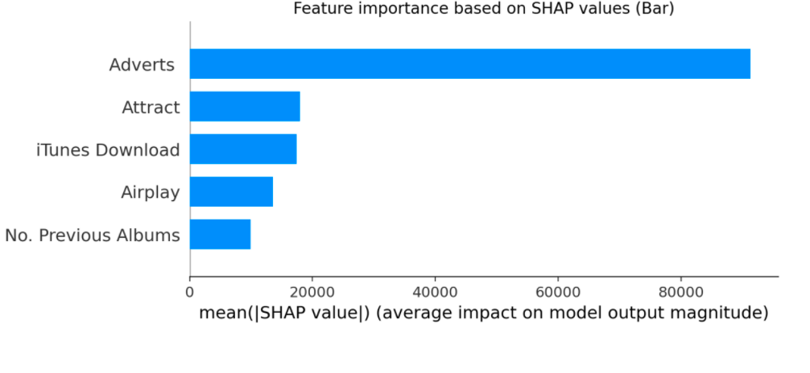

Figure 9-Feature importance

## Sales predictor App:

The app predicts sales based on the features specified by the contributor. The features are selected and sales are predicted through the application of machine learning using the random forest model.

(Random Forest Model showed best accuracy for these kinds of predictions)

Example:

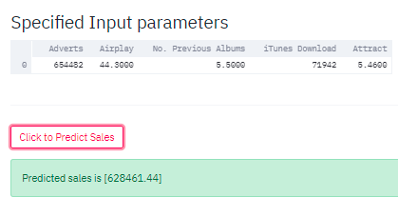

Figure 10-Sales prediction for specified inputs

Note: Feature engineering was performed in addition to removing variables due to the memory problem faced when running the app.

# Findings & Recommendation:

The app showed us that advertisement play an important role in sales; however, we should be careful as they could increase the cost. It’s important to figure a smart effective advertisement for the labels to increase the sales without increasing the cost. On the other hand, attractiveness is revealed to be an important feature by that Sony could work on the level of attractiveness of the band and singer through applying a unique favored style or theme for the singer/band.

Another important recommendation is to recruit more R&B singers as they are favored by European countries yet recruited less than Pop genre.