Original exercise by Ellen Berntell

Institutionen för naturgeografi och kvartärgeologi

Stockholms universitet

Translated and edited by Sara Blichner (January 2023)

Sara.blichner@aces.su.se

**Energy balance models – lab exercises**

Goals of these exercises:

1. You should understand what an energy balance model is
2. You will do some simple experiments with energy balance models and get a feeling for some fundamentals within climate modelling

*This exercise starts with some theory which you should read and understand before you do the exercises. If you read the theory properly first, you will understand more when you start the exercises!*

To start off, you need to have python installed on your computer. You find instructions on Athena for this. Then you need to download from github the code:

XXXX FILL IN!

# 1. Theory

## 1.1. What is an energy balance model?

One of the basic physical laws that all climate models must follow is that there must be a balance between incoming and outgoing energy. The easiest way to consider the climate system on Earth (or any planet), is to imagine that you see the planet from afar (or as a "small ball") and then describe its global energy balance and calculate the prevailing global average temperature at balance. Since electromagnetic radiation is the only form of energy that can be transported in free space, the energy balance is determined by the fact that the radiation energy coming in from the sun must be as great as the radiation energy leaving the earth. There are then primarily three things you need to think about:

1. The solar radiation comes in from only one direction, while the radiation from the Earth goes out in all directions.
2. Part of the incoming solar radiation is reflected away from the Earth.
3. The Earth's radiation temperature (as well as for all intents and purposes) is determined by Stefan-Boltzmann's law.

The figure below visualizes this model:

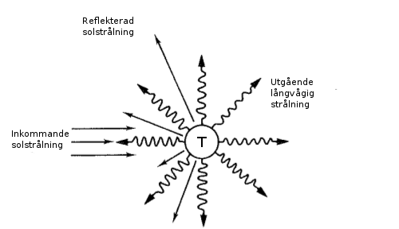

**Figur 1***. The idea behind a global (0-dim) energy balance model is that the average temperature of the planet is determined by the balance between incoming, minus reflected, solar radiation and outgoing long-wave radiation. This balance determines the planet's effective radiant temperature. (Modified from Fig. 3.1a, p. 70, in A climate modelling primer.[1])*

In this simple model, the Earth has no “dimension”, i.e. we don't care about latitude and longitude, nor about height above or below sea level. This is therefore called a zero-dimensional energy balance model, or a global energy balance model. The word energy-balance model is usually abbreviated EBM, and in the following we use that abbreviation.

We get a slightly more realistic model if we also take into account that the energy balance is different at different latitudes. We can then divide the earth into a number of “zones”, i.e. areas bounded by certain definite latitudes. If we do that, we can consider the energy balance in each zone separately. The model becomes even more realistic if we also take into account that energy can be transported between the zones. In reality this happens in the atmosphere and in the oceans, but in the simplified model we can simply assume that energy can be transported between the zones without specifying how it happens. We can illustrate such a model as in the figure below:

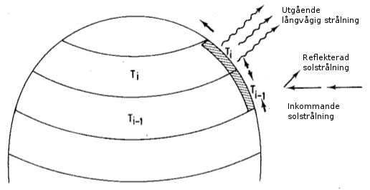

**Figur 2***. The idea behind a 1-dim energy balance model with latitudinal heat flow is that the average temperature in a latitude zone is determined by the balance between incoming, minus reflected, solar radiation, outgoing longwave radiation, and energy flow to neighboring latitude zones. (Modified from Fig. 3.1b, p. 70, in A climate modelling primer.)*

In such a model we have a "dimension" - we thus have a **1-dimensional energy balance model** (1-dim EBM). It is the latitude that is our dimension in this case. You will use such a model later in this computer lab.

After this conceptual introduction, we move on to describe the models using equations.

## 1.2. 0-dim EBM

In the very simplest case, we can limit ourselves to calculating the effective radiation temperature obtained if we assume that the outgoing radiation energy R is equal to the absorbed radiation energy R for the planet as a whole, i.e. that:

In the very simplest case, we can limit ourselves to calculating the effective radiation temperature obtained if we assume that the outgoing radiation energy ***R***  is equal to the absorbed radiation energy ***R*** for the planet as a whole, i.e.:

*R* = *R*

(radiation in) = (radiation out).

The absorbed energy can be described by

 , (1)  
  
where S is the total incoming solar energy per surface and  is the planetary albedo.

Up until recently, S was called the solar constant, but since it actually changes somewhat over time, we now call it “total solar irradiance”, abbreviated as TSI. In the equation above, we divide S by 4 because the TSI is per area perpendicular to the incoming radiation (), but the radiation is divided by the total surface of the Earth ().

For the Earth, at this point in time, the TSI is 1361 W m-2 and the planetary albedo is  = 0.3.

För planeten jorden i nutid gäller att *S* = 1361 W m-2 och  = 0.3.

# For the outgoing energy, we assume that the earth radiates as a black body:

, (2)

Where is the Stefan-Boltzmann constant and T is the temperature measured in Kelvin (K).

If we now set *R* = *R* we get

, (3)

which has the solution

. (4)

With equation (4) and the values of **, *S* och **  as stated above, we can calculate the effective radiation temperature of the planet Earth. A calculator works fine, but you can also do it with the python function in ebm_models.ebm0.py in the files you downloaded earlier. You will soon do that in the first lab exercise below.

However, the model in equation (3) is very simple compared to reality. In part, it assumes that the Earth radiates as a perfect blackbody. There are no perfect blackbodies and by definition all real objects radiate less energy than a theoretical blackbody. In addition, an important component is completely missing if we want to consider the Earth's radiation balance at the surface: The model does not take into account at all that the atmosphere is almost transparent to the incoming solar radiation (which is short-wave), while it absorbs and re-emits a large part of the Earths outgoing radiation (which is long-wave because the Earth is colder than the Sun). In reality, the Earth at the surface receives the sum of incoming (minus reflected) solar radiation and the long-wave radiation re-emitted from the atmosphere. It is this reemission of radiation that is called the greenhouse effect. The easiest way to include the fact that the Earth is not a perfect blackbody, include the greenhouse effect, and thus get a better model for the radiation balance at the Earth's surface, is to introduce a factor that reduces the amount of outgoing radiation. We therefore introduce an **effective emissivity** factor, ε, which is a number between 0 and 1. The expression for the outgoing radiation *R* in the equation above is multiplied by this factor, and our model then becomes:

. (5)

The Earths effective emissivity at the surface has been estimated to be ε = 0.612.

## 1.3. 1-dim EBM

The 1-dim EBM used in this exercise includes meridional (across latitudes) heat flux. The model, which is described by North (1975), can be expressed with the following formula:

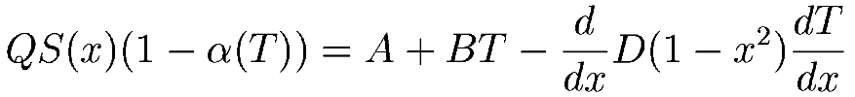

This model is considerably more complicated than the 0-dimensional EBM described in the section above. You don't need to understand everything in the model in detail, but you should understand the ideas behind it. Just as in the case of 0-dim EBM, an equilibrium is expressed between incoming energy (in the left term) and outgoing energy (in the right term). One difference, however, is that in the 1-dim model the expression applies to a certain latitude zone instead of the entire earth. In the formula above, the latitude is indicated by the symbol . Other components in the model are:

Incoming energy:

* *Q* : the incoming solar energy divided by 4 (as the term S/4 in the 0-dim model).
* *S*(*x*): indicates what percentage of the solar energy is received at a certain latitude x
* (NOTE! the symbol S thus has a different meaning here than in the 0-dim model).
* α(*T*) : The albedo α at a certain temperature T. The albedo is thus allowed to vary with temperature.

Outgoing energy:

* *A* + *BT*: outgoing long-wave radiation taking into account the model's greenhouse effect. A is a constant and B a factor that is multiplied by the temperature T. As in the 0-dim model, the outgoing radiation is thus dependent on the temperature. A big difference, however, is that here this dependence is assumed to be linear, instead of depending on T4. This is a gross simplification which means that the chosen values of A and B only realistically apply within a small temperature range.
* 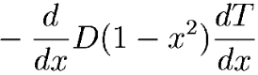 : expresses the heat flux between the latitudes. The factor D ett uttryck för värmeflödet mellan latituderna. The factor D is called the heat diffusion coefficient.

The 1-dim model has, in a way, another dimension, namely time. Unlike the 0-dim model, the equilibrium temperature T cannot be solved with a simple equation solution. Instead, one must specify an initial value of T for each latitude band, and then let the model count forward in time enough time steps for the entire model to balance.

**You are now done with the introduction! Please go to the notebook Exercises_EBM_model.ipynb in the downloaded folder.**

1. McGuffie, K. och Henderson-Sellers, A. 1997: A climate modelling primer. John Wiley & Sons, 253 sid. (Kapitel 3, Energy Balance Models, förklarar ingående principerna för energibalansmodeller.)