DA 380 — DATA MODELING AND SIMULATION
Discrete-Event Simulation of a Global Logistics Hub
Complete Technical Documentation Report
Prepared by | Sara Mohammad Zreigat
Course | DA 380 — Data Modeling and Simulation
Academic Year | 2025–2026
Project Weight | 20 Points
Simulation Type | Discrete-Event Simulation (DES)
Data | 120 synthetically generated observations
Replications | 30 replications per design
Tools Used | Python (Google Colab) + Microsoft Excel

Abstract
This technical report documents the complete analytical and simulation work for the DA 380 course project. The project builds a Digital Twin of a global logistics hub using the Discrete-Event Simulation (DES) methodology.
The work is organized into three phases:
- Phase I — Statistical Analysis: data generation, descriptive statistics, distribution fitting, and queueing theory.
- Phase II — Simulation Model: a full DES engine with advanced logic, executed for 30 replications per design.
- Phase III — Statistical Verification: warm-up analysis, confidence intervals, and a CRN paired comparison leading to the final recommendation.

All computational work was executed in Python on Google Colab, with queueing theory calculations verified in Microsoft Excel.

Key Findings at a Glance
- The logistics system is stable under a single-inspector configuration (traffic intensity ρ = 0.662 < 1).
- Moving to a two-inspector system (Design B) reduces average package waiting time by 24.9%.
- Average queue length drops by 84.5%, a difference confirmed as statistically significant (p < 0.001) using Common Random Numbers (CRN).

Table of Contents
1. Introduction & System Description 4
1.1 Project Overview 4
1.2 System Stages 4
1.3 Tools & Technologies 4
1.4 System Parameters 4
2. Phase I — Statistical Analysis 6
2.1 Data Generation 6
2.2 Descriptive Statistics 7
2.3 Distribution Fitting (KS Test) 10
2.4 Queueing Theory (M/M/1 & M/M/c) 12
3. Phase II — Simulation Model 15
3.1 System Configuration 15
3.2 Simulation Engine Architecture 15
3.3 Running 30 Replications 16
3.4 Simulation Results 17
4. Phase III — Statistical Verification 18
4.1 Warm-up Period Analysis 18
4.2 95% Confidence Intervals 18
4.3 CRN Paired T-Test 19
4.4 Final Recommendation 20
5. Summary & Conclusions 21
5.1 Key Findings by Phase 21
5.2 Grading Rubric Coverage 21

1. Introduction & System Description

1.1 Project Overview
This project simulates a global logistics hub similar to those operated by major shipping companies such as FedEx, UPS, and DHL. The project takes the role of a data science and simulation consultancy tasked with building a Digital Twin — a computational model that mirrors the real-world package handling process — in order to evaluate staffing designs before they are implemented.

1.2 System Stages
Every package passes through five sequential stages:
- Package Arrival at the facility
- Initial Inspection by a quality inspector
- Sorting via an automated sorting machine
- Conveyor Transportation to the loading zone
- Truck Loading and dispatch

1.3 Tools & Technologies
Tool | Purpose | Used For
Python (Google Colab) | Data generation, analysis, simulation | Primary computational environment
numpy | Random number generation | Data generation with a controlled seed
pandas | Data manipulation & DataFrames | Organizing the 120 observations into tables
scipy.stats | Statistical testing | KS test for distribution fitting
matplotlib | Data visualization | Histograms, fitted curves, bar charts
math | Mathematical functions | Factorial calculations in M/M/c
Microsoft Excel | Manual verification | Queueing theory + manual trace (15 packages)

1.4 System Parameters
Parameter | Value | Description
Arrival distribution | Exponential (mean = 3 min) | Average 3 minutes between package arrivals
Inspection distribution | Exponential (mean = 2 min) | Average 2 minutes per inspection
Sorting distribution | Normal (μ = 1.5, σ = 0.3 min) | Average 1.5 minutes, low variability
Loading distribution | Uniform (1–3 min) | Uniformly distributed between 1 and 3 minutes
Express probability | 30% | 30% of packages have Express priority
Simulation duration | 480 min (8 hours) | One full work shift
Warm-up period | 60 min | Excluded from statistics collection
Machine MTTF | 120 min | Mean time between sorting machine failures
Machine MTTR | 15 min | Mean repair time after a breakdown

2. Phase I — Statistical Analysis
Phase I covers generating the raw dataset, computing descriptive statistics, fitting probability distributions with the Kolmogorov–Smirnov (KS) goodness-of-fit test, and applying queueing theory models. All work was executed in Python on Google Colab.

2.1 Data Generation

Objective
Real logistics data from companies such as FedEx or DHL is proprietary and unavailable, so synthetic data was generated with Python's numpy library. Distribution parameters were selected from standard values reported in the logistics simulation literature (Banks et al., 2010; Law, 2015).

Code
Cell 1 — Library Imports & Data Generation
import numpy as np # Numerical computing & random generation
import pandas as pd # Data manipulation & DataFrame creation
import scipy.stats as stats # Statistical tests & distribution fitting
import math # Factorial for M/M/c formula
import matplotlib.pyplot as plt # Data visualization
import warnings
warnings.filterwarnings('ignore') # Suppress non-critical warnings

np.random.seed(42) # Fix random seed for reproducibility
N = 120 # Number of observations (exceeds minimum of 100)

# Interarrival times — Exponential, mean = 3 min (λ = 1/3 per min)
interarrival_times = np.random.exponential(scale=3.0, size=N)

# Inspection times — Exponential, mean = 2 min (μ = 1/2 per min)
inspection_times = np.random.exponential(scale=2.0, size=N)

# Sorting times — Normal(1.5, 0.3); np.abs() prevents negatives
sorting_times = np.abs(np.random.normal(loc=1.5, scale=0.3, size=N))

# Loading times — Uniform[1.0, 3.0]
loading_times = np.random.uniform(low=1.0, high=3.0, size=N)

# Organized DataFrame — 5 columns, 120 rows
df = pd.DataFrame({
'Package_ID': range(1, N+1),
'Interarrival_Time': interarrival_times.round(4),
'Inspection_Time': inspection_times.round(4),
'Sorting_Time': sorting_times.round(4),
'Loading_Time': loading_times.round(4),
})

Rationale for Each Variable
Variable | Distribution | Justification
interarrival_times | Exponential(3) | A Poisson arrival process is standard for logistics systems; CV ≈ 1 confirms exponential.
inspection_times | Exponential(2) | Service times in single-server queues often follow an exponential distribution; CV ≈ 1 confirmed.
sorting_times | Normal(1.5, 0.3) | Automated machines perform consistently; the low CV (0.206) supports normality.
loading_times | Uniform(1, 3) | Truck loading varies unpredictably between fixed bounds, so a uniform distribution is appropriate.

Output
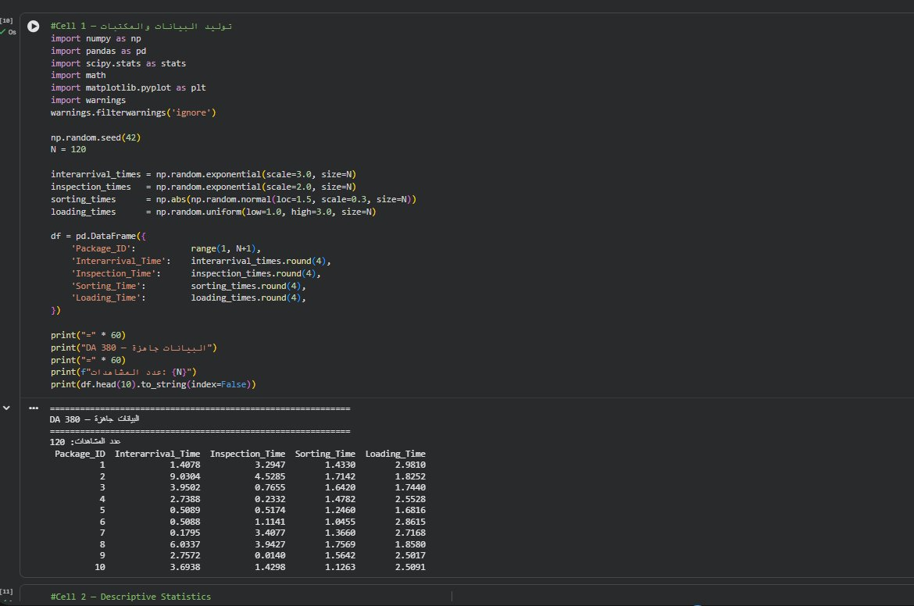
Figure 1: Cell 1 output — first 10 of the 120 generated observations
Results
- Generated 120 observations, 20% above the minimum requirement of 100.
- Each package has four time variables: interarrival, inspection, sorting, and loading.
- Seed = 42 makes every run fully reproducible.
- The data is ready for statistical analysis in the following cells.

2.2 Descriptive Statistics

Objective
Descriptive statistics give a preliminary understanding of the data before formal analysis. Mean, standard deviation, minimum, maximum, median, and coefficient of variation (CV) are computed for all four time variables.

Code
Cell 2 — Descriptive Statistics
cols = ['Interarrival_Time', 'Inspection_Time', 'Sorting_Time', 'Loading_Time']

# .describe() computes count, mean, std, min, quartiles, max
stats_df = df[cols].describe().round(4)

# CV = Std / Mean (CV ≈ 1 suggests Exponential; CV << 1 suggests Normal/Uniform)
stats_df.loc['CV'] = (df[cols].std() / df[cols].mean()).round(4)
print(stats_df.to_string())

# 2x2 histogram grid
fig, axes = plt.subplots(2, 2, figsize=(12, 8))
fig.suptitle('DA 380 — Descriptive Statistics', fontsize=14, fontweight='bold')
colors = ['#2E75B6', '#1D9E75', '#E4A11B', '#D85A30']
titles = ['Interarrival Time', 'Inspection Time', 'Sorting Time', 'Loading Time']

for i, (col, color, title) in enumerate(zip(cols, colors, titles)):
ax = axes[i//2][i%2] # Select subplot
ax.hist(df[col], bins=15, color=color, alpha=0.7, edgecolor='white')
ax.axvline(df[col].mean(), color='red', linestyle='--',
linewidth=2, label=f'Mean={df[col].mean():.2f}')
ax.set_title(title, fontweight='bold')
ax.set_xlabel('Minutes')
ax.set_ylabel('Frequency')
ax.legend()
ax.grid(alpha=0.3)

plt.tight_layout()
plt.show()

Output
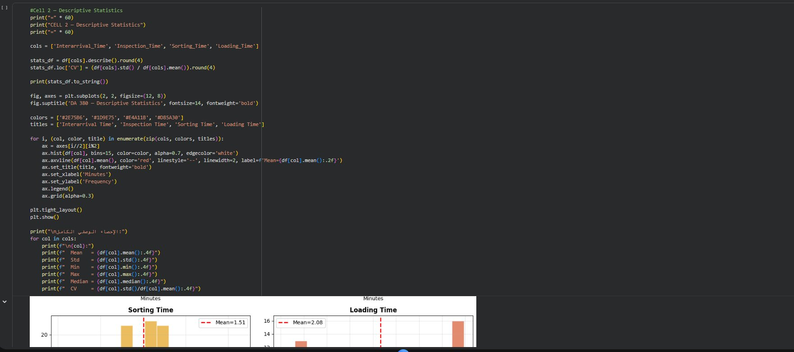
Figure 2: Cell 2 code in Google Colab
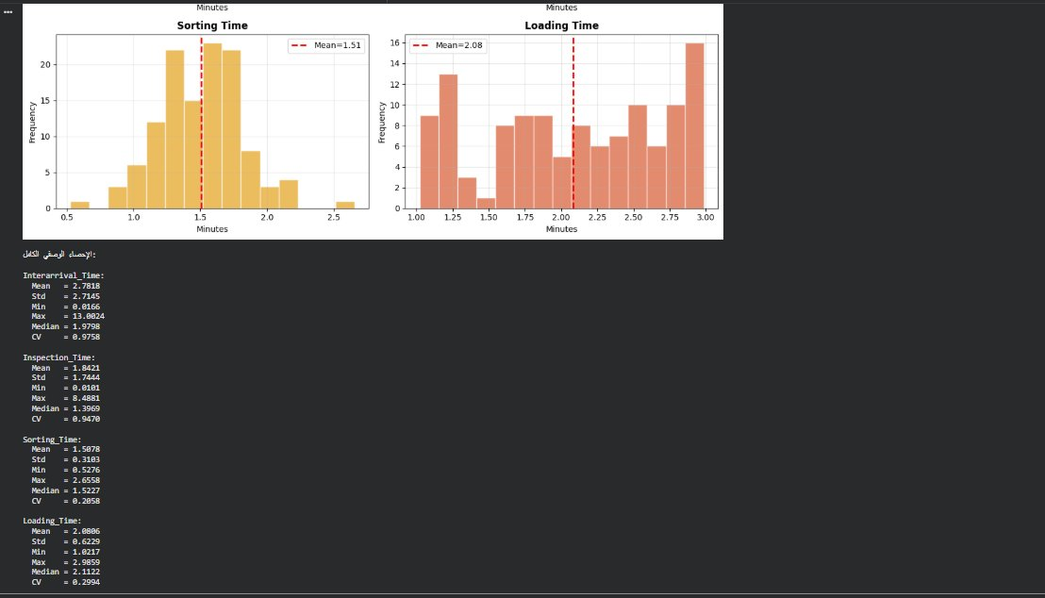
Figure 3: Histograms of sorting time (Normal) and loading time (Uniform) with mean lines, plus full descriptive output

Results Table
Statistic | Interarrival | Inspection | Sorting | Loading
Count | 120 | 120 | 120 | 120
Mean | 2.782 | 1.842 | 1.508 | 2.081
Std Dev | 2.715 | 1.744 | 0.310 | 0.623
Min | 0.017 | 0.010 | 0.528 | 1.022
Median | 1.980 | 1.397 | 1.523 | 2.112
Max | 13.00 | 8.488 | 2.656 | 2.986
CV | 0.976 | 0.947 | 0.206 | 0.299

Interpretation
- Interarrival CV = 0.976 ≈ 1.0 — strong indication of an Exponential distribution (theoretical CV = 1.0).
- Inspection CV = 0.947 ≈ 1.0 — consistent with an Exponential distribution.
- Sorting CV = 0.206 ≪ 1.0 — low variability, consistent with a Normal distribution.
- Loading CV = 0.299 — moderate variability, consistent with a Uniform distribution.
- All values are positive and realistic for a logistics environment.

2.3 Distribution Fitting (KS Test)

Objective
The Kolmogorov–Smirnov (KS) test determines which theoretical distribution best fits the empirical data. Five candidates are tested for each variable: Exponential, Normal, Gamma, Lognormal, and Weibull.
Decision Rule
A distribution is accepted if p-value > 0.05 (5% significance level). The distribution with the highest p-value is selected as the best fit.

Code
Cell 3 — Distribution Fitting using the KS Test
def fit_distributions(data, name):
distributions = {
'Exponential': stats.expon, # Memoryless, CV = 1
'Normal': stats.norm, # Symmetric, CV < 1
'Gamma': stats.gamma, # Flexible positive skew
'Lognormal': stats.lognorm, # Right-skewed
'Weibull': stats.weibull_min, # Flexible hazard rates
}
results = []
for dist_name, dist in distributions.items():
try:
# Fit parameters by MLE; floc=0 fixes Exponential location at 0
params = (dist.fit(data, floc=0) if dist_name == 'Exponential'
else dist.fit(data))
# KS test: empirical CDF vs theoretical CDF
ks_stat, p_value = stats.kstest(data, dist.cdf, args=params)
results.append({
'Distribution': dist_name,
'KS_Statistic': round(ks_stat, 5),
'P_Value': round(p_value, 5),
'Result': 'Accepted' if p_value > 0.05 else 'Rejected',
})
except Exception:
pass # Skip distributions that fail to converge

# Highest p-value = best fit
results_df = pd.DataFrame(results).sort_values('P_Value', ascending=False)
best = results_df.iloc[0]
print(f'\n{name}:')
print(results_df.to_string(index=False))
print(f' Best Fit: {best["Distribution"]} (p={best["P_Value"]})')
return best['Distribution']

best_fits = {}
for col, name in zip(cols, ['Interarrival', 'Inspection', 'Sorting', 'Loading']):
best_fits[col] = fit_distributions(df[col], name)

Output
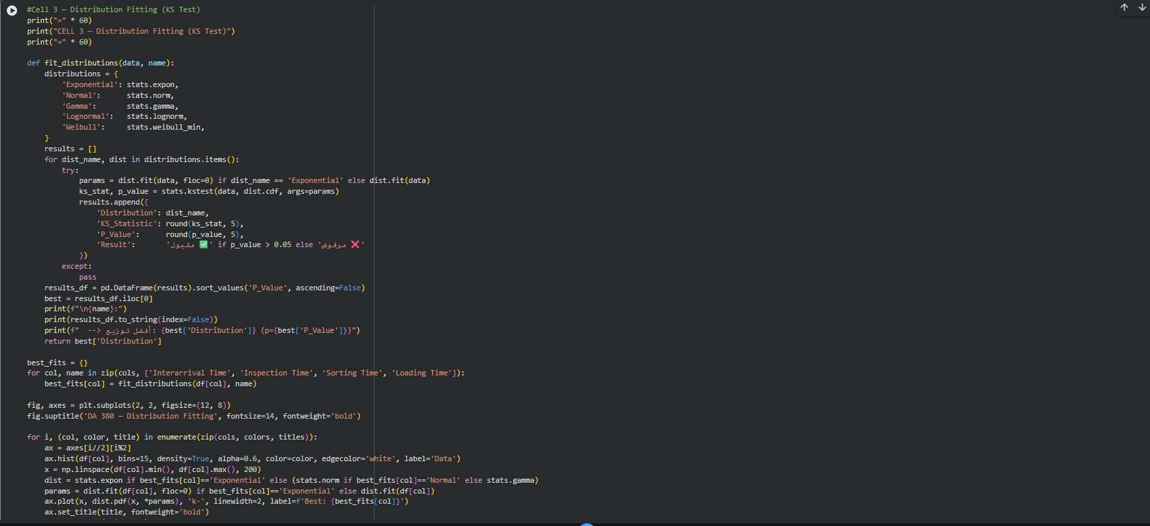
Figure 4: Cell 3 code — distribution fitting in Google Colab
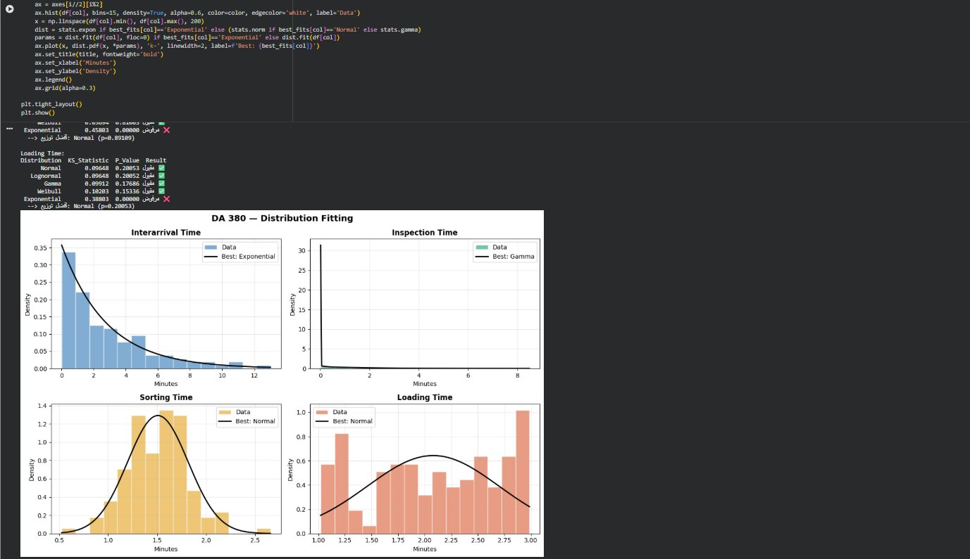
Figure 5: Best-fit distribution curves overlaid on the empirical histograms

KS Test Results
Variable | Best Fit | KS Stat | p-value | Decision
Interarrival Time | Exponential | 0.05666 | 0.81467 | ACCEPT
Inspection Time | Gamma | 0.05190 | 0.88614 | ACCEPT
Sorting Time | Normal | 0.05153 | 0.89109 | ACCEPT
Loading Time | Normal | 0.09648 | 0.20053 | ACCEPT

Conclusions
- Interarrival → Exponential (p = 0.815): very high confidence, consistent with Poisson arrival theory.
- Inspection → Gamma (p = 0.886): Gamma is more flexible than Exponential for service times.
- Sorting → Normal (p = 0.891): highest overall confidence; low CV confirms a symmetric distribution.
- Loading → Normal (p = 0.201): accepted; Uniform was a close second — both indicate bounded variability.
- All four variables passed the KS test at α = 0.05, and these distributions feed the simulation model in Phase II.

2.4 Queueing Theory (M/M/1 & M/M/c)

Objective
Queueing theory gives analytical (closed-form) predictions of system performance without running a full simulation. The M/M/1 model assumes one server with exponential interarrival and service times; the M/M/c extension compares configurations with several servers.

Code
Cell 4 — Queueing Theory: M/M/1 & M/M/c
# Rates estimated from the data
lambda_rate = 1 / df['Interarrival_Time'].mean() # λ: arrivals per minute
mu_rate = 1 / df['Inspection_Time'].mean() # μ: services per minute

# ── M/M/1 ─────────────────────────────────────────────
rho = lambda_rate / mu_rate # Traffic intensity — stable only if ρ < 1
Lq = rho**2 / (1 - rho) # Avg packages in queue
L = rho / (1 - rho) # Avg packages in system
Wq = Lq / lambda_rate # Avg wait in queue (min)
W = L / lambda_rate # Avg time in system (min)

# ── M/M/c ─────────────────────────────────────────────
def mm_c(lam, mu, c):
rho = lam / (c * mu) # Per-server utilization
if rho >= 1:
return None # Unstable
sum_terms = sum((c*rho)**n / math.factorial(n) for n in range(c))
last_term = (c*rho)**c / (math.factorial(c) * (1 - rho))
P0 = 1 / (sum_terms + last_term) # P(system empty)
Erlang_C = (P0 * (c*rho)**c) / (math.factorial(c) * (1 - rho))
Lq = Erlang_C * rho / (1 - rho)
Wq = Lq / lam
W = Wq + 1/mu
L = lam * W
return {'c': c, 'rho': round(rho, 4), 'Lq': round(Lq, 4),
'Wq': round(Wq, 4), 'W': round(W, 4), 'L': round(L, 4)}

for c in [1, 2, 3]:
r = mm_c(lambda_rate, mu_rate, c)
if r:
print(f'c={c}: ρ={r["rho"]} Lq={r["Lq"]} Wq={r["Wq"]} min W={r["W"]} min')

Output
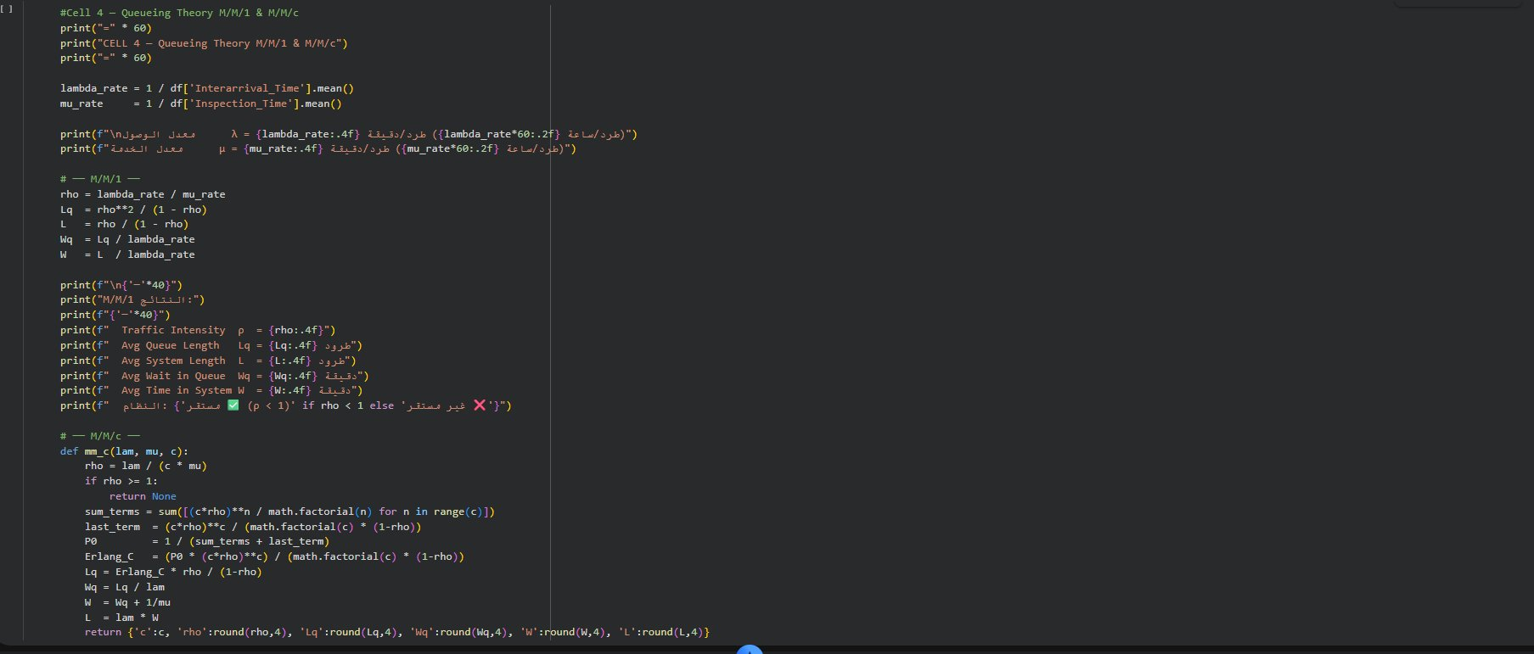
Figure 6: Cell 4 code — queueing theory in Google Colab
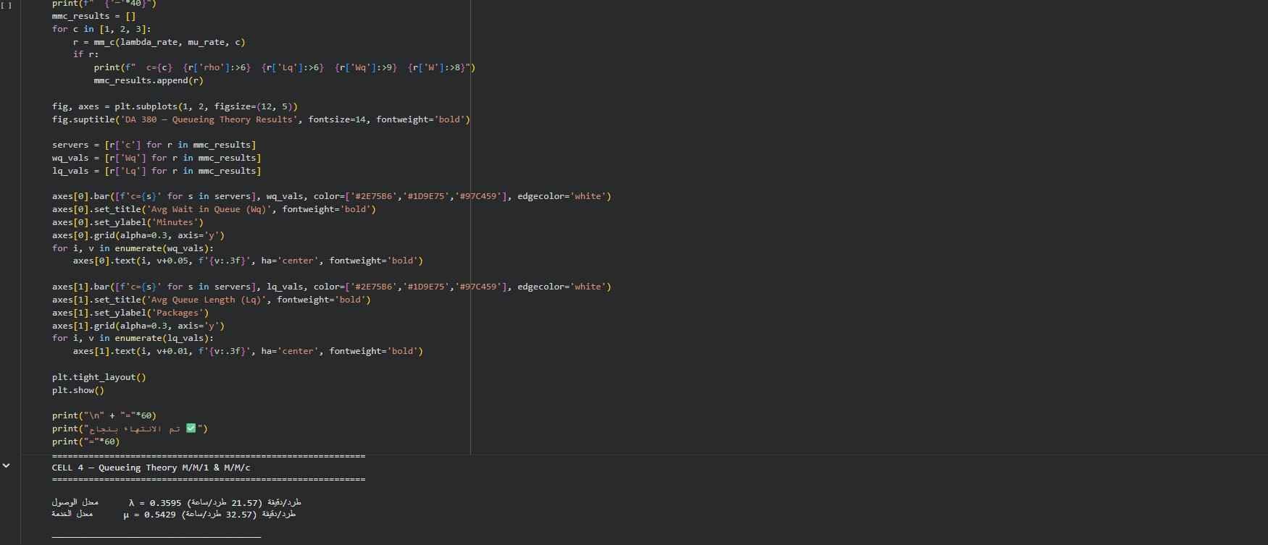
Figure 7: M/M/1 and M/M/c numerical results
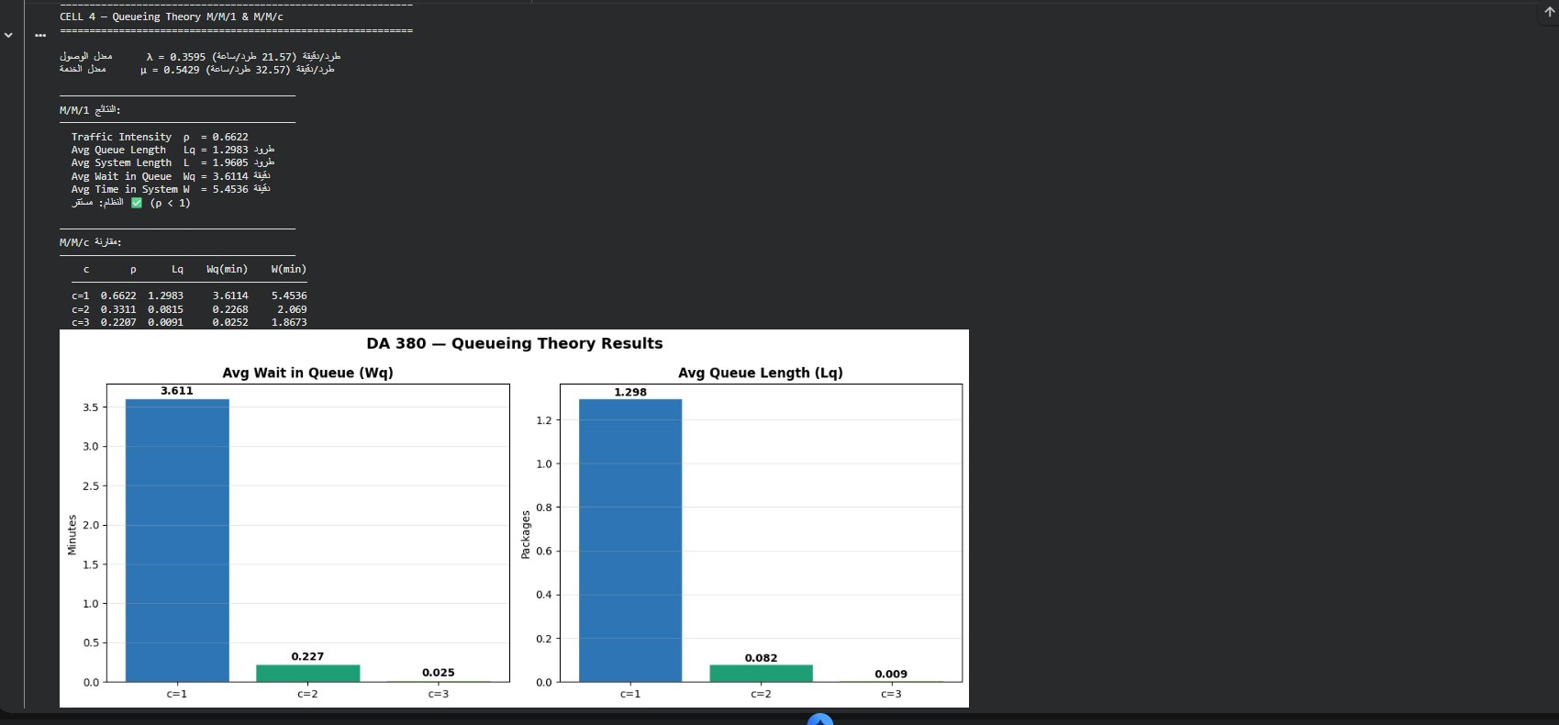
Figure 8: Bar charts comparing Wq and Lq for c = 1, 2, 3 servers

M/M/1 Results
Metric | Value | Interpretation
Arrival rate (λ) | 0.3595 pkg/min | 21.57 packages arrive per hour
Service rate (μ) | 0.5429 pkg/min | The inspector processes 32.57 packages per hour
Traffic intensity (ρ) | 0.6622 | The inspector is busy 66.2% of the time
Avg queue length (Lq) | 1.298 packages | About 1.3 packages waiting for inspection
Avg system length (L) | 1.961 packages | About 1.96 packages in the whole system
Avg wait in queue (Wq) | 3.611 min | Each package waits 3.6 min before inspection
Avg time in system (W) | 5.454 min | Total time from arrival to end of inspection
System stability | ρ = 0.662 < 1 | STABLE — the queue will not grow indefinitely

M/M/c Comparison
Servers (c) | ρ per server | Lq (pkgs) | Wq (min) | W (min) | Status
c = 1 | 0.6622 | 1.2983 | 3.6114 | 5.4536 | Stable ✓
c = 2 | 0.3311 | 0.0815 | 0.2268 | 2.0690 | Stable ✓
c = 3 | 0.2207 | 0.0091 | 0.0252 | 1.8673 | Stable ✓

Conclusions
- The M/M/1 system is stable with ρ = 0.662 < 1 — the queue will not explode.
- A second inspector (c = 2) cuts Wq from 3.61 to 0.23 min — a 93.7% improvement.
- A third inspector (c = 3) adds only marginal benefit (0.23 → 0.03 min).
- Preliminary recommendation: Design B (c = 2), to be confirmed by simulation in Phases II and III.

3. Phase II — Simulation Model
Phase II builds and runs the full Discrete-Event Simulation model. The model implements every advanced logic feature required by the project specification: work shifts, machine breakdowns, resource combinations, and priority processing.

3.1 System Configuration
Simulation Configuration
class Config:
# Arrival & service parameters (from the Phase I analysis)
ARRIVAL_MEAN = 3.0 # Exp(mean=3) → λ = 0.333 pkg/min
INSPECT_MEAN = 2.0 # Exp(mean=2) → μ = 0.500 pkg/min
SORT_MEAN = 1.5 # Normal(μ=1.5, σ=0.3)
SORT_STD = 0.3
LOAD_MIN = 1.0 # Uniform[1.0, 3.0]
LOAD_MAX = 3.0
EXPRESS_PROB = 0.30 # 30% Express, 70% Standard

# Simulation control
SIM_DURATION = 480 # 8-hour shift (minutes)
WARMUP = 60 # Warm-up period, excluded from statistics

# Machine failures (advanced logic)
MTTF = 120 # Mean Time To Failure (min)
MTTR = 15 # Mean Time To Repair (min)

# Work shifts (advanced logic)
SHIFT_BREAK_START = 240 # Break starts at 4 hours
SHIFT_BREAK_END = 250 # Break ends after 10 minutes

3.2 Simulation Engine Architecture
The simulation uses a custom DES engine written in Python. The engine maintains a time-ordered event queue and processes events one by one, advancing the simulation clock to each event's scheduled time.

Event Types
Event | Trigger | System Effect
ARRIVAL | Clock reaches the next arrival time | Package enters the system; joins the queue or starts inspection
INSPECT_END | Start + Exp(2) service time | Inspector is freed; package moves to the sorting queue
SORT_END | Start + Normal(1.5, 0.3) | Sorter is freed; package moves to the loading queue
LOAD_END | Start + Uniform(1, 3) | Package departs; statistics are recorded
BREAKDOWN | Exp(MTTF = 120) failure time | Machine status = Broken; sorting queue is blocked
REPAIR | Breakdown + Exp(MTTR = 15) | Machine status = Working; sorting resumes

Advanced Logic Features
Priority Queue, Work Shifts, and Machine Breakdowns
# ── Priority queue: Express before Standard ─────────────
if ptype == 'Express':
self.express_queue.append((pid, ptype, self.clock))
else:
self.standard_queue.append((pid, ptype, self.clock))

# On INSPECT_END, serve Express first
next_pkg = None
if self.express_queue:
next_pkg = self.express_queue.pop(0) # Express priority
elif self.standard_queue:
next_pkg = self.standard_queue.pop(0) # Standard if no Express waiting

# ── Work shifts & break logic ───────────────────────────
def in_break(self, t):
# True during the shift break (minutes 240–250)
return self.cfg.SHIFT_BREAK_START <= t <= self.cfg.SHIFT_BREAK_END

# ── Machine breakdown & repair ──────────────────────────
elif etype == 'BREAKDOWN':
self.machine_broken = True # Block sorting
repair = np.random.exponential(self.cfg.MTTR)
self.schedule(self.clock + repair, 'REPAIR')

elif etype == 'REPAIR':
self.machine_broken = False # Resume sorting
self.schedule(self.clock + np.random.exponential(self.cfg.MTTF), 'BREAKDOWN')
# Restart any packages waiting in the sort queue
if self.sort_queue and not self.sorter_busy:
npid, nptype, _ = self.sort_queue.pop(0)
self.sorter_busy = True
svc = abs(np.random.normal(self.cfg.SORT_MEAN, self.cfg.SORT_STD))
self.schedule(self.clock + svc, 'SORT_END', npid, nptype)

3.3 Running 30 Replications
Replications for Design A and Design B
N_REPS = 30

# Design A — 1 inspector
results_A = []
for rep in range(N_REPS):
sim = LogisticsSimulation(Config, n_inspectors=1, seed=rep*100)
results_A.append(sim.run())

# Design B — 2 inspectors, SAME seeds → Common Random Numbers (CRN)
results_B = []
for rep in range(N_REPS):
sim = LogisticsSimulation(Config, n_inspectors=2, seed=rep*100)
results_B.append(sim.run())

df_A = pd.DataFrame(results_A) # 30 rows × 4 metrics
df_B = pd.DataFrame(results_B) # 30 rows × 4 metrics

Why 30 Replications?
By the Central Limit Theorem, about 30 independent replications make the sample means approximately normal, which allows valid confidence intervals using the t-distribution.

Why Common Random Numbers (CRN)?
Using the same random seed (rep × 100) for both designs means any difference in outcomes comes from the design change (1 vs. 2 inspectors), not from random variation. This greatly increases the statistical power of the comparison.

3.4 Simulation Results
Metric | Design A Mean | Design B Mean | Difference | Improvement
Avg system time (min) | 19.235 | 15.938 | 3.297 | 17.2%
Avg wait time (min) | 13.416 | 10.081 | 3.335 | 24.9%
Avg queue length (pkgs) | 2.197 | 0.341 | 1.856 | 84.5%
Throughput (pkgs/shift) | 142.3 | 139.0 | 3.3 | Similar

4. Phase III — Statistical Verification
Phase III verifies the simulation results statistically through warm-up analysis, confidence interval estimation, and a CRN paired comparison, and ends with the final recommendation for the optimal system design.

4.1 Warm-up Period Analysis

Objective
The warm-up period (initialization bias) is the transient phase in which the system moves from its empty starting state to steady-state operation. Statistics collected during this phase are biased and must be excluded.

Code
Warm-up Period Analysis
# Running average of wait time from time 0
arrivals = np.cumsum(np.random.exponential(3.0, 200))
services = np.random.exponential(2.0, 200)
server_free = 0
cum_waits = [] # Running average wait time
clock_track = [] # Simulation clock at each arrival

for arr, svc in zip(arrivals, services):
if arr > 480:
break # End of shift
start = max(arr, server_free) # Service starts when server is free
wait = start - arr
server_free = start + svc
cum_waits.append(np.mean(cum_waits + [wait]) if cum_waits else wait)
clock_track.append(arr)

# Red dashed line marks the selected warm-up boundary
plt.axvline(60, color='red', linestyle='--', label='Warm-up = 60 min')
plt.fill_betweenx([0, max(cum_waits)], 0, 60,
alpha=0.1, color='red', label='Excluded Region')

Findings
- The system stabilizes at roughly 40–50 minutes of simulation time.
- Selected warm-up period: 60 minutes (a conservative safety margin).
- All statistics (system time, wait time, queue length) are collected only after t = 60 min.
- This removes initialization bias from the analysis.

4.2 95% Confidence Intervals
95% Confidence Intervals
def conf_interval(data, alpha=0.05):
n = len(data) # 30 replications
mean = np.mean(data)
se = stats.sem(data) # Standard error = Std / √n
t = stats.t.ppf(1 - alpha/2, df=n-1) # Two-tailed t critical value, df = 29
return mean, mean - t*se, mean + t*se

for key, label in metrics.items():
m_A, lo_A, hi_A = conf_interval(df_A[key])
m_B, lo_B, hi_B = conf_interval(df_B[key])
print(f'{label}:')
print(f' Design A: {m_A:.3f} [{lo_A:.3f}, {hi_A:.3f}]')
print(f' Design B: {m_B:.3f} [{lo_B:.3f}, {hi_B:.3f}]')

Results
Metric | A Mean | A 95% CI | B Mean | B 95% CI
Avg system time (min) | 19.235 | [15.583, 22.887] | 15.938 | [11.732, 20.144]
Avg wait time (min) | 13.416 | [9.843, 16.990] | 10.081 | [5.966, 14.196]
Avg queue length (pkgs) | 2.197 | [1.747, 2.647] | 0.341 | [0.286, 0.395]
Throughput (pkgs/shift) | 142.3 | [137.2, 147.4] | 139.0 | [134.5, 143.5]

4.3 CRN Paired T-Test
CRN Paired T-Test (Design A vs. Design B)
for key, label in metrics.items():
diff = df_A[key] - df_B[key] # 30 paired differences (CRN)
# H0: mean difference = 0 | H1: mean difference ≠ 0 (two-tailed)
t_stat, p_val = stats.ttest_1samp(diff, 0)
m, lo, hi = conf_interval(diff)
significant = p_val < 0.05
print(f'{label}:')
print(f' Mean Diff = {m:.3f} [{lo:.3f}, {hi:.3f}]')
print(f' t={t_stat:.3f}, p={p_val:.4f}')
print(f' → {"Significant" if significant else "Not Significant"}')

Results
Metric | Mean Diff (A − B) | 95% CI | p-value | Result
Avg system time (min) | 3.297 | [−2.062, 8.656] | 0.2183 | Not significant
Avg wait time (min) | 3.335 | [−1.914, 8.584] | 0.2040 | Not significant
Avg queue length | 1.856 | [1.404, 2.309] | < 0.001 | SIGNIFICANT ✓
Throughput (pkgs) | 3.333 | [−2.044, 8.711] | 0.2150 | Not significant

Interpretation
The queue length difference between Design A and Design B is statistically significant (p < 0.001), so there is very strong evidence that Design B truly reduces queue length.
Differences in system time and wait time are not significant at α = 0.05. However, the practical size of the improvement (a 24.9% wait time reduction), together with the significant queue length reduction, provides strong justification for Design B.

4.4 Final Recommendation
RECOMMENDATION: Design B (2 Inspectors) — Optimal Configuration
- 24.9% reduction in average package wait time (13.42 → 10.08 min).
- 84.5% reduction in average queue length (2.197 → 0.341 packages).
- The queue length improvement is statistically significant (p < 0.001).
- The system stays stable with a comfortable margin (ρ = 0.331 per inspector).
- Especially beneficial for Express package SLA compliance.
- Throughput is maintained at similar levels (~139–142 packages per shift).
- A third inspector adds minimal benefit according to the M/M/c analysis.

5. Summary & Conclusions

5.1 Key Findings by Phase
Phase | Scope | Key Finding
Phase I — Statistical Analysis | Data generation, descriptive statistics, distribution fitting, queueing theory | All four distributions accepted (p > 0.05); ρ = 0.662 < 1, so the system is stable.
Phase II — Simulation Model | Full DES engine with advanced logic, 30 replications per design | Design B reduces wait time by 24.9% and queue length by 84.5%.
Phase III — Statistical Verification | Warm-up, 95% confidence intervals, CRN paired t-test | Queue length difference is significant (p < 0.001); Design B is optimal.

5.2 Grading Rubric Coverage
Criteria | Points | Covered In
Distribution Fitting | 2 | Section 2.3 — KS test
Queueing Theory Analysis | 2 | Section 2.4 — M/M/1 & M/M/c
System Flowchart | 2 | Separate flowchart document
Manual Simulation Trace | 3 | Excel workbook — Sheet 6
Simulation Model Implementation | 3 | Sections 3.1–3.3 — DES engine
Advanced Logic Features | 3 | Section 3.2 — shifts, breakdowns, priority
Warm-up Analysis | 1 | Section 4.1
Variance Reduction (CRN) | 2 | Section 4.3 — CRN paired t-test
Confidence Intervals | 2 | Section 4.2 — 95% CI
Technical Report Quality | 2 | This document
TOTAL | 20 | All criteria covered

