Cairo University  
Faculty of Computers and Information



**CS251**

**Software Engineering I**

(Multiple choice Educational Game)

Software Requirements Specifications

radwa ragab

sheriene Ahmed

Aisha Shokry

Sarah Mohammed

5/11/2016

Contents

Team 3

Document Purpose and Audience 4

Introduction 4

Software Purpose 4

Software Scope 4

Functional Requirements 5

Non Functional Requirements 6

Use Case Model 7

Use Case Tables 8

Ownership Report 4

# 

# Team

|  |  |  |  |
| --- | --- | --- | --- |
| **ID** | **Name** | **Email** | **Mobile** |
|  | Sherine Ahmed Elmosalamy | Sherine.ahmed.fci@gmail.com | 01061592387 |
|  | Radwa Ragab Youssef | Radwaragab119@gmail.com | 01142340509 |
|  | Aisha Shokry Abdfatah | aishashokry58@gmail.com | 01205738973 |
|  | Sara Mohamed | saramuhamed25@gmail | 01143263993 |

# 

# Document Purpose and Audience

**This document is a proposal for requirements specification in response to software project . our team is very excited about the idea of the game and working on its development. and in this proposal we're going to show you system requirements and use case diagram.**

**our audience are going to be The Doctor and our TAs .**

# Introduction

## Software Purpose:

**the main purpose of our software project is designing and making an educational game in different categories that would help little children to play , have fun and also educate . it will enable also their teacher to check their progress .**

## Software Scope:

**It will be educational game for children to learn basic sciences and also teacher could follow their achievements , the game will enable you as a student or teacher to create account by adding your basic information and have a user name and password , then choose from the menu which category of science would you play , the game will be multiple choice questions , save your score and achievements , also you can rate or add any comment if you want . the teacher can create a game or play any of existed games and it will enable him to interact with the students by comments .**

# Requirements

## Functional Requirements

* **Enter ID and password:**
* **System should allow user to enter ID and password check validity if valid allow log in if not recommend sign up teacher and administrations have authentication so they have open ID**
* **Choose suitable category from menu:**
* **System support choose from more than one option collected in menu user is able to choose the category he/she prefers from mathematics English and Programming**
* **View edit and update:**
* **Supporting profile edit to allow user change name or password update bio or send main**
* **Short description for each game:**
* **Game demonstration is very helpful to make students know how to deal with games**
* **single player:**
* **System support single playing only**
* **Rating:**
* **System support rate and comment for the games played**
* **Teacher role:**
* **Teacher can create game as system allow more authentication for high board also can edit or delete and old game use open ID**
* **Pause or resume :**
* **system has buttons for pausing or exit from the game**
* **Play again:**
* **if the user want to play any valid level after he lose , he can press new game and start to play again**
* **Control the games:**
* **the player can play using mouse or keyboard**
* **Update level and score :**
* **if user could make it and win he can go to next level and every right answer his score would be updated according to this**
* **main menu:**
* **system has main menu that contain play , categories of the games, help and exit buttons**
* **Record the progress:**
* **every player have a profile that contain his basic information and his/her scores**
* **When the user win :**
* **when the player answer all the questions in the level he wins and can go to next level**
* **Display right answers:**
* **when he lose or answer wrong question, the right will be displayed to him on the screen**
* **The user should have a choice from three levels of difficulty**

## Non Functional Requirements

|  |  |
| --- | --- |
|  | **Details** |
| **Performance** | * **Response Time : System should has a fast response on end users commands** |
| **Scalability** | * **System should be able to support up to 1000 simultaneous game players.** |
| **Supportability** | * **Testability : System should be testable even the corner cases should be handled** * **Extensibility : new games will be added by the teachers so system should allow extensions** * **Adaptability : system should be adaptable work on each device and operating system** * **Main ability : system should be easy to use as the end users include students who need a simple organized software** |
| **Reliability** | * **Recoverability : System should easily and fast recover as every system may face issues but it should maintain return** * **Predictability : System should be predictable as will it be reliable after 10 years from now if so would it face new system with same features** * **Accuracy : system should be specific and accurate to achieve purpose and goals** * **System should be secure as it allow only staff with ID and password to use system** |
| **Usability** | * **Easy to play** * **Esthetics** * **Is user experience what was intended?** * **Consistency of the user interface** * **Online help** * **Wizards and tutorials** * **User Documentation** * **Training materials** |

# System Models

## Use Case Model

**use case diagram :**

* 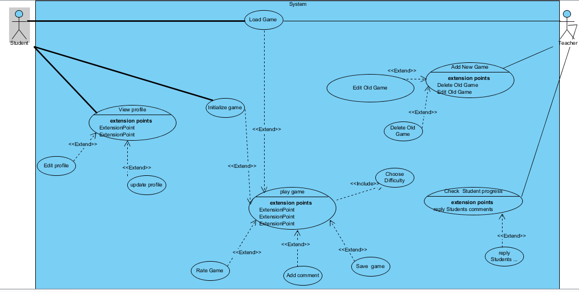

## 

## Use Case Tables:

|  |  |  |
| --- | --- | --- |
| Use Case ID: | 1 | |
| Use Case Name: | Play Game | |
| Actors: | Students | |
| Pre-conditions: | System should check accounts validity for teachers and students to insure sign in if not they are allowed to sign up teachers are allowed to sign up with open ID | |
| Post-conditions: | Save and update score | |
| Flow of events: | **User Action** | **System Action** |
| **1.end user click on game link and wait for it to open** | **System load game aspects** |
| 2. User Enter ID and Password. | Check validity for entered account details  If the end user is a teacher ,system allow teacher to enter open ID |
| 3. user click on home page | System display content of home page and start to initialize game by opening it on the last edit for the user |
|  | 4.end user choose one of the categories and determine difficulty level | System submit choice and display games inside the certain category |
|  | 5. user choose one of the games in the specified category | System submit choice and load game |
|  | 6. user starts to play game | System update score directly and display the saved questions |
|  | 7. user win | System open option menu again for user to choose if he want to precede for the next level exit game or try to enhance score for the same level |
|  | 8.lose | System open option menu again for user to choose if he want to try again or exit game |
|  | 9. on exit game | System display if user want to rate game now or leave a comment |
| Exceptions: | **User Action** | **System Action** |
| 1- User Enter ID and Password. | ID and password are not found in database  System reject user data |
| Includes: | Choose Difficulty | |
| Notes and Issues: |  | |

# 

|  |  |  |
| --- | --- | --- |
| Use case ID | 2 | |
| Use case name | View Profile | |
| Actors | Student | |
| Pre-conditions | Log in | |
| Post- conditions | Save Changes | |
| Flow of events | Use user action | System Action |
| 1.Student click on game link  2.Student click on main menu  3.Student Choose edit profile  4.Student may click on update photo  5.Student may click on change name or character  6.Student may change password  7.Student save changes and update profile | System starts to load game interface and aspects  System display contents of main menu  System display student profile and allow changes  System allow student to choose photo  System allow changes if the last change from more than 60 days  System allow student to change password after enter old password  System update students data |
| Exceptions | User Action | System Action |
| 1.user enters different password pattern | System refuses new password and alert user to follow decided pattern 8-digits with characters and numbers |
| 2. Student update name before 60 days | System refuses changes for ensure identification of student (refuse no user name) |
| Includes | ---- | ---- |
| Notes and issues | ---- | ---- |

|  |  |  |
| --- | --- | --- |
| **use case ID** | 3 | |
| **Use case name** | Add New Game | |
| **Actors** | Teachers | |
| **Pre-conditions** | Check open source ID to ensure authentication of the user and validation of password | |
| **Post-conditions** | Save and update game on server | |
| **Flow of events** | User Actions | System Actions |
| 1. Open game website2. Teacher Click on game link  3. Teacher click on add new game  4.Teacher choose new game category  5.Teacher save new game  6.Teacher delete old game  7.Teacher edit old game | Load game content and aspects System display menu content  System display edit , modification tools and ready templates  System add the game to the specified category  System add the new game to database and server and update teacher profile  System update profile and remove game from server  System update game to the new one |
| **exceptions** | User Actions | System Actions |
| Invalid open source ID | System alert user of the invalidation of ID |
| **Include** | --- | --- |
| **Notes and Issues** | --- | --- |

|  |  |  |
| --- | --- | --- |
| Use case ID | 4 | |
| Use case Name | Check Student Progress | |
| Actors | Teachers | |
| Pre-conditions | Log in use open source ID for Teachers  Check student profile | |
| Post-conditions | Update and Save Student profile after adding notes and comments on their progress | |
| Flow Of events | User Action | System Action |
|  | 1.teacher enter open source ID authentication  2.teacher click on edit profile  3.teacher click on check progress button  4. teacher reply student comments  5.teacher click on save | System check for validity  System display profile content  System display each student name and his history progress  System notify students  System save and update data |
| Exceptions | Uuser Action | System Action |
|  | Enter invalid open source ID | System refuse ID and alert user |

# Ownership Report

|  |  |
| --- | --- |
| **Item** | **Owners** |
| Non-Functional | *Sherine Elmosalamy* |
| Functional | *Radwa Ragab* |
| Use case Diagram | *Aisha shokry* |
| Use case table | *Sara Mohamed* |