Q 33: Connect to database using PostgreSQL and increase the temperature 2 degrees for participant with maximum humidity and display the result

--Create database

CREATE DATBASE Python;

--Create table

CREATE TABLE IF NOT EXISTS subject_info (

Age DOUBLE PRECISION NOT NULL,

Weight DOUBLE PRECISION NOT NULL,

Height DOUBLE PRECISION NOT NULL,

Humidity DOUBLE PRECISION,

Temperature DOUBLE PRECISION,

Sex INTEGER NOT NULL,

ID INTEGER NOT NULL,

ID_test TEXT NOT NULL

);

SELECT * FROM subject_info;

--To load data from your local csv file to postgres use below query

COPY subject_info

FROM 'C:\Swati\study\Python\Python_Hackathon2025\Datasets\subject_info.csv'

DELIMITER ','

CSV HEADER;

SELECT * FROM subject_info;

select max(Humidity),Temperature

from subject_info

Group by Temperature

order by Temperature,max(Humidity);

## Use Update to increase temperature by 2 wherever humidity is max

update subject_info

set Temperature = Temperature + 2

where Humidity in (

select max(Humidity)

from subject_info

where Humidity is not NULL

Group by Temperature

)

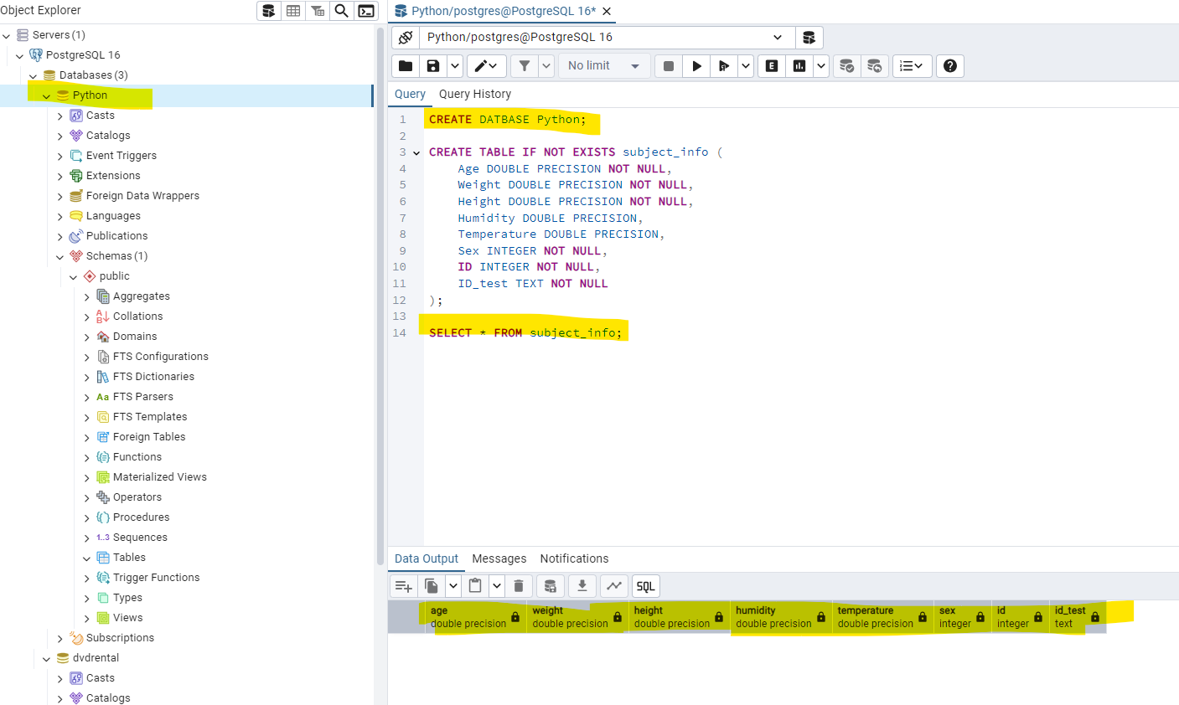

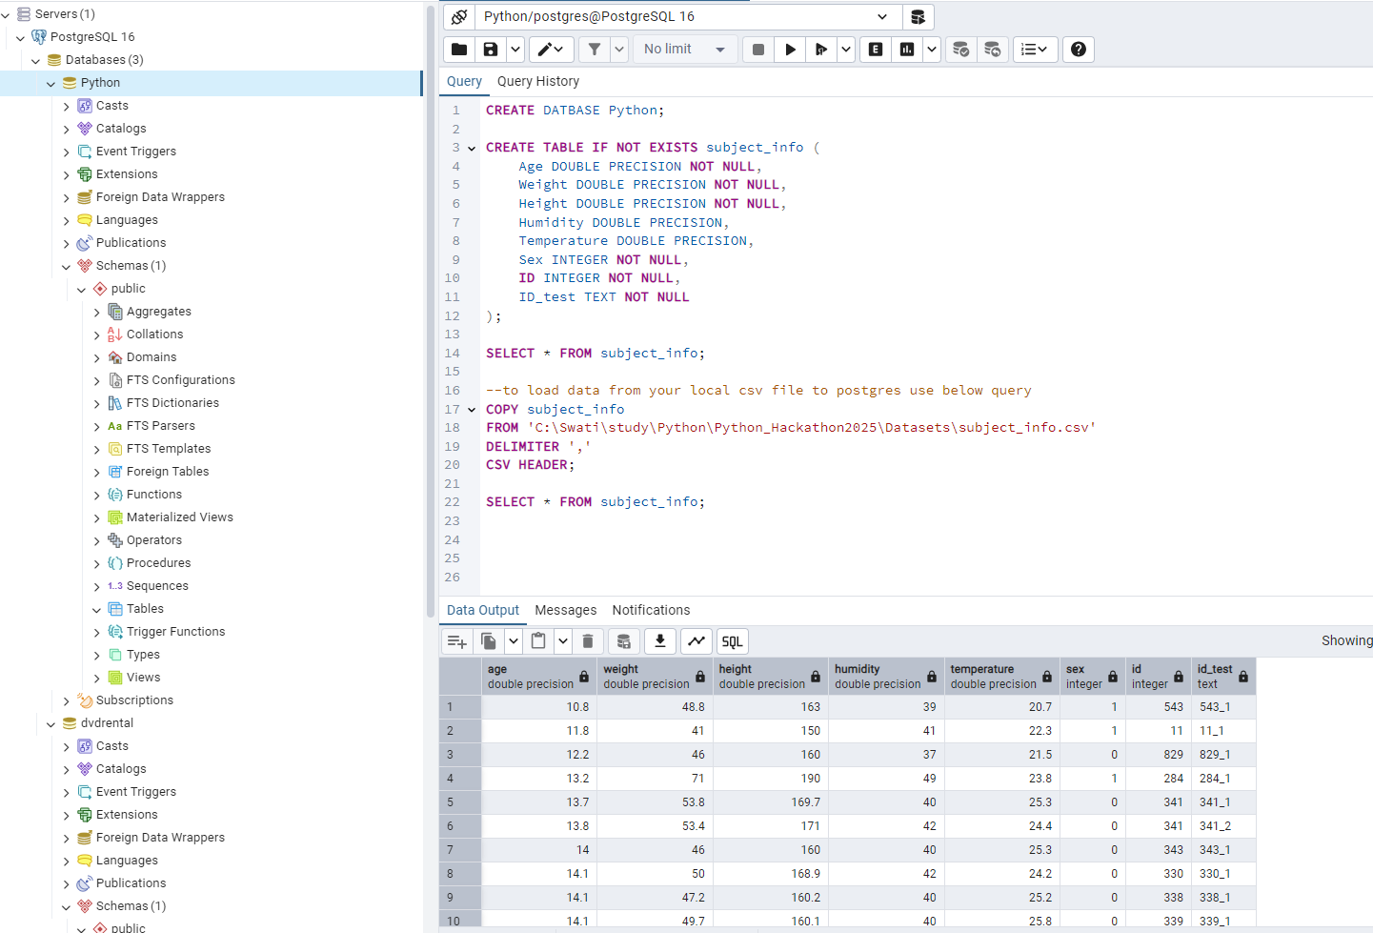

Before Query:

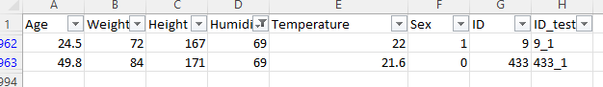

Output After query ran successfully and check in Jupyter notebook:

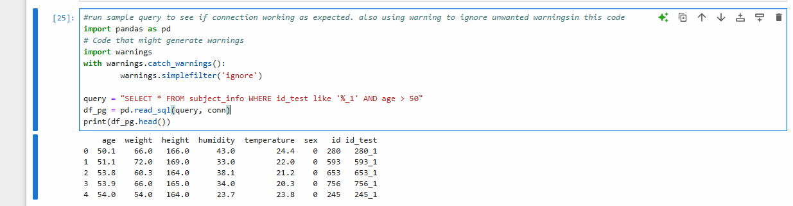

Q12: connect to database using PostgreSQL and get the details of participants in test 1 and age > 50

#using warning function to ignore unwanted warningsin this code

import pandas as pd

# Code that might generate warnings

import warnings

with warnings.catch_warnings():

warnings.simplefilter('ignore')

query = "SELECT * FROM subject_info WHERE id_test like '%_1' AND age > 50"

df_pg = pd.read_sql(query, conn)

print(df_pg.head())

