LoginUser Test: -

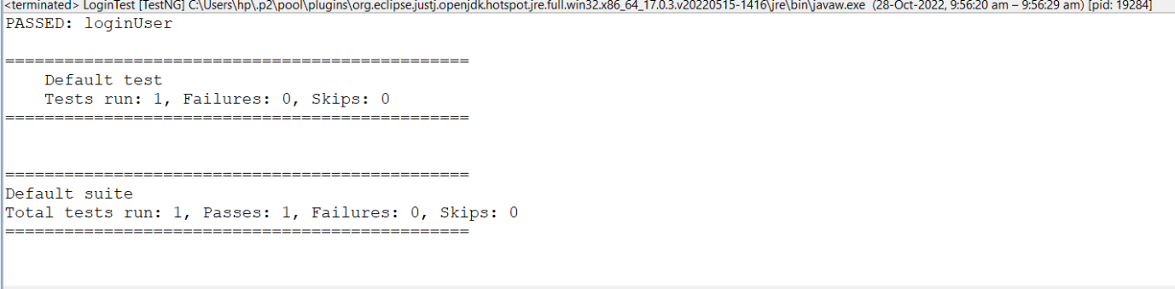

Register User Test: -

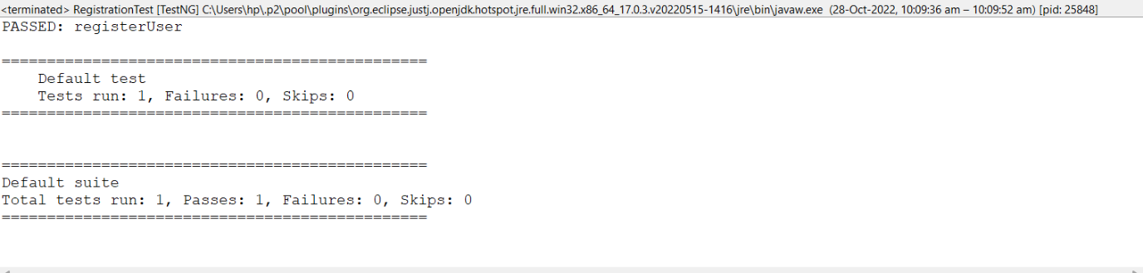

Primary and saving account deposit

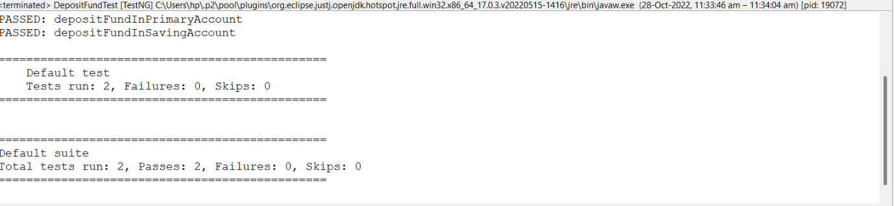

Withdraw from primary and saving

Primary Account details

Saving Account details

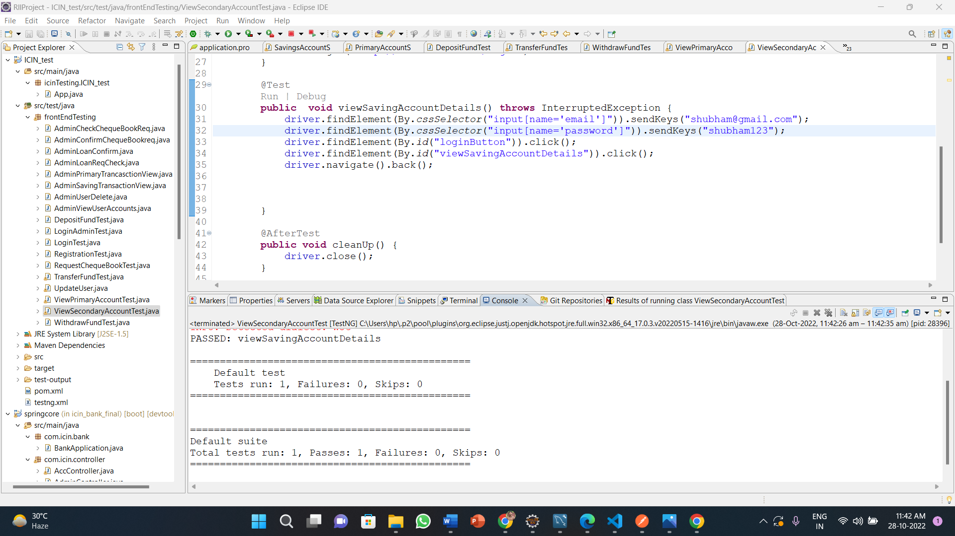

Chequebook req:--

Transfer Fund: -

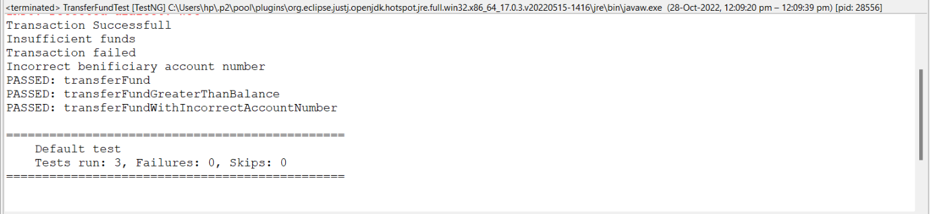

Update User:-

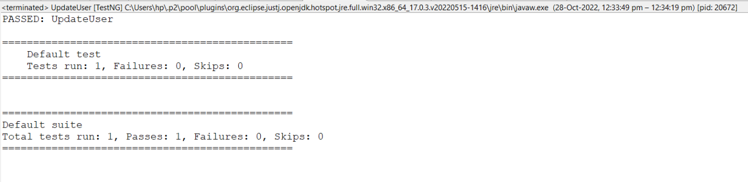

Admin Login

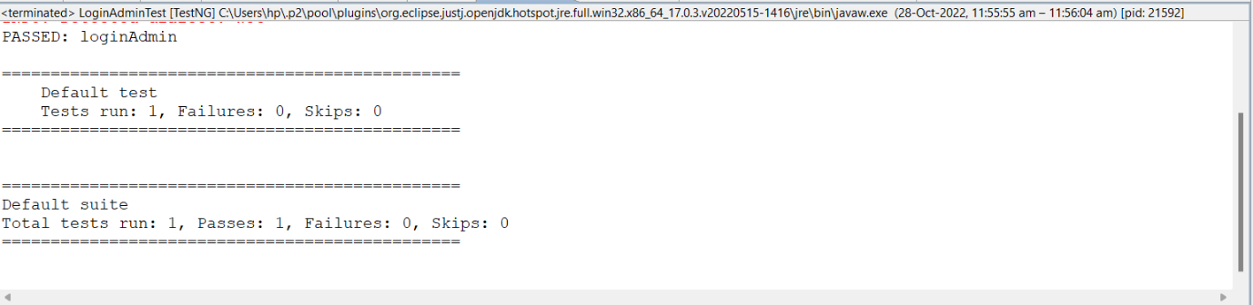

Admin View User Account

Admin Saving view

Admin Primary View

Admin Loan Req

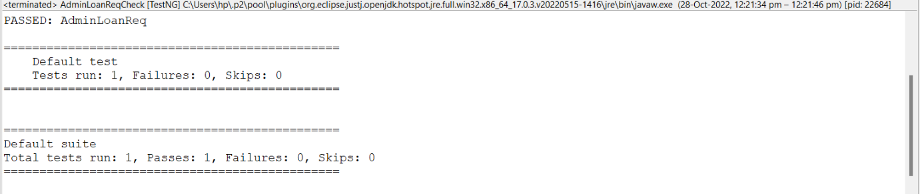

Admin Cheque Book Req

Admin Confirm Cheque Book

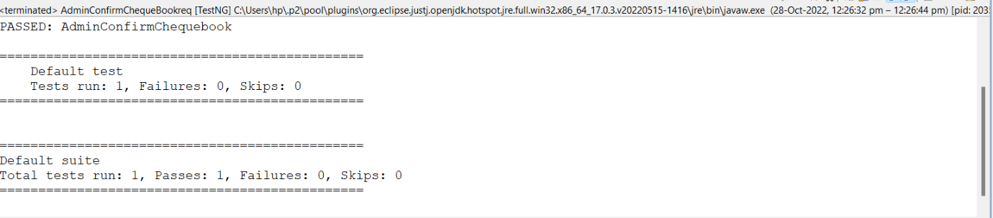

Admin User Delete

