LOAN PREDICTION SYSTEM USING MACHINE LEARNING

PROJECT DOCUMENTATION

Submitted By: Esakki saran S
Department: Artificial Intelligence and Data Science
Institution: Christ The King Engineering College
Academic Year: 2025 – 2026

Table of Contents

S.no Title Page No
1 ABSTRACT 3
2 INTRODUCTION 3
3 OBJECTIVES 4
4 PROBLEM STATEMENT 4
5 TECHNOLOGIES USED 5
6 DATASET DESCRIPTION 5
7 METHODOLOGY 6
6.1 Data Collection 6
6.2 Data Preprocessing 6
6.3 Exploratory Data Analysis 6
6.4 Feature Engineering 6
6.5 Model Training 6
6.6 Prediction 6
6.7 Model Evaluation 6
8 SYSTEM WORKFLOW 7
9 MACHINE LEARNING IMPLEMENTATION 7
10 RESULTS AND DISCUSSION 8
11 ADVANTAGES 8
12 FUTURE ENHANCEMENTS 9
13 CONCLUSION 9
14 REFERENCES 10

ABSTRACT
The Loan Prediction System is a Machine Learning-based application developed to automate the process of loan approval prediction using applicant information. Financial institutions receive a large number of loan applications every day, making manual verification difficult, time-consuming, and prone to human error. This project predicts loan eligibility based on various applicant details such as income, education, employment status, credit history, marital status, and loan amount.
The system uses Machine Learning techniques along with data preprocessing and visualization methods to build an accurate prediction model. Python libraries such as Pandas, NumPy, Matplotlib, and Scikit-learn are used during implementation. The proposed system helps improve the efficiency and reliability of loan approval decisions while reducing manual effort in banking operations.
The project demonstrates how Machine Learning can be applied in real-world financial applications to support intelligent decision-making systems.

INTRODUCTION

Loan approval is one of the most important services provided by banks and financial institutions. Traditional loan approval systems involve manual verification and analysis of applicant records, which may lead to delays and human errors. Machine Learning techniques provide a modern approach for automating prediction systems using historical data. The Loan Prediction System analyzes applicant details and predicts whether the loan application should be approved or rejected.

OBJECTIVES
The major objectives of the Loan Prediction System are:
- To analyze loan applicant data efficiently.
- To clean and preprocess the dataset.
- To perform exploratory data analysis using graphs and charts.
- To identify important factors affecting loan approval.
- To train Machine Learning models for prediction.
- To predict loan approval status accurately.
- To reduce manual work in the banking sector.
- To improve decision-making efficiency using intelligent systems.
- To demonstrate the practical application of Machine Learning in finance.

PROBLEM STATEMENT
Banks and financial institutions receive thousands of loan applications from customers. Manually verifying each application requires considerable time and effort. The traditional loan approval system may also lead to delays, inconsistencies, and incorrect decisions due to human limitations.
Financial institutions need an automated system that can quickly analyze applicant details and accurately predict loan eligibility. An intelligent prediction system can help banks reduce operational costs and improve customer satisfaction.
The proposed Loan Prediction System addresses this issue by using Machine Learning algorithms to automate the loan approval prediction process. The system uses applicant data to determine whether the loan should be approved or rejected based on learned patterns from historical records.

TECHNOLOGIES USED
Technology | Purpose
Python | Programming Language
Pandas | Data Manipulation and Analysis
NumPy | Numerical Computation
Matplotlib | Data Visualization
Scikit-learn | Machine Learning Algorithms
Google Colab | Cloud-based Development Environment

DATASET DESCRIPTION
The dataset used in this project contains loan applicant information collected from financial records. The dataset includes both categorical and numerical features related to loan approval decisions.
The target variable in the dataset is Loan_Status, which indicates whether the loan is approved or rejected.
Dataset Features
- Gender
- Married
- Dependents
- Education
- Self_Employed
- ApplicantIncome
- CoapplicantIncome
- LoanAmount
- Loan_Amount_Term
- Credit_History
- Property_Area
- Loan_Status

METHODOLOGY

6.1 Data Collection
The dataset is collected in CSV format from an online repository. The data contains information about loan applicants and their loan approval status.

6.2 Data Preprocessing
Data preprocessing is performed to improve data quality. Missing values are identified and handled using appropriate techniques. Unnecessary data is removed, and categorical variables are converted into numerical form.

6.3 Exploratory Data Analysis
Graphs and charts are generated to analyze relationships between different features. Visualization helps identify patterns and important factors influencing loan approval.

6.4 Feature Engineering
Feature engineering techniques are applied to improve model performance. Relevant features are selected for training the Machine Learning model.

6.5 Model Training
The dataset is divided into training and testing data. The Machine Learning model learns patterns from historical records during the training process.

6.6 Prediction
The trained model predicts whether a loan application will be approved or rejected based on applicant details.

6.7 Model Evaluation
The performance of the model is evaluated using accuracy scores and prediction metrics.

SYSTEM WORKFLOW
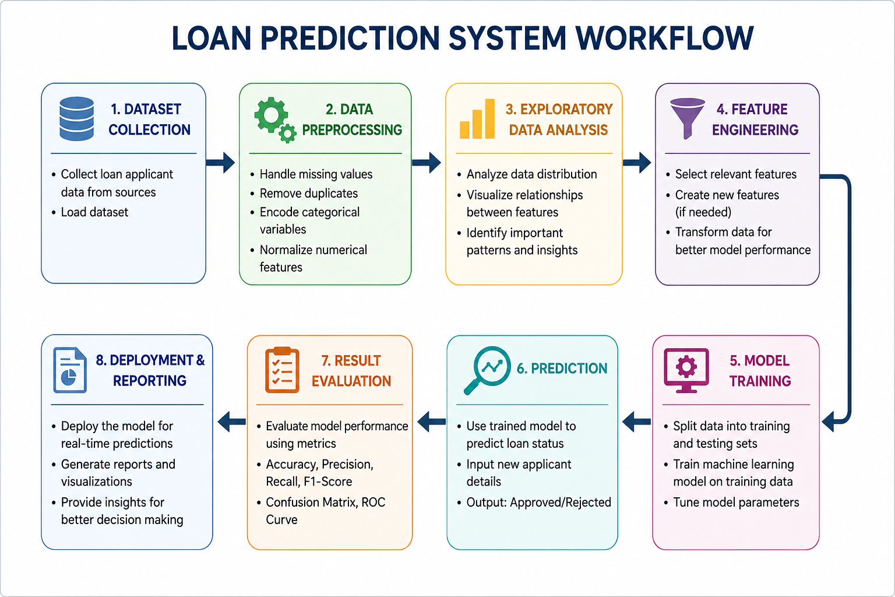Figure 1: Workflow of Loan Prediction System

MACHINE LEARNING IMPLEMENTATION
The project uses classification techniques for loan approval prediction. The dataset is split into training and testing datasets to evaluate model performance. The implementation process includes importing libraries, loading the dataset, handling missing values, encoding categorical variables, splitting training and testing data, model training, prediction, and accuracy evaluation.
The Machine Learning model learns patterns and relationships from historical loan records to make accurate predictions for new applicants. Various preprocessing techniques are applied to improve data quality and enhance model performance. The prediction results help determine whether a loan application is likely to be approved or rejected based on the applicant’s information.

RESULTS AND DISCUSSION
The Loan Prediction System successfully predicts loan approval status using Machine Learning techniques. The model was trained using historical loan applicant data and tested using separate testing data.
The prediction results indicate whether a loan application is approved or rejected based on the applicant’s information. The system demonstrates good prediction accuracy and reliable performance.
Data visualization techniques helped identify important factors affecting loan approval, such as credit history, applicant income, and education level.
The project demonstrates how Machine Learning techniques can support intelligent decision-making systems in financial institutions.

ADVANTAGES

• Reduces manual work in loan processing.
• Improves prediction accuracy.
• Saves processing time for banks.
• Helps identify eligible applicants quickly.
• Reduces human errors in decision-making.
• Supports automated banking systems.
• Improves customer service efficiency.
• Easy to implement and scalable.
• Helps financial institutions reduce operational costs.

FUTURE ENHANCEMENTS

The Loan Prediction System can be further improved using advanced technologies and deployment methods.
Future enhancements include:
- Implementation of advanced Deep Learning algorithms.
- Development of a real-time prediction system.
- Deployment as a web application.
- Integration with cloud databases.
- Mobile application support.
- Improved prediction accuracy using large datasets.
- Integration with banking management systems.
- Development of a user-friendly graphical interface.
These enhancements can make the system more efficient and suitable for real-world banking applications.

CONCLUSION
The Loan Prediction System is an effective Machine Learning application developed for predicting loan approval status using applicant information. The system automates the loan approval process and improves efficiency in banking operations.
The project demonstrates the practical implementation of Machine Learning techniques such as data preprocessing, visualization, feature engineering, model training, and prediction. The proposed system reduces manual effort, improves prediction accuracy, and supports intelligent financial decision-making.
The project highlights the importance of Machine Learning in modern banking systems and its potential to improve real-world financial applications.

REFERENCES

1. Python Official Documentation – https://docs.python.org/3/
2. Pandas Documentation – https://pandas.pydata.org/docs/
3. NumPy Documentation – https://numpy.org/doc/
4. Matplotlib Documentation – https://matplotlib.org/stable/contents.html
5. Scikit-learn Documentation – https://scikit-learn.org/stable/documentation.html
6. Google Colab Documentation – https://colab.research.google.com/
7. Loan Prediction Dataset Repository – https://github.com/dsrscientist/DSData
8. Google Machine Learning Crash Course – https://developers.google.com/machine-learning/crash-course
9. IBM Machine Learning Overview – https://www.ibm.com/topics/machine-learning
10. Towards Data Science – https://towardsdatascience.com/

